**Lec.3 Oral Physiology Dr. Muna**

**The types of blood circulation through the human heart:**

**1.Systemic circulation.**

**2.Pulmonary circulation.**

**3.Coronary circulation.**

**1.The systemic circulation:** is the portion of the cardiovascular system which is transport the oxygenated blood away from the heart to the rest of the body and returns the oxygen-depleted blood back to the heart. Systemic circulation is much longer than the pulmonary circulation so it transporting the blood to every part of the body.

It begins when the aorta which is the largest artery in the body that gives three main branches subclavian artery, brachiocephalic artery and common carotid artery the common carotid artery supplies the head and neck area which is subdivided into internal carotid artery and external carotid artery. 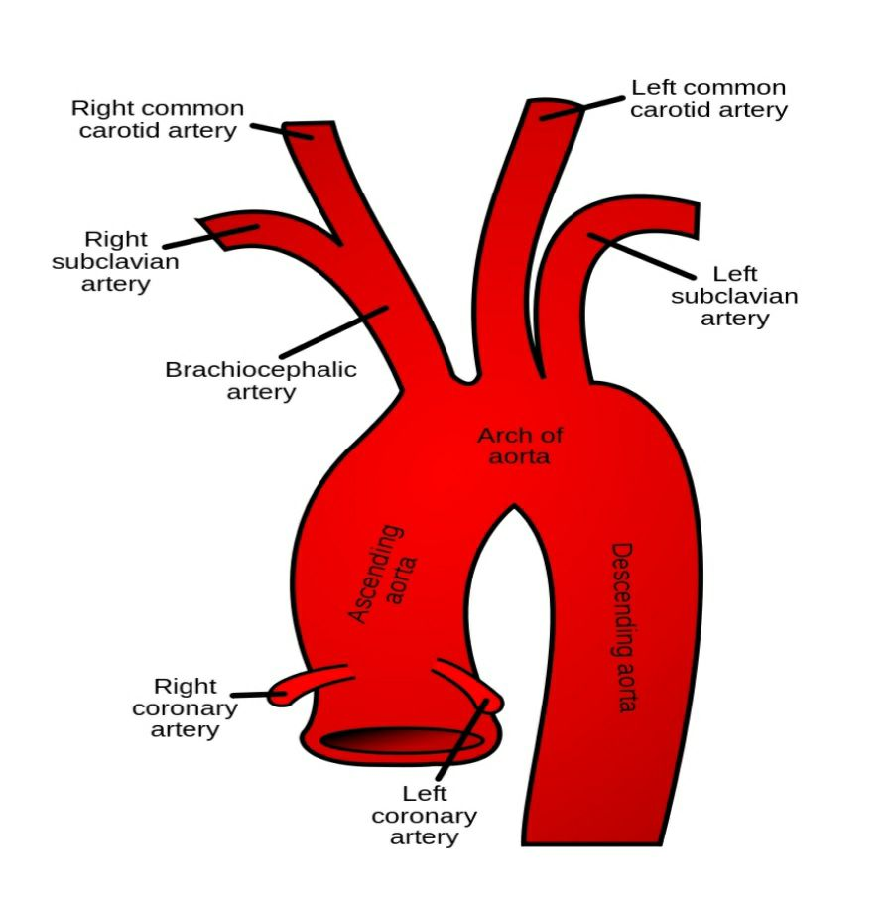

These arteries become smaller and smaller to become arterioles to end finally to capillaries where the work of the blood is done into the tissue in which the water and substances such as the glucose and amino acids are needed for cell metabolism.

The oxygen is the greatest concentration in the capillary blood stream than the intercellular spaces so it diffuses from the blood to the tissue.

While the CO2 is the greater concentrations in the tissue spaces than it is in the blood so it diffuses into the blood stream to be return to the right atrium of the heart through the veins.

It then enters the right ventricles that pumped the deoxygenated blood through the pulmonary artery to the lunges. 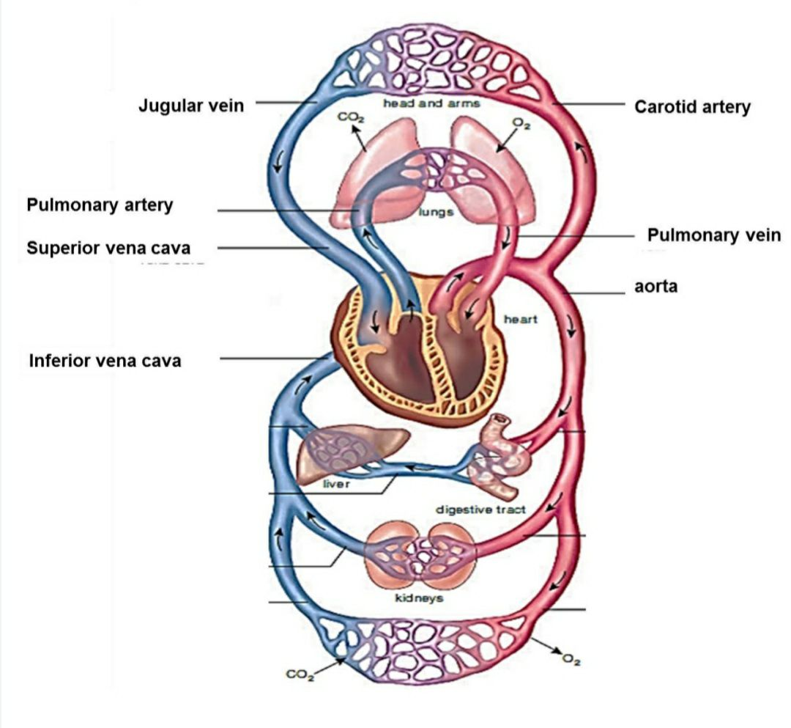

**2. The pulmonary circulation** it is the portion of the cardiovascular system which transports the oxygen-depleted blood away from the heart to the lunges and returns the oxygenated blood back to the heart.

Oxygen depleted blood from the vena cava enters the right atrium of the heart and flows through tricuspid valve to the right ventricle which is pumped though the pulmonary arteries to the lunges.

The pulmonary veins returns the oxygen rich blood to the left atrium of the heart which is flow though the mitral valve to the left ventricle to pump the oxygen rich blood through the aorta to rest of the body.

It arises from the pulmonary artery then it branches down to the capillaries that surround the alveoli in which the blood gases (O2 and CO2) are exchange. Once the blood is oxygenated it is returned to the left atrium of the heart by the pulmonary veins to be circulated again.

The arterial blood carries the oxygen from the inhaled air to all the cell of the body while the venous blood carries the carbon dioxide and waste product of the metabolism by the cells to the lunges to be exhaled.

All the arteries carry the oxygenated blood except the pulmonary artery caries the deoxygenated blood. All veins carry the deoxygenated blood except the pulmonary veins carry the oxygenated blood.

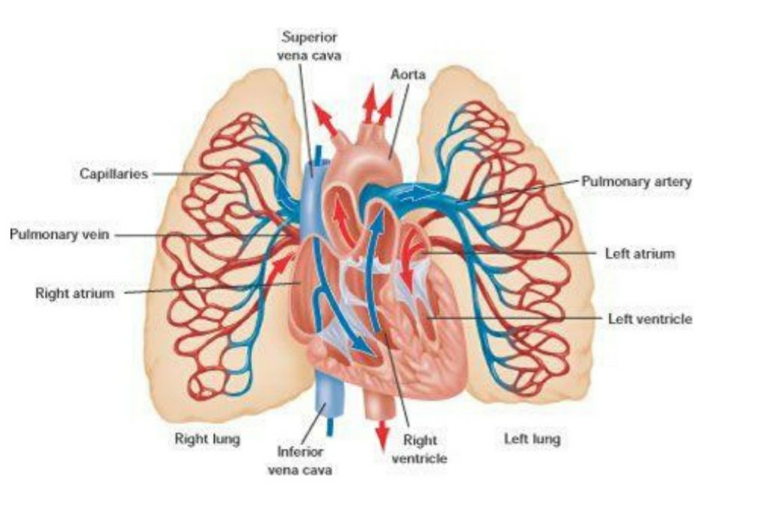

**Pulmonary circulation:** It consist of :

**1. Arteries:** it carries the deoxygenated blood

Pulmonary trunk is a short artery transporting deoxygenated blood from the heart towaed the lung……..right ventricle then divided into two branches:

1. Right pulmonary artery……….. right lung.

2. Left pulmonary artery…………. left lung.

**2. Veins:** it carries the oxygenated blood to left atrium of the heart by:

1. a. Right pulmonary veins: two veins for right lung.
2. b. Left pulmonary veins: two veins for left lung.

**3.The coronary circulation:** the coronary circulation provides the blood to supply the heart by the coronary artery which carries oxygenated blood.

1. **Coronary circulation** is the circulation of blood in the blood vessels that supply the heart muscle. Coronary arteries supply the oxygenated blood to the heart muscle, and cardiac veins drain away the blood once it has been deoxygenated.



**The lymphatic circulation:**

The lymphatic system is part of the circulatory system. It is a network of lymphatic vessels and lymph capillaries, lymph nodes and organs, and lymphatic tissues and circulating lymph.

One of its major functions is to carry the lymph, draining and returning interstitial fluid back towards the heart for return to the cardiovascular system, by emptying into the lymphatic duct. Its other main function is in the immune system.

As the blood enters the capillaries some of blood fluid forces into the tissue from the blood capillaries walls. Therefore, the function of lymphatic system collects the excess fluid escape from the capillaries wall and retain to the circulatory system this fluid is called lymph.

The lymph is collected by a network of small lymphatic vessels which collected to form the lymphatic duct which is drain into the subclavian vein where the lymph empties into the blood circulation.

The lymphatic system consist from :

1. Lymphatic capillaries joined to the lymphatic vessels.

2. Lymph nodes also called lymphatic glands which are occur interval along lymphatic vessels.

They are occurs numerous in neck, armpits, and around the alimentary canal. The lymph node is consist of lymphoid tissue contain lymphocyte and macrophage where the lymph filters so it play important role in body's defense against the disease.

