# Introduction

Experiment No. 4 RLC Series Circuit

An RLC series circuit is an electrical circuit containing a resistor R, an inductor L, and a capacitor C, connected in series. The name of the circuit is derived from the letters that are used to denote the constituent components of this circuit, where the sequence of the components may vary from RLC.

The circuit forms a harmonic oscillator for current and resonates like an LC circuit. Introducing the resistor increases the decay of these oscillations, which is also known as damping. The resistor also reduces the peak resonant frequency. Some resistance is unavoidable even if a resistor is not specifically included as a component.

## Objectives

The aims of this experiment are:

* + - To study the electrical characteristics of an RLC circuit in series;
    - To investigate the relation between the input frequency *f* and the circuit impedance *Z.*

## Components

* Function generator;
* Oscilloscope;
* Resistor;
* Inductor;
* Capacitor;
* Connection wires.

## Theory

RLC circuits have many applications as oscillator circuits. Radio receivers and television sets use them for tuning to select a narrow frequency range from ambient radio waves. In this role, the circuit is often referred to as a tuned circuit. An RLC circuit can be used as a band-pass filter, band-stop filter, low-pass filter or high-pass filter. The tuning application, for instance, is an example of band-pass filtering. The RLC filter is described as a second-order circuit, meaning that any voltage or current in the circuit can be described by a second-order differential equation in circuit analysis.

In a pure ohmic resistor the voltage waveforms are “in-phase” with the current. In a pure inductance the voltage waveform “leads” the current by 90°. In a pure capacitance the voltage waveform “lags” the current by 90°.

This phase difference, 𝜃 depends upon the reactive value of the components being used and hopefully by now:

**“We know that reactance, *X* is zero if the circuit element is resistive, positive if the circuit element is inductive and negative if it is capacitive”**

thus, giving their resulting impedances as:

Table 1: Shows the resistivity, reactence, and Theta of each element in the circuit.

|  |  |  |  |
| --- | --- | --- | --- |
| **Circuit element** | **Resistance, *R*** | **Reactance, *X*** | **Theta** 𝜽 |
| Resistor | R | 0 | 0 |
| Inductor | 0 | 2𝜋𝑓𝐿 | + 90° |
| Capacitor | 0 | 1  2𝜋𝑓𝐶 | - 90° |

Instead of analysing each element individually, we can combine the three together elements into a series *RLC* circuit.

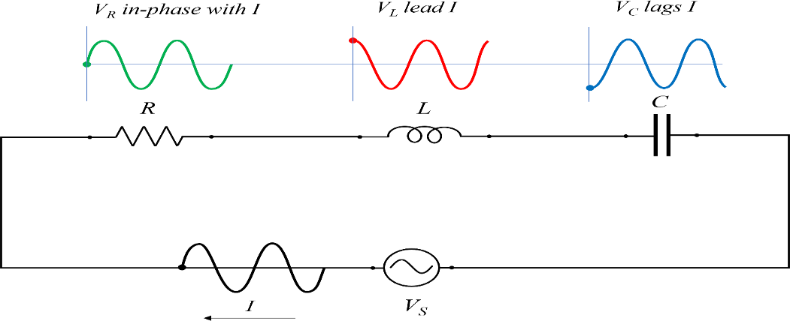

Figure 1: illustrate the equivelant circuit or RLC in series and the voltages across each element.

The analysis of a series RLC circuit is the same as that for the series RL and RC circuits we looked at previously, except this time we need to consider the magnitudes of both *XL* and *XC* to find the overall circuit reactance. Series RLC circuits are classed as second- order circuits because they contain two energy storage elements, an inductance L and a capacitance C. Consider the RLC circuit below. The phasor diagram for a series RLC circuit is produced by combining the three individual phasors above and adding these voltages vectorially. Since the current flowing through the circuit is common to all three circuit elements, we can use this as the reference vector with the three voltage vectors drawn relative to this at their corresponding angles.

The resulting vector *VS* is obtained by adding together two of the vectors, *VL* and *VC* and then adding this sum to the remaining vector *VR*. The resulting angle obtained between *VS* and *I* will be the circuits phase angle as shown below.

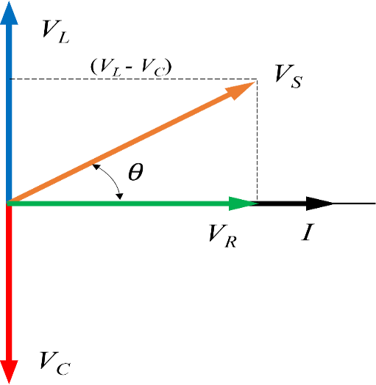

Figure 2: Phasor Diagram for a Series RLC Circuit

We can see from the phasor diagram in Fig. 2 above that the voltage vectors produce a rectangular triangle, comprising of hypotenuse VS, horizontal axis VR and vertical axis VL

– VC. We notice that this forms our old favourite the Voltage Triangle and we can therefore use Pythagoras’s theorem on this voltage triangle to mathematically obtain the value of VS as shown. The voltage triangle for a series RLC Circuit:

|  |  |
| --- | --- |
| 𝑍 = √𝑅2 + (𝑋𝐿 − 𝑋𝐶)2 | (1) |

From Fig. 3, to calculate the phase diffrence of the RLC circuit:

|  |  |
| --- | --- |
| 𝜃 = tan−1 𝑉𝐿 − 𝑉𝐶  𝑉𝑅 | (2) |

Or

|  |  |
| --- | --- |
| 𝜃 = tan−1 𝑋𝐿 − 𝑋𝐶  𝑅 | (3) |

# Procedure

1. Connect the circuit shown in Fig. 1 using a 1kΩ resistor, a 100 mH inductor and 0.1µF capacitor.
2. Set the input voltage at 5V and frequency at 500 Hz.
3. Using the Oscilloscope, read the voltage across the 1kΩ resistor 100 mH inductor and 0.1µF capacitor.
4. Change the input frequency from 500 to 1 kHz, 1.5 kHz 2 kHz 2.5 kHz and 3 kHz.
5. Repeat step 3, measuring the voltage across the 1kΩ resistor 100 mH inductor and 0.1µF capacitor.
6. Based on the experimental measurement, Calculate the phase shift difference (𝜃) theoretically using equation 2.
7. Write down all the measured and calculated values.

# Discussion

1. What are the applications of the RLC circuit?
2. Why the phase shift (𝜃) changed from negative to positive when we changed the frequencies?
3. Based on the phase diagram in Fig. 3, if we remove the resistor, what will be 𝜃 at the frequency 1.5 KHz