Experiment No. 5 Parallel RL Circuit

# Introduction

In a parallel RL circuit, [resistor](https://www.electrical4u.com/types-of-resistor/) R and [inductor](https://www.electrical4u.com/what-is-inductor-and-inductance-theory-of-inductor/) L are connected in parallel, and both are supplied by a [voltage source,](https://www.electrical4u.com/voltage-source/) *Vin*. Since the resistor R and inductor L are connected in parallel, the voltage across them is equal. However, the currents *I* flowing in the resistor and inductor are different. The parallel RL circuit is not used as a filter for voltages becausein this circuit, the output voltage is equal to the input voltage, and for this reason, it is not commonly used as compared to a [series RL circuit](https://www.electrical4u.com/rl-series-circuit/).

## Objectives

The main objectives of this experiment are: to measure the current flow in each element, determine the current phasor diagram for a parallel RL circuit, and measure the phase difference between the current and voltage at different frequencies.

## Components

1. Function generator;
2. Oscilloscope;
3. Two resistors;
4. Inductor;
5. Connection wires.

## Theory

The combination of a resistor and inductor connected in parallel to an AC source, as illustrated in Fig. 1, is called a parallel RL circuit. In a parallel DC circuit, the voltage across each parallel branch is equal. This is also true of the AC parallel circuit. The voltages across each parallel branch are:

* + - The same value.
    - Equal in value to the total applied voltage Vin.
    - All in phase with each other.

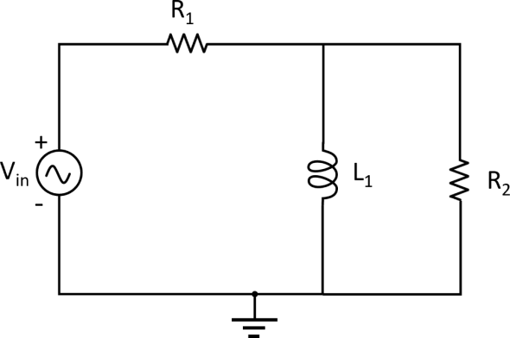

Figure 1: Illustrating the equivalent circuit of a parallel *RL* circuit.

Therefore, for an RL parallel circuit, we know that in a parallel circuit, the voltage acrossthe inductor and [resistor](https://www.electrical4u.com/types-of-resistor/) remains the same so,

𝑽𝑹 = 𝑽𝑳 = 𝑽𝑻

In parallel DC circuits, the simple arithmetic sum of the individual branch currents equals the total current. The same is true in an AC parallel circuit if only pure resistors or only pure inductors are connected in parallel.

However, when a resistor and inductor are connected in parallel, the two currents will be out of phase with each other. In this case, the total current is equal to the vector sum rather than the arithmetic sum of the currents.

Recall that the voltage and current through a resistor are in phase, but through a pure inductor, the current lags the voltage by precisely 90 degrees. This is still the case when the two are connected in parallel.

The relationship between the voltage and currents in a parallel RL circuit is illustrated in the vector (phasor) diagram in Fig. 2 and summarized as follows:

* The ***reference vector is labeled V*** and represents the voltage in the circuit, which is common to all elements.
* The angle theta (θ) represents the phase between the applied line voltage and current.

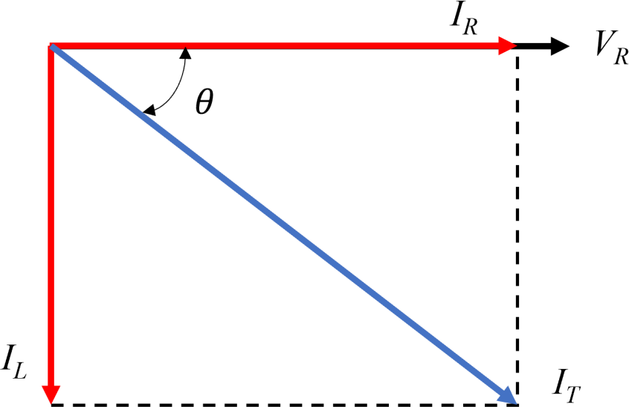

Figure 2: Parallel *RL* circuit vector (phasor) diagram**.**

As is the case in all parallel circuits, the current in each branch of a parallel RL circuit acts independently of the currents in the other branches. The current flow in each branch is determined by the voltage across that branch and the opposition to current flow, in theform of either resistance or inductive reactance, contained in the branch.

Ohm’s law can then be used to find the individual branch currents as follows:

𝐄

𝐈𝐑 = 𝐑

𝐄

𝐈𝐋 = 𝐗

𝐋

In the resistive branch, the current has the same phase as the applied voltage, but the inductive branch current lags the applied voltage by 90 degrees. As a result, the total line current (IT) consists of *IR* and *IL* with 90 degrees out of phase with each other.

The current flow through the resistor and the inductor form the legs of a right triangle, and the total current is the hypotenuse. Therefore, the Pythagorean theorem can be applied to add these currents together by using the equation:

𝑰𝑻 = √𝑰𝟐 + 𝑰𝟐

𝑹 𝑳

The **impedance** (*Z*) of a parallel RL circuit is the total opposition to the flow of current. It includes the opposition (*R*) offered by the resistive branch and the inductive reactance (*XL*) offered by the inductive branch.

The impedance of a parallel RL circuit is calculated similarly to a parallel resistive circuit.However, since *XL* and *R* are vector quantities, they must be added vectorially. As a result, the equation for the impedance of a parallel *RL* circuit consisting of a single resistor and inductor is:

To solve for equivalent Z,

use Ohm’s law:

**Z=** 𝑹𝑿𝑳

√𝑹𝟐+𝑿𝑳𝟐

**Z=**𝑽𝑻

𝑰𝑻

In all parallel RL circuits, the phase angle theta (θ) by which the total current lags the voltage is somewhere between 0 and 90 degrees. The size of the angle is determined by whether there is more inductive current or resistive current.

If there is more inductive current, the phase angle will be closer to 90 degrees. It will be closer to 0 degrees if there is more resistive current. From the circuit vector diagram, you can see that the value of the phase angle can be calculated from the equation:

**θ=**𝐭𝐚𝐧−𝟏 𝑰𝑳

𝑰𝑹

# Procedure

1- Connect the circuit shown in Fig. 1 using two 1kΩ resistors and a 100 mHinductor. 2- Set the input voltage at 5V and frequency at 500Hz.

1. Using the Oscilloscope, read the voltage across the R11kΩ resistor and L1100 mH inductor.
2. Change the input frequency from 500 to 1 kHz, 1.5 kHz 2 kHz 2.5 kHz and 3 kHz.
3. Mathematically, calculate the current resistors inductor and the total current and the total impedance.
4. Write down all the measured and calculated values.

# Discussion

1. How do you find the current in a parallel RL circuit?
2. In a table, compare between parallel and series RL circuit. In regard to the phase shift, and total impedance.