Experiment No. 1

Properties of AC Signals

## Introduction

* 1. **Objective:**

The aim of this experiment is to study the basic properties of Alternating Current (AC) waveforms.

## Components:

* Oscilloscope: is an instrument used to display and analyze the electrical signals variation over the time, that enables to study its amplitude, period, frequency, and phase angle.
* Function generator: is an equipment to generate input functions for your circuit. It can generate sinewaves, square waves, triangular waves.
* Electrical and electronic system trainer.

|  |  |
| --- | --- |
| MP720106 - Multicomp Pro - Digital Oscilloscope, 14-bit, 4-in-1 | Function Generator - Digital Function Generator Service Provider from  Kolkata |
| (A) | (B) |

Figure 1. (A) Oscilloscope, (B) Function Generator.

## Theory:

The AC waveforms may be sine wave, square wave, triangular wave as well as sawtooth wave. These different waveforms are illustrated in Figure 2.

1

0.5

Amplitude

0

-0.5

-1

1

0.5

Amplitude

0

-0.5

-1

Periodic sine Wave

0 1 2 3 4

Time (msec) Periodic tri-angular Wave

0 1 2 3 4

Time (msec)

1

0.5

Amplitude

0

-0.5

-1

1

0.5

Amplitude

0

-0.5

-1

Periodic sqaure Wave

0 1 2 3 4

Time (msec) Periodic sawtooth Wave

0 1 2 3 4

Time (msec)

Figure 2. Different Types of Waveforms.

Alternating current changes its direction of flow continuously, in contrast to direct current (DC), which always flows always in same direction.

The basic parameters of the AC waveform that will be studied in this experiment are the peak amplitude, Root-Mean-Square (RMS), period, and frequency of the sinusoidal waveform.

Since the sinusoidal waveform is the most commonly used waveform in electrical systems, the theory in this experiment will be briefly reviewed for sinusoidal wave form which is expressed mathematically by

𝑣(𝑡) = 𝑣𝑝 sin(𝜔0𝑡 + 𝜃𝑣)

𝑖(𝑡) = 𝑖𝑝 sin(𝜔0𝑡 + 𝜃𝑖)

Where 𝑣𝑝 is the peak amplitude of the voltage waveform, 𝑖𝑝 is the peak amplitude of the current waveform, 𝜔𝑜 is the angular frequency, 𝜃𝑣 is the phase of the voltage wave and 𝜃𝑖 is the phase of the current wave. A sinusoidal voltage waveform is plotted in Figure 3.

1

Vp

Vpp

VRMS

Period T

-Vp

0.8

0.6

0.4

0.2

Voltage, V

0

-0.2

-0.4

-0.6

-0.8

-1

0 0.1 0.2 0.3 0.4 0.5 0.6 0.7 0.8 0.9 1

time,ms

Figure 3. Sinusoidal Waveform.

The peak amplitude of AC signal can be measured directly by using the oscilloscope. However, the digital voltmeter can be used to measure the RMS value of the signal. In order to convert the measured RMS voltage into peak amplitude we can use the following equation

𝒗𝒑 = √𝟐 × 𝑽𝑹𝑴𝑺

that the frequency and the period and the wave form are related by

𝟏

𝒇 = 𝑻

Also the angular frequency is related to the frequency of the wave form by

𝑚𝟎 = 𝟐𝝅𝒇

By Ohm’s law the current is given by

𝒗 𝒗

𝒊 = 𝑹 = 𝟏 = 𝒗

**Phase Difference Equation**

𝑨(𝒕) = 𝑨𝒎𝒂𝒙 ∗ 𝐬𝐢𝐧( 𝒕 ± Ø)

* Where:
* Am: is the amplitude of the waveform.
* ω: is the angular frequency of the waveform in radian/sec.
* Ø (phi): is the phase angle in degrees or radians that the waveform has shifted either left or right from the reference point.

## Phase Relationship of a Sinusoidal Waveform

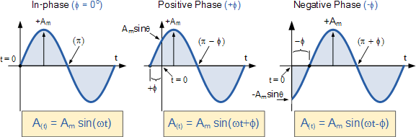

Figure 4. Phase Relationship

## Two Sinusoidal Waveforms – “in-phase”

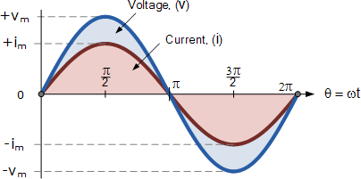

Figure 5. Two Sinusoidal Waveforms – in-phase.

## Phase Difference of a Sinusoidal Waveform

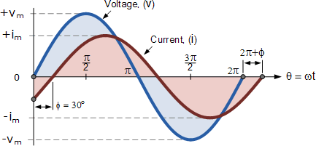

Figure 6. Two Sinusoidal Waveforms – Phase Difference.

The current waveform can also be said to be “lagging” behind the voltage waveform by the phase angle, Φ. Then in our example above the two waveforms have a **Lagging Phase Difference** so the expression for both the voltage and current above will be given as.

# 𝒗 (𝒕) = 𝑽𝒎 𝐬𝐢𝐧 𝒕

𝒊(𝒕) = 𝑰𝒎 𝐬𝐢𝐧(𝒕 − Ø)

Where current, i “lags” voltage, v by phase angle Φ

Likewise, if the current, i has a positive value and crosses the reference axis reaching its maximum peak and zero values at some time before the voltage, v then the current waveform will be “leading” the voltage by some phase angle. Then the two waveforms are said to have a **Leading Phase Difference** and the expression for both the voltage and the current will be.

# 𝒗(𝒕) = 𝑽𝒎 𝐬𝐢𝐧 𝒕

𝒊 (𝒕) = 𝑰𝒎 𝐬𝐢𝐧(𝒕 + Ø)

Where current, i “leads” the voltage v by phase angle Φ

The phase angle of a sine wave can be used to describe the relationship of one sine wave to another by using the terms “Leading” and “Lagging” to indicate the relationship between two sinusoidal waveforms of the same frequency, plotted onto the same reference axis. In our example above the two waveforms are *out-of-phase* by 30o. So we can correctly say that i lags v or we can say that v leads i by 30o depending upon which one we choose as our reference.

## Procedure:

1. 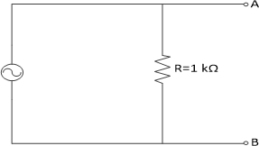Connect the circuit as shown in Figure 7.

Figure 7. Simple AC Circuit.

1. Connect channel one of the oscilloscope to point A in the circuit. adjust the voltage and time scales of the oscilloscope to display one cycle of the sinusoidal waveform.
2. Sketch the signal as it appears on the screen of the oscilloscope
3. From the signal shown on the oscilloscope screen determine the quantities listed in **Error! Reference source not found.**.
4. To demonstrate how can the oscilloscope be used to measure current connect the circuit as shown in Figure 7.
5. On channel Ch1 measure the voltage across 𝑅1.

Table 1. Experiment Results

|  |  |  |  |
| --- | --- | --- | --- |
| Input voltage Vp- p | Vrms | | Current |
| Measured | Calculated |
| 1V |  |  |  |
| 2V |  |  |  |
| 5V |  |  |  |
| 10V |  |  |  |

## Discussion:

* 1. What is the difference between the AC and DC signal?
  2. What the function of oscilloscope and the function generator?
  3. What is the difference between the Vp and the Vp-p?
  4. What is the phase difference?
  5. Discuss the difference between the theorical and practical result in Table 1.