# Introduction

Experiment No. 3 RL Series Circuit

A resistor-inductor circuit (also known as an RL filter) is defined as an electrical circuit consisting of the passive circuit elements of a resistor (R) and an inductor (L) connected, in series, driven by a voltage source or current source.

## Objectives

The experiment aims to study the electrical characteristics of an RL circuit in series. Also, to study the relation between the input frequency *f* and the circuit impedance *XL.*

## Components

* + - Function generator;
    - Oscilloscope;
    - Digital Multimeter;
    - Resistor;
    - Inductor;
    - Connection wires.

## Theory:

Consider a simple RL circuit in which resistor, R, and inductor, L are connected in series with a voltage supply of *Vin*. The current flowing in the circuit is *I* and the current through resistor R and inductor L is *IR* and *IL*, respectively. However, the resistor and inductor are connected in series, that’s why the current passing through both elements is the same. i.e.,

𝐼𝐿 = 𝐼𝑅 = 𝐼 (1)

The voltages *VR* and *VL* are the voltage drop across the resistor and inductor

By applying the Kirchhoff voltage law (The summation of the drop voltages across *R* and

*L* equal to the input voltage *Vin*) to this circuit, we get:

𝑉𝑖𝑛 = 𝑉𝑅 + 𝑉𝐿 (2)

Before drawing the phasor diagram of a series RL circuit, one should know the relationship between voltage and current in the case of resistor and inductor.

In the case of the resistor R, the voltage and current are in the same phase, or we can say that the phase angle difference 𝜃 between voltage and current is zero.

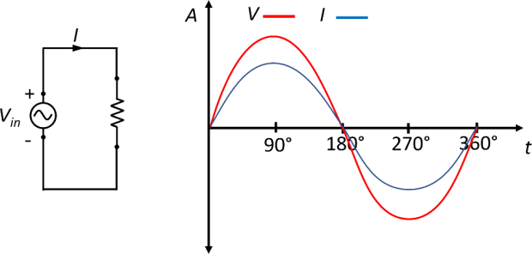

**Figure 1**: illustrate that the voltage and current wave are in phase in purely resistive load In the case of the inductor *L*, the voltage and current are not in phase. The voltage leads

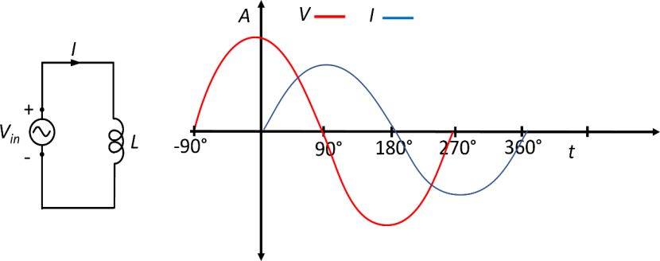the current by 90°. This means the voltage reaches its maximum when the current attains the zero value.

**Figure 2:** illustrate the voltage and current phase shift in a purely inductive load

**Inductor** (also named as a choke) is basically a coil or loops of wire that are either wound around a hollow tube former (air cored) or wound around some ferromagnetic material like iron core to increase their inductive value (inductance).

The inductor stores its energy in the form of a magnetic field that is created when a voltage is applied across an inductor. The growth of the current flowing through the inductor is not instant but is determined by the inductors own self-induced or back emf value. Then for an inductor coil, this back emf voltage *VL* is proportional to the rate of change of the current

flowing through it.

In an AC circuit, the opposition to the current flowing through the coils not only depends upon the inductance of the coil but also the frequency f of the applied voltage waveform as it varies from its positive to negative values.

The actual opposition to the current flowing through a coil in an AC circuit is determined by the AC Resistance of the coil with this AC resistance being represented by a complex number. But to distinguish a DC resistance value from an AC resistance value, which is also known as Impedance, the term Reactance is used.

Like resistance, reactance is measured in Ohm’s but is given the symbol X to distinguish it from a purely resistive “R” value and as the component in question is an inductor, the reactance of an inductor is called Inductive Reactance, XL and is measured in Ohms. Its value can be found from the formula.

𝑋𝐿 = 2𝜋𝑓𝐿 (3)

Where *XL* is inductive reactance in (Ω), π is the numeric constant of 3.142, ƒ is the frequency in Hz, and *L* = inductance in H

Whenever a sinusoidal voltage is applied to an inductor, the back emf opposes the rise andfall of the current flowing through the coil and in a purely inductive coil which has zero resistance, this impedance (which can be a complex number) is equal to its inductive reactance. Also, reactance is represented by a vector as it has both a magnitude and a direction (angle). See Fig. 3.

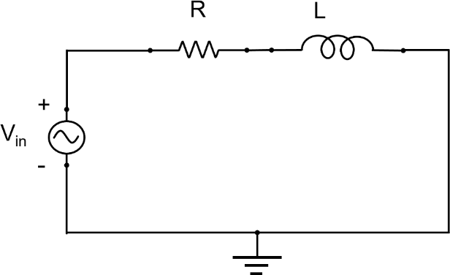

**Figure 3:** Schematic diagram illustrate an RC circuit connected in series

This simple circuit above consists of a pure inductance of *L* Henries (H), connected in series with a resistor *R* (Ohm) and a sinusoidal voltage given by the expression:

𝑉𝑖𝑛 = 𝑉𝑚𝑎𝑥𝑠𝑖𝑛𝑒 𝑤𝑡 (4)

This sinusoidal voltage will cause a current to flow and rise from zero to its maximum value. This rise or change in the current will induce a magnetic field within the coil which in turn will oppose or restrict this change in the current.

But before the current has had time to reach its maximum value as it would in a DC circuit, the voltage changes polarity causing the current to change direction. This change in the other direction once again being delayed by the self-induced back emf in the coil, and in a circuit containing a pure inductance only, the current is delayed by 90o.

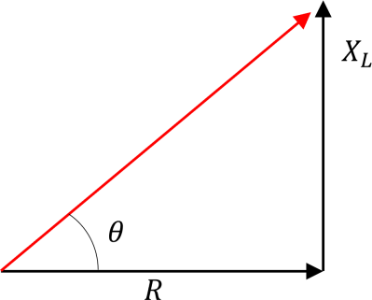

**Figure 4:** RL circuit, 𝜃 depend on the values of the R and XL

In an *RL* circuit, a phase shift occurs as well between the voltage across the inductor *VL* and the current *I.* As the circuit is a resistive-inductive load, the voltage *V* leads the current *I*, as shown in Fig. 4. The phase shift can also be calculated using equation

𝜃 = tan−1 𝑉𝐿

𝑉𝑅

(5)

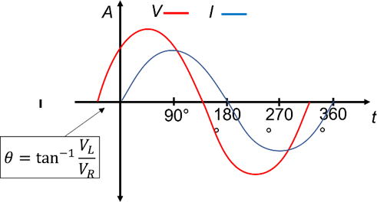.

**Figure 5:** illustrate the voltage and current phase shift of a resistive-capacitive load.

Table 1, shows important equations required to theoretically calculate *VR, VL, Vs, R, XL,* and Z.

**Table 1:** Important equations

|  |  |
| --- | --- |
| **For voltages** | **For impedance** |
| |𝑉𝑅| = |𝑉𝑆| × cos(𝜃) | 𝑅 = |𝑍| × cos(𝜃) |
| |𝑉𝐿| = |𝑉𝑆| × sin(𝜃) | |𝑋𝐿| = |𝑍| × sin(𝜃) |
| |𝑉𝑠| = √|𝑉𝑅|2 + |𝑉𝐿|2 | |𝑍| = √𝑅2 + |𝑋𝐿|2 |

# Procedure

1- Connect the circuit shown in Fig. 1 using a 1 kΩ resistor and a 100 mH inductor. 2- Set the input voltage at 5 V and frequency at 500 Hz.

1. Using the Oscilloscope, read the voltage across the 1 kΩ resistor and the 100 mH inductor.
2. Change the input frequency from 500 to 1 kHz, 1.5 kHz 2 kHz 2.5 kHz and 3 kHz.
3. Repeat step 3, measuring the voltage across the 1 kΩ resistor and the 100 mH inductor.
4. Based on the experimental measurement, Calculate the phase shift (𝜃) between *VR* and

*VL* theoretically using equation 5.

1. Write down all the measured and calculated values.

# Discussion

1. What are the applications of the RL circuit?
2. Why there is a phase shift (𝜃) between the measured voltage *VL* and current *I*?
3. If we increase the input frequency from 1kHz to 5 kHz, what is the phase shift (𝜃) between the voltage *VC* and current *I*?