periment No.6

Parallel R-C Circuit

**1.Introduction**

In this experiment, capacitor and resistor are connected in parallel supplied by an AC voltage. Due to the presence of a resistor in the ideal form of the circuit, an RC circuit will consume energy, akin to an RL circuit or RLC circuit. This is unlike the ideal form of an LC circuit, which will consume no energy due to the absence of a resistor. Although this is only in the ideal form of the circuit, and in practice, even an LC circuit will consume some energy because of the non-zero resistance of the components and connecting wires.

**1.1Objectives**

The main Objectives of this lab are: measure the current phasors for a parallel RC circuit and how the current phasors and phase angle are affected by a change in parallel RC circuits.

# **1.2Components**

* Function generator
* Oscilloscope
* Two resistors
* Capacitor
* Connection wires

**1.3Theory**

This guide covers Parallel RC Circuit Analysis, of a resistor and capacitor connected in parallel to an AC source, as illustrated in Fig. 1. is called a parallel RC circuit. The conditions that exist in RC parallel circuits and the methods used for solving them are quite similar to those used for RL parallel circuits. The voltage is the same value across

each parallel branch and provides the basis for expressing any phase differences. The principal difference is one of phase relationship. In a pure capacitor the current leads the voltage by 90 degrees, while in a pure inductor the current lags the voltage by 90 degrees.

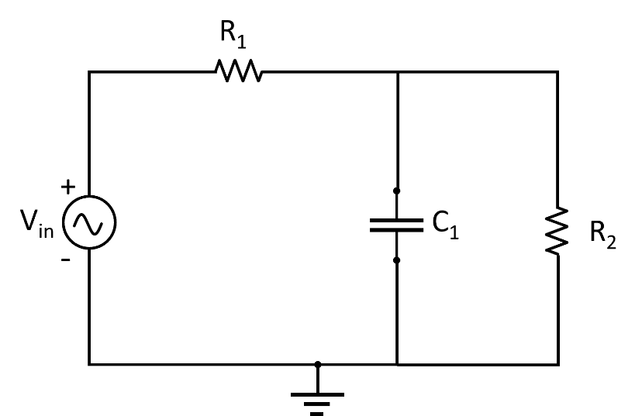

**Figure 1** Parallel RC circuit.

 The **current through the resistor (IR)** is:

$$I_{R}=\frac{V}{R}$$

The **Current through the capacitor** **(IC)** is:

$$I_{C}=\frac{V}{X_{C}}$$

The vector addition of *IR* and *IC* gives a resultant that represents the total (IT) use individual branch currents:

$$I_{T}=\sqrt{{I_{R}}^{2}+{I_{C}}^{2}}$$

The **impedance (Z**) of a parallel RC circuit is similar to that of a parallel RL circuit and is summarized as follows:

* Impedance can be calculated directly from the resistance and capacitive reactance values using the equation:
$$z= \frac{R X_{C}}{\sqrt{R^{2}+ X_{C}^{2}}}$$

* Impedance can be calculated using the Ohm’s law equation
$$Z= V_{T}/I_{T}$$

* The impedance of a parallel RC circuit is always less than the resistance or capacitive reactance of the individual branches.

The relationship between the voltage and currents in a parallel RC circuit ($θ$) is illustrated in the vector (phasor) diagram of Fig. **2** and summarized as follows:

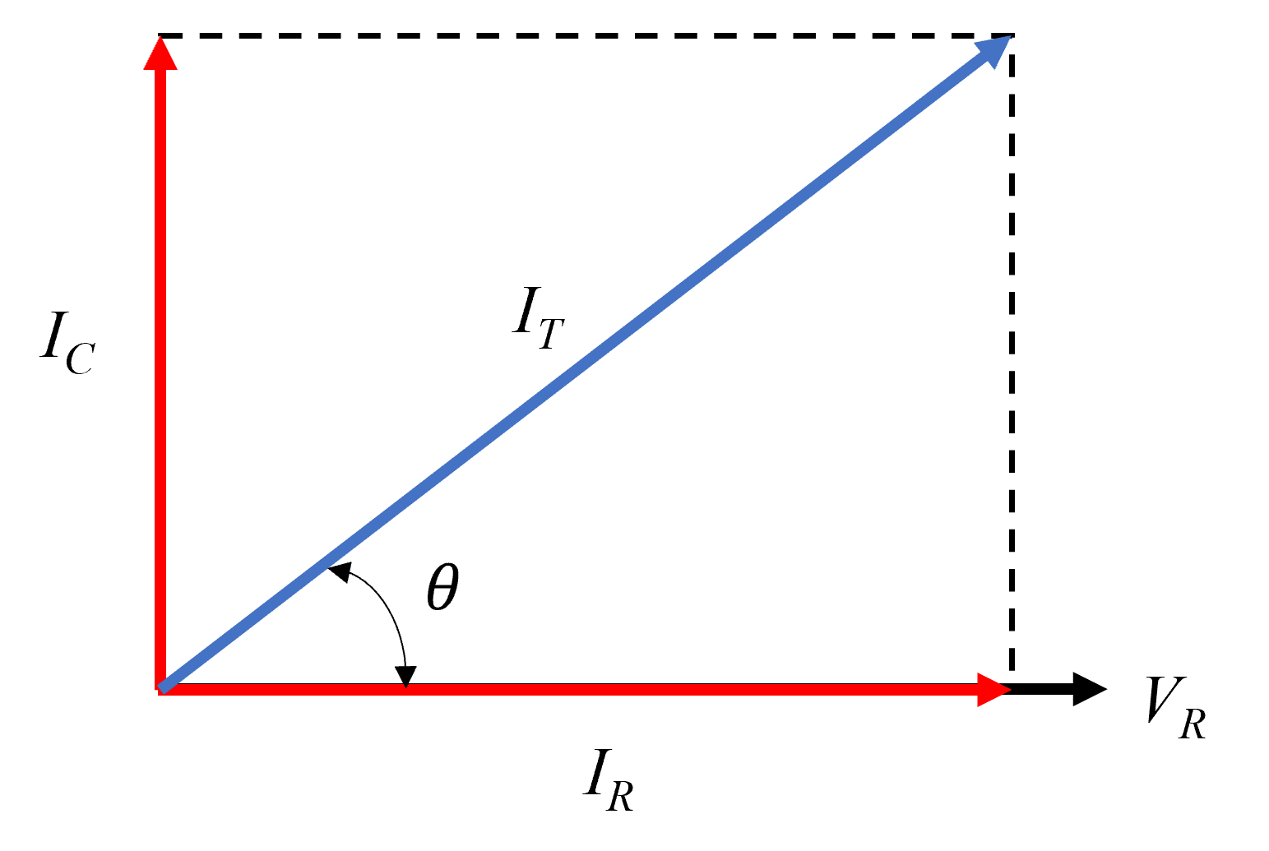

**Figure 2** Parallel RC circuit (phasor) diagram

In a parallel RC circuit, the line current leads the applied voltage by some phase angle less than $90°$ but greater than $0°$. The exact angle depends on whether the capacitive current or resistive current is greater. If there is more capacitive current, the angle will be closer to 90 degrees, while if the resistive current is greater, the angle is closer to 0 degrees.

The value of the phase angle can be calculated from the values of the two branch currents using the following equation:

$$θ=\tan^{-1}{\frac{I_{C}}{I_{R}}}$$

# **2.Experiment procedure**

1. Build, connect the circuit shown in Fig. 1 using a 1kΩ resistor, a 0.1 µf capacitor.
2. Set the input voltage at 5V and frequency at 500Hz………3000Hz.
3. Using the Oscilloscope, read the voltage across the 1kΩ resistor 0.1µF capacitor and IR1, IR2, IC, IT, ZT and $θ$.
4. Change the input frequency from 500Hz to 1000Hz, 1500Hz, 2000Hz, 2500Hz and 3000Hz.
5. Repeat step 3, measuring the voltage across the 1kΩ resistor 0.1µf capacitor and IR1, IR2, IC, IT, ZT and $θ$.
6. Write down all the measured and calculated values.

# **3.Discussion**

1. Why is the total current increasing at high frequencies in the circuit above?
2. Based on the practical results, draw the relation between the input frequency *f* and *IR1, IR2 IC.* All in one chart.