

**Department of biology**

**))Invertebrates((**

**2 stage**

**Lab 2**

**Dissecting microscope**

**By**

Duha Abd Al-ameer

**Dissecting microscope**

This microscopic lens or two eyepieces promised something different in number. This microscope is used to examine small animals and plants and their parts, which cannot be seen clearly with the naked eye. There is no need here to make some parts in different neighborhoods. With this microscope, we see the microscope, that is, in nine dimensions, and its magnification range ranges from 7 to 50 times

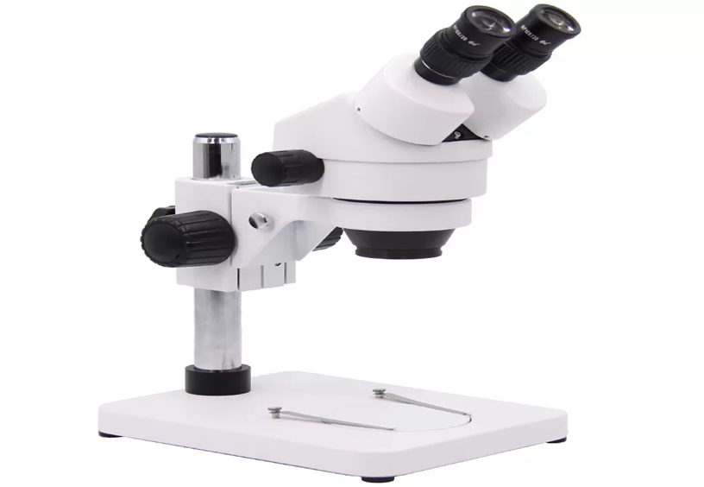

**Dissecting microscope**

**Part of the anatomical microscope:**

The anatomical microscope consists of the following parts:

1-eyepiece lenses:, which are the lenses that are located in the highest part of the microscope, and their magnification power ranges from 5 to 30 times.

2- Eyepiece tube: The tube that holds the eyepieces

3-Diopter adjustment ring: a disk that helps adjust the distance of lenses from each other to suit the distance between the user's eyes.

4-Objective lenses: (in English: Objective Lenses), which are the basic lenses in the microscope.

5- Focus control: The anatomical microscope contains a coarse focus control only.

6- Stage: which is the place on which the samples to be examined are placed.

7-The two adjusters, or catchers: are used to fix the chip on the table in the event that a mechanical table is not available.

8-Illumination source: The anatomical microscope contains a mobile upper illumination source that is used to direct light towards the sample, and some anatomical microscopes contain a lower illumination source as well

**Advantages of the dissecting microscope**

The following are the most important advantages of the dissecting microscope:

1-It contains two eyepieces instead of one.

2-It gives a three-dimensional image of the sample being studied. This is because it provides an independent viewing angle for each eye.

3- Its magnification ranges from 5-250 times.

4-The dissecting microscope does not require slide preparation; Therefore, it can be used to study large opaque samples that cannot be examined using a compound light microscope.

**Uses of the dissecting microscope**

The dissecting microscope is used in several fields, including the following

1-Manufacturing precision-made tools or devices.

2-Anatomy of living organisms.

3- Performing delicate microsurgical operations.

4- Electronics manufacturing, where technicians can connect tiny conductive wires to create integrated electronic circuits