

**Department of biology**

**((Invertebrates ))**

**2 stage**

**Lab -1-**

**Electronic Microscope**

**By**

**Duha Abd Al ameer**

**Electron microscope**

Electron microscope (EM) is a type of microscope that uses electrons to create an

image of the target. It has much higher magnification or resolving power than a normal light microscope.

**Principle working**

An electron microscope uses an 'electron beam' to produce the image of the object

and magnification is obtained by 'electromagnetic fields'; unlike light or

optical microscopes, in which 'light waves' are used to produce the image and

magnification is obtained by a system of 'optical lenses,

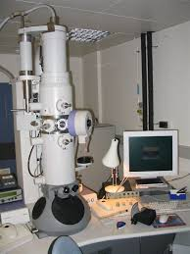

**Electron microscope**

**Parts of an electron microscope**

1-Electron gun

2-Electron magnetic lenses

a-condenser lens

b-Objective lens

c-Projector lens

3-Fluorescent screen

4- Camera

5-Deflation device

6-Voltage measuring device

**Types of Electron microscope**

The major types of Electron Microscopes are as follow

A. Transmission electron microscope (TEM).

used to view thin specimens (tissue sections, molecules, etc) through

which electrons can pass generating a projection image.

B. Scanning electron microscope (SEM).

scans a focused electron beam over a surface to create an image. The

electrons in the beam interact with the sample, producing various signals

that can be used to obtain information about the surface topography and

composition

.

C. Reflection electron microscope (REM).

Is now well established as a technique for the study of the structure of

surfaces of crystals