

**University of Al-Mustaqbal**

**College of Science**

**Department of Medical Physics**

***Optics***

***Lecture 2: Optical path of light in the optical mediums***

***Second stage***

**Dr. Duaa jaafer Al-fayadh**

***2025 – 2026***

# Refraction

* + Definition – is defined as the changing of direction of a light ray and its speed of propagation as it passes from one medium into another.
  + 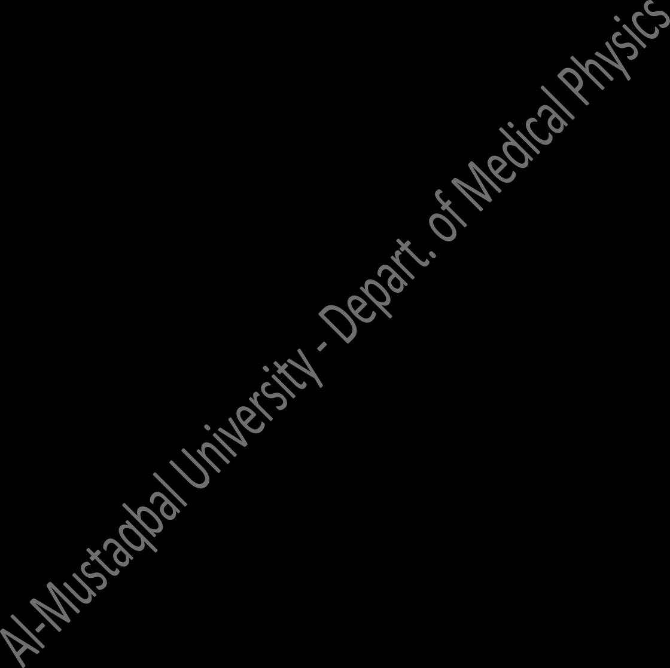Light ray refracted in material, amount of refraction depends on refractive index (*n*) of material.
  + Laws of refraction :
* *The refracted ray lies in the plane of incidence*.
* *The sine of the angle of refraction bears a constant ratio to the sine of the angle of incidence*. so that:

𝑠𝑖𝑛 𝑟

𝑠𝑖𝑛 𝑖 **=** *constant*

In the refraction at a boundary between two such substances having incidences of refraction *n1* and *n2*, Snell’s law may be written in the form

# Snell’s law

sin 𝑟 𝑛1

sin 𝑖 = 𝑛2 = 𝑐𝑜𝑛𝑠𝑡𝑎𝑛𝑡

Or

*n1 sin i* = *n2 sin r*

Where:

*i*: angle of incidence

*r*: angle of refraction

*n1*: refractive index of the medium 1 (Medium containing the incident ray)

*n2*: refractive index of the medium 2 (Medium containing the refracted ray)

* + Figures 1 and 2 show the refraction of light travels from one medium to another medium

****(1)** *n1* **<** *n2* **(2)** *n1* > *n2*

**Medium 1 is less density than medium 2**

**Medium 1 is denser than medium 2**

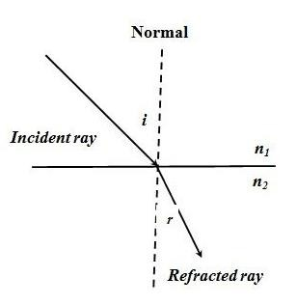

The light ray is bent toward the normal, thus ***r*** < ***i***

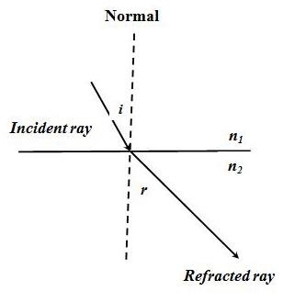

The light ray is bent away the normal, thus ***r*** > ***i***

**Notes:** Depending on the Snell’s law the **refractive index** can be defined as the constant ratio sin *i* / sin *r* for the two given media.

* The value of refractive index depends on the type of medium and the colour of the light. It is dimensionless and its value **>** 1.
* Consider the light ray travels from medium 1 into medium 2 , the refractive index can be denoted by:

*1n2* = 𝑣𝑒𝑙𝑜𝑐𝑖𝑡𝑦 𝑜𝑓 𝑙𝑖gℎ𝑡 𝑖𝑛 𝑚𝑒𝑑𝑖𝑢𝑚 1 = 𝑣1

𝑣𝑒𝑙𝑜𝑐𝑖𝑡𝑦 𝑜𝑓 𝑙𝑖gℎ𝑡 𝑖𝑛 𝑚𝑒𝑑𝑖𝑢𝑚 2 𝑣2

**(Medium containing incident ray) (Medium containing refracted ray)**

* Absolute refractive index, *n* (for the incident ray is travelling in vacuum or air and is then refracted into the medium concerned is written by:

𝑛 = 𝑐

𝑣

* The relationship between refractive index and the wave length. As light travels from one medium to another, its **wavelength changes** but its **frequency remains constant**. The wavelength changes because of different materials while the frequency remains constant because the number of wave cycles arriving per unit time must equal the number

leaving per time so that the boundary surface cannot create or destroy waves.

By considering of light travels from medium 1 (*n1*) into medium 2 (*n2*), the velocity of light in each medium is given by:

*v1* = *ƒ λ1* and *v2* = *ƒ λ2*

𝑣1 = ∫ 𝜆1

where *v1* = 𝑐

and *v2* = 𝑐

𝑣2

𝑐⁄𝑛1

∫ 𝜆2

𝜆1

𝑛1

𝑛2

**(Refractive index is inversely**

𝑐⁄𝑛 = 𝜆2

2

n1 λ1 = n2 λ2

**proportional to the wavelength)**

* + If medium 1 is vacuum or air, then n1 = 1. Hence the refractive index for any medium, n can be expressed as:

*n* = 𝜆𝑜

𝜆

**λo:** wavelength of light in vacuum; **λ:** wavelength of light in medium.

Example 1: The speed of light in an unknown medium is measured to be 2.76 x 108 m/s. What is the refractive index of the medium?

**Solution:**

*n* = *c*/*v*

*n* = (3 x 108 m/s) / (2.76 x 108 m/s) = 1.09

**Example 2:** The wavelength of green light in air is 524 nm. If the light is travailing through the water (n = 1.33). What is the (a) velocity, (b) wavelength and (c) the frequency of this light?

# Solution:

1. *n = c / v*

*v = c / n * *v* = (3× 108 m/s) / 1.33 = 2.26 × 108 m/s.

1. *n = λo / λ*

*λ = λo / n * *λ = 524 / 1.33 = 394 nm.*

1. *v* = λ × ƒ

ƒ = *v / λ * *ƒ =* (2.26 × 108 m/s) / 394 × 10 -9 m = 5.7 × 1014 Hz.

# The frequency of light in air ƒ = c / *λo*

ƒ = (3× 108 m/s) / 524 × 10-9 m = 5.7 × 1014 Hz.

**Example 3:** Light travels from air into an optical fiber with refraction index

1.44. (a) In which direction does the light bend? (b) If the angle of incidence on the end of the fiber is 22o, what is the angle of refraction inside the fiber? **Solution:**

1. Since the light traveling from a rarer region (lower *n*) to a denser region (higher *n*), it will bend **toward the normal**.
2. We will identify air as medium 1 and the optical fiber as medium 2. Thus,

*n1* = 1, *n2* = 1.44 and the angle of incidence is θ1 = 22°

*n1 sin θ1 = n2 sin θ2*

1 × sin 22° = 1.44 × sin θ2

sin θ2 = 0.37 / 1.44 = 0.26

؞ θ2 = sin-1 (0.26) = 15°

# [Fermat](https://en.wikipedia.org/wiki/Pierre_de_Fermat)'s principle

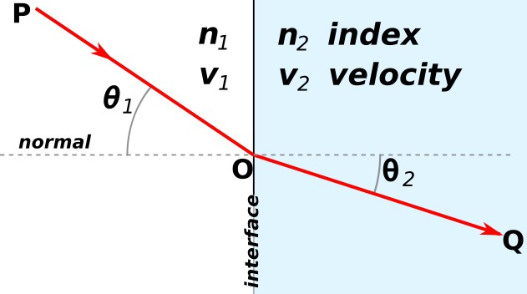[Fermat](https://en.wikipedia.org/wiki/Pierre_de_Fermat)'s principle or the principle of least time is the principle that the path taken between two points by a ray of light is the path that can be traversed in the least time.

**Note:** Fermat's principle leads to Snell's law; when the sines of the angles in the different media are in the same proportion as the propagation velocities, the time to get from P to Q is minimized.

***Home works about lecture 2:***

Q1: Defined as the path taken between two points by a ray of light is the path that can be traversed in the least time.

(A) Speed of light (B) refractive index (C) [Fermat'](https://en.wikipedia.org/wiki/Pierre_de_Fermat)s principle (D) frequency

Q2: Snell’s law can be expressed as

(A) n1 sin i = n2 sin r (B) n2 sin i = n1 sin r (C) n1 sin r = n2 sin i (D) n1 n2 = sin i sin r

Q3: The speed of light in an unknown medium is measured to be 2.5 x 108 m/s. What is the refractive index of the medium?

(A) 1.2 (B) 1.4 (C) 1.6 (D) 1.8

Q4: The wavelength of green light in air is 420 nm. If the light is travailing through the water (n = 1.33). What is the wave length?

(A) 312 nm (B) 315 nm (C) 318 nm (D) 321 nm

Q5: By using the information in question 4 find the frequency of light?

(A) 4.1 × 1014 Hz (B) 5.1 × 1014 Hz (C) 6.1 × 1014 Hz (D) 7.1 × 1014 Hz