

**University of Al-Mustaqbal**

**College of Science**

**Department of Medical Physics**

***Optics***

***Lecture 3: Reflection critical angle , total internal reflection***

***Second stage***

**Dr. Duaa jaafer Al-fayadh**

***2025 – 2026***

***Lecture 3: Reflection critical angle , total internal reflection***

# Reflection

* + Definition – is defined as the return of all or part of a beam of particles or waves when it encounters the boundary between two media.
  + 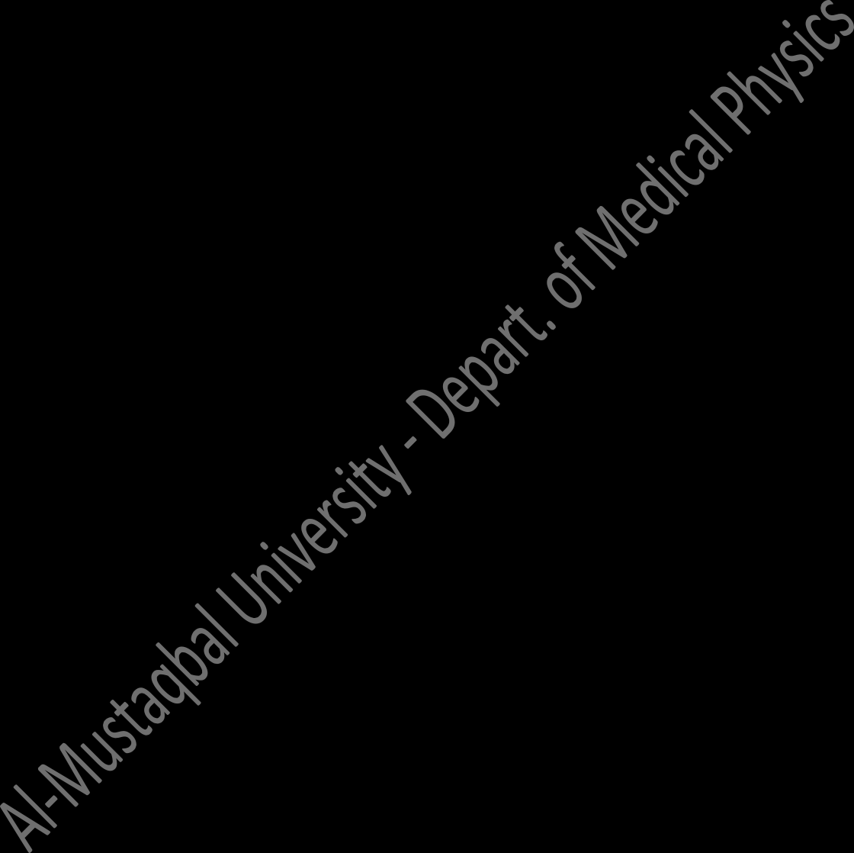Laws of reflection:
    - *The reflected ray lies in the plane of incidence.*
    - *The angle of reflection equals the angle of incidence.*

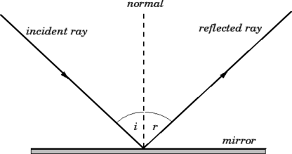



*i = r*

There are two types of reflection:

**Specular reflection**: in which all the light travelling in one direction and reflected in one direction (as in mirror).

**Diffuse reflection**: is the reflection of light from a surface such that an incident ray is reflected at many angles rather than at just one angle as in the case of specular reflection.

The visibility of objects, excluding light-emitting ones, is primarily caused by diffuse reflection of light: it is diffusely-scattered light that forms the image of the object in the observer's eye.

# Critical angle and total internal reflection

* + When light crosses an interface into a medium with a higher refractive index, the light will bend toward the normal. Conversely, light traveling across an interface from higher *n* to lower *n* will bend away from the normal.
  + At some angle, known as the **critical angle**, light traveling from a medium with higher *n* to a medium with lower *n* will be refracted at 90° (refracted along the interface). If the light hits the interface at any angle larger than this critical angle, it will not pass through to the second medium at all. Instead, it will be reflected back into the first medium, this is known as **total internal reflection**.
  + The critical angle can be found from Snell's law: n1sin i = n2 sin r

n1 sin θc = n2 sin 90° n1 sin θc = n2

sin θc = n2/n1

θc = sin−1 [𝑛2]

𝑛1

***Note***: Because sine any angle cannot be greater than **1**

so (***n2*** / ***n1***) ≤ **1**, therefore ***n2*** < ***n1***.

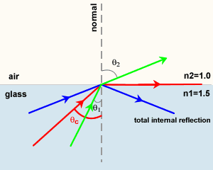

* + Optical fibers are based on this principle of total internal reflection. An optical fiber is a flexible strand of glass. The light travels along the optical fiber, reflecting off the walls of the fiber. With a straight or smoothly bending fiber, the light will hit the wall at an angle higher than the critical angle and will all be reflected back into the fiber.

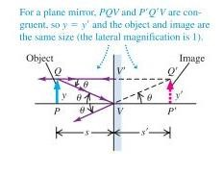

# Image formation by a plane mirror

Figure 1 and 2 shows the light ray radiating from **a point object** and **vertical (extended) object** then reflecting from reflected surface.

# (1) Point object (2) Vertical (extended) object

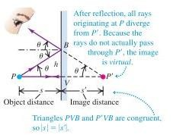

Where:

*s*: object distance; *sˈ*: image distance; *y*: object height; *yˈ*: image height

# The properties of image formed by a plane mirror are:

* Virtual
* Upright or erect
* laterally reverse
* The object distance, ***s*** equals to the image distance ***sˈ***
* Obey the law of reflection
* Same size.

***Home works about lecture 3:***

**Q1:** The formula of critical angle can written as

1. θc

= sin−1

[𝑛2]

𝑛1

1. θc

= sin−1

[𝑛1]

𝑛2

1. θc = 𝑠𝑖𝑛 [

𝑛2]

𝑛1

1. θ

c = 𝑠𝑖𝑛 [

𝑛1]

𝑛2

**Q2:** The property of image formed by a plane mirror is

(A) Bigger than object (B) smaller than object (C) same size (D) diminished

**Q3:** An optical fiber is a flexible strand of

(A) Wood (B) glass (C) plastic (D) none of them

**Q4:** Defined as the return of all or part of a beam of particles or waves when it encounters the boundary between two media.

(A) Refraction (B) critical angle (C) reflection (D) total internal reflection

Q5 in which all the light travelling in one direction and reflected in one direction.

(A) Diffuse reflection (B) refraction (C) critical angle (D) specular reflection