## eng.png

**Al-Mustaqbal University / College of Engineering & Technology**

**Department (Communications Technologies Engineering)**

**Class (First)**

**Subject (dc electric circuit) / Code (ATU11105)**

**Lecturer (M.Sc. Salwan Saud hatif )**

**1st term – Lecture No. & Lecture Name (Lec1 current,volt,charge )**

1

### Electron Drift Velocity

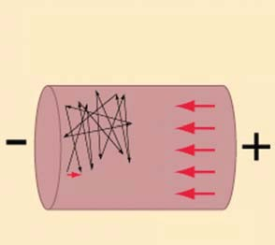

The electron moves at the Fermi speed, and has only

a tiny drift velocity superimposed by the applied electric field

**Vd** velocity

drift

Electric Field E

Suppose that in a conductor, the number of free electrons

3

available per m of the conductor material is *n* and let their

axial drift velocity be  metres/second. In time *dt*, distance travelled would be   *dt*. If *A* is area of cross-section of the conductor, then the volume is *Adt* and the number of elec- trons contained in this volume is *A dt*. Obviously, all these electrons will cross the conductor cross-section in time *dt*. If *e* is the charge of each electron, then total charge which crosses the section in time *dt* is *dq* = *nAe* *dt*.

Since current is the rate of flow of charge, it is given as

*i* =  *dq*   *nAe* *dt dt dt*

 *i* = *nAe*

Current density, *J* = *i*/*A* = *ne*  ampere/metre2

Assuming a normal current density *J* = 1.55  106 A/m2, *n* = 1029 for a copper conductor and *e* = 1.6  1019 coulomb, we get

1.55  106 = 1029  1.6  1019    = 9.7  105 m/s = 0.58 cm/min It is seen that contrary to the common but mistaken view, the electron drift velocity is rather very

slow and is independent of the current flowing and the area of the conductor.

→

**N.B.** Current density *i.e.*, the current per unit area, is a vector quantity. It is denoted by the symbol *J* .

Therefore, in vector notation, the relationship between current *I* and *J* is :

→

*I* =  

*J* . *a*

→

[where *a* is the vector notation for area ‘*a*’]

For extending the scope of the above relationship, so that it becomes applicable for area of any shape, we write :

*I* = *J* .*da*

*Electronic charge is 1.6*  *10**19 coulomb.*

The magnitude of the current density can, therefore, be written as *J*·.

*A conductor material has a free-electron density of 1024 electrons per metre3. When a voltage is applied, a constant drift velocity of 1.5*  *10**2 metre/second is attained by the electrons. If the cross-sectional area of the material is 1 cm2, calculate the magnitude of the current.*

**(Electrical Engg. Aligarh Muslim University)**

**Example 1.1.**

**Solution.** The magnitude of the current is

*i* = *nAe* amperes

Here, *n* = 1024 ; *A* = 1 cm2 = 104 m2

*e* = 1.6  1019 C ; *v* = 1.5  102 m/s

 *i* = 1024  104  1.6  1019  1.5  102 = **0.24 A**

### Charge Velocity and Velocity of Field Propagation

The speed with which charge drifts in a conductor is called the ***velocity of charge****.* As seen from above, its value is quite low, typically fraction of a metre per second.

However, the *speed* with which the effect of e.m.f. is experienced at all parts of the conductor resulting in the flow of current is called the ***velocity of propagation of electrical field***. It is indepen- dent of current and voltage and has high but constant value of nearly 3  108 m/s.

**Emi: salwan.saud.hatif@uomus.edu.iq**

# Electric Current

**3**

**Electric Current and Ohm’s Law**

**Example 1.2.** *Find the velocity of charge leading to 1 A current which flows in a copper conductor of cross-section 1 cm2 and length 10 km. Free electron density of copper = 8.5*  *1028 per m3. How long will it take the electric charge to travel from one end of the conductor to the other?*

**Solution.** *i* = *neA* or  = *i*/*neA*

  = 1/(8.5  1028  1.6  1019  1  104) = 7.35  107 m/s = **0.735 µm/s**

Time taken by the charge to travel conductor length of 10 km is

distance 10  103 10

*t* = velocity  7.35  107

= 1.36  10 s

Now, 1 year = 365  24  3600 = 31,536,000 s

*t* = 1.36  1010/31,536,000 = **431 years**

### The Idea of Electric Potential

In Fig. 1.1, a simple voltaic cell is shown. It consists of copper plate (known as anode) and a

chemical action taking place within the cell causes the electrons to be removed from copper plate and

contained in a suitable vessel. The

zinc rod (*i.e.* cathode) immersed in dilute sulphuric acid (H2SO4)

This transfer of electrons is accomplished through the agency of the diluted H2SO4 which is known as the electrolyte. The result is that zinc rod becomes negative due to the deposition of electrons on it and the copper plate becomes positive due to the removal of electrons from it. The large number of electrons collected on the zinc rod is being attracted by anode but is prevented from returning to it by the force set up by the chemical action within the cell.

to be deposited on the zinc rod at the same time.

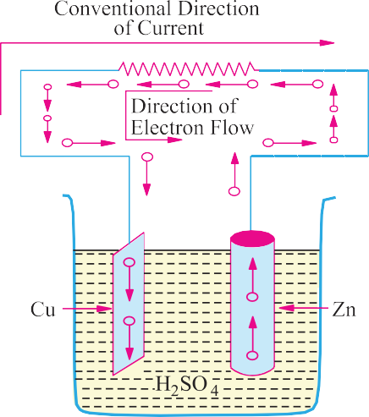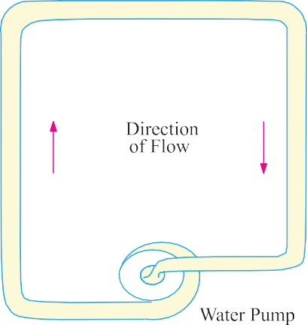

**Fig. 1.1. Fig. 1.2**

But if the two electrodes are joined by a wire ***externally***, then electrons rush to the anode thereby equalizing the charges of the two electrodes. However, due to the continuity of chemical action, a continuous difference in the number of electrons on the two electrodes is maintained which keeps up a continuous flow of current through the external circuit. The action of an electric cell is similar to that of a water pump which, while working, maintains a continuous flow of water *i.e.,* water current through the pipe (Fig. 1.2).

It should be particularly noted that the direction of ***electronic*** current is from zinc to copper in the external circuit. However, the direction of ***conventional*** current (which is given by the direction

# Electric Current

**4**

**Electrical Technology**

of flow of positive charge) is from copper to zinc. In the present case, there is no flow of positive charge as such from one electrode to another. But we can look upon the arrival of electrons on copper plate (with subsequent decrease in its positive charge) as equivalent to an actual departure of positive charge from it.

When zinc is negatively charged, it is said to be at negative potential with respect to the electrolyte, whereas anode is said to be at positive potential relative to the electrolyte. Between themselves, copper plate is assumed to be at a higher potential than the zinc rod. The difference in potential is continuously maintained by the chemical action going on in the cell which supplies energy to establish this potential difference.

### Resistance

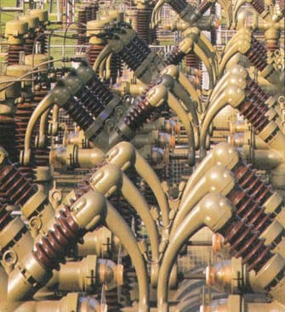

Cables are often covered with materials that do not carry electric current easily

It may be defined as the property of a substance due to which it opposes (or restricts) the flow of electricity (*i.e.*, electrons) through it.

Metals (as a class), acids and salts solutions are good conductors of electricity. Amongst pure metals, silver, copper and aluminium are very good conductors in the given order.* This, as discussed earlier, is due to the presence of a large number of free or loosely-attached electrons in their atoms. These vagrant electrons assume a directed motion on the application of an electric potential difference. These electrons while flowing pass ***through*** the molecules or the atoms of the conductor, collide and other atoms and electrons, thereby producing heat.

Those substances which offer relatively greater difficulty or hindrance to the passage of these electrons are said to be relatively poor conductors of electricity like

bakelite, mica, glass, rubber, p.v.c. (polyvinyl chloride) and dry wood etc. Amongst good insulators can be included fibrous substances such as paper and cotton when dry, mineral oils free from acids and water, ceramics like hard porcelain and asbestos and many other plastics besides p.v.c. It is helpful to remember that electric friction is similar to friction in Mechanics.

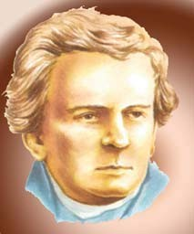

**1.5. The Unit of Resistance**

The practical unit of resistance is ohm.**\*\*** A conductor is said to have a resistance of one ohm if it permits one ampere current to flow through it when one volt is impressed across its terminals.

For insulators whose resistances are very high, a much bigger unit is used *i.e.,* mega-ohm = 106 ohm (the prefix ‘mega’ or mego meaning a million) or kilo-ohm = 103 ohm (kilo means thousand). In the case of very small resistances, smaller units like milli-ohm = 103 ohm or mi- cro-ohm = 106 ohm are used. The symbol for ohm is .

George Simon Ohm

**\*** However, for the same resistance per unit length, cross-sectional area of aluminium conductor has to be

1.6 times that of the copper conductor but it weighs only half as much. Hence, it is used where economy of weight is more important than economy of space.

**\*\*** After George Simon Ohm (1787-1854), a German mathematician who in about 1827 formulated the law known after his name as Ohm’s Law.

**Electric Current and Ohm’s Law**

**5**

|  |  |  |  |
| --- | --- | --- | --- |
| **Table 1.1. Multiples and Sub-multiples of Ohm** | | | |
| ***Prefix*** | ***Its meaning*** | ***Abbreviation*** | ***Equal to*** |
| Mega- | One million | M  | 106  |
| Kilo- | One thousand | k  | 103  |
| Centi- | One hundredth | – | – |
| Milli- | One thousandth | m  | 103  |
| Micro- | One millionth | µ  | 106  |

### Laws of Resistance

The resistance *R* offered by a conductor depends on the following factors :

* + 1. It varies directly as its length, *l*.
    2. It varies inversely as the cross-section *A* of the conductor.
    3. It depends on the nature of the material.
    4. It also depends on the temperature of the conductor.

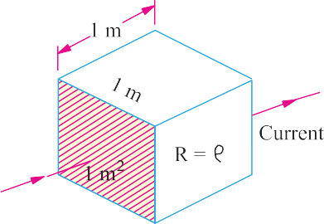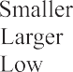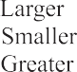

**Fig. 1.3. Fig. 1.4**

Neglecting the last factor for the time being, we can say that

*R*   *l*

*A*

or

*R* =   *l*

*A*

...**(*i*)**

where  is a constant depending on the nature of the material of the conductor and is known as its

***specific resistance* or *resistivity***.

If in Eq. **(*i*)**, we put

*l* = 1 metre and *A* = 1 metre2, then *R* =  (Fig. 1.4)

Hence, specific resistance of a material may be defined as ***the resistance between the opposite faces of a metre cube of that material****.*

### Units of Resistivity

From Eq. **(*i*)**, we have

❒ =

*AR*

*l*

**6**

**Electrical Technology**

In the S.I. system of units,

❒ =

*A* metre  *R* ohm   *AR* ohm-metre

2

*l* metre

*l*

Hence, the unit of resistivity is ohm-metre (-m).

It may, however, be noted that resistivity is sometimes expressed as so many ohm per m3.

Although, it is incorrect to say so but it means the same thing as ohm-metre. If *l* is in centimetres and *A* in cm2, then  is in ohm-centimetre (-cm).

Values of resistivity and temperature coefficients for various materials are given in Table 1.2.

The resistivities of commercial materials may differ by several per cent due to impurities etc.

|  |  |  |
| --- | --- | --- |
| **Table 1.2. Resistivities and Temperature Coefficients** | | |
| ***Material*** | ***Resistivity in ohm-metre at 20ºC (*** ***10******8)*** | ***Temperature coefficient at 20ºC (*** ***10******4)*** |
| Aluminium, commercial | 2.8 | 40.3 |
| Brass | 6 – 8 | 20 |
| Carbon | 3000 – 7000 | 5 |
| Constantan or Eureka | 49 | +0.1 to 0.4 |
| Copper (annealed) | 1.72 | 39.3 |
| German Silver | 20.2 | 2.7 |
| (84% Cu; 12% Ni; 4% Zn) |  |  |
| Gold | 2.44 | 36.5 |
| Iron | 9.8 | 65 |
| Manganin | 44 – 48 | 0.15 |
| (84% Cu ; 12% Mn ; 4% Ni) |  |  |
| Mercury | 95.8 | 8.9 |
| Nichrome | 108.5 | 1.5 |
| (60% Cu ; 25% Fe ; 15% Cr) |  |  |
| Nickel | 7.8 | 54 |
| Platinum | 9 – 15.5 | 36.7 |
| Silver | 1.64 | 38 |
| Tungsten | 5.5 | 47 |
| Amber | 5  1014 |  |
| Bakelite | 1010 |  |
| Glass | 1010 – 1012 |  |
| Mica | 1015 |  |
| Rubber | 1016 |  |
| Shellac | 1014 |  |
| Sulphur | 1015 |  |

**7**

**Electric Current and Ohm’s Law**

*R* =  *l*1

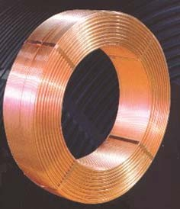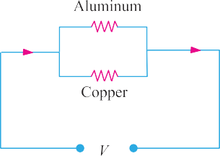

**Example 1.4.** *An aluminium wire 7.5 m long is connected in a parallel with a copper wire 6 m long. When a current of 5 A is passed through the combination, it is found that the current in the aluminium wire is 3 A. The diameter of the aluminium wire is 1 mm. Determine the diameter of the copper wire. Resistivity of copper is 0.017 µ**-m ; that of the aluminium is 0.028 µ**-m.*

**(F.Y. Engg. Pune Univ. May 1991)**

**Solution.** Let the subscript 1 represent aluminium and sub- script 2 represent copper.

Power absorbed = *V*2 / *R* = 1102/40 = **302.5 W**

*A*

*R* =   *l* = 0.02  106  1600/0.8  106 = **40** 

**Example 1.3.** *A coil consists of 2000 turns of copper wire hav- ing a cross-sectional area of 0.8 mm2. The mean length per turn is 80 cm and the resistivity of copper is 0.02 µ**–m. Find the resistance of the coil and power absorbed by the coil when connected across 110 V*

*d.c. supply.*

**(F.Y. Engg. Pune Univ. May 1990)**

**Solution.** Length of the coil, *l* = 0.8  2000 = 1600 m ;

*A* = 0.8 mm2 = 0.8  106 m2.

and *R*   *l*2

 *R*2  2 . *l*2 . *a*1

1. *a*1

2 2 *a*2

*R*1 1 *l*1 *a*2

 *a* = *a* . *R*1 . 2 . *l*2

...**(*i*)**

1. 1 *R*2 1 *l*1

Now *I*1 = 3 A ; *I*2 = 5 3 = 2 A.

If *V* is the common voltage across the parallel combination of aluminium and copper wires, then

*V* = *I*1 *R*1 = *I*2 *R*2  *R*1/*R*2 = *I*2/*I*1 = 2/3

*a*1 =

*d* 2

4

  12

4

   mm2

4

Substituting the given values in Eq. (*i*), we get

*a*2 =

   2  0.017  6  0.2544 m2

4 3 0.028 7.5

   *d*22/4 = 0.2544 or *d*2 = **0.569 mm**

**Example 1.5. (*a*)** *A rectangular carbon block has dimensions 1.0 cm*  *1.0 cm*  *50 cm.*

1. *What is the resistance measured between the two square ends ?* **(*ii*)** *between two opposing rectan- gular faces / Resistivity of carbon at 20°C is 3.5*  *10**5* *-m.*

**(*b*)** *A current of 5 A exists in a 10-* *resistance for 4 minutes* ***(i)*** *how many coulombs and*

1. *how many electrons pass through any section of the resistor in this time ? Charge of the electron*

*= 1.6*  *10**19 C.* **(M.S. Univ. Baroda)**

#### Solution.

* 1. **(*i*)** *R* =  *l/A*

Here, *A* = 1  1 = 1 cm2 = 104 m2 ; *l* = 0.5 m

 *R* = 3.5  105  0.5/104 = **0.175** 

**(*ii*)** Here, *l* = 1 cm; *A* = 1  50 = 50 cm2 = 5  103 m2

*R* = 3.5  105  102/5  103 = **7**  **10****5** 

#### Electrical Technology

**8**

* 1. **(*i*)** *Q* = *It* = 5  (4  60) = **1200 C**

**(*ii*)** *n* =

*Q*  1200  **75 × 1020**

*e* 1.6  1019

**Example 1.6.** *Calculate the resistance of 1 km long cable com- posed of 19 stands of similar copper conductors, each strand being*

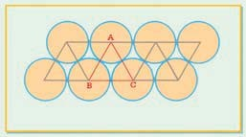

*1.32 mm in diameter. Allow 5% increase in length for the ‘lay’(twist) of each strand in completed cable. Resistivity of copper may be taken as 1.72*  *10**8* *-m.*

**Solution.** Allowing for twist, the length of the stands.

= 1000 m + 5% of 1000 m = 1050 m

Area of cross-section of 19 strands of copper conductors is 19    *d*2/4 = 19   (1.32  103)2/4 m2

❒  *l*  1.72  108  1050  4 

Cross section of a packed bundle of strands

Now, *R* = *A*

19 1.322  106

**0.694** 

**Example 1.7.** *A lead wire and an iron wire are connected in parallel. Their respective specific resistances are in the ratio 49 : 24. The former carries 80 percent more current than the latter and the latter is 47 percent longer than the former. Determine the ratio of their cross sectional areas.*

**(Elect. Engg. Nagpur Univ. 1993)**

**Solution.** Let suffix 1 represent lead and suffix 2 represent iron. We are given that

1/2 = 49/24; if *i*2 = 1, *i*1 = 1.8; if *l*1 = 1, *l*2 = 1.47

*l*1

❒

Now, *R* =

and

*R*   *l*2

1 1 *A*1 2 2 *A*2

Since the two wires are in parallel, *i*1 = *V*/*R*1 and *i*2 = *V*/*R*2

 *i*2 = *R*1  1*l*1  *A*2



*A*2 *i*2  2*l*2

*A*1 *i*1 1*l*1 1.8 49

=

 1  24  1.47  **0.4**

**Solution.** For silver wire, *R* = *l*1 ; For manganin wire, *R* = 2 *A*

2

*l*2

1

*A*

1

**Example 1.8.** *A piece of silver wire has a resistance of 1* . *What will be the resistance of*

*manganin wire of one-third the length and one-third the diameter, if the specific resistance of manganin is 30 times that of silver.* **(Electrical Engineering-I, Delhi Univ.)**

*i*1 *R*2 *A*1 2*l*2

 *R*2 = 2  *l*2  *A*1

*R*1 1 *l*1 *A*2

Now *A* = *d* 2/4 and *A* =  *d* 2/4  *A* /*A* = *d* 2/*d* 2

1 1 2 2 1 2 1 2

*R*  *l*

 *d* 2

 2 = 2 

2   1 

*R*1 1

*l*1  *d*2 

*R*1 = 1 ; *l*2/*l*1  1/3, (*d*1/*d*2)2 = (3/1)2 = 9; 2/1 = 30

 *R*2 = 1  30  (1/3)  9 = **90** 

#### Electric Current and Ohm’s Law

**9**

**Example 1.9.** *The resistivity of a ferric-chromium-aluminium alloy is 51*  *10**8* *-m. A sheet of the material is 15 cm long, 6 cm wide and 0.014 cm thick. Determine resistance between*

***(a)*** *opposite ends and* ***(b)*** *opposite sides.* **(Electric Circuits, Allahabad Univ.)**

**Solution. (*a*)** As seen from Fig. 1.5 (*a*) in this case,

*l* = 15 cm = 0.15 cm



*A* = 6  0.014 = 0.084 cm2

= 0.084  104 m2

❒  *l*  51  108  0.15

*R* = *A*

0.084  104

= **9.1**  **10****3** 

**(*b*)** As seen from Fig. 1.5 (*b*) here

*l* = 0.014 cm = 14  105 m

*A* = 15  6 = 90 cm2 = 9  103 m2

 *R* = 51  108  14  105/9  103 = **79.3**  **10****10** 

**Fig. 1.5**

**Example 1.10.** *The resistance of the wire used for telephone is 35*  *per kilometre when the*

*weight of the wire is 5 kg per kilometre. If the specific resistance of the material is 1.95*  *10**8* *-m, what is the cross-sectional area of the wire ? What will be the resistance of a loop to a subscriber 8 km from the exchange if wire of the same material but weighing 20 kg per kilometre is used ?*

**Solution.** Here *R* = 35 ; *l* = 1 km = 1000 m;  = 1.95  108 -m

Now, *R* =

❒  *l* or

*A*

*A*  *l*

*R*

 *A* 

1.95  108  1000

35

####  55.7 × 10–8 m2

If the second case, if the wire is of the material but weighs 20 kg/km, then its cross-section must

be greater than that in the first case.

Cross-section in the second case = 20  55.7  108  222.8  108 m2

5   *l*  1.95  108  16000 

Length of wire = 2  8 = 16 km = 16000 m  *R* = *A*

222.8  108

**140.1** 

**Tutorial Problems No. 1.1**

1. Calculate the resistance of 100 m length of a wire having a uniform cross-sectional area of 0.1 mm2 if the wire is made of manganin having a resistivity of 50  108 -m.

If the wire is drawn out to three times its original length, by how many times would you expect its resistance to be increased ? **[500** **; 9 times]**

1. A cube of a material of side 1 cm has a resistance of 0.001  between its opposite faces. If the same volume of the material has a length of 8 cm and a uniform cross-section, what will be the resistance of this length ? **[0.064** **]**
2. A lead wire and an iron wire are connected in parallel. Their respective specific resistances are in the ratio 49 : 24. The former carries 80 per cent more current than the latter and the latter is 47 per cent longer than the former. Determine the ratio of their cross-sectional area. **[2.5 : 1]**
3. A rectangular metal strip has the following dimensions :

*x* = 10 cm, *y* = 0.5 cm, *z* = 0.2 cm

Determine the ratio of resistances *Rx*, *Ry*, and *Rz* between the respective pairs of opposite faces.

**[*Rx* : *Ry* : *R*z : 10,000 : 25 : 4] (*Elect. Engg. A.M.Ae. S.I.*)**

1. The resistance of a conductor 1 mm2 in cross-section and 20 m long is 0.346 . Determine the specific resistance of the conducting material. **[1.73**  **10****8** **-m] (*Elect. Circuits-1, Bangalore Univ. 1991*)**
2. When a current of 2 A flows for 3 micro-seconds in a coper wire, estimate the number of electrons crossing the cross-section of the wire. ***(Bombay University, 2000)* Hint :** With 2 A for 3 µ Sec, charge transferred = 6 µ-coulombs

Number of electrons crossed = 6  106/(1.6  1019) = 3.75  10+ 13

Electric Current