



**University of Al-Mustaqbal**

**College of Science**

**Department of Medical Physics**

**Electricity**

**Conductors, Insulators and Coulomb’s law**

**Lecture Two**

**first stage**

**Lect. Dr Duaa jaafer Al-fayadh**

**2024-2025**

***Outline***

1. Conductors and Insulators
2. Induced Charge
3. Charging an object
4. Coulomb’s Law
5. References
   1. Conductors and Insulators

What is the classification of materials according to the ability of charge moving through them or according to the conductivity?

* + 1. ***Conductors*** are materials through which charge can move rather freely; examples include metals Examples of good conductors include copper, aluminum and silver

-Free electrons are not bound to the atoms.

-These electrons can move relatively freely through the material.

* + 1. ***Insulators***: Electrical insulators are materials in which all of the electrons are bound to atoms. Examples of good insulators include glass, rubber and wood

-These electrons cannot move relatively freely through the material.

* + 1. ***Semiconductors:*** The electrical properties of semiconductors are somewhere between those of insulators and conductors. include silicon and germanium.

The properties of **conductors** and **insulators** are due to **the structure and electrical nature of atoms**

-The protons and neutrons are packed tightly together in a central nucleus.

- An electrically neutral atom contains equal numbers of electrons and protons.

**Electrons** are held near the nucleus because they have the electrical sign opposite that of the protons in the nucleus and thus are attracted to the nucleus.

-Most metals are good conductors, while most nonmetals are insulators. Within a solid metal such as copper,

-Some materials called semiconductors are intermediate in their properties between good conductors and good insulators.

* 1. ***Induced***مستحثة ***Charge***

The experiment of Figure 1 demonstrates the mobility of charge in a conductor. A negatively charged plastic rod will attract either end of an isolated neutral copper rod. What happens is that many of the conduction electrons in the closer end of the copper rod are repelled by the negative charge on the plastic rod. Some of the conduction electrons move to the far end of the copper rod, leaving the near end depleted in electrons and thus with an unbalanced positive charge. This positive charge is attracted to the negative charge in the plastic rod. Although the copper rod is still neutral, it is said to have an *induced charge*, which means that some of its positive and negative charges have been separated due to the presence of a nearby charge.

***What are the steps for charging an object by induction?***

1. *Negative rod brought near neutral object.*
2. *Electrons in rod repel electrons to opposite end of object, causing one end to become positive.*
3. *If object is grounded (connected to ground), electrons from negative end of object travel into the ground.*
4. *Now object has more protons than electrons so it becomes positive.*

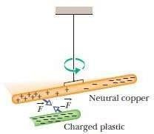

Figure 1: A neutral copper rod is electrically isolated. Either end of the copper rod will be attracted by a charged rod.

# Charging an object

There are Main methods of charging an object:

## Charging by Friction (Rubbing)

Electrons are transferred by rubbing from one material that becomes negatively charged to the other material becomes positively charged.

## Charging by Contact

“Electrons are transferred from a negatively charged object to either a neutral or positively charged object by contact.”

## Charging by Induction

The movement of electrons within a substance caused by a nearby charged object, without direct contact between the substance and the object.

# Coulomb’s Law

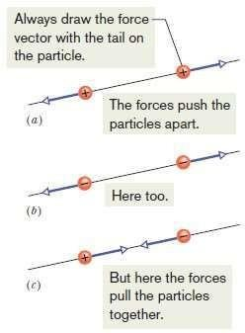If two charged particles are brought near each other, they each exert an **electrostatic force** on the other. The direction of the force vectors depends on the signs of the charges. If the particles have the same sign of charge, they repel each other. That means that the force vector on each is directly away from the other particle (Figure 2 a and b). If we release the particles, they accelerate away from each other. If, instead, the particles have opposite signs of charge, they attract each other.

Figure 2: Two charged particles repel each other if they have the same sign of charge, either (*a*) both positive or (*b*) both negative. (*c*) They attract each other if they have opposite signs of charge.

**Coulomb’s law** after Charles-Augustin de Coulomb, whose experiments in 1785 led him to it. Let’s write the equation in vector form and in terms of the particles shown in Figure 3, where particle 1 has charge *q1* and particle 2 has charge *q*2.

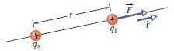

Figure 3: The electrostatic force on particle 1 can be described in terms of a unit vector along an axis through the two particles, radially away from particle 2.

Let’s write the force acting on particle 1 in terms of a unit vector rˆ has a magnitude of exactly 1 and no unit that points along a radial axis extending through the two particles, radially away from particle 2. we write the electrostatic force as:



where *r* is the separation between the particles and *k* is a positive constant called the electrostatic constant or the Coulomb constant.

***Unit.*** The SI unit of charge is the **coulomb**.



Rearranging above and replacing the symbols with their units (coulombs C, amperes A, and seconds s) we see that:



***Force Magnitude***مقدار The electrostatic constant *k* is often written as1/4π

0 and The quantity 𝜀 0, called the permittivity نفاذية constant.



***Multiple Forces.*** Suppose we have *n* charged particles near particle 1, then the net force on particle 1 is given by the vector sum:



In which, for example,  is the force on particle 1 due to the presence of particle 4.

## Examples:

1. ****Figure 4 *a* shows two positively charged particles fixed in place on an *x* axis. The charges are *q*1 = 1.60×10-19 C and *q*2=3.2×10-19 C, and the particle separation is *R*=0.02 m. **What are the magnitude and direction of the**

## electrostatic force ⃗𝐹⃗⃗𝟏 𝟐 on particle 1 from particle 2?

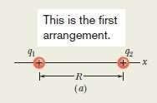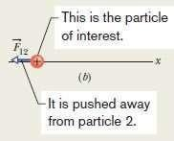

**Figure 4:** (*a*) Two charged particles of charges *q*1 and *q*2 are fixed in place on an *x* axis. (*b*), showing the electrostatic force on particle 1from particle 2.

# Solution:

Because both particles are positively charged, particle 1 is repelled by particle

1. Thus, the direction of force on particle 1 is *away from* particle 2, in the negative direction of the *x* axis, as indicated in Figure 4 *b*.

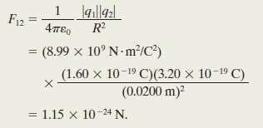

With 180° We can also write in unit-vector notation as:



**2.** Figure 5 *c:* is identical to Figure 4 *a* except that particle 3 now lies on the *x* axis between particles 1 and 2. Particle 3 has charge *q*3 = - 3.2 ×10-19 C and is at a distance  from particle 1.**What is the net electrostatic**

## force

 **on particle 1 due to particles 2 and 3?**

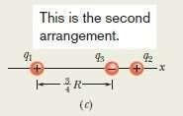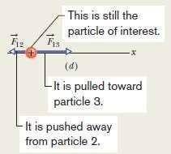

Figure 5: (*a*) Three charged particles of charges *q*1, *q*2 and *q*3 are fixed in place on an *x*

axis.

(*b*), showing the electrostatic force on particle 1from particle 2 and 3.

The presence of particle 3 does not alter the electrostatic force on particle 1 from particle 2. Thus, force still acts on particle 1. Similarly, the force  that acts on particle 1 due to particle 3 is not affected by the presence

of particle 2. Because particles 1and 3 have charge of opposite signs, particle 1 is attracted to particle 3. Thus, force v is directed toward particle 3, as indicated in of Figure 5 d.

## Solution:

To find the magnitude of 

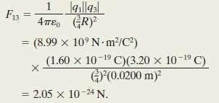

We can also write  in unit-vector notation:

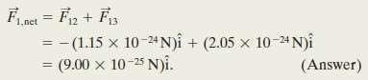

Thus,  has the following magnitude and direction (relative to the positive direction of the *x* axis):



# References

Walker, Jearl, Robert Resnick, and David Halliday. Halliday and resnick fundamentals of physics. Wiley, 2014.

What is a characteristic of good conductors in terms of electron movement?

A) Electrons are bound to atoms B) Electrons can't move freely C) Electrons distribute readily over the material

D) Electrons are confined to small regions E) Electrons move slowly through the material.

Which materials are mentioned as examples of good insulators?

A) Copper, aluminum, and silver B) Glass, rubber, and wood C) Silicon and germanium D) Metals and tap water E) Human body and electronic chips.

.