



**University of Al-Mustaqbal**

**College of Science**

**Department of Medical Physics**

**Electricity**

**Capacitor with a Dielectric**

**Lecture Nine**

**Lect. Dr Duaa jaafer Al-fayadh**

**2024-2025**

**first stage**



***Outline***

1. **Capacitor with a Dielectric**
2. **Dielectrics: An Atomic View**
3. **References**



* 1. **Capacitor with a Dielectric**

If you fill the space between the plates of a capacitor with a **dielectric**, which is an insulating material such as mineral **oil or plastic**, what happens to the capacitance?

Michael Faraday first looked into this matter in 1837. Using simple equipment much like that shown in Fig. 25-12, he found that **the capacitance increased** by a **numerical factor k**, which he called the **dielectric constant k** of the insulating material.

𝐶 = 𝑘 𝐶𝑎𝑖𝑟

where Cair is the capacitance with **only air** between the plates and C is the

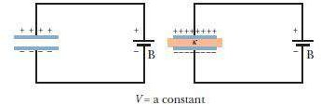

capacitance with **dielectric** between the plates.

In a region completely filled by a dielectric material of dielectric constant k, all electrostatic equations containing the permittivity constant 𝜀0 are to be modified by replacing 𝜀0 with 𝐾𝜀0.

Figure 2: If the potential difference between the plates of a capacitor is maintained, as by battery B, the effect of a dielectric is to increase the charge on the plates.

* 1. **Dielectrics: An Atomic View**

What happens, in atomic and molecular terms, when we put a dielectric in an electric field? There are two possibilities, depending on the type of molecule:



1. Polar dielectrics. The molecules of some dielectrics, like water, have permanent electric dipole moments. In such materials (called polar dielectrics), the electric dipoles tend to line up with an external electric field. The alignment of the electric dipoles produces an electric field that is directed opposite the applied field and is smaller in magnitude.
2. Nonpolar dielectrics. Regardless of whether they have permanent electric dipole moments, molecules acquire dipole moments by induction when placed in an external electric field. we saw that this occurs because the external field tends to “stretch” the molecules, slightly separating the centers of negative and positive charge.

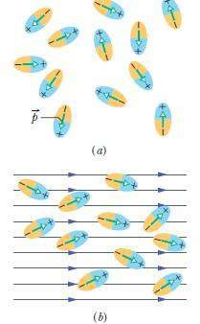

**Figure 3:** Molecules with a permanent electric dipole moment,showing their random orientation in the absence of an external electric field. (*b*) An electric field is applied, producing partial alignment of the dipoles.Thermal agitation prevents complete alignment.

* 1. **Refrences**

Walker, Jearl, Robert Resnick, and David Halliday. Halliday and resnick fundamentals of physics. Wiley, 2014.