

**University of Al-Mustaqbal**

**College of Science**

**Department of Medical Physics**

**Electricity**

**Lect. Dr Duaa jaafer Al-fayadh**

**2024-2025**

**first stage**



**Capacitance**

**Lecture Eight**



***Outline***

1. **Capacitance**
2. **Calculating the Capacitance**
3. **Energy Stored in an Electric Field**
4. **References**



1. **Capacitance**

**The capacitor, a device in which electrical energy can be stored.** For example, the **batteries in a camera** store energy in the photoflash unit by charging a capacitor.

Figure 1 shows some of the many sizes and shapes of capacitors. Figure 2 shows **the basic elements of any capacitor—two isolated conductors of any shape**. No matter what their geometry, flat or not, we call these **conductors plates**.

Figure 25-3a shows a parallel-plate capacitor, consisting of two parallel

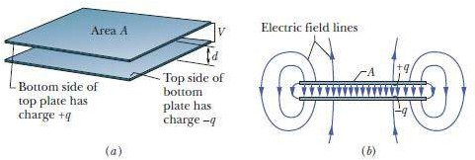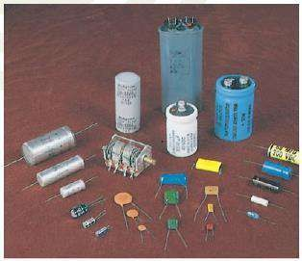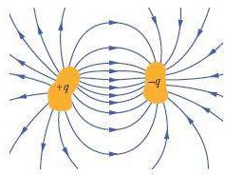

conducting plates of area A separated by a distance d. The symbol we use to

represent a capacitor ~~(~~  ).

Figure 1: An assortment of capacitors. Two conductors, isolated electrically from each other. (a) A parallel-plate capacitor, (b) As the field lines show

When a capacitor is charged, its plates have charges of equal magnitudes but opposite signs: +q and -q.



The charge q and the potential difference V for a capacitor are proportional to each other; that is:

The proportionality constant C is called the capacitance of the capacitor. The SI unit of capacitance is the **coulomb per volt**.

This unit occurs so often that it is given a special name, the **farad (F)**: 1 farad = 1 F = 1 coulomb per volt = 1 C/V.

1. **Calculating the Capacitance**

To calculating the capacitance (C): (1) Assume a charge q on the plates;

(2) calculate the electric field between the plates, using Gauss’ law; (3) calculate the potential difference V between the plates.

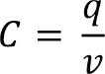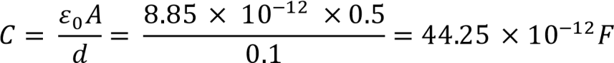

Letting V represent the difference Vf - Vi:

**Example:** Find the capacitance for the parallel plates of area A = 0.5 m2 separated by a distance d = 10 cm?

**Solution:**

1. **Energy Stored in an Electric Field**

The energy is stored in the electrical field in the space between the capacitor plates. It depends on the amount of electrical charge on the plates and on the potential difference between the plates. The work required to bring the total capacitor charge up to a final value q, this work



is stored as potential energy U in the capacitor:

The potential energy of a charged capacitor may be viewed as being stored in the electric field between its plates.

**Example:** An capacitor plates has a capacitance C = 1.25 F, how much potential energy is stored in the capacitor plates when potential difference between the plates V= 5mv?

**Solution:**

1. **Refrences**

Walker, Jearl, Robert Resnick, and David Halliday. Halliday and resnick fundamentals of physics. Wiley, 2014.