

**University of Al-Mustaqbal**

**College of Science**

**Department of Medical Physics**

**Electricity**

**Lect. Dr Duaa jaafer Al-fayadh**

**2024-2025**

**first stage**

Gauss’ Law and Coulomb’s Law

**Lecture Five**

***Outline***

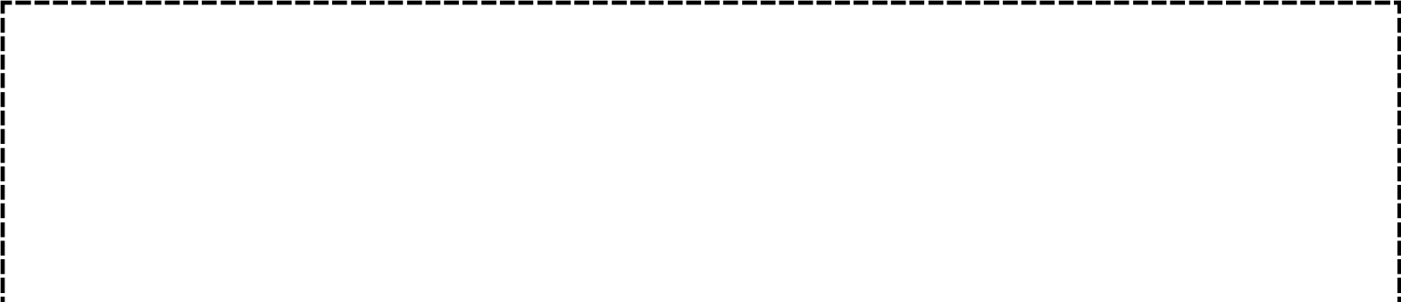

1. **Gauss’ Law and Coulomb’s Law**
2. **A Charged Isolated Conductor**
3. **References**
   1. **Gauss’ Law and Coulomb’s Law** we rewrite Gauss’ law as:

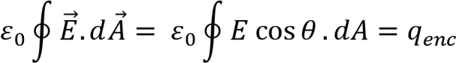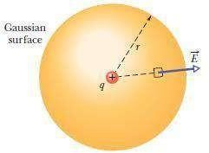

As shown in (Fig.4) for a particle with positive charge q. Then the electric field has the same magnitude E at any point on the sphere (all points are at the same distance r).

Figure 4: A spherical Gaussian surface centered on a particle with charge q.

we know that the electric field at the patch is also radially outward and

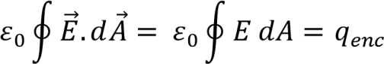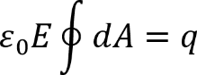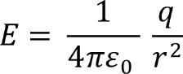

thus at angle with .So, we rewrite Gauss’ law as

Here qenc = q. Because the field magnitude E is the same at every patch element, E can be pulled outside the integral:

We already know that the total area of the sphere is :

**Example**: Figure below shows, in cross section, a plastic, spherical shell with uniform charge *Q= -16e* and radius *R* = 10 cm. A particle with charge *q*=5*e* is at the center. What is the electric field magnitude at (a) point *P*1 at radial distance *r*1= 6 cm and (b) point *P*2 at radial distance *r*2=12 cm?

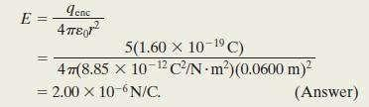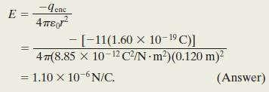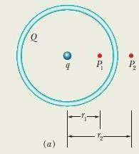

**Solution**:

The only charge enclosed by the Gaussian surface through *P*1 is that of the particle. qenc = 5e and r = r1 = 0.06 m.

The only charge enclosed by the Gaussian surface through *P*2 is that of the particle. qenc = q + Q = 5e – 16e = -11e and r = r2 = 0.12 m.



## A Charged Isolated Conductor

If an excess charge is placed on an isolated conductor, that amount of charge will move entirely to the surface of the conductor. None of the excess charge will be found within the body of the conductor.

Thus, the magnitude of the electric field just outside a conductor is proportional to the surface charge density on the conductor. The sign of the charge gives us the direction of the field. If the charge on the conductor is positive, the electric field is directed away from the conductor toward the conductor if the charge is negative.

If is the charge per unit area, then *q*enc is equal to *A*. When we substitute *A* for *q*enc and *EA* for :

## Refrences

Walker, Jearl, Robert Resnick, and David Halliday. Halliday