

**University of Al-Mustaqbal**

**College of Science**

**Department of Medical Physics**

**Electricity**

**Lecture Ten**

**Type of capacitors**

**Lect. Dr Duaa jaafer Al-fayadh**

**2024-2025**

**first stage**

**Capacitors**

Capacitors generally consist of two adjacent conductive plates isolated from each other, each of which carries two charges of equal amount and different signal, and the charging process is carried out by linking them to a battery for a brief period and

determines the types of amplitudes according to their capacity, which is measured in **Alfred.**

**Capacitors** are an essential element of electrical circuits and their main function is to control the flow of electric charge in an electronic circuit. It is used in the evaluation of alternating current, the generation or detection of electromagnetic waves, the betrayal of electromagnetic energy and its discharge from need. They are also called capacitors because they retain the charge inside them like an instantaneous battery The rolling symbol of the expander

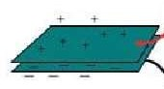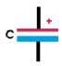

## Electrical capacitance

**The electrical capacitance of a conductor is defined as the ratio of the amount of charge carried by the conductor to its voltage.C = q /V ( Farad ):**

The units of measurement according to the system S.I are c / v which is equal to Farad

And that the stored energy is expanding **:**

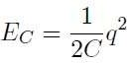

The amplitude of the amplitude depends on 1– the geometric shape of the two **1**

panels 2 – the virtuous distance between them 3 – the dielectric medium between the two panels

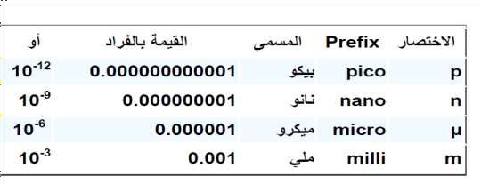

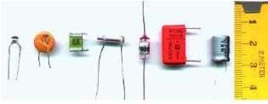

Types of capacitors used in practice:-

Fixed capacitors:- And its value is fixed according to the manufacturer, and the types of fixed amplitudes are paper amplitudes, ceramic expanders

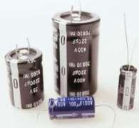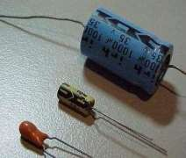

Variable value capacitors:- Different capacities can be obtained from the

**Connect capacitors– Series connection**

**prove that :**

**The value of the total capacitance of the capacitors is less than the value of the lowest capacitance capacitor**

**Series Formula:**

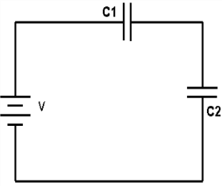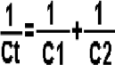

## parallel connection توازي ربط

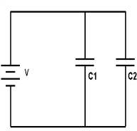

[T](https://kahraba4u.com/%D8%A3%D9%86%D9%88%D8%A7%D8%B9-%D8%A7%D9%84%D9%85%D9%83%D8%AB%D9%81%D8%A7%D8%AA-%D8%A7%D9%84%D9%83%D9%87%D8%B1%D8%A8%D8%A7%D8%A6%D9%8A%D8%A9/#%D8%A3%D9%86%D9%88%D8%A7%D8%B9-%D8%A7%D9%84%D9%85%D9%83%D8%AB%D9%81%D8%A7%D8%AA)ype of Capacitors

1. [( Paper Capacitors)](https://kahraba4u.com/%D8%A3%D9%86%D9%88%D8%A7%D8%B9-%D8%A7%D9%84%D9%85%D9%83%D8%AB%D9%81%D8%A7%D8%AA-%D8%A7%D9%84%D9%83%D9%87%D8%B1%D8%A8%D8%A7%D8%A6%D9%8A%D8%A9/#%D8%A7%D9%84%D9%85%D9%83%D8%AB%D9%81%D8%A7%D8%AA-%D8%A7%D9%84%D9%88%D8%B1%D9%82%D9%8A%D8%A9-paper-capacitors)
2. [(Film Capacitors)](https://kahraba4u.com/%D8%A3%D9%86%D9%88%D8%A7%D8%B9-%D8%A7%D9%84%D9%85%D9%83%D8%AB%D9%81%D8%A7%D8%AA-%D8%A7%D9%84%D9%83%D9%87%D8%B1%D8%A8%D8%A7%D8%A6%D9%8A%D8%A9/#%D8%A7%D9%84%D9%85%D9%83%D8%AB%D9%81%D8%A7%D8%AA-%D8%A7%D9%84%D9%81%D9%84%D9%85%D9%8A%D8%A9-film-capacitors)
3. [(Mica Capacitors)](https://kahraba4u.com/%D8%A3%D9%86%D9%88%D8%A7%D8%B9-%D8%A7%D9%84%D9%85%D9%83%D8%AB%D9%81%D8%A7%D8%AA-%D8%A7%D9%84%D9%83%D9%87%D8%B1%D8%A8%D8%A7%D8%A6%D9%8A%D8%A9/#%D9%85%D9%83%D8%AB%D9%81%D8%A7%D8%AA-%D8%A7%D9%84%D9%85%D9%8A%D9%83%D8%A7-mica-capacitors)
4. [(Ceramic Capacitor)](https://kahraba4u.com/%D8%A3%D9%86%D9%88%D8%A7%D8%B9-%D8%A7%D9%84%D9%85%D9%83%D8%AB%D9%81%D8%A7%D8%AA-%D8%A7%D9%84%D9%83%D9%87%D8%B1%D8%A8%D8%A7%D8%A6%D9%8A%D8%A9/#%D9%85%D9%83%D8%AB%D9%81%D8%A7%D8%AA-%D8%A7%D9%84%D8%B3%D9%8A%D8%B1%D8%A7%D9%85%D9%8A%D9%83-ceramic-capacitor)
5. [(Electrolytic Capacitors)](https://kahraba4u.com/%D8%A3%D9%86%D9%88%D8%A7%D8%B9-%D8%A7%D9%84%D9%85%D9%83%D8%AB%D9%81%D8%A7%D8%AA-%D8%A7%D9%84%D9%83%D9%87%D8%B1%D8%A8%D8%A7%D8%A6%D9%8A%D8%A9/#%D8%A7%D9%84%D9%85%D9%83%D8%AB%D9%81%D8%A7%D8%AA-%D8%A7%D9%84%D8%A5%D9%84%D9%83%D8%AA%D8%B1%D9%88%D9%84%D9%8A%D8%AA%D9%8A%D8%A9-electrolytic-capacitors)
6. [(Air Capacitor)](https://kahraba4u.com/%D8%A3%D9%86%D9%88%D8%A7%D8%B9-%D8%A7%D9%84%D9%85%D9%83%D8%AB%D9%81%D8%A7%D8%AA-%D8%A7%D9%84%D9%83%D9%87%D8%B1%D8%A8%D8%A7%D8%A6%D9%8A%D8%A9/#%D8%A7%D9%84%D9%85%D9%83%D8%AB%D9%81-%D8%A7%D9%84%D9%87%D9%88%D8%A7%D8%A6%D9%8A-air-capacitor)
7. [(Super Capacitor](https://kahraba4u.com/%D8%A3%D9%86%D9%88%D8%A7%D8%B9-%D8%A7%D9%84%D9%85%D9%83%D8%AB%D9%81%D8%A7%D8%AA-%D8%A7%D9%84%D9%83%D9%87%D8%B1%D8%A8%D8%A7%D8%A6%D9%8A%D8%A9/#%D8%A7%D9%84%D9%85%D9%83%D8%AB%D9%81%D8%A7%D8%AA-%D8%A7%D9%84%D9%81%D8%A7%D8%A6%D9%82%D8%A9-super-capacitors)s

**Polarized capacitors**: meaning that they have negative and positive terminals and the potential difference between their ends must be connected correctly, and in the case of reverse polarity, they do not work and may collapse in the insulation layers and it is

possible to explode. Non-polarized capacitors: These capacitors have no difference

between their ends and the potential difference between their ends can be connected in any way without any problem

**Electrolytic Capacitors**

An electrolyte is a chemical solution that has the property of conducting current and decomposition when a current passes through it. These capacitors are one of the most commonly used types with high capacities. Electrolytic capacitors are usually easy to distinguish by their prominent and large shape, and they are polarized capacitors,

although electrolytic capacitors are available for non-polarized applications.