

**University of Al-Mustaqbal**

**College of Science**

**Department of Medical Physics**

**Electricity**

**Lect. Dr Duaa jaafer Al-fayadh**

**2024-2025**

**first stage**

**Flux of the Electric Field and Gauss's Law**

**Lecture Four**

***Outline***

1. **Flux of the Electric Field**
2. **Gauss’ Law**
3. **References**

# Flux of the Electric Field

Electric fluxالفيض **is the rate of flow of the electric field through a given area**

(Fig. 1). Electric flux is proportional to the number of electric field lines going through a virtual surface.

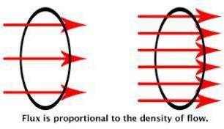

Figure 1: Electric Flux: Electric flux visualized. The ring shows the surface boundaries.

The red arrows for the electric field lines.

***Flat Surface, Uniform Field:*** We begin with a flat surface (Fig. 2) with area *A* in a uniform electric field . The total flux Ø is then:

When the electric field is uniform and the surface is flat:

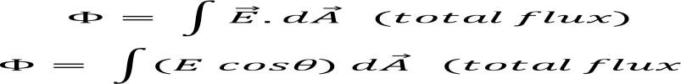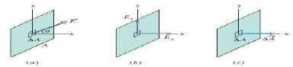

Figure 2: An electric field vector pierces a small square patch on a flat surface.

**Example**: A nonuniform electric field given by 𝐸→ =3𝑥𝑖^+4𝑗̂^^pierces the

Gaussian Square area 𝑑𝐴with length 2 m. what is the flux throw the surface when x= 3m point in the positive direction of the x axis.?

**Solution**:

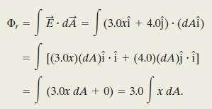

The integral ∫𝑑𝐴 gives us the area A = 4 m2 of the surface:



***Closed Surface.*** Let’s use the closed surface in (Fig.3) that sits in a nonuniform electric field. To use Gauss’ law to relate flux and charge, we need a closed surface.

*An inward field is negative flux. An outward field is positive flux*

**

The loop on the integral sign indicates that we must integrate over the entire closed surface, to get the net flux through the surface (flux might enter on one side and leave on another side).

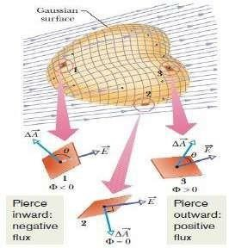

Figur 3: A Gaussian surface of arbitrary shape immersed in an electric field.

# Gauss’ Law

**Gauss’ law relates the net flux** Ø **of an electric field through a closed surface (a Gaussian surface) to the *net* charge *q*enc that is *enclosed* by that surface**. It tells us that:





The net charge *q*enc is the algebraic sum of all the *enclosed* positive and negative charges, and it can be positive, negative, or zero.

If qenc is positive, the net flux is outward; if qenc is negative, the net flux is inward.

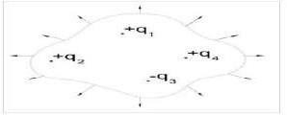

qenc in figure above given below:

qenc = q1 + q2 - q3 + q4

* 1. **Refrences**

Walker, Jearl, Robert Resnick, and David Halliday. Halliday and resnick fundamentals of physics. Wiley, 2014.

What is electric flux, and how is it related to the number of electric field lines passing through a virtual surface?

* A) Electric flux is unrelated to electric field lines.
* B) Electric flux is inversely proportional to the number of field lines.
* C) Electric flux is proportional to the number of electric field lines.
* D) Electric flux is constant regardless of field lines.
* E) Electric flux depends on the color of field lines. What does Gauss' law relate?
* A) Magnetic field and charge
* **B)** Electric field and charge
* C) Electric field and mass
* D) Gravitational field and charge
* E) Magnetic field and mass

Gauss' law relates the net flux Ø of an electric field through a closed surface to:

* A) Velocity of charged particles
* B) Temperature of the surface
* **C)** Net charge enclosed by the surface
* D) Distance from the surface
* E) Color of the surface