**Unit 1: Foundations of Mental Health and the Legal and Ethical issues**

**First lec 1—part1**

Mental Health and Mental Illness

• Diagnostic and Statistical Manual of Mental Disorders

• History and trends in psychiatric mental health nursing.

• Legal and Ethical issues of Mental Health

**MENTAL HEALTH AND MENTAL ILLNESS**

**Mental health and mental illness are difficult to define precisely.**

The culture of any society strongly influences its values and beliefs, and this, in turn, affects how that society defines health and illness. What one society may view as acceptable and appropriate, another society may see as maladaptive and inappropriate

**Mental Health**

The World Health Organization defines health as a state of complete physical, mental, and social wellness, not merely the absence of disease or infirmity.

This definition emphasizes health as a positive state of well-being. People in a state of emotional, physical, and social well-being fulfill life responsibilities, function effectively in daily life, and are satisfied with their interpersonal relationships and themselves.

Mental health has many components, and a wide variety of factors influence it. These factors interact; thus, a person’s mental health is a dynamic, or ever-changing, state.

**Factors influencing a person’s mental health can be categorized as individual, interpersonal, and social/cultural.**

**1.Individual, or personal, factors** include a person’s biologic makeup, autonomy and independence, self-esteem, capacity for growth, vitality, ability to find meaning in life, emotional resilience or hardiness, sense of belonging, reality orientation, and coping or stress management abilities.

**2.Interpersonal, or relationship, factors** include effective communication, ability to help others, intimacy, and a balance of separateness and connectedness.

**3.Social/cultural, or environmental, factors** include a sense of community, access to adequate resources, intolerance of violence, support of diversity among people, mastery of the environment, and a positive, but realistic toward view of one’s world

**Mental Illness**

Mental illness includes disorders that affect mood, behavior, and thinking, such as depression, schizophrenia, anxiety disorders, and addictive disorders. Mental disorders often cause significant distress or impaired functioning or both. Individuals experience dissatisfaction with self, relationships, and ineffective coping. Daily life can seem overwhelming or unbearable. Individuals may believe that their situation is hopeless.

**Factors contributing to mental illness can also be viewed within individual, interpersonal, and social/cultural categories.**

**1.Individual factors** include biologic makeup, intolerable or unrealistic worries or fears, inability to distinguish reality from fantasy, intolerance of life’s uncertainties, a sense of disharmony in life, and a loss of meaning in one’s life.

**2.Interpersonal factors** include ineffective communication, excessive dependency on or withdrawal from relationships, no sense of belonging, inadequate social support, and loss of emotional control.

**3.Social/cultural factors** include lack of resources, violence, homelessness, poverty, an unwarranted negative view of the world, and discrimination such as stigma, racism, classism, ageism, and sexism. It is important to note that some of these social/cultural factors can result in isolation, feelings of alienation, and maladaptive, violent, or criminal behavior. This may support a diagnosis of a personality disorder but not necessarily a mental illness with symptoms amenable to treatment with medication.

**DIAGNOSTIC AND STATISTICAL MANUAL OF MENTAL DISORDERS**

The Diagnostic and Statistical Manual of Mental Disorders, fifth edition (DSM-5), is a taxonomy published by the American Psychiatric Association and revised as needed. The current edition made some major revisions and was released in 2013. The DSM-5 describes all mental disorders, outlining specific diagnostic criteria for each based on clinical experience and research.

All mental health clinicians who diagnose psychiatric disorders use this diagnostic taxonomy.

**The DSM-5 has three purposes:**

• To provide a standardized nomenclature and language for all mental health professionals

• To present defining characteristics or symptoms that differentiate specific diagnoses

• To assist in identifying the underlying causes of disorders

**The classification system allows the practitioner to identify all the factors that relate to a person’s condition:**

• All major psychiatric disorders such as depression, schizophrenia, anxiety, and substance-related disorders

• Medical conditions that are potentially relevant to the understanding or managing the person’s mental disorder as well as medical conditions that might contribute to understanding the person

• Psychosocial and environmental problems that may affect the diagnosis, treatment, and prognosis of mental disorders. Included are problems with the primary support group, the social environment, education, occupation, housing, economics, access to health care, and the legal system.

1. **So what’s different?**

Why is the roman numeral discarded? DSM –IV to DSM-5,because the incremental updates will be identified with decimals, i.e. DSM–5.1, DSM–5.2, etc., until a new edition is required.

1. Diagnostic codes will change from numeric to alphanumeric e.g., Obsessive Compulsive Disorder will change from 300.3 to F42.

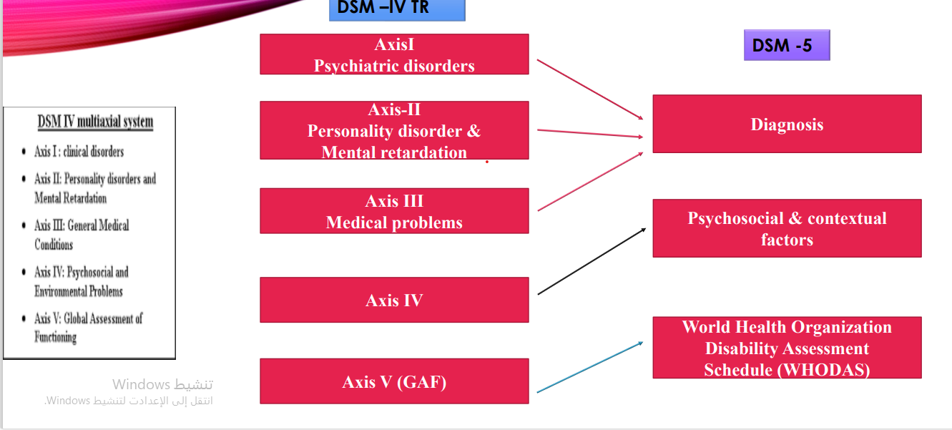

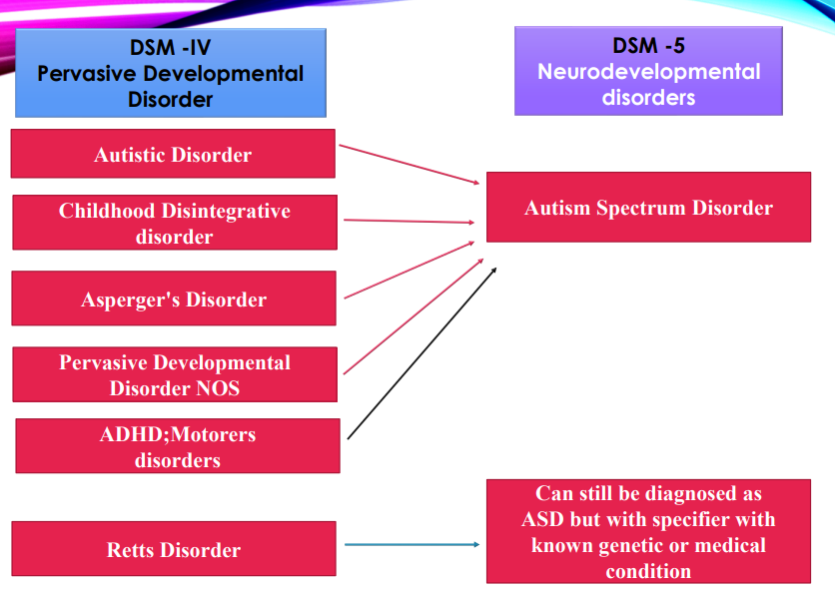

**INTELLECTUAL DISABILITY**

❑**Formerly Mental retardation.** Previously part of Axis II of DSM-IV TR

❑In DSM IV Levels of Retardation based on Intelligence Quotient (IQ Scores):

▪Mild (IQ = 50/55 to 70),

▪Moderate (IQ=35/40 to 50/55),

▪Severe (IQ= 20/25 to 35/40),

▪Profound (IQ= <20/25)

▪Severity Unspecified (Un measurable)

❑DSM 5 focus is on adaptive functioning assessment with severity based on adaptive functioning rather than (IQ Scores) and all symptoms must have an onset during the developmental period

**CHANGES RELATED TO ATTENTION DEFICIT HYPERACTIVITY DISORDER**

DSM –5: Symptoms present prior to age 12 years (formerly age 7 years in DSM –IV TR).

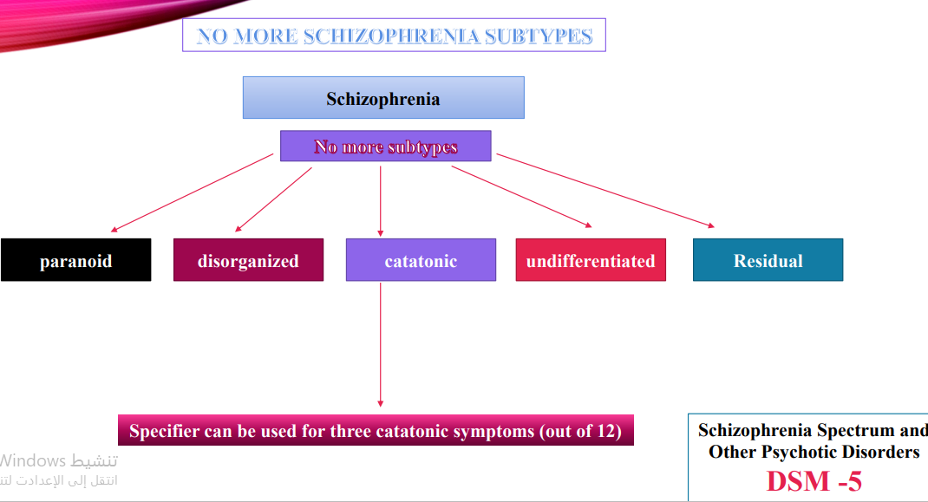

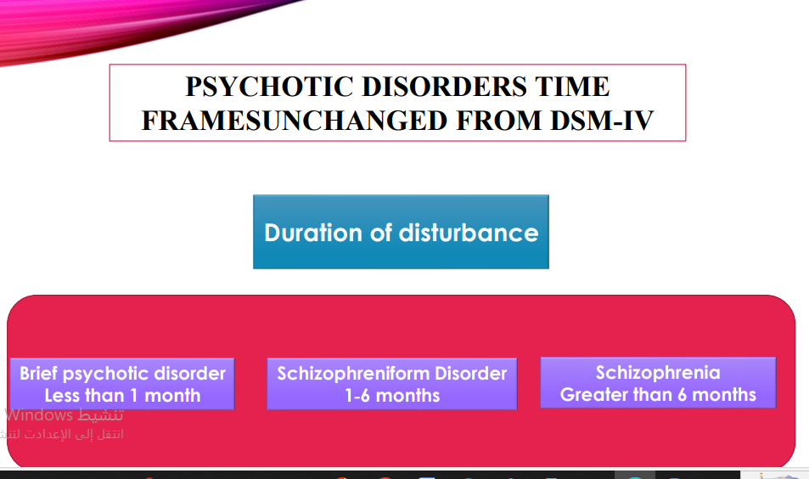

**Anxiety disorders**

**Anxiety disorders:** Agoraphobia, Specific Phobia, and Social AnxietyDisorder (Social Phobia).

Social Anxiety Disorder Generalized ” specifier in DSM IV has been deleted.

Replaced with performance only.

DSM 5 creates new chapters for Obsessive-Compulsive and Related Disorders and Trauma and Stressor Related Disorders.

**SUBSTANCE-RELATED AND ADDICTIVE DISORDERS**

1. **Gambling Disorder:** Gambling, activates the same brain reward system as other substance use disorders.

**History of Psychiatry and Psychiatric Nursing**

**Psychiatry :** is the branch of medicine focused on the diagnosis, treatment and prevention of mental, emotional and behavioral disorders

• **Psychiatric Nursing:** It focuses on the care and rehabilitation of people with mental illnesses or disorders

**• Psychiatric nursing :** deals with the promotion of mental health, prevention of mental illness, care and rehabilitation of mentally ill individuals both in hospital and community

**Important Milestones**

**•(1773 Years):** The first mental hospital in the US was built in Williamsburg, Virginia.

**•(1793 Years) :** Philip Pinel removed the chains from mentally ill patients confined in Bicetre a hospital outside Paris i.e. the first revolution in psychiatry.

**•(1812 Years) :** The first American text book in psychiatry was written by Benjamin Rush, who is referred to as the father of American Psychiatry.

**•(1911-1912 Years) :** Paul Eugen Bleuler, a Swiss psychiatrist He coined many psychiatric terms, such as schizophrenia, schizoid, autism.

**•(1927 Years) :** Insulin shock treatment was introduced for schizophrenia

**•(1936 Years) :** frontal lobotomy was advocated for the management of psychiatric disorder.

**•(1937 Years) :** Electro Convulsive Therapy ( was used for the treatment of psychoses.

**•(1939 Years) :** development of psychoanalytical theory by Sigmund Freud led to new concepts in the treatment of mental illness.

**•(1949 Years) :** Lithium was first used for the treatment of mania.

**•(1952 Years) :** Chlorpromazine was introduced which brought about a revolution in psychopharmacology.

**•(1963 Years) :** The community Mental Health centers Act was passed 20 century.

**HISTORICAL PERSPECTIVES OF THE TREATMENT OF MENTAL ILLNESS**

Ancient Times People of ancient times believed that any sickness indicated displeasure of the gods and, in fact, was a punishment for sins and wrongdoing. Those with mental disorders were viewed as either divine or demonic, depending on their behavior. Individuals seen as divine were worshipped and adored; those seen as demonic were ostracized, punished, and sometimes burned at the stake.

**Later, Aristotle (382–322 BC)** attempted to relate mental disorders to physical disorders and developed his theory that the amounts of blood, water, and yellow and black bile in the body controlled the emotions. These four substances, or humors, corresponded with happiness, calmness, anger, and sadness. Imbalances of the four humors were believed to cause mental disorders; therefore, treatment was aimed at restoring balance through bloodletting, starving, and purging. Such “treatments” persisted well into the 19th century (Baly, 1982).

**Possessed by demons**

In early Christian times (1–1000 AD), primitive beliefs and superstitions were strong. All diseases were again blamed on demons, and the mentally ill were viewed as possessed. Priests performed exorcisms to rid sufferers of evil spirits. When that failed, they used more severe and brutal measures, such as incarceration in dungeons, flogging, and starving.

**In England during the Renaissance (1300–1600),** people with mental illness were distinguished from criminals. Those considered harmless were allowed to wander the countryside or live in rural communities, but the more “dangerous lunatics” were thrown in prison, chained, and starved

**Period of Enlightenment and Creation of Mental Institutions**

In the 1790s, a period of enlightenment concerning persons with mental illness began. Philippe Pinel in France and William Tuke in England formulated the concept of asylum as a safe refuge or haven offering protection at institutions where people had been whipped, beaten, and starved because they were mentally ill (Gollaher, 1995). With this movement began the moral treatment of the mentally ill. In the United States, Dorothea Dix (1802–1887) began a crusade to reform the treatment of mental illness after a visit to Tuke’s institution in England. She was instrumental in opening state hospitals that offered asylum to the suffering. Dix believed that society was obligated to those who were mentally ill; she advocated adequate shelter, nutritious food, and warm clothing (Gollaher, 1995). The period of enlightenment was short-lived. Within 100 years after the establishment of the first asylum, state hospitals were in trouble. Attendants were accused of abusing the residents, the rural locations of hospitals were viewed as isolating patients from their families and homes, and the phrase insane asylum took on a negative connotation.

**Sigmund Freud and Treatment of Mental Disorders**

The period of scientific study and treatment of mental disorders began with Sigmund Freud (1856–1939) and others, such as Emil Kraepelin (1856–1926) and Eugen Bleuler (1857–1939). With these men, the study of psychiatry and the diagnosis and treatment of mental illness started in earnest. Freud challenged society to view human beings objectively.

**Development of Psychopharmacology**

A great leap in the treatment of mental illness began in about 1950 with the development of psychotropic drugs, or drugs used to treat mental illness. Chlorpromazine (Thorazine), an antipsychotic drug, and lithium, an antimanic agent, were the first drugs to be developed. Over the following 10 years, monoamine oxidase inhibitor antidepressants; haloperidol (Haldol), an antipsychotic; tricyclic antidepressants; and antianxiety agents, called benzodiazepines, were introduced.

م.م

عباس عبد الحسين حسن