**Lecture: Compression Members**

**Course:** Steel Structures Design and Analysis  
**Reference:** *Steel Design* by William T. Segui, 5th Edition

**4.1: Introduction to Compression Members**

* **Definition**: Compression members are structural elements subjected to axial compressive forces.
  + Stress is ideally uniform, f=P/A -- fa = P/Ag, but in practice, minor bending moments occur due to eccentricities.
  + Examples: Columns, struts, and truss members.
* **Applications**: Common in buildings (columns) and bridges (truss members).
  + In small structures, forces are derived directly from roof/floor loads.
  + For rigid frames, bending moments must be calculated along with axial forces.
* **Columns Failures:** Crashing (compression in short columns), Buckling (bend due to slenderness) or both (ideal state – good length to thickness ratio)

**4.2: Column Theory and Effective Length**

* **In Figure 4.1a**. If the axial load **P** in figure below is slowly applied, it will ultimately become large enough to cause the member to become unstable and assume the shape indicated by the dashed line. The member is said to have buckled, and the corresponding load is called the ***critical buckling load***.
* If the member is **stockier**, as shown in **Figure 4.1b**, a larger load will be required to bring the member to the point of instability. For extremely stocky members, failure may occur by **compressive yielding** rather than buckling.

* **Critical Buckling Load**: When a compression member becomes unstable (buckles), the load at this point is the **critical buckling load** (Pcr).
  + **Euler Buckling Formula**: Pcr=n2π2EI/L2

E: Modulus of elasticity, I: Moment of inertia, L: Length between supports.

* The various values of **n** correspond to different buckling modes are illustrated in Figure 4.4. Values of n larger than 1 are not possible unless the compression member is physically restrained from deflecting at the points where the reversal of curvature would occur.

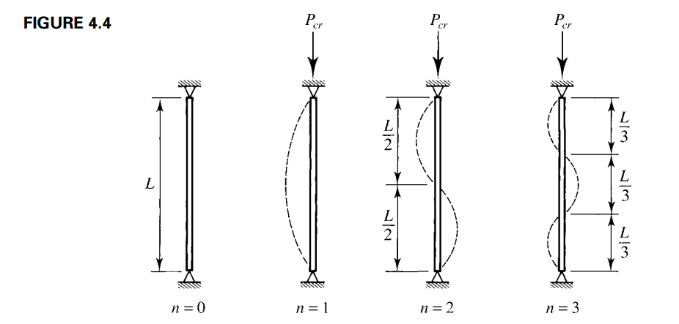

* If the critical load is divided by the cross-sectional area, the critical buckling stress is obtained:

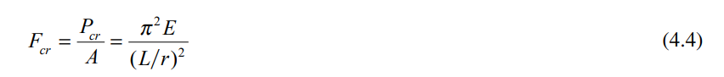

* **Effective Length (KL)**: Adjusts the actual length based on end conditions.
  + End conditions affect buckling resistance:
    - **Pinned ends**: K=1.0
    - **Fixed-free**: K=2.0
    - **Fixed-fixed**: K=0.5
* **Slenderness Ratio (KL/r)**: Determines buckling behavior.

r= $\sqrt{I/Ar }$, where A is the cross-sectional area.

**Example 4.1**

A W12 × 50 is used as a column to support an axial compressive load of 145 kips. The length is 20 feet, and the ends are pinned. Without regard to load or resistance factors, investigate this member for stability. (The grade of steel need not be known: The critical buckling load is a function of the modulus of elasticity, not the yield stress or ultimate tensile strength.)

For a W12 × 50:

r=1.96 in. (from the AISC Steel Manual)

L=20×12=240 in. (pinned ends, K=1.0) then KL = 240 in

The slenderness ratio is:

KL/r=240/1.96=122.4

The critical buckling load is determined from Euler's equation:

Pcr=π2EI/(KL)2 - - - Pcr=π2(29,000)(14.6)/(240)2=278.9 kips

Since the applied load (145 kips) is less than Pcr, the column remains stable and has a factor of safety against buckling of:

Pcr/Applied Load=278.9/145=1.92

**4.3: AISC Requirements**

* **Nominal Compressive Strength** (Pn): Pn=Fcr.Ag
  + Fcr: Critical stress, Ag: Gross cross-sectional area.
* **Design Checks**:
  + **LRFD**: Ensure factored load (Pu) satisfies Pu ≤ ϕPn.
    - Resistance factor (ϕ) = 0.90 for compression.
  + **ASD**: Ensure allowable load satisfies Pa ≤ Pn/Ωc.
    - Safety factor (Ωc) = 1.67.
* The nominal compressive strength, Pn, shall be the lowest value obtained according to the limit states of:

1. flexural buckling,

2. torsional buckling and

3. flexural-torsional buckling.

* **Critical Stress** (Fcr): THE FLEXURAL BUCKLING STRESS, Fcr, IS DETERMINED AS FOLLOWS

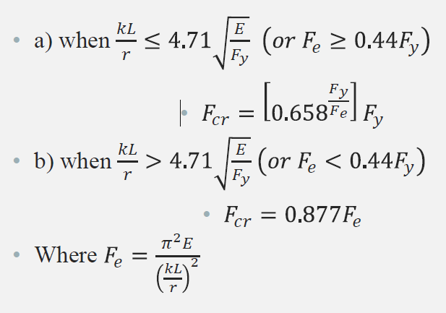

Fy: Yield stress. Fe: Euler Stress

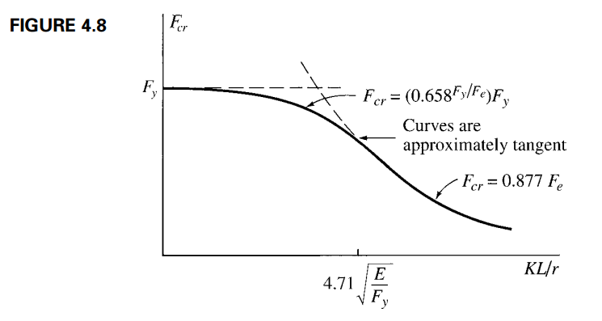

**Example 4.2**

*A W14 × 74 is used as a column to support an axial compressive load of 450 kips. The length is 20 feet, and the ends are pinned. Investigate this member for stability using LRFD and ASD.*

For a W14 × 74:

ry=2.48 in., and Ag=21.8 in.2 L=20×12=240 in. KL=240 in. (pinned ends, K=1.0)

The slenderness ratio is: KL/ry=240/2.48 = 96.77

4.71 $\sqrt{\frac{E}{Fy}}$ = 4.71 $\sqrt{\frac{29000}{50}}$ = 113 > 96.77 then

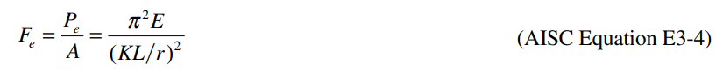

Fe = (π2 x 29000)/(96.77)2 = 30.56 ksi

Fcr = 0.658(Fy/Fe)Fy = 0.658(50/30.56) x 50 = 25.21ksi

The nominal strength is:

Pn=FcrAg=25.21×21.8=549.6 kips

For LRFD, the design strength is:

ϕPn=0.90×549.6=495 kips

For ASD, the allowable stress is:

Fa=0.6Fcr = 0.6×25.21 = 15.13ksi

The allowable strength is:

FaAg=15.13×21.8=330 kips

Conclusion:

* **LRFD**: Design compressive strength = **495 kips**.
* **ASD**: Allowable compressive strength = **330 kips**.