Forearm

Dr. Fazlina Kasim Department of Anatomy [fazlinakb@usm.my](mailto:fazlinakb@usm.my)

Outline

1. Forearm
   1. Anterior Compartment
   2. Posterior Compartment
2. Muscles in Anterior Compartment of Forearm
3. Superficial layer
4. Intermediate layer
5. Deep layer
6. Muscles in Posterior Compartment of Forearm
7. Superficial Layer
8. Deep Layer
9. Arteries - Radial & ulnar arteries
10. Periarticular Arterial Anastomoses of the Elbow Region
11. Extensor Retinaculum
12. Clinical Correlation

Forearm

* Extends from elbow to

wrist

* Surrounded by **deep fascia of forearm** (antebrachial fascia)

**Lateral intermuscular septum**

**Radius**

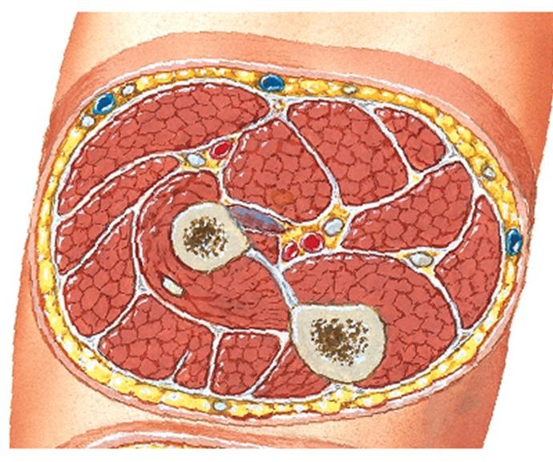

**Anterior**

* Divided into 2 compartments by:

**Interosseous membrane**

1. lateral intermuscular

septum

1. Radius
2. interosseous membrane
3. ulna

**Deep fascia of forearm**

**Inferior View of Transverse**

**Section of Proximal Right Forearm**

**Ulna**

**Posterior**

Forearm

* + 2 compartments:



**compartment**

**Posterior**

**compartment**

**Inferior View of Transverse**

**Section of Proximal Right Forearm**

**Posterior**

**Anterior**

# Ant. compartment

1. **Post. compartment**
   * The proximal parts of anterior compartment does not lie strictly anteriorly & vice versa

**Anterior**

Forearm

### Proximal part of:

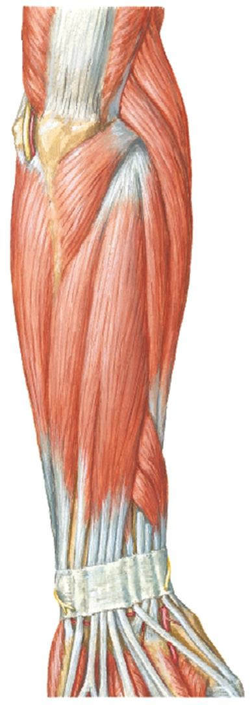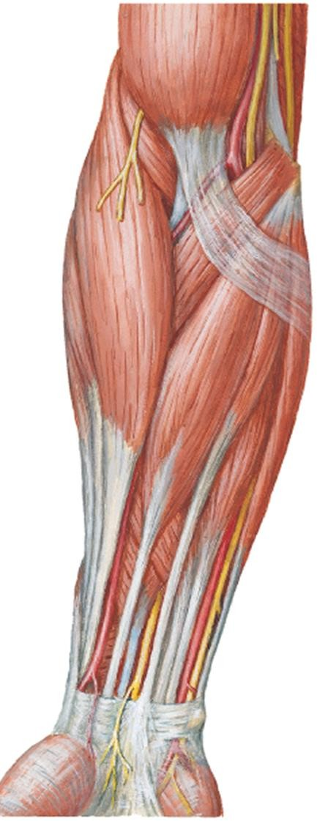

1. Anterior

compartment lies anteromedially

1. Posterior compartment lies posterolaterally
   * Muscles mainly act on:

### Wrist joint

(radiocarpal joint)

### Joints of fingers

(MCP & IP joints)

### Radio-ulnar joint

**Post. Com- part- ment**

**Ant. Com- part-**

**ment Post.**

**Com- part- ment**

**Anterior view**

**Posterior view**

Movements of Hand & Fingers

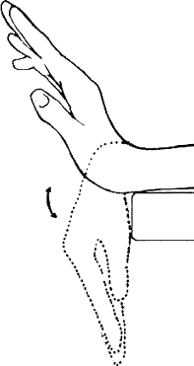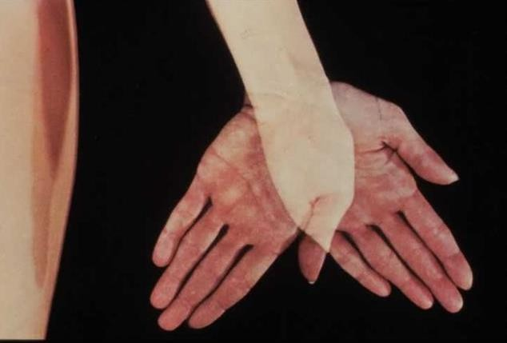**Extension**

**Flexion**

**ADDuction ABDuction**

**ADDuction & ABDuction of Hand**

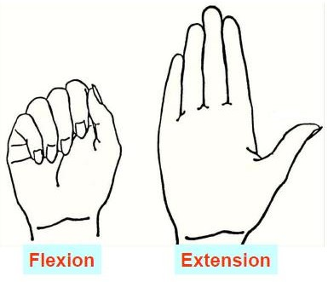

**Flexion & Extension**

**of HAnd**

**Flexion Extension**

**Flexion & Extension**

**of Fingers**

Movements of Thumb

# Flexion – Extension

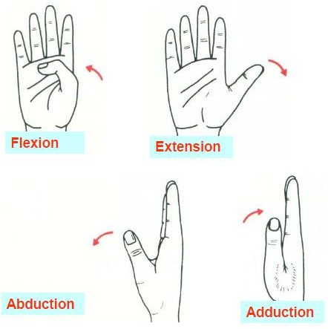

* + Movement parallel to plane of palm

# ABDuction - ADDuction

* + Movement at right angles to plane of palm

Anterior Compartment of Forearm

* Flexor-pronator compartment

**Muscles of Ant.**

**Compartment of Forearm**

* 8 muscles. Divided into 3 layers based on its location

### Main action:

1. **PT**
2. **FCR**
3. **PL**
4. **FCU**

**1)**

**Superficial Layer**

**3) Deep Layer**

**2) Inter- mediate Layer**

1. **Flex hand** at wrist jt
2. **Flex fingers** at MCP &

IP jts

1. **Pronate forearm** at RUJ
2. **FDP**
3. **FPL**
4. **PQ**

**1) FDS**

* + **Blood supply** – ulnar & radial arteries
    - The **proximal attachment** of all muscles in anterior compartment is the **medial epicondyle** of **humerus (common flexor origin** (**CFO**)) **EXC**ept for **deep layer muscles**

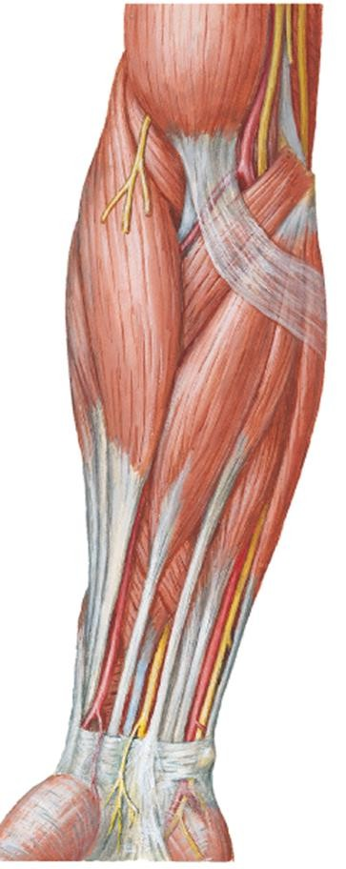

Muscles of anterior compartment of forearm

* + - All muscles cross the **elbow joint EXC**ept the 3 muscles in the **deep layer** (attach to anterior aspects of radius & ulna).

**Medial epicondyle of humerus**

Anterior

Compartment

* All muscles supplied by **median nerve** except for **1 ½ muscles**:
  1. FCU
  2. Medial part of FDP
* **Deep layer muscles** are supplied by a **branch of median nerve** – **anterior interosseous nerve**.

### Supplied by ulnar nerve

**FCU**

**FDP**

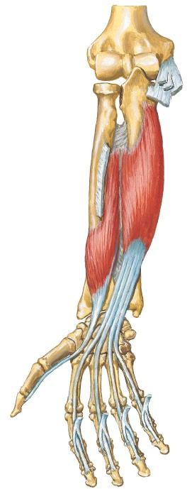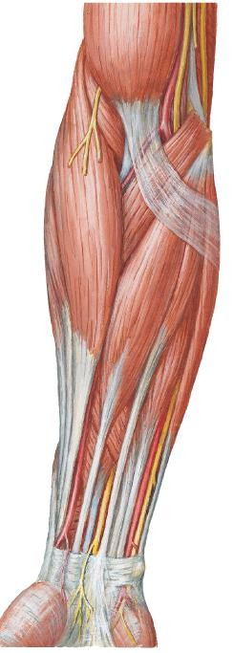

**Anterior view**

Superficial Layer

Superficial Layer

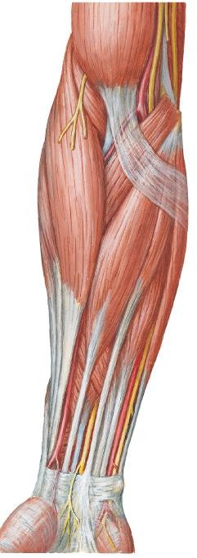

**Pronator**

**teres**

**FCR PL**

**FCU**

* The superficial muscles consist of (from medial to lateral):

1. Flexor carpi ulnaris (FCU)
2. Palmaris Longus (PL)
3. Flexor carpi radialis (FCR)
4. Pronator teres (PT)

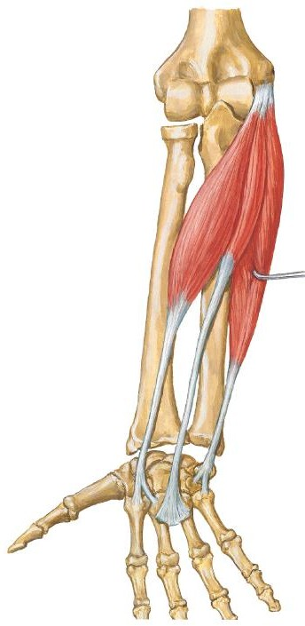

**Anterior**

**view**

1) Flexor Carpi Ulnaris

* + Most **medial** muscle of superficial

layer muscles

**FCU**

|  |  |  |
| --- | --- | --- |
|  | **Humeral head** | **Ulnar head** |
| **PA** | Medial epicondyle of humerus (common flexor origin) | Olecranon & posterior ulna |
| **DA** | 1. Pisiform 2. Hook of hamate 3. Base of 5th metacarpal | |
| **Act-**  **ion** | Flexes & **ADD**ucts hand | |



**Ulnar**

1) Flexor Carpi Ulnaris

**nerve**

* + - After ulnar nerve pass **posterior** to **medial epicondyle** of humerus, it enters anterior part of forearm by passing between **2 heads of FCU**.

**Medial epicondyle of humerus**

**Olecranon**

**FCU**

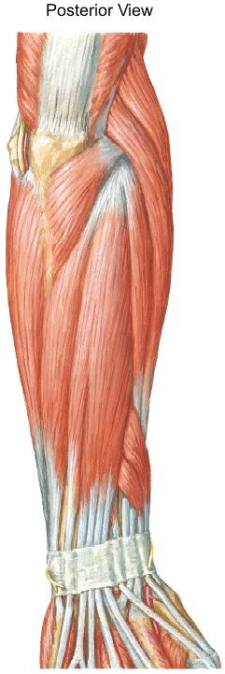

**Posterior view**

1) Flexor Carpi Ulnaris

FCU tendon is a landmark for **ulnar artery & nerve**. Ulnar artery and nerve is **lateral** to FCU tendon

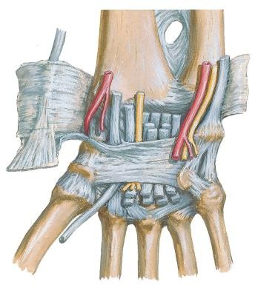

**FCU tendon**

**Ulnar artery**

**Palmar carpal ligament**

**Ulnar nerve**

**Flexor retinaculum**

Palmar view





2) Palmaris Longus

* Absent in 14% of people.
* PL has a short belly & a **long**

### tendon

**Palmaris**

|  |  |
| --- | --- |
| **Proximal attachment** | Medial epicondyle of humerus (common flexor origin) |
| **Distal attachment** | Flexor retinaculum and palmar aponeurosis |
| **Action** | Flexes hand at wrist joint |

**longus**

**Anterior**

**view**



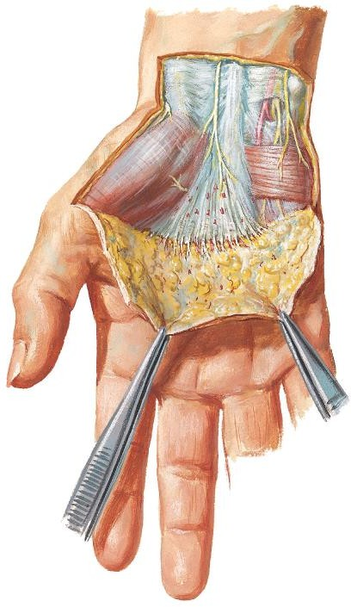

Palmar view

**Palmar aponeurosis**

**Palmar carpal ligament**

**Palmaris longus tendon**

2)

Palmaris Longus

PL tendon passes superficial to the **flexor retinaculum** and attaches to it and the **palmar aponeurosis**.



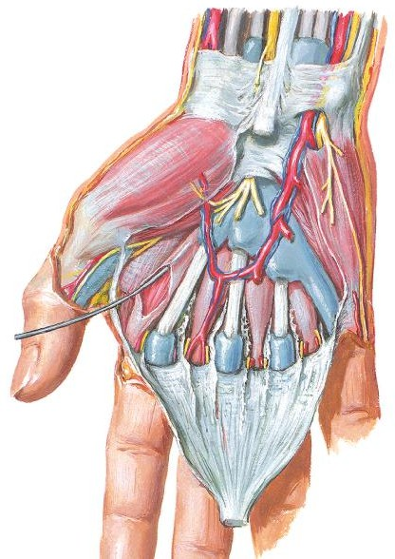

Flexor retinaculum

PL tendon

Median nerve

2)

Palmaris Longus

* PL tendon is a landmark for **median nerve**.
* Median nerve is **inferolateral** to PL tendon.

**Anterior view**



**FCR**

**Anterior view**

3) Flexor Carpi Radialis

* + FCR is lateral to PL

|  |  |
| --- | --- |
| **Proximal attachment** | Medial epicondyle of humerus (common flexor origin) |
| **Distal attachment** | Base of 2nd & 3rd  metacarpal |
| **Action** | Flexes & **ABD**ucts hand |



3) Flexor Carpi Radialis

**Radial artery**

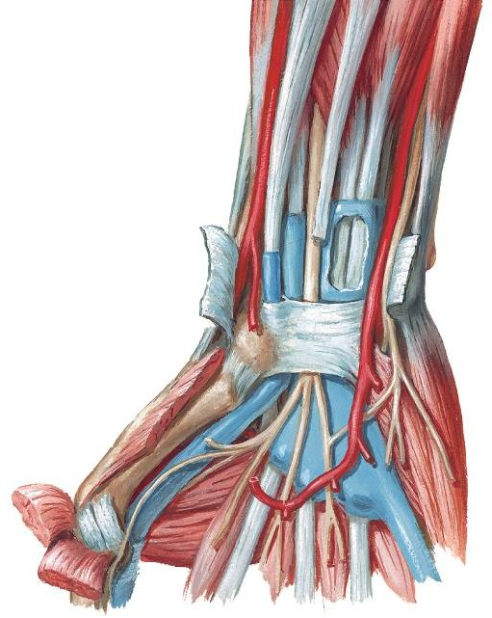

* FCR tendon is a good landmark for **radial artery**.
* Radial artery lies

**lateral** to FCR tendon.

* FCR tendon in its synovial sheath passes through a **canal** in the **lateral part** of the **flexor retinaculum**.

**FCR tendon Flexor retinaculum**



**Wrist – palmar view**

3) Flexor Carpi Radialis

**Flexor retinaculum FCR tendon**

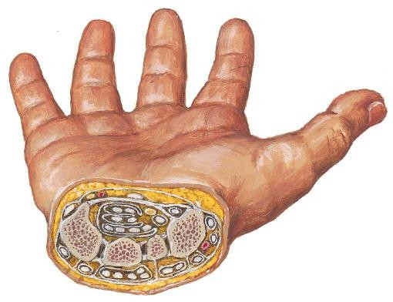

The canal is bounded by:

1. **Laterally**
   * a groove in the trapezium
2. **Medially**
   * Flexor retinaculum that splits into 2 slips (attach to margins of groove)

**Trapezium**

**Cross section of wrist**

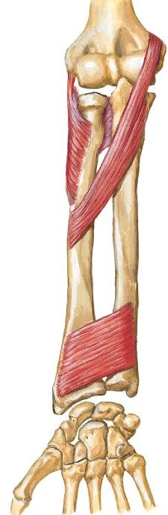

4) Pronator Teres

* + Most **lateral** muscle of

superficial layer muscles

**Pronator teres**

|  |  |  |
| --- | --- | --- |
|  | **Humeral head** | **Ulnar head** |
| **PA** | Medial epicondyle of humerus (common flexor origin) | Coronoid process (ulna) |
| **DA** | Midshaft of radius | |
| **Act-**  **ion** | Pronates forearm at radio-  ulnar joint | |



**Anterior view**

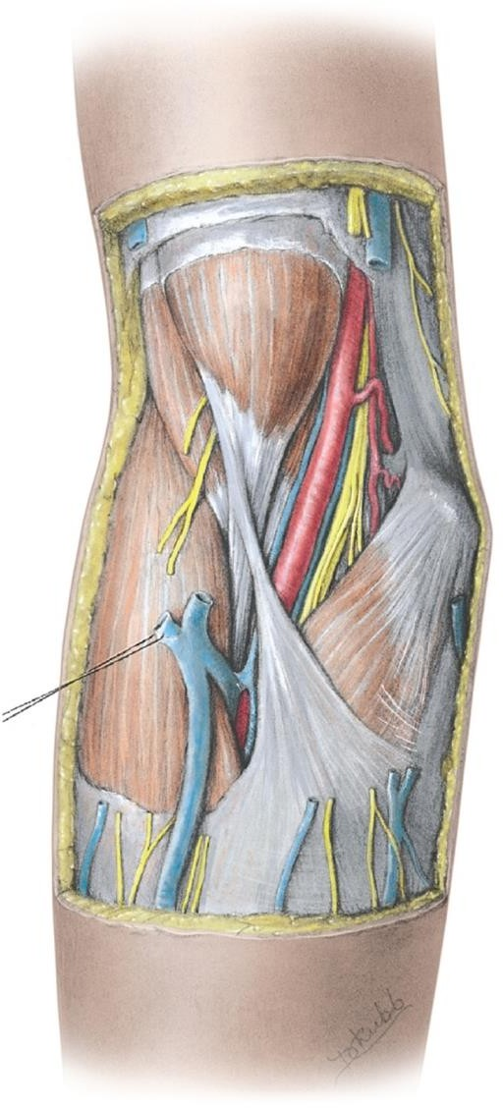

**Pronator teres**

4) Pronator

Teres

The lateral border of pronator teres forms the **medial boundary** of the **cubital fossa**

**Anterior view**

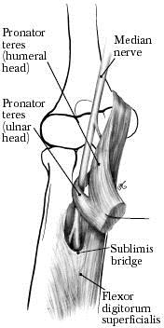

**Anterior view**

4) Pronator Teres

* + - Median nerve leave cubital fossa & enters forearm by passing between the **2 heads of pronator teres**.

Intermediate Layer

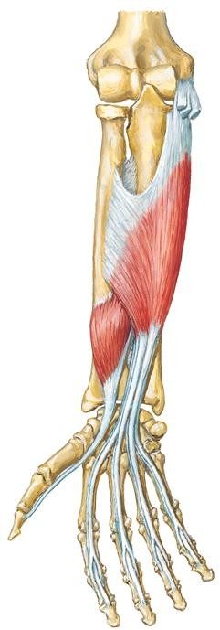

1) Flexor Digitorum Superficialis

**FDS**

|  |  |  |
| --- | --- | --- |
|  | **Humero-ulnar head** | **Radial head** |
| **PA** | 1. Medial epicondyle of humerus (common flexor origin) 2. Coronoid process (ulna) | Oblique line of radius |
| **DA** | Base of **middle phalanges** of medial 4  fingers | |
| **Act- ion** | Flexes:   1. **Middle phalanges** at **PIPJs** of medial   4 fingers   1. **Proximal phalanges** at **MCPJs** 2. **Hand** at **wrist joint** | |



**Site of common flexor origin – medial epicondyle**

The superficial & intermediate muscles are located anteromedially because arise mainly from **common flexor** attachment.

**Pronator teres**

**FCR**

**PT**

**FCR**

**PL**

**FCU**

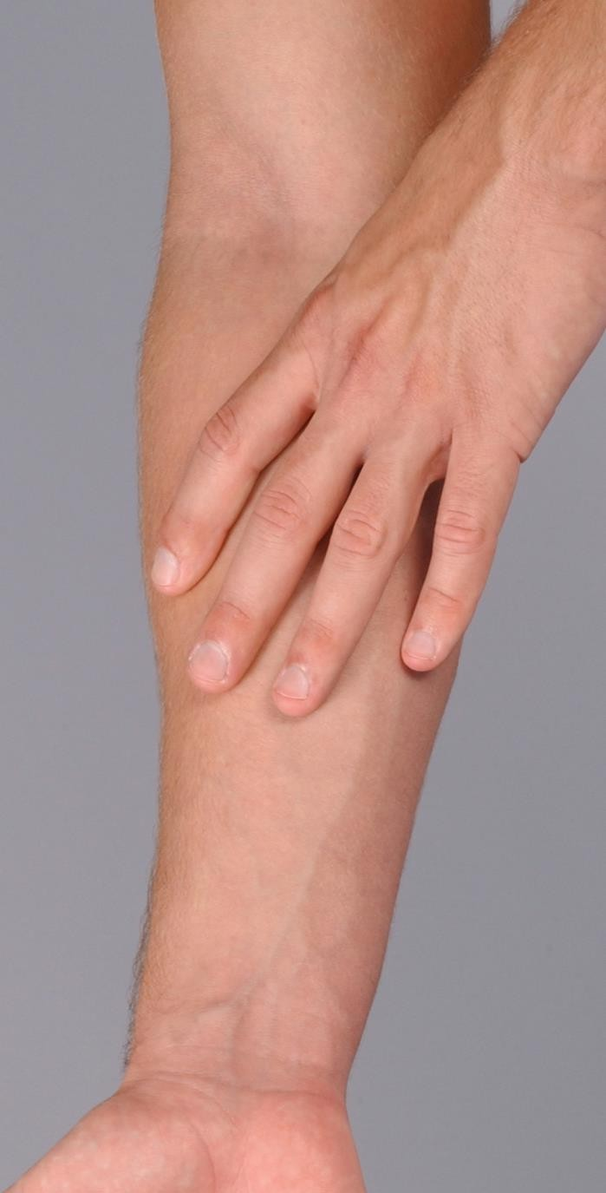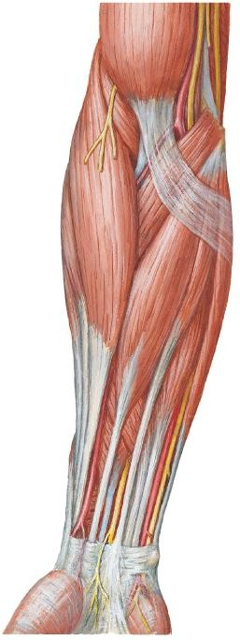

**PL**

**FCU**

Deep Layer

* The fascial plane between **intermediate & deep layer** of muscles is the **neurovascular plane** of the anterior compartment.
* **Blood vessels** & **nerves** course within it.



**Anterior view**

**FDS (cut)**

**FDP**

1) Flexor Digitorum Profundus

|  |  |
| --- | --- |
| **PA** | 1. Anterior surface of   ulna   1. Anterior surface of interosseous membrane |
| **DA** | Base of **distal phalanges** of medial 4 fingers |





**Anterior view**

**FDP**

1) Flexor Digitorum Profundus



|  |  |
| --- | --- |
| **Innervat-**  **ion** | 1. **Medial part** – **ulnar**   **nerve**   1. **Lateral part** – **anterior interosseous nerve** (median nerve) |
| **Action** | Flexes:   1. **Distal phalanges** at DIPJ & **middle phalanges** at PIPj of medial 4 fingers 2. **Proximal phalanges** at   MCPJ   1. **Hand** at wrist joint |



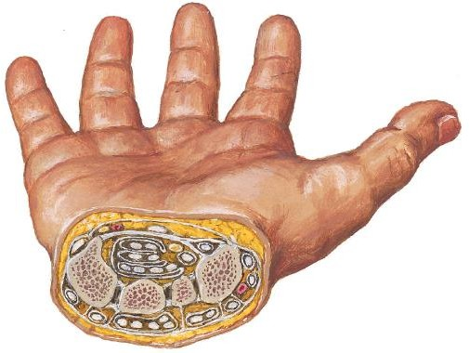

4 FDP tendons **posterior** to the 4 FDS tendons in **common synovial sheath**

**FDS & FDP**

**tendons in a synovial common flexor sheath**

**Flexor retinaculum**

Near the wrist, its 4 tendons in **common synovial sheath** (with the 4 tendons of **FDS**) pass **deep to flexor retinaculum**, through the **carpal tunnel** to reach the fingers.

1) Flexor Digitorum Profundus

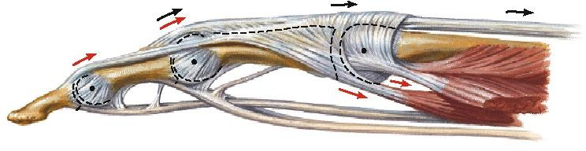

**FDP tendon**

**FDS**

**tendon**

Each FDP tendon passes through a split in the overlying FDS tendon.

Superficialis splits into 2 to permit profundus to pass through



**Lateral view**



**Anterior view**

**FPL**

**FDP**

2) Flexor Pollicis Longus

•

•

•

Pollex = thumb

FPL = the long flexor of thumb Lateral to the FDP

|  |  |
| --- | --- |
| **PA** | Anterior surface of radius & interosseous  membrane |
| **DA** | Base of **distal phalanx** of thumb |





**Anterior view**

**FPL**

**FDP**

2) Flexor Pollicis Longus

|  |  |
| --- | --- |
| **Innervat- ion** | **Anterior interosseous nerve** (median nerve) |
| **Action** | Flexes:   1. **Distal phalanx** of   **thumb** at IPJ   1. **Proximal phalanx** at MCPJ 2. **1st metacarpal** at carpometacarpal jt (CMCJ) |





**Median nerve**



FPL tendon in its synovial sheath passes **deep to the flexor retinaculum**, lateral to the common flexor sheath.

**FPL tendon in its synovial sheath**



**Anterior view**

3) Pronator Quadratus

* Quadratus = quadrangular
* Deepest muscle
* Lies proximal to wrist joint

**Pronator quadratus**

|  |  |
| --- | --- |
| **PA** | Distal ¼ ulna |
| **DA** | Distal ¼ radius |
| **Innervat- ion** | **Anterior interosseous nerve** (median nerve) |
| **Action** | Pronates forearm at radio-ulnar joint |



|  |  |  |  |  |
| --- | --- | --- | --- | --- |
|  | **Proximal**  **attachment** | **Distal attachment** | **Innervation** | **Action** |
| **Superficial Layer** | | | | |
| **Pronator Teres** | CFO & Coronoid  process (ulna) | Mid-radius | Median nerve | Pronates forearm |
| **FCR** | CFO | Base of 2nd & 3rd metacarpal | Flexes & **abd**ucts hand at wrist joint |
| **Palmaris Longus** | CFO | Flexor retinaculum & palmar aponeurosis | Flexes hand at wrist joint |
| **FCU** | CFO & Olecranon & posterior ulna | Pisiform, hook of hamate & base of 5th metacarpal | Ulnar nerve | Flexes & **add**ucts hand at wrist joint |
| **Intermediate Layer** | | | | |
| **FDS** | CFO, coronoid process & oblique line (radius) | Middle phalanges of medial 4 digits | Median nerve | Flexes PIP joints of medial 4 digits, MCP Joint & wrist |
| **Deep Layer** | | | | |
| **FDP** | Anterior surface of ulna & interosseous membrane | Distal phalanges of medial 4 digits | Lateral ½ - (AIN) median nerve  Medial ½ - ulnar nerve | Flexes DIP joints of medial 4 digits, MCP Joint & wrist |
| **FPL** | Anterior surface of radius & interosseous membrane | Distal phalanx of thumb | Anterior interosseous nerve (median nerve) | Flexes IP & MCP joints of thumb |
| **Pronator Quadratus** | Distal ¼ ulna | Distal ¼ radius | Pronates forearm |

Posterior Compartment of Forearm

* Extensor-supinator **compartment**
* Total **11** muscles



* All muscles cross wrist joint except **BR & supinator.** All muscles are extensors **EXC**ept **BR & supinator**

### Innervated by radial nerve

(directly or by its branches)

### Main action:

1. **Extensor of hand** at wrist joint (RCJ) **EXC**ept **brachioradialis**
2. **Extensor of fingers** at IPJs &

MCPJs

**Inferior View of Transverse Section of Proximal Right Forearm**

1. **Supinator** of forearm at RUJ

**Anterior**

**U**

**Posterior**

**compartment**

**Posterior**



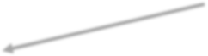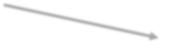

2) Deep layer

Muscles

1. Supinator
2. Extensor indices (EI)
3. Outcropping Muscles of Deep Layer
   1. ABDuctor pollicis longus (ABD PL)
   2. Extensor pollicis longus (EPL)
   3. Extensor pollicis brevis (EPB)

1) Superficial Layer

1. Brachioradialis
2. Ext. carpi radialis longus (ECRL)
3. Ext. carpi radialis brevis (ECRB)
4. Extensor Digitorum (ED)
5. Ext. digiti minimi (EDM)
6. Ext. carpi ulnaris (ECU)

* All muscles attach to **common extensor origin (CEO)** = **lateral epicondyle of humerus EXC**ept**:**

Superficial Layer

## BR

* 1. **ECRL**

### Innervation:

* + **Radial nerve** supplies the 2 most superficial & lateral muscles – **BR & ECRL**
  + The rest of the muscles in the superficial layer are supplied by **deep branch** of radial nerve (**post. Interosseous nerve)**

**BR ECRL**

Posterior View





* **Location** – at anterolateral surface of forearm

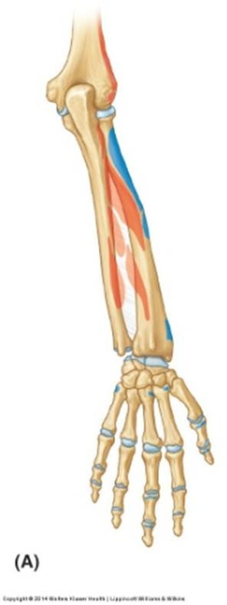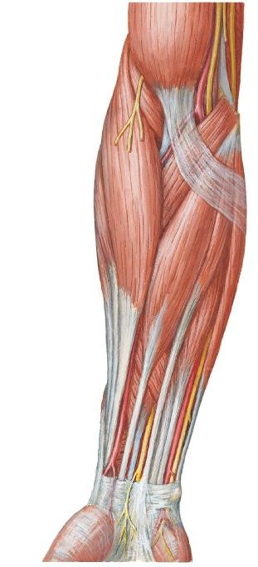

**BR**

Posterior View

Anterior View

1) Brachioradialis

* Forms lateral boundary of

### cubital fossa

* Overlies **radial nerve & art**

|  |  |
| --- | --- |
| **PA** | Latera supracondylar  ridge (humerus) |
| **DA** | Distal end of radius (lateral surface) |
| **Act- ion** | **Flexes** forearm |

### Location:

**Extensor Carpi Radialis Longus & Brevis**

* + Part of ECRL is deep to BR
  + Part of ECRB deep to ECRL

**BR ECRL**

**ECRB**





Posterior View

|  |  |  |
| --- | --- | --- |
|  | **ECRL** | **ECRB** |
| **PA** | Lateral supracondylar ridge (humerus) | Lateral epicondyle (humerus)  **CEO** |
| **DA** | Base of 2nd metacarpal (dorsal aspect) | Base of 3rd metacarpal (dorsal aspect) |
| **Act- ion** | * At wrist joint  1. Extend hand 2. **ABD**uct hand | |

* ECRL & ECRB tendon distally covered by tendons of **ABD PL** & **EPB**

**2 & 3) Extensor Carpi Radialis Longus & Brevis**

* ECRL & ECRB together in a common tendinuous sheath pass under the **extensor retinaculum**

**Extensor Retinaculum**

**ABD PL**

**EPB**

**ECRB**

**ECRL**

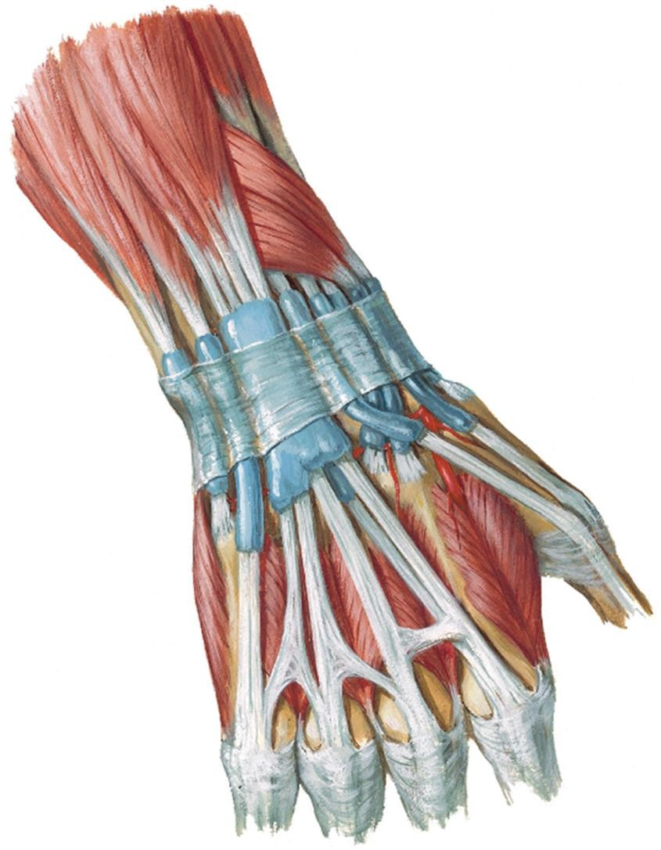

Posterior View



**ED**

**EDM**

1. Extensor Digitorum &
2. Extensor Digiti Minimi

Posterior View

* ED occupies most of post. surface of forearm
* EDM partially attached to ED



|  |  |  |
| --- | --- | --- |
|  | **ED** | **EDM** |
| **PA** | Lateral epicondyle (humerus) **CEO** | |
| **DA** | Extensor expansions of: | |
| Medial 4 fingers | Little finger (5th finger) |
| **Act- ion** | Extends at MCPJ & IPJs | |
| Medial 4 fingers | Little finger |

4) ED & 5) EDM

Posterior View

* Proximal to wrist,

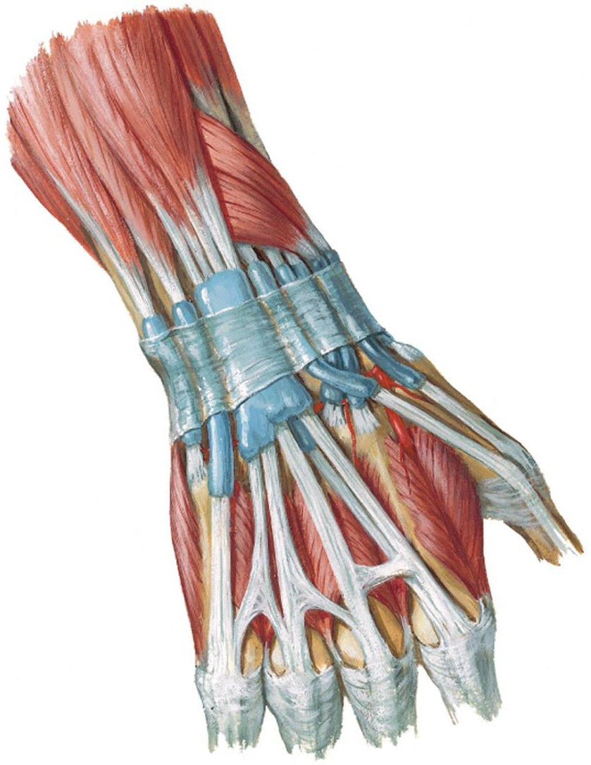

1. 4 tendons of **ED**
2. tendon of **extensor indices, EI** (muscle of deep layer)
   * in a common synovial sheath → together pass deep to **extensor retinaculum**

* Tendon of **EDM** runs through a separate compartment beneath **extensor retinaculum,** then it **divides into 2 slips**

**EDM**

**ED**

**EDM**

**ED**

**Extensor**

**Retinaculum**

**EI**

ED & EDM

* On dorsum of hand, proximal to MCP jt of medial 4 fingers, adjacent tendons of ED & EDM are interconnected by **3 intertendinous connections**



* Intertendinous connections restrict independent extension of middle & ring fingers

**EDM**

**Intertendinous**

**connections**

**ED**

**Extensor**

Posterior View

**Retinaculum**

**EI**

Tendon of Extensor Digitorum – Extensor Expansion

**Lateral band**

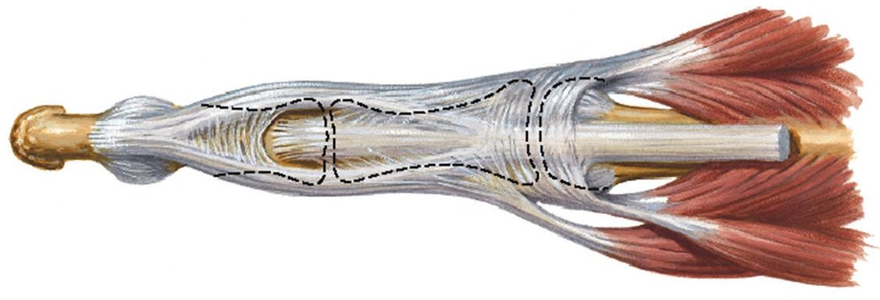

**Central band**

Dorsal View

**IOM**

**ED**

**Lumbrical**

* Over each medial 4 fingers, each **ED tendon** divides into:

### 1 central (median) band

* + Attach to base of **middle phalanx**

### 2 lateral bands

* + Attach to base of **distal phalanx**
  + Joined by tendon of **interossei & lumbrical muscles**

**IOM**

* Tendon of ED expands (flatten) forming a triangular **aponeurosis =**

### extensor expansion

Tendon of ED - Extensor Expansion

**Base**



**IOM**

**ED**

Dorsal View

**Lumbrical**

**IOM**

* Dorsal digital expansion
* Triangular in shape.

### Parts – Base, Sides & Apex

1. **Base**
   * Covers head of metacarpal & MCPJT
   * The corners of the base are attached to palmar ligt (MCPJ) & joined by tendon of **interosseous (IOM) & lumbrical muscles**

Tendon of ED - Extensor Expansion

**ED**

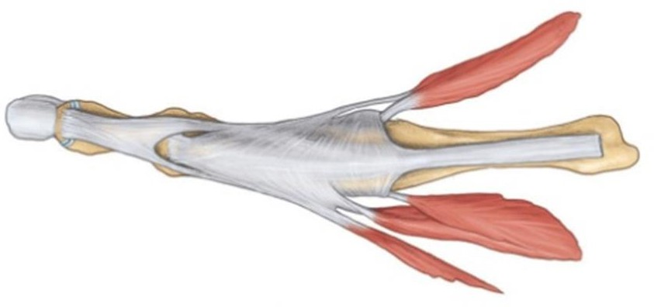

**Base**

**IOM**

**Lumbrical**

**IOM**

Dorsal View

### Sides

* + **Lateral side** – thickened by tendon of interossei & lumbrical muscles
  + **Medial side** – thickened by tendon of interossei only

1. **Apex** at base of distal phalanx

* **Location** – on medial border of forearm (pos surface)



t.

**CU**

**ECU**

Posterior View

6) Extensor Carpi Ulnaris

* Passes through a separate compartment beneath extensor retinaculum

**F**

|  |  |  |
| --- | --- | --- |
|  | **Humeral head** | **Ulnar head** |
| **PA** | Lateral epicondyle  (humerus) **CEO** | Posterior  ulna |
| **DA** | Base of 5th metacarpal (dorsal) | |
| **Act- ion** | 1. Extends hand with ECRL & ECRB 2. **ADD**ucts hand with FCU | |



2) Deep layer

Muscles

1) Superficial Layer

* 1. Supinator
  2. ABDuctor pollicis longus
  3. Extensor pollicis longus (EPL)
  4. Extensor pollicis brevis (EPB)
  5. Extensor indices (EI)

**Outcropping**

**Muscles**

* PA of all deep layer muscles are post. surface of radius, ulna & interosseous membrane **EXC**ept supinator
* Muscles in the deep layer are supplied by **deep branch** of **radial nerve** (posterior interosseous nerve)

1) Supinator

* **Location** – Lies deep in cubital fossa. Forms **floor** of **cubital fossa**
* Envelops the neck & proximal radius

**Supinator**

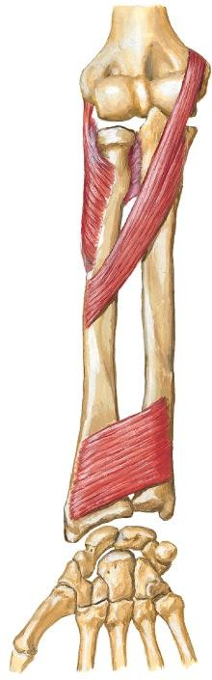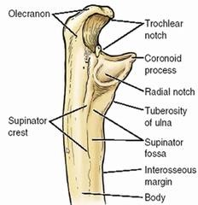

Anterior View

Lateral View

|  |  |
| --- | --- |
| **PA** | 1. Lateral epicondyle (humerus) **CEO** 2. Anular ligament 3. Supinator crest of ulna |
| **DA** | Proximal radius |
| **Act- ion** | **Supinates** forearm (forearm extended) |

1) Supinator

* Forms **floor** of **cubital fossa**
* Pierced by **deep branch of radial n.** (post. interosseous nerve)

**Radial n.**

**Deep br. Super-**

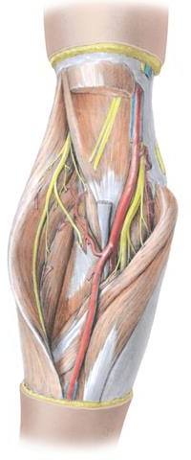

**ficial br.**

**Supinator**

Anterior

View

3) Outcropping Muscles

* Consist of **3** muscles:
  1. ABDuctor pollicis longus (ABD PL)
  2. Extensor pollicis longus (EPL)
  3. Extensor pollicis brevis (EPB)
* These muscles act on the **thumb**
* Location – deep to superficial layer muscle
* They become superficial by emerging (‘crop out’) in lateral part of forearm, between **ECRB & ED**

Posterior

View

**ED**

**ECRB ABD PL**

**EPB**

**EPL**

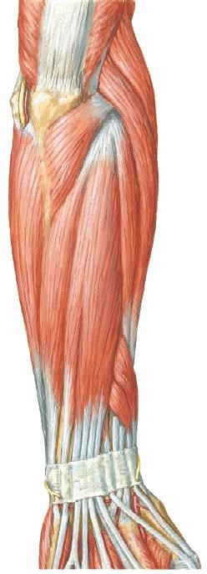



3) Outcropping Muscles

### ABDuctor Pollicis Longus (ABD PL)

* + Lies just distal to supinator
  + Most **lateral** of the outcropping muscles

**Supinator**

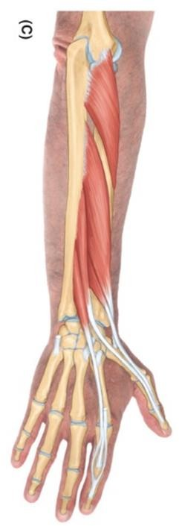

**ABD PL**

|  |  |
| --- | --- |
| **PA** | 1. Proximal ulna & radius (posterior surface ) 2. Interosseous membrane |
| **DA** | Base of 1st metacarpal |
| **Act- ion** | Acts on thumb at CMC jt:   1. **ABD**ucts (with ABD PB) 2. Extends thumb with extensor pollicis muscles |



Posterior View

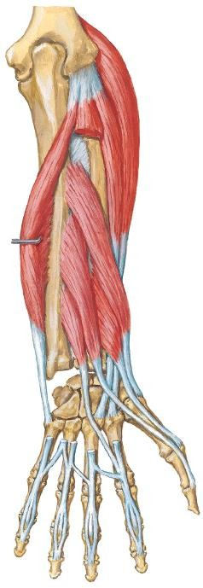

3) Outcropping Muscles

### Extensor Pollicis Brevis (EPB)

Posterior View

* + Short muscle. Lies distal to ABD PL
  + Its tendon lies medial to ABD PL tendon
  + Passes deep to **extensor retinaculum** with

**ABD PL** tendon

**ABD PL EPB**

|  |  |
| --- | --- |
| **PA** | 1. Distal radius (posterior surface) 2. Interosseous membrane |
| **DA** | Base of proximal phalanx of thumb  (dorsal) |
| **Act-**  **ion** | Extends:   1. Proximal phalanx of thumb at   MCP jt   1. Extend 1st metacarpal at CMC jt |





**EPL**

**EPB**

Posterior View

3) Outcropping Muscles

### Extensor Pollicis Longus (EPL)

* Muscle is medial to EPB.

|  |  |
| --- | --- |
| **PA** | 1. Posterior surface of ulna 2. Interosseous membrane |
| **DA** | Base of distal phalanx of thumb (dorsal) |
| **Act- ion** | Extends:   1. Distal phalanx of thumb at IPJ 2. MCPJ & CMCJ of thumb |



Outcropping Muscle - 3) Extensor Pollicis Longus

* EPL tendon passes deep to extensor retinaculum in its own compartment

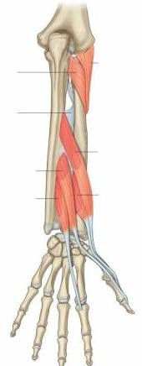

Posterior

View

* Passes medial to **dorsal tubercle of radius**, thus creating a gap between tendon of EPB & EPL – **anatomical snuff box**

**EPL**

**Dorsal**

**tubercle**

* + Has a narrow belly



**ED**

**U**

**EPL**

**EI**

Posterior

View

5) Extensor Indices (EI)

* + Medial to extensor pollicis longus, EPL
  + Most medial muscle of deep layer

**EC**

|  |  |
| --- | --- |
| **PA** | 1. Distal ulna (posterior surface) 2. Interosseous   membrane |
| **DA** | Extensor expansion of index finger (joins ED tendon to index finger) |
| **Act-**  **ion** | Extend index finger |

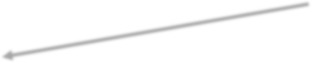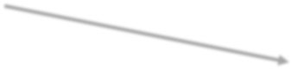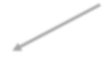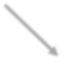

Physiological Subdivision of Muscles

2) Act on Wrist

1. ED
2. EDM
3. EI

4) Act on Medial 4 Fingers

1. EPL
2. EPB
3. ABD

PL

3) Act on Thumb

1. BR
2. Supinator

1) Act on Elbow & RUJ

1. ECRL
2. ECRB
3. ECU

Extensor Retinaculum

* A thickening of deep fascia of forearm (antebrachial fascia)
* Attached to distal ends radius & ulna (**posterior** surface)
* **Function** – Holds tendons of extensor muscles in place. Prevents bowstringing of extensor tendons when hand is extended at wrist joint

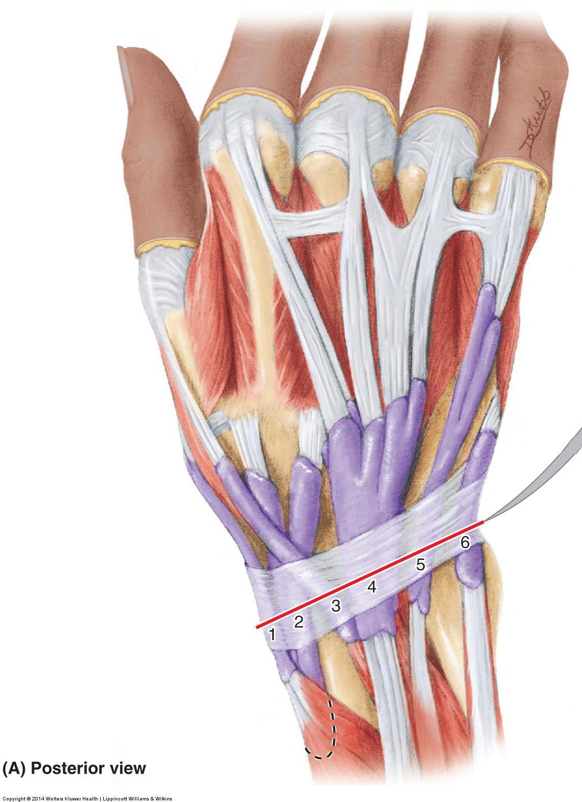

**Extensor**

**Retinaculum**

Posterior

View

Extensor Retinaculum

* + Form 6 osseofibrous tunnels providing passage for tendons of 9 extensor muscles (from lateral to medial):

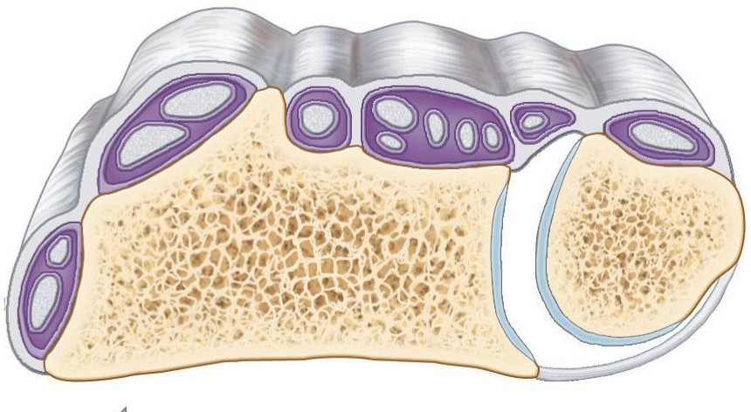

**Radius**

**6**

**3**

**2**

**5**

**4**

1. ABD PL & EPB

**1**

1. ECRL & ECRB
2. EPL
3. ED & EI
4. EDM
5. ECU

Oblique transverse section at wrist



Arteries of Forearm

* 1. Ulnar artery
  2. Radial artery

1) Ulnar artery

* One of the terminal branches of **brachial artery** in cubital fossa.
* Leaves cubital fossa by passing deep to pronator teres
* Descends inferiorly in between FDS & FDP muscle (in neurovascular plane).

**Brachial art.**

**Ulnar art.**

**Pronator**

**teres**

**FDS**

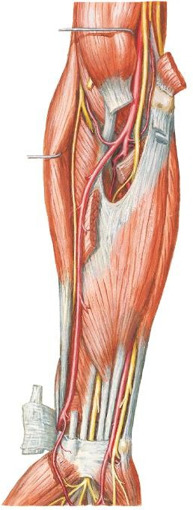

**Anterior view**

1) Ulnar artery

* Crossed by **median nerve**
* Reaches **medial side** of

forearm.

* Passes **superficial** to **flexor retinaculum** at wrist **lateral** to **ulnar nerve.**
* Passes through **ulnar (Guyon) canal** to enter hand.

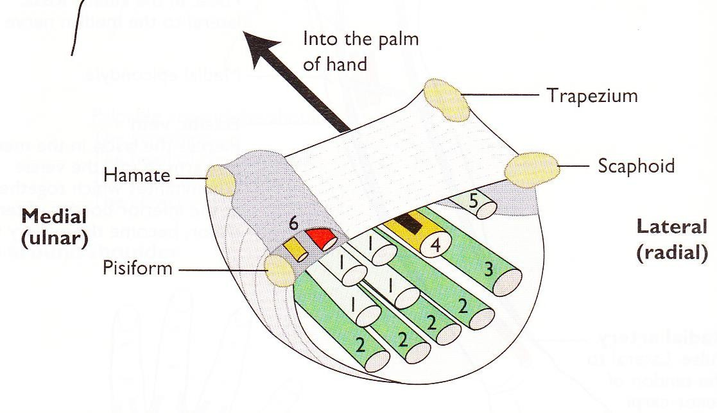

**Ulnar art.**

**Median n.**

**Ulnar artery**

**Ulnar nerve**

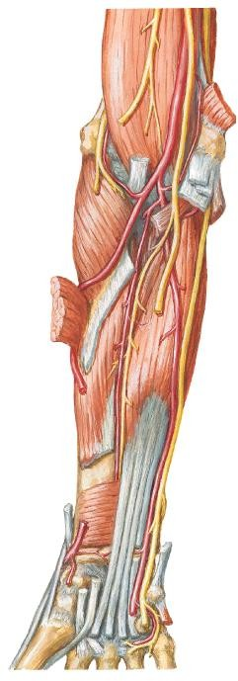

**Anterior view**

### Anterior & Posterior Ulnar Recurrent Arteries

* + Participate in **periarticular anastomosis** of the elbow.

**Deep a. of arm**

### Common Interosseous Artery

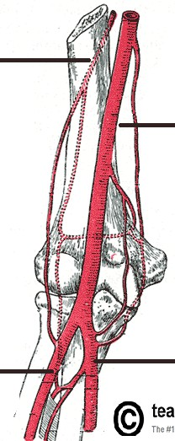

**Brachial**

**a.**

**Ant. &**

**post. ulnar recur- rent a.**

**Ulnar**

**a.**

**Common interosseous a.**

**Anterior view**

Branches of Ulnar Artery in Forearm

* + A short branch
  + Divides into **anterior** & **posterior interosseous art.s**

**Radial a.**

**Post. inter-**

**osseous a.**

**Ant. interosseous a.**

### Branches of Common Interosseous Artery

**a. Anterior Interosseous Artery**

* Descends anterior to interosseous membrane.
* Lateral to the **ANT. interosseous branch of median nerve**

**Ulnar**

**art.**

Branches of Ulnar Artery in Forearm

**Common inter- osseous a.**

**ANT. inter- osseous a.**

**ANT.**

**ulnar recurrent art.**

**POST. ulnar recurrent art.**

**Anterior view**





Branches of Ulnar Artery in Forearm

* **Branches of Common Interosseous Artery**

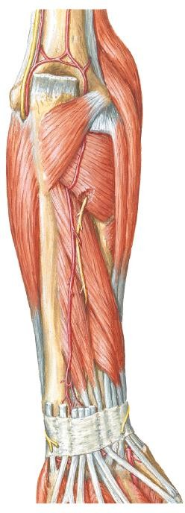

1. **Posterior Interosseous**

**Artery**

* Passes posterior to interosseous membrane.
* Gives rise to **recurrent interosseous artery** that participates in **periarticular anastomosis** of the elbow.

**Posterior view**

**Recurrent interosseous art.**

**Post. interosseous art.**

2) Radial artery

* One of the terminal branches of **brachial artery** in cubital fossa.

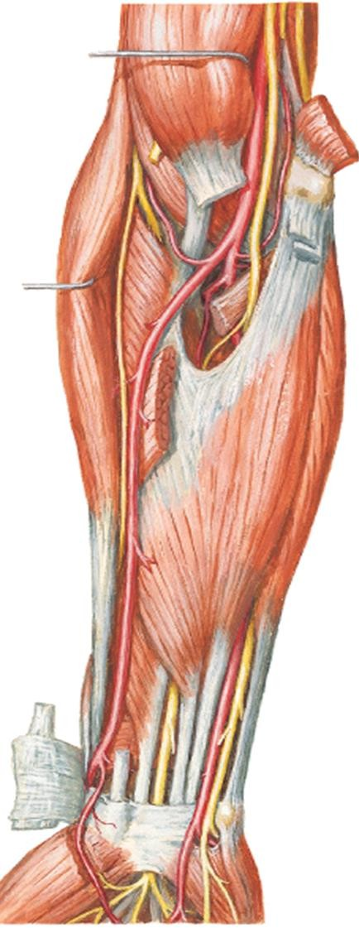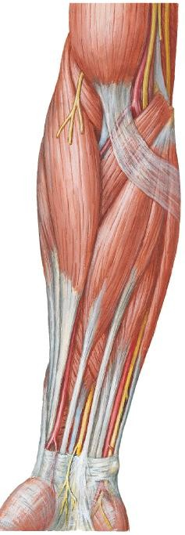

* From cubital fossa, it descends laterally deep to **brachioradialis**.
* At middle 1/3 of forearm, it is **medial** to **superficial branch of radial nerve**

**Radial artery**

**BR**

**Radial artery**

**Super- ficial br. Radial n.**

**Radial artery**

**Anterior view**

2) Radial artery

* + At distal forearm, it becomes superficial (covered only by skin & fascia) & becomes **lateral to FCR tendon**.

**Radial artery**

**BR**

**Radial artery**

**Radial artery**

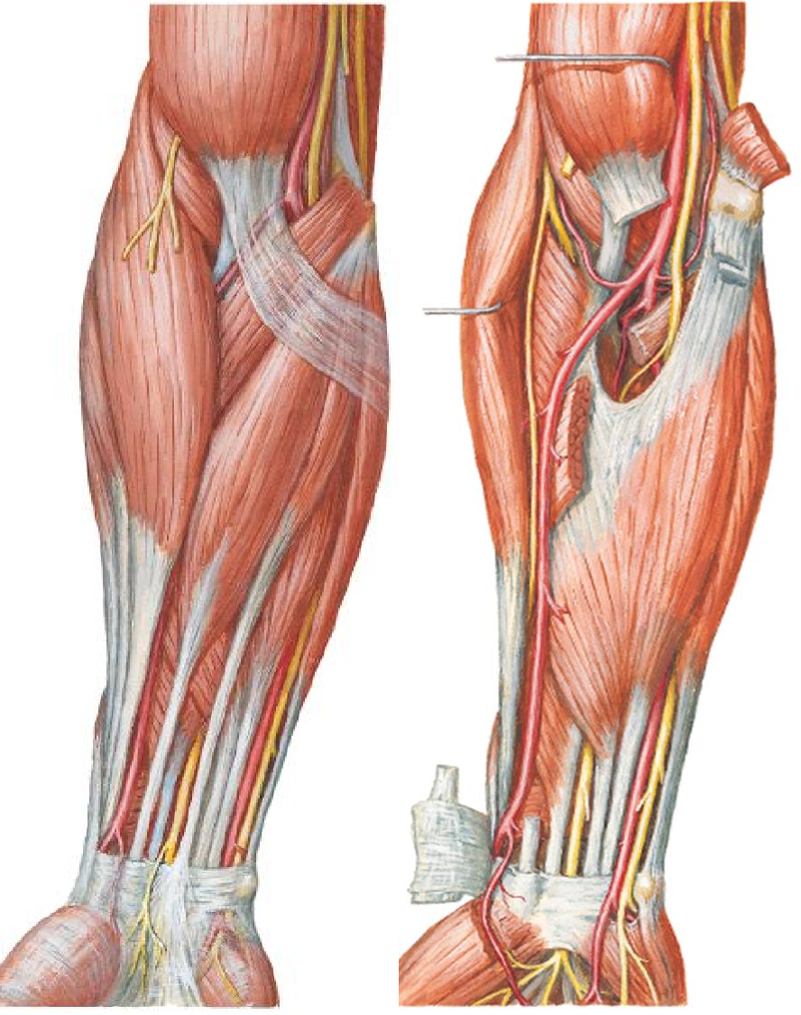

**FCR**

**Anterior view**

**tendon**

* It curves around **lateral side** of **wrist**.

2) Radial artery

**Radial artery in anatomical snuffbox**

**Radial a.**

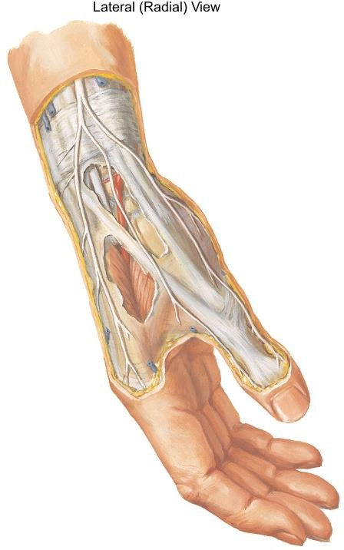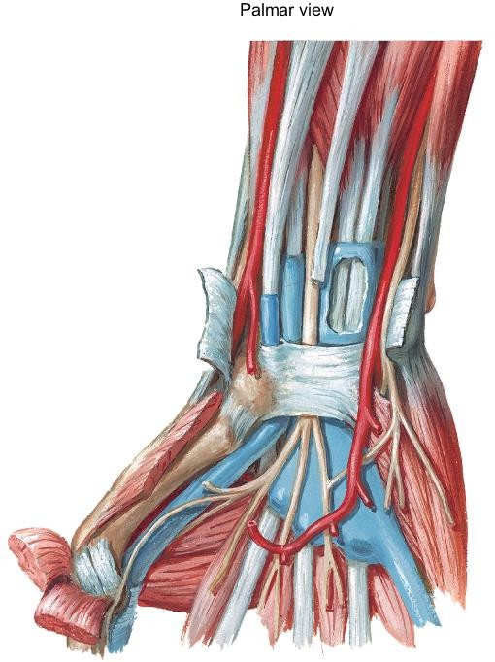

* Crosses the floor of the **anatomical snuff box**
* Reach **dorsum**

**of hand**

Branches of Radial Artery in Forearm

# Radial recurrent artery

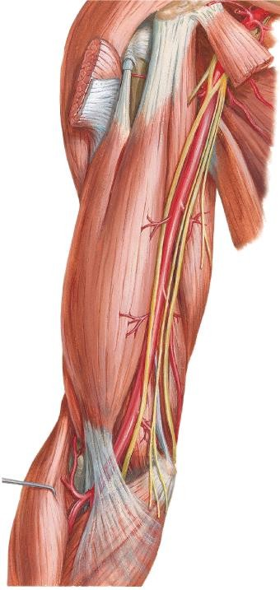

* + - Arises just distal to the elbow.
    - Participate in **periarticular anastomosis of the elbow**
    - Anastomose with the **radial collateral artery** (a branch of deep artery of arm).

**Radial recurrent**

**art.**

**Radial**

**Anterior view**

**art.**

Anastomoses around the elbow joint exists between

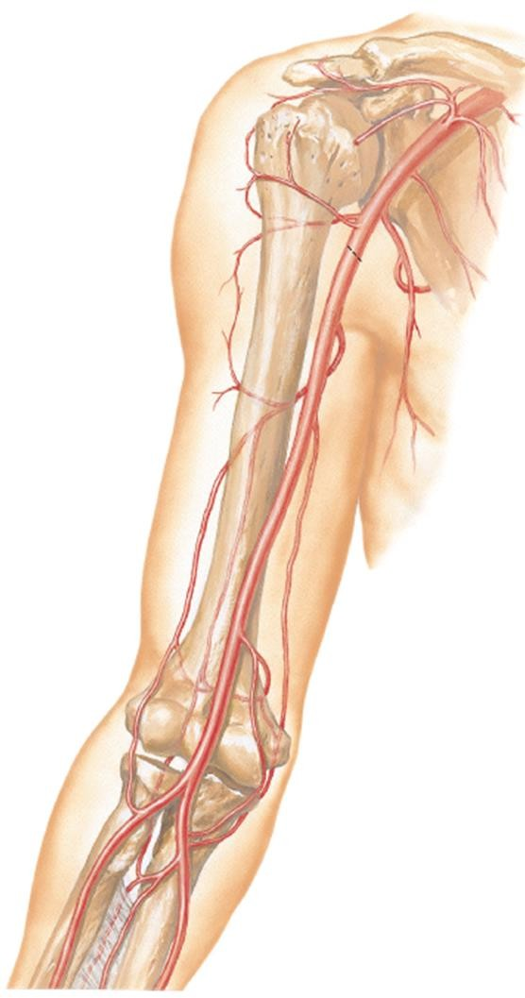

Periarticular Arterial Anastomoses

of the Elbow Region

Anterior View

br.s of brachial a., deep art. of arm, radial & ulnar a.s:

**Middle collat. a.**

|  |  |  |
| --- | --- | --- |
| **Branches of brachial a.** | **Branches of ulnar a.** | **Branches of radial a.** |
| Middle collateral a. | Recurrent interosseous  a. (RIA) |  |
| Radial collateral a. |  | Radial recurrent a. |
| Sup. ulnar  collateral a. | Post. Ulnar  recurrent a. |  |
| Inf. ulnar collateral a | Ant. Ulnar recurrent a. |  |

**Radial**

**collat. a.**

**RIA RRA**

**Sup. ulnar collat. a.**

**Inf. ulnar collat. a.**

**AURA PURA**

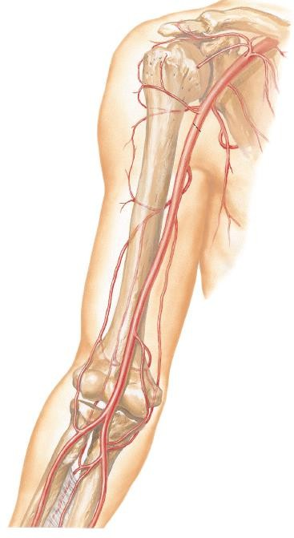

**Posterior**

**interosseous artery**

**Anterior ulnar recurrent artery**

**Recurrent interosseous artery**

**Anterior**

**view**

**Brachial artery**

**Radial recurrent artery**

**Ulnar artery**

**Superior ulnar collateral artery**

**Common interosseous artery**

**Inferior ulnar collateral**

**artery**

**Anterior interosseous artery**

**Posterior ulnar recurrent artery**

|  |  |  |
| --- | --- | --- |
|  | **ARTERIES** | |
| **Ulnar artery** | **Radial artery** |
| Descends in  forearm | Descends medially between  FDS & FDP. | Descends laterally deep  to brachioradialis. |
|  | Crossed by median nerve. | - |
| At distal forearm | Becomes superficial. Lateral to ulnar nerve. | Superficial. Lateral to FCR tendon. |
| Accompanied by | Ulnar nerve. | - |
| Enters hand | By passing through ulnar canal (Guyon’s canal). | Winds around lateral aspect of wrist to cross the floor of the anatomical snuff box. |

Supracondylar Humerus Fracture

* Sudden, complete occlusion or laceration of brachial a. can result in **ischaemia** of muscles in forearm
* Collateral circulation cannot compensate for the sudden occlusion

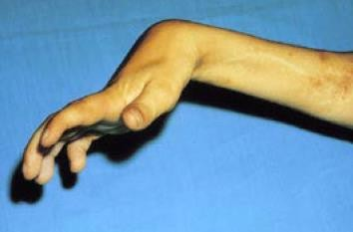

* Can lead to **necrosis** of muscles in forearm → **fibrous scar tissue** replaces necrotic tissue → affected muscles shorten permanently → **flexion deformity** - **flexion of fingers & wrist**
* Ischaemic compartment syndrome

**(Volkmann or ischaemic contracture)**

Supracondylar Humerus Fracture

* Muscle in deep layer of anterior compartment of forearm is most prone to a compartment syndrome because radial & ulnar artery runs in the neurovascular plane
* Tsuge has classified deformities of Volkmann ischaemic contracture into 3 types:
  1. The mild (localised) type
  2. The moderate (classic) type
  3. The severe type

# The Mild Type

* + The flexors are involved and the extensors are spared
  + Clinically, there is flexion contracture of the fingers. Sometimes the thumb is involved

Supracondylar Humerus Fracture

# The moderate (classic) type

* + the flexors of the fingers, thumb and wrist are involved.

The extensors are spared.

* + Clinically, there is flexion contracture of all fingers and wrist

# The severe type

* + the flexors of the fingers, thumb and wrist are involved,

and the extensors are involved partially.

* + Clinically, the wrist joint is flexed, the MCPJ is extended & the IPJs are flexed

Example Essay Questions

1. Describe the anterior compartment of forearm. Describe the muscles present within this compartment with regards to their innervation and action
2. Describe the posterior compartment of forearm. Describe the muscles present within this compartment with regards to their innervation and action
3. Describe the radial & ulnar artery and their branches

References

* 1. Clinically Oriented Anatomy. 7th edition. 2014. Keith L. Moore, Anne M. R. Agur & Arthur F. Dally. Lippincott Williams & Wilkins.
  2. Atlas of Human Anatomy. 4th edition. 2006. Frank H. Netter. Saunders Elsevier.
  3. Clinical Anatomy by Regions. 9th edition. 2012. Richard

S. Snell. Lippincott Williams & Wilkins.