Outline

1. Arm
   1. Anterior Compartment
   2. Posterior Compartment
2. Cubital Fossa
3. Brachial Art.
4. Periarticular Arterial Anastomoses of the Elbow Region
5. Veins of Arm
6. Clinical Correlation

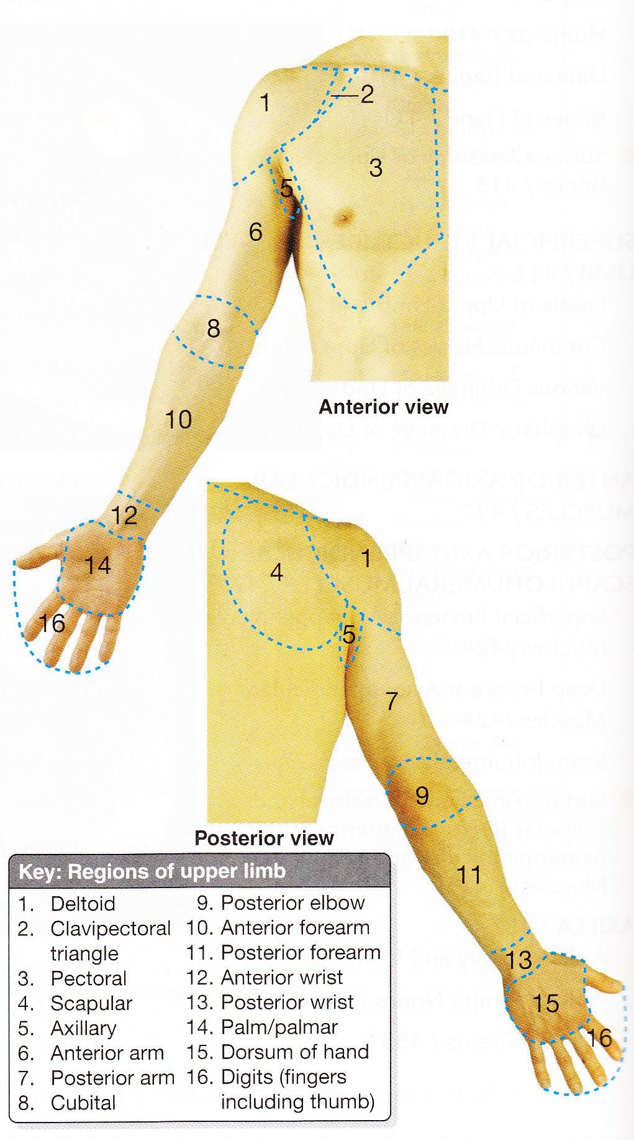

Arm

* Upper limb (UL) consists of 4 segments:

**Deltoid 1**

**region 3 Pectoral**

**region**

**Anterior view**

**Scapular**

**4 1 region**

**Posterior view**

**6**

1. Shoulder
2. Arm
3. Forearm
4. Hand

# Arm

**7**

* + 1st segment of UL.
  + Extends from shoulder to elbow.
  + Consists of:

1. Anterior region of arm (6)
2. Posterior region of arm (7)

**Anatomical neck**

Humerus

**Greater tubercle**

**Intertubercular**

**groove**

**Head Lesser**

**tubercle**

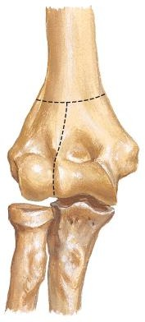

**Surgical**

**neck**

**Radial**

**fossa Coronoid**

**fossa**

**Deltoid**

**tuberosity**

**Lateral supra- condylar ridge**

**Capitulum**

**Head of radius**

**Anterior**

**View**

**Medial supra- condylar ridge**

**Trochlea**

**Coronoid process**

**Right elbow**

**Lateral epicondyle**

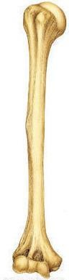

**Medial epicondyle**

**Head**

**Greater**

**tubercle**

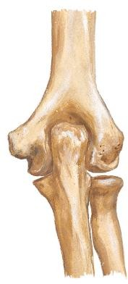

**Medial**

**epicondyle**

**Olecranon**

**fossa**

**Olecranon**

Humerus

**Anatomical**

**neck**

**Surgical neck**

**Radial groove**

**Deltoid tuberosity**

**Posterior View**

**Olecranon**

**fossa**

**Trochlea**

**Right elbow**

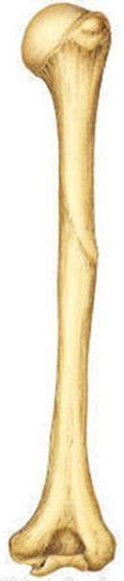



**Olecranon Trochlear notch**

Ulna

**Coronoid process**

**Ulnar tuberosity**

**Olecranon Trochlear notch**

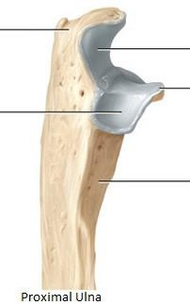

**Anterior View of Ulna**

**Coronoid**

**Radial**

**notch**

**process**

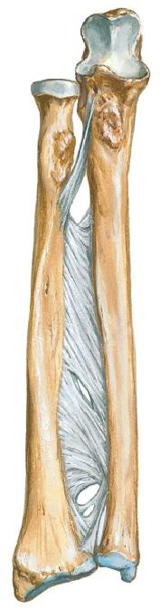

**Lateral View of proximal ulna**

**Head of ulna Styloid process**

**Anterior View of Radius**

Radius

**Head**

**Neck Radial**

**tuberosity**

**Inferior View of Distal**

**End of Radius & Ulna**

**Ulnar notch**

**Ulna**

**Radius**

**Interosseous**

**border**

**Interosseous membrane**

**For scaphoid**

**For lunate**

**Styloid process**

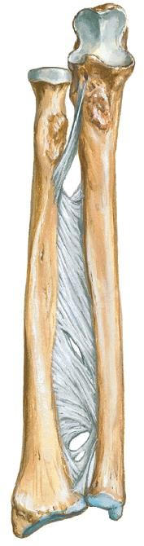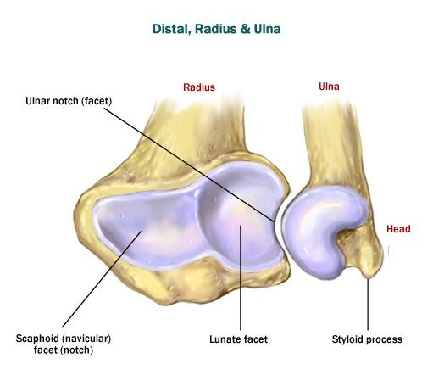

**Styloid process**

Arm

* Muscles in arm & forearm can be grouped into **compartments**
* Muscles in same compartment have similar:

1. Function
2. Innervation (with some exceptions)
   * Muscles in arm divided into **2 compartments** by humerus & medial & lateral **intermuscular septae**:
3. Anterior (flexor)
4. Posterior (extensor)

**Anterior compartment**

**Lat. IM septum**

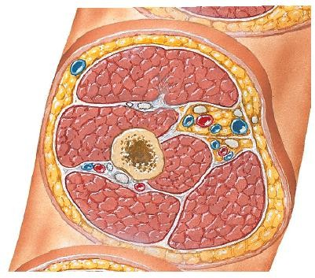

**Posterior**

**compartment**

**Medial IM septum**



Middle Cross-section of Arm

Anterior Compartment of Arm

# 3 muscles:

1. Biceps brachii
2. Coracobrachialis
3. Brachialis

# Action:

* + - Flexion of forearm at elbow joint

# Innervation:

**Brachialis**

**Coraco-**

**brachialis**

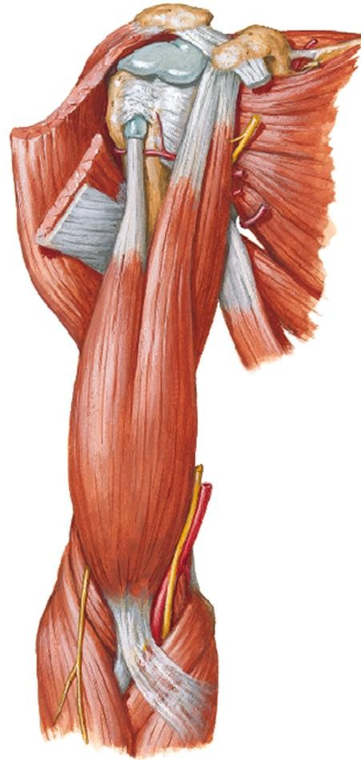

**Biceps brachii**

* + - Musculocutaneous nerve

Anterior View



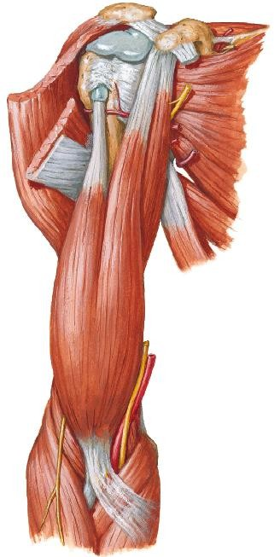

1) Biceps Brachii

**Long**

|  |  |  |
| --- | --- | --- |
|  | **Short head** | **Long head** |
| **PA** | Coracoid process (scapula) | Supraglenoid tubercle (scapula) |
| **DA** | 1. Radial tuberosity (via   **biceps tendon**)   1. Fascia of forearm (via   **bicipital aponeurosis**) | |
| **Act- ion** | 1. **Supinates** forearm (elbow flexed 90˚, forearm pronated- drive screw) 2. **Flexes** forearm | |

**head**

**Biceps tendon**

**Coracoid process**

**Biceps brachii**

Anterior View

**Bicipital**

**aponeurosis**

1) Biceps Brachii

## Tendon of Long Head

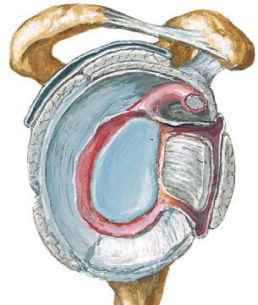

**Cavity of gleno- humeral joint**

Enter cavity of **glenohumeral joint** (GHj) & surrounded by synovial membrane

Supraglenoid tubercle (scapula)

**Tendon of long head of biceps**

Lateral view



**Transverse humeral ligament**

**Tendon of long head of biceps**

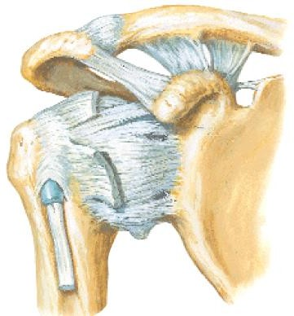

Anterior

View

Descend in **intertubercular groove of humerus** (held by **transverse humeral ligament**) & exit GHj

Cross head of humerus

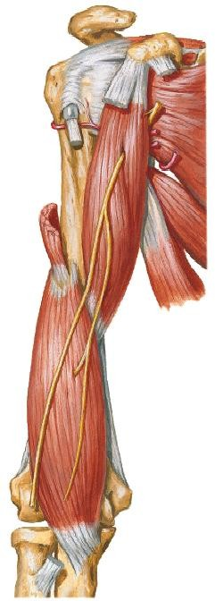

2) Brachialis

* + **Location** – Deep to biceps brachii

**Humerus**

|  |  |
| --- | --- |
| **PA** | Distal ½ of ant. Surface of humerus |
| **DA** | Coronoid process & ulnar tuberosity (ulna) |
| **Action** | Flexes forearm.  Most powerful  flexor |

**Brachialis**

Anterior View



3) Coracobrachialis

* + **Location** – superomedial part of arm
  + Pierced by **musculocutaneous n.**

**Coracoid process**

**Musculo-**

|  |  |
| --- | --- |
| **PA** | Coracoid process (scapula) |
| **DA** | Middle of medial humerus |
| **Action** | Flex & adduct **arm** (at shoulder jt) |

**cutaneous n.**

**Coraco-**

**brachialis**



Anterior View



Anterior Compartment of Arm

**Coraco- brachialis**

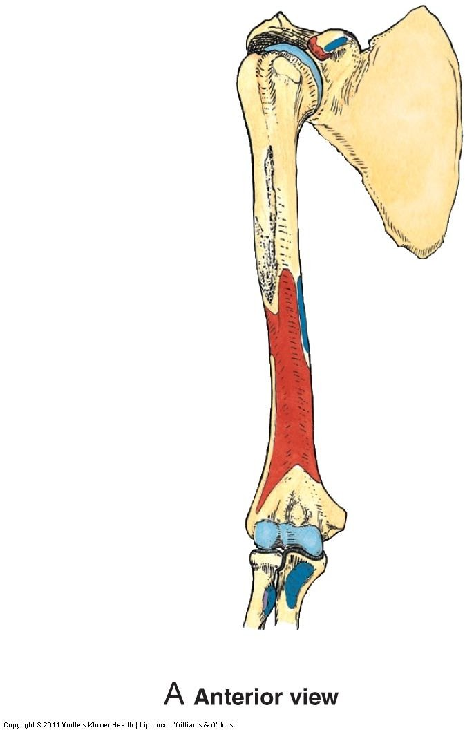

**Brachialis**

Anterior View

Posterior Compartment of Arm

# 2 muscles:

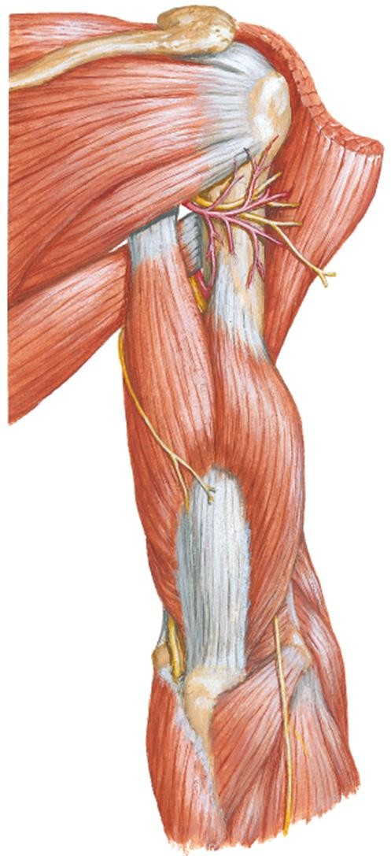

1. Triceps brachii
2. Anconeus

# Action:

* + - Extension of forearm at elbow joint

# Innervation:

* + - Radial nerve

**Anconeus**

**Triceps brachii**

Posterior View



1) Triceps Brachii

**Long**

|  |  |  |  |
| --- | --- | --- | --- |
|  | **Long head** | **Lateral head** | **Medial head** |
| **PA** | Infra- glenoid tubercle (scapula) | **Sup.** To **radial groove** on post. surface humerus | **Inf.** To **radial groove** on post. surface humerus |
| **DA** | Olecranon (ulna) | | |
| **Act-**  **ion** | Extend forearm | | |

**head**

**Olecranon**

**Lateral**

**head**

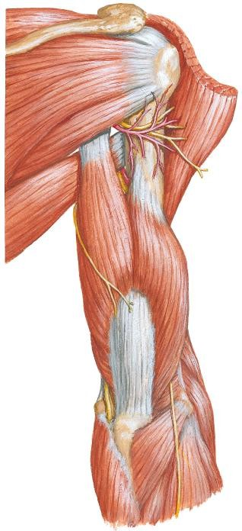



Posterior View

1) Triceps Brachii

* + Medial head is deep to long & lateral head

**Long head Radial nerve**

**Lateral head**

**Medial head**

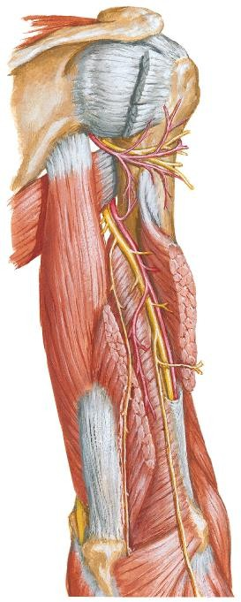

Posterior

View



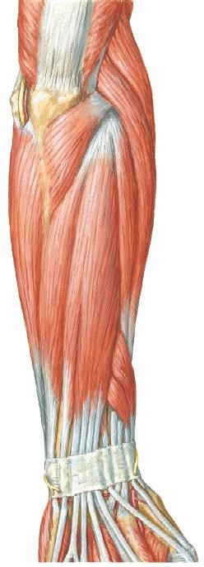

Postero- lateral View

2) Anconeus

* + Small triangular muscle
  + **Location** – posterolateral aspect of

elbow

**Anconeus**



|  |  |
| --- | --- |
| **PA** | Lateral epicondyle (humerus) |
| **DA** | Superior part of post. surface of ulna |
| **Action** | 1. Assist triceps in extending forearm 2. Stabilize elbow joint |

Cubital Fossa

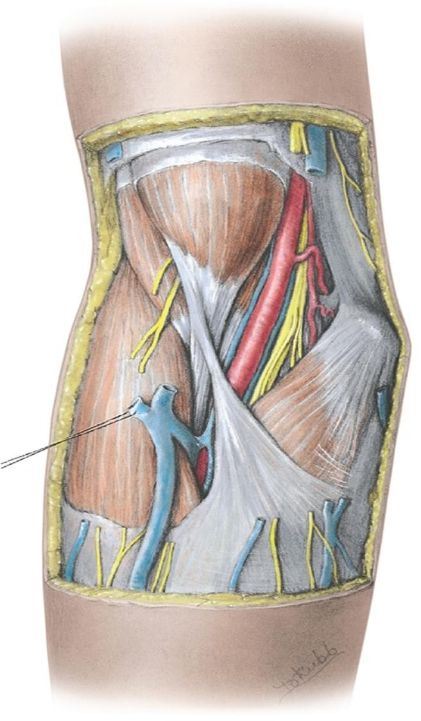

Anterior

View

Cubital Fossa

* Space filled with fat

## Location:

* + Anterior to distal part of humerus & elbow joint
* **Shape** - ∆
* 3 boundaries:

1. Superior boundary
2. Medial boundary
3. Lateral boundary

* Floor
* Roof

Cubital Fossa

# Superior Boundary

* + An imaginary line connecting medial & lateral epicondyles (humerus)

**Medial**

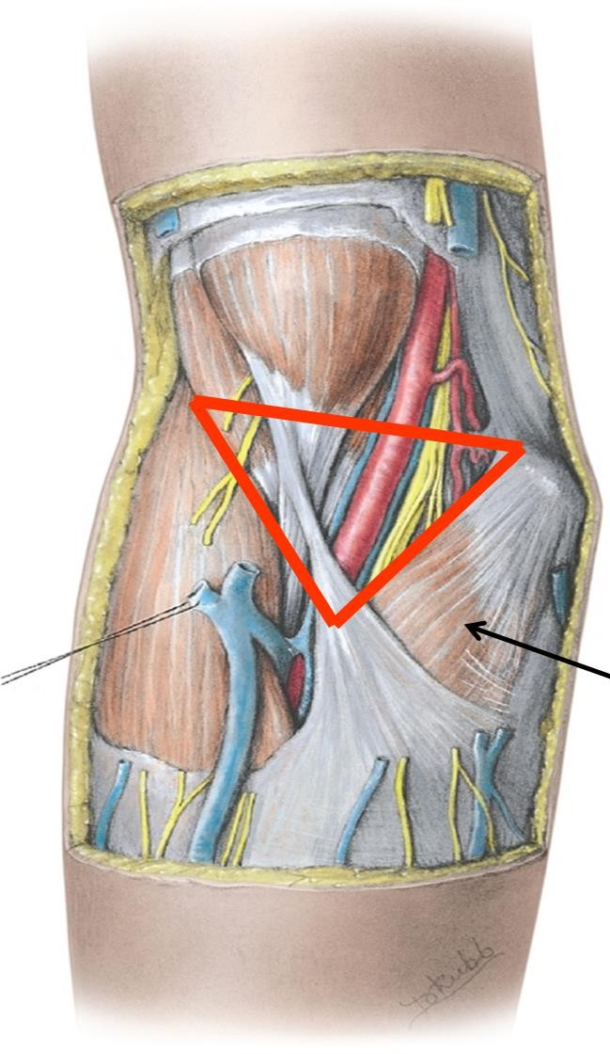

**epi-**

**S condyle**

# Medial Boundary

* + Pronator teres

# Lateral Boundary

* + Brachioradialis

**L**

**Brachio-**

**radialis**

**M**

**Pronator teres**

Anterior View

Cubital Fossa

# ​Floor

1. Brachialis
2. Supinator

**Brachialis**

**Biceps**

**brachii**

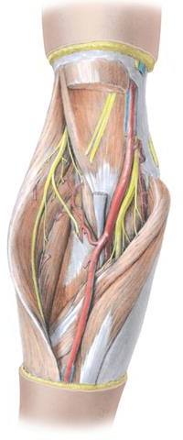

**Supinator**

Anterior View

Cubital Fossa

## Roof

1. Brachial, antebrachial **fascia** & bicipital **aponeurosis**

## Subcutaneous tissue

* 1. Median cubital **vein**
  2. Medial & lateral cutaneous **nerves** of forearm

## Skin

**Skin**

**Brachial fascia**

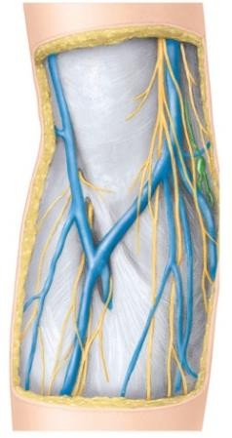

**Lat.**

**Cutaneous**

**n. forearm**

**Ante- brachial fascia**

Anterior View

**Sub- cutaneous tissue**

**Medial**

**Cutaneous**

**n. forearm**

**Median cubital v**

**Bicipital apo- neurosis**

Cubital Fossa

## Contents (from lateral to medial)

1. **Radial n.**
   * Beneath brachioradialis
   * Divides into superficial &

deep br.

## Tendon of biceps brachii

1. **Brachial art.** (& accompanying **veins**)
   * Terminal part of brachial art. & commencement of its terminal branches

## Median n.

**Radial n.**

**Deep br. Super-**



**ficial br.**

**Median**

**n.**

**Brachial**

**a.**

**Ulnar a. Radial a.**

Anterior View

Brachial Artery

Brachial Artery

* **Main** arterial supply to arm
* Continuation of **axillary art.**
* Begins at inferior border of

## teres major

* From medial side of upper part of arm, it runs inferolaterally in the **medial bicipital groove** to the cubital fossa
* Accompanies **median n.** In

the middle of the arm, median

n. **crosses** brachial art., from lateral to medial side

**Median n.**

**Teres major**

**Brachial a.**

**Median n. crosses brachial a.**

Anterior View

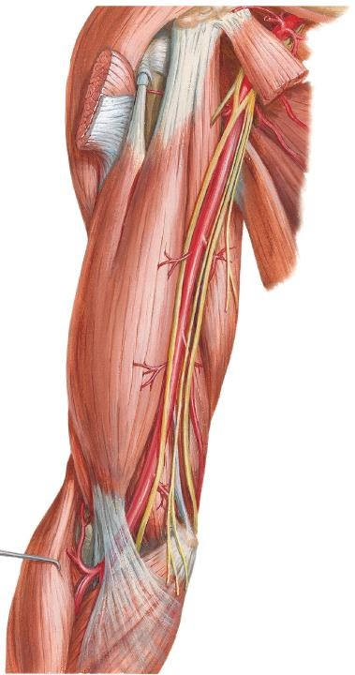



Brachial Artery

## Relations in the Upper ARM:

1. **Laterally**
   * Biceps & median n.

## Medially

* + Upper part of arm - medial cutaneous nerve of arm & ulnar n.
  + Lower part of arm – median nerve

## Posteriorly

* + triceps, radial n.

**Coraco- brachialis**

**Biceps**

**Brachial a.**

**Ulnar n.**

**Triceps**

**Brachialis**

Anterior

View





Brachial Artery

## Relations in the Cubital Fossa:

1. **Laterally**
   * tendon of biceps

## Medially

* + Median n.

## Posteriorly

* + Brachialis

## Anteriorly

* + Bicipital aponeurosis
  + Median cubital vein
  + Fascia & skin

**Coraco- brachialis**

**Biceps**

**Brachial a.**

**Ulnar n.**

**Triceps**

**Brachialis**

Anterior

View





Brachial Artery

* In the cubital fossa, it is covered by **bicipital aponeurosis** & **median cubital vein** (anterior relations)
* **Ends** by dividing into radial & ulnar arteries in cubital fossa

## Main branches:

1. Deep artery of the arm
2. Humeral nutrient a.
3. Superior & inferior ulnar collateral arteries

Anterior View

**Radial a.**

**Deep a. of arm**

**Sup. ulnar**

**collat. a.**

1. **terminal branches** - ulnar & radial art



**Bicipital**

**aponeurosis**

Brachial Artery

## Deep art. of arm

* + Profunda brachii art.
  + The first & largest branch
  + Accompanies **radial nerve**
  + Passes **posteriorly** through **lower triangular space** – descends along **radial groove** of humerus
  + **Terminates** by dividing into **middle & radial collateral art.s** (participate in the periarticular arterial anastomoses of the elbow region)

**Radial n.**

**Middle collat. a.**

Posterior View

**Deep a. of arm**

**Radial collat. a.**



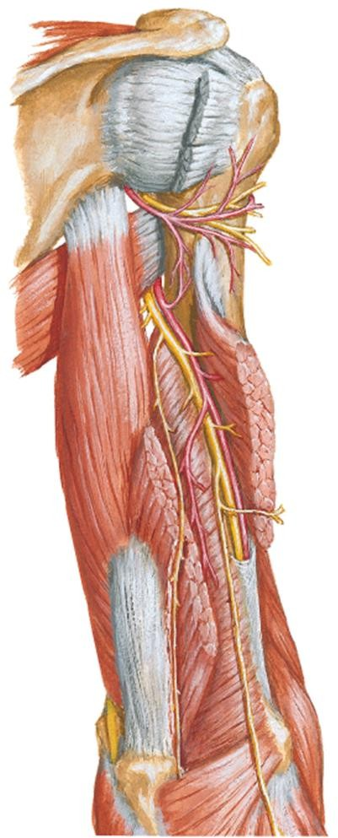

Periarticular Arterial Anastomoses

of the Elbow Region

* + Anastomoses around the elbow

joint exists between br.s of brachial

a. & br.s of radial & ulnar a.s:

## Branches of brachial a.:

* 1. Middle & radial collateral a.s (br.s of deep artery of arm)
  2. Superior & inferior ulnar collateral a.s (br.s of brachial a.)

## Branches of radial & ulnar a.s. Recurrent br.s from the:

* 1. **Radial art** – radial recurrent a.

**Middle**

**collat. a.**

**Radial**

**collat. a.**

**Sup. ulnar collat. a.**

**Inf. ulnar collat. a.**

* 1. **Ulnar art** – ant. & post. ulnar recurrent art.s & recurrent interosseous a.

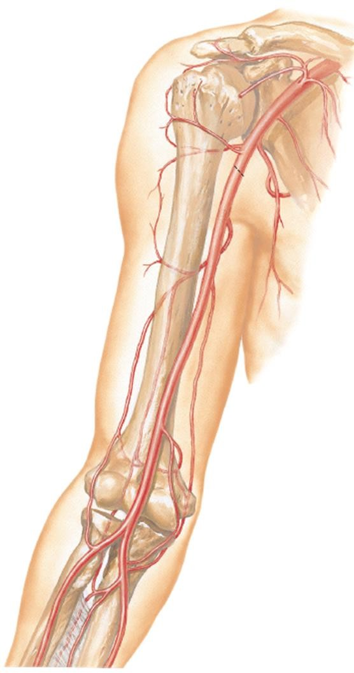

**Radial a.**

Anterior View

Veins of Arm

Veins of Arm

* 2 sets of veins of the arms:

## Superficial Veins (SVs)

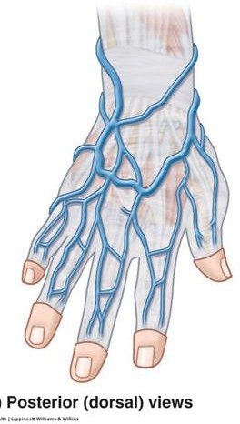

* + In subcutaneous tissue
  + 2 main SVs – cephalic & basilic v.s
  + Originate from **dorsal venous network** (DVN) on the dorsum of hand

## Deep veins (DVs)

* + Paired. Accompany arteries as venae

comitantes & having similar names

* SVs & DVs anastomose freely with each

other via **perforating veins**

* Have valves

**Dorsal Venous Network**

Superficial Veins of Upper Limb

## Cephalic vein

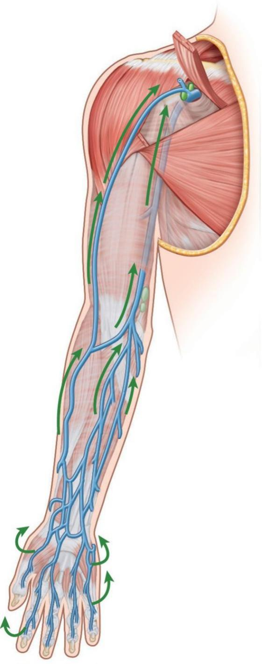

From **lateral** end of **DVN**

Ascends along **lateral** border

of **wrist**

**Cephalic v.**

**Anterolatera**l surface of

**forearm** & **arm**

Ascend between deltoid &

pectoralis major (in

**deltopectoral groove**)

Enters **clavipectoral triangle**

Join **axillary vein**

Palmar View

Superficial Veins of Upper Limb – Cephalic Vein

* Between pectoralis major & deltoid is **deltopectoral groove**.

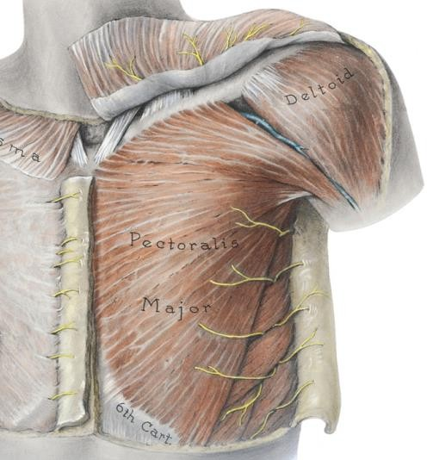

* Superiorly, groove widens into triangular-shaped space - **deltopectoral (clavipectoral) triangle**. Cephalic vein enters it & pierces fascia beneath it.

**Deltopectoral triangle**

**Deltoid**

**Cephalic v.**

**Delto- pectoral groove**

**Pectoralis major**

**Anterior view**

Superficial Veins of Upper Limb

**Basilic vein**

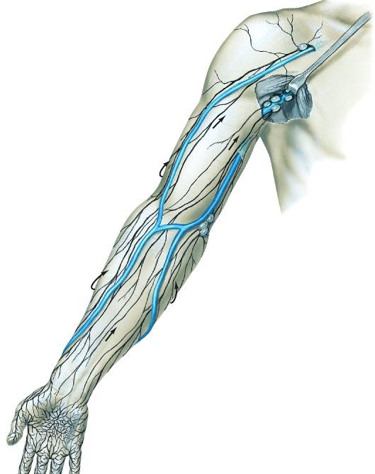

**Basilic v.**

**Median cubital v.** passes obliquely across **cubital fossa**, joining the cephalic & basilic v.s

Palmar View

From **medial end** of **DVN**

Ascends along **medial** side of

**forearm** & **arm**

**Pierce** brachial fascia at lower part of arm

Ascend towards **axilla**

Merges with brachial v. to form

**axillary v**.

Clinical Correlation

Supracondylar Fractures of the Humerus

Supracondylar Humerus Fracture

* Most common type of elbow injury in **children** (more common in children because thinner cortex in children)

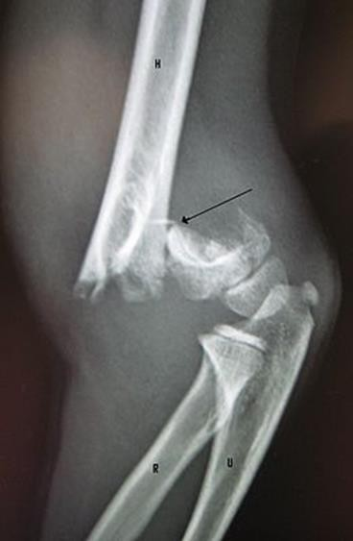

* Occurs more frequent in children after a fall on an **outstretched hand**
* The most common **complication** associated with **displaced** supracondylar fractures is **neuropraxia**
* The median nerve, specifically the **anterior interosseous nerve** (52%) and **radial nerve** (32%) are most frequently injured - due to **stretching** or **compression** of the nerve

Supracondylar Fractures of the Humerus

* 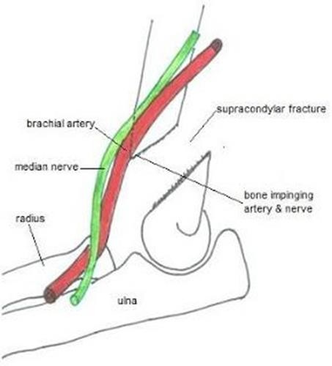**Vascular injury** can also occur in supracondylar fractures
* **Brachial a.** can be:
  + stretched or kinked (occluded) over the displaced bone fragments
  + partially lacerated or transected
* **Arterial anastomosis** around the **elbow** provide important **collateral circulation** if the occlusion is gradual, temporary & partial.
* Ulnar & radial art.s will still receive sufficient blood from **deep art. of arm** through anastomosis around the elbow

Supraepicondylar Humerus Fracture

* Sudden, complete occlusion or laceration of brachial a. can result in **ischaemia** of muscles in forearm
* Collateral circulation cannot compensate for the sudden occlusion

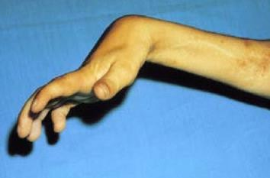

* Muscles can only tolerate up to 6 hours of ischaemia → **necrosis** of muscles → **fibrous scar tissue** replaces necrotic tissue → fibrous tissue of involved muscles contracts

→ muscle shorten permanently →

## flexion deformity - flexion of wrist

* Ischaemic compartment syndrome /

**Volkmann or ischaemic contracture**

Example Essay Questions

* 1. Describe the anterior and posterior compartments of arm. Describe the muscles present within each compartment with regards to their innervation and action
  2. Describe the brachial artery with regards to its origin, course, relations in the arm and cubital fossa and branches
  3. Briefly describe the location, boundaries and contents of the cubital fossa

References

* + 1. Clinically Oriented Anatomy. 7th edition. 2014. Keith L. Moore, Anne M. R. Agur & Arthur F. Dally. Lippincott Williams & Wilkins.
    2. Atlas of Human Anatomy. 4th edition. 2006. Frank H. Netter. Saunders Elsevier.
    3. Clinical Anatomy by Regions. 9th edition. 2012. Richard

S. Snell. Lippincott Williams & Wilkins.