Biology Foransic avidanc

First class Prof. Dr. Dina M.R.Alkhafaf

**Prokaryotic cells**

Prokaryotic cells are single-celled microorganisms known to be the earliest on earth. Prokaryotes include Bacteria and Archaea. The photosynthetic prokaryotes include cyanobacteria that perform photosynthesis.

Prokaryotes are organisms whose cells lack a nucleus and other organelles. Prokaryotes are divided into two distinct groups: the bacteria and the archaea, which scientists believe have unique evolutionary lineages. Most prokaryotes are small, single-celled organisms that have a relatively simple structure

**Archaeal Cells**

Archaebacteria are unicellular organisms similar to bacteria in shape and size

They are found in extreme environments such as hot springs and other places such as soil, marshes, and even inside humans.

**Bacterial Cells**

These are unicellular organisms found everywhere on earth from soil to the human body.

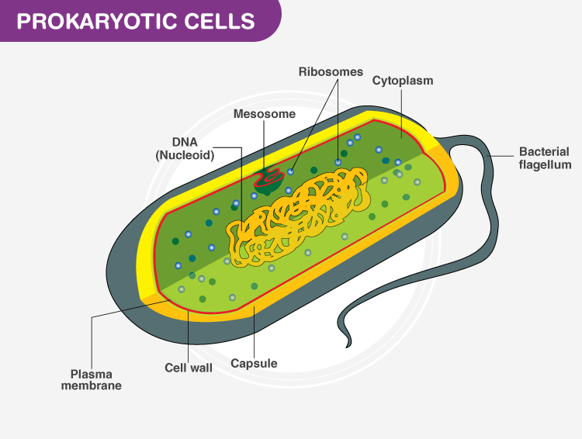

**Components of Prokaryotic Cells**

The prokaryotic cells have four main components:

Plasma Membrane- It is an outer protective covering of phospholipid molecules which separates the cell from the surrounding environment.

Cytoplasm- It is a jelly-like substance present inside the cell. All the cell organelles are suspended in it.

DNA- It is the genetic material of the cell. All the prokaryotes possess a circular DNA. It directs what proteins the cell creates. It also regulates the actions of the cell.

**Ribosomes**- Protein synthesis occurs here

Some prokaryotic cells possess **cilia** and **flagella** which helps in locomotion

**Binary Fission**

1-The DNA of an organism replicates and the new copies attach to the cell membrane

2-The cell wall starts increasing in size and starts moving inwards

3-A cell wall is then formed between each DNA, dividing the cell into two daughter cells.

**Recombination**

In this process, genes from one bacteria are transferred to the genome of other bacteria. It takes place in three ways-**conjugation, transformation, transduction.**

**Conjugation** is the process in which genes are transferred between two bacteria through a protein tube structure called a pilus.

**Transformation** is the mode of sexual reproduction in which the DNA from the surroundings is taken by the bacterial cell and incorporated in its DNA.

**Transduction** is the process in which the genetic material is transferred into the bacterial cell with the help of viruses. Bacteriophages are the virus that initiates the process.

**Bacterial Cells**

They have different shapes and structures

The cell wall is composed of peptidoglycan that provides structure to the cell wall.

Bacteria have some unique structures such as **pili, flagella** and **capsule**

They also possess extrachromosomal DNA known as **plasmids.**

They have the ability to form tough, dormant structures known as **endospores** that helps them to survive under unfavourable conditions. The endospores become active when the conditions are favourable again.

**Viruses**

Viruses are microscopic organisms that can infect hosts, like humans, plants or animals. They’re a small piece of genetic information (DNA or RNA) inside of a protective shell (capsid). Some viruses also have an envelope. Viruses can’t reproduce without a host. Some common diseases caused by viruses include the flu, the common cold and COVID-19.

**Are viruses living or nonliving?**

Viruses aren’t living organisms. But there’s some debate over this. Generally, biologists don’t consider viruses to be alive because they can’t perform the functions that living organisms do. For instance, they can’t convert food into energy (metabolism) and they can’t live or reproduce without a host cell.

On the other hand, they can reproduce in the right host cell and they evolve over time to survive. Plus, they can damage and destroy host cells to do so. Because of this, many consider them a “gray area” between living and nonliving things.

Viruses are small germs (pathogens) that can infect you and make you sick. They can infect humans, plants, animals, bacteria and fungi. Each one infects only specific types of hosts.

Viruses share some common features:

1-Are made up of genetic material (RNA or DNA) and a protective protein coating (capsid).

2-Sometimes have another layer called an envelope around the capsid. Viruses without an envelope are called “naked viruses".

3-Are similar to parasites — they need a host to reproduce. They’ll survive outside of a host until their capsid breaks down over time.

4-Are 100 to 1,000 times smaller than the cells in your body.

Experts group viruses into categories — like family and genus — based on similar features, like size, shape and the type of genetic material they carry. Some common types of viruses that you might hear about include:

Influenza viruses , Human herpesviruses , Coronavirus , Human papillomaviruses , Enteroviruses and others.

**Viruses have several steps to infecting cells and reproducing**. They include:

1-Attachment

2-Entry

3-Replication

4-Assembly

5-Releas

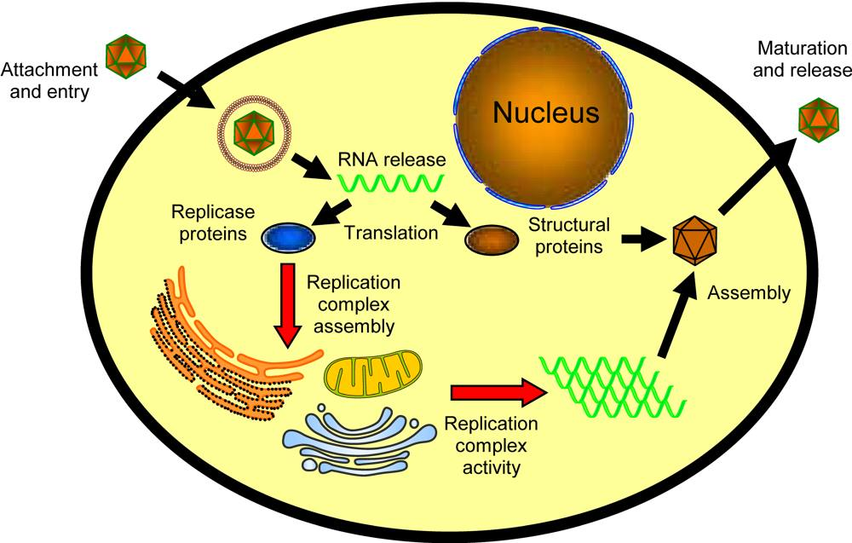

Viruses can look very different from each other. Scientists often described them by shape. Types of virus shapes include:

**Icosahedral or polyhedral.** This is a geometric shape with many sides, similar to a soccer ball. Most viruses that infect people are icosahedral.

**Helical**. This virus shape looks like a cylinder. Its genetic information is coiled up like a spring inside

Spherical. Spherical viruses are helical or polyhedral viruses that have an envelope around them. They’re shaped mostly like a ball

**Complex**. Complex viruses combine more than one shape. Viruses that infect bacteria have a polyhedral “head” con Enteroviruses nected to a helix “body".

