Biology Foransic avidance

First class Prof. Dr. Dina M.R.Alkhafaf

**Cell biology**

**Cell biology is a branch of biology, which is mainly involved with the study of the cell, its types, structure, functions, and its interaction with other cells. Cell biology is also called cytology and is derived from the Greek word "ketos", meaning vessel. The prefix cyto means 'cell' and suffix logy means study of.**

**Cell Theory**

Every living organism is composed one or more cells

1-A cell is the basic unit of life

2-All living organisms are made up of cells

3-All cells arise from pre-existing cell

The small size of cells means that are measured by micrometer ( m) . Amicrometer is 1/1000 millimeters (mm). Cells cannot be seen with the naked eye, so we used light and electron microscoped

Eukaryotic cells, in the realm of cellular biology, are distinguished by a set of defining characteristics that set them apart from their prokaryotic counterparts. These intricate and highly organized cells, constituting the building blocks of complex multicellular organisms, exhibit several hallmark features

**1-Nucleus:** The nucleus, enclosed within a double membrane, serves as the repository of genetic material in the form of linear DNA. This pivotal organelle orchestrates gene expression and houses the genetic information necessary for cellular functions

**2-Membrane-bound organelles**: Eukaryotic cells contain a multitude of membrane-bound organelles, including the endoplasmic reticulum, Golgi apparatus, mitochondria, and chloroplasts in plant cells. Each of these organelles has distinct functions, contributing to diverse cellular processes

**3-Complex cytoskeleton**: Eukaryotic cells are underpinned by a complex cytoskeleton composed of microtubules, microfilaments, and intermediate filaments. This intricate network provides structural support, facilitates intracellular transport, and enables cell motility

**4-Compartmentalization**: Eukaryotic cells exhibit compartmentalization, which involves the segregation of various cellular functions into distinct organelles. This allows for specialization and optimization of processes, enhancing cellular efficiency

**5-Mitosis and meiosis**: Eukaryotic cells engage in mitosis, enabling cell division for growth and tissue repair, and meiosis, which is vital for sexual reproduction. These processes ensure genetic diversity and accurate inheritance of genetic material

**6-Endocytosis and exocytosis**: Eukaryotic cells possess the ability to internalize extracellular substances through endocytosis and expel materials through exocytosis, essential for nutrient uptake, waste removal, and cellular communication

**7-Linear chromosomes**: Eukaryotic organisms feature linear chromosomes as opposed to the circular DNA characteristic of prokaryotes. This linear DNA is packaged into chromatin, a complex of DNA and histone proteins.

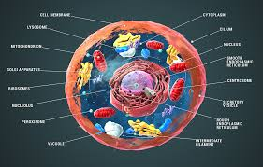

**Eukaryotic cell**

Eukaryotic cells, as the fundamental units of complex life forms, showcase a level of structural organization and compartmentalization that is unparalleled in the biological world. This intricate and highly specialized structure is essential for the execution of a wide spectrum of biological processes, allowing eukaryotic cells to adapt, respond, and thrive in diverse environments and conditions

Cell membrane: The cell membrane, often referred to as the plasma membrane, encases the cell in a phospholipid bilayer studded with various proteins. This semipermeable barrier serves as the cell’s first line of defense, governing the selective passage of molecules, ions, and nutrients in and out of the cell. It also participates in cell adhesion and signal transduction, making it a critical interface for cellular interactions

**Cytoplasm**: Within the cell’s boundaries lies the cytoplasm, a semi-fluidmedium that encompasses all cellular organelles. It is primarilycomposed of cytosol, a gel-like substance containing water, ions, and a myriad of organic molecules. The cytoplasm is the stage for numerous intracellular processes and metabolic reactions

**Nucleus**: Often referred to as the cell’s command center, the nucleus houses the genetic material in the form of chromosomes. It is the epicenter of genetic regulation and cellular control. The nucleus manages essential processes, including DNA replication, transcription, and the intricate orchestration of gene expression

**Endoplasmic reticulum (ER):** The ER is a membranous network of interconnected sacs and tubules responsible for protein synthesis, lipid metabolism, and the detoxification of drugs and poisons. It comes in two forms: the rough ER, adorned with ribosomes for protein synthesis, and the smooth ER, which plays a pivotal role in lipid metabolism

**Golgi apparatus**: Golgi apparatus, a cellular structure akin to stacked membranes, serves as a hub for processing and packaging proteins and lipids. It transforms, organizes, and dispatches these biomolecules within transport vesicles, directing them to their specific intracellular endpoints

**Mitochondria**: Often dubbed the cell’s powerhouse, mitochondria are the sites of cellular respiration, where energy in the form of adenosine triphosphate (ATP) is produced. Their double-membraned structure houses the electron transport chain, converting nutrients and oxygen into energy

**Lysosomes**: Lysosomes are membrane-bound vesicles filled with enzymes that facilitate the degradation of cellular waste, damaged organelles, and foreign invaders. They play a vital role in cellular recycling and waste management

**Peroxisomes**: These organelles contain enzymes crucial for lipid metabolism and the detoxification of harmful substances, such as hydrogen peroxide, via enzymatic reactions

**Cytoskeleton**: The cytoskeleton is an intricate network of microfilaments, microtubules, and intermediate filaments. It providesstructural support to the cell, contributing to its shape and aiding in cellular locomotion, intracellular transport, and cell division

**Vacuoles**: In plant cells, vacuoles are large, membrane-bound organelles responsible for storing water, ions, and nutrients. They contribute to turgor pressure, maintaining cell rigidity. In some animal cells, smaller vacuoles are involved in intracellular digestion

**Centrosome**: The centrosome contains a pair of centrioles and is pivotal in organizing microtubules during cell division, ensuring the proper segregation of chromosomes

**Nuclear envelope**: Surrounding the nucleus, the nuclear envelope consists of a double membrane that separates the nucleus from the cytoplasm. It controls the passage of molecules between the nucleus and cytoplasm, thereby safeguarding the genetic material

**Nucleolus**: Housed within the nucleus, the nucleolus is responsible for ribosome production. It assembles ribosomal RNA (rRNA) and ribosomal proteins into functional ribosomes

The structural complexity of eukaryotic cells, along with the multifaceted functions of their organelles, forms the foundation of biological processes. This intricate organization enables eukaryotic cells to perform an extensive array of tasks, ranging from energy generation to genetic regulation, making them the indispensable and versatile units of life within multicellular organisms. Their capacity for compartmentalization, regulation, and adaptability underscores the extraordinary complexity of life at the cellular level....

**Eukaryotic cell vs. Prokaryotic cell**

Eukaryotic and prokaryotic cells represent two fundamental paradigms in the realm of cellular biology, each distinguished by intricate structural and organizational disparities, reflecting their unique evolutionary trajectories and biological complexities.

Eukaryotic cells, comprising the cells of animals, plants, fungi, and protists, are characterized by a wealth of subcellular structures enclosed within a double-membraned nucleus, a defining feature. The presence of membrane-bound organelles, such as mitochondria, endoplasmic reticulum, Golgi apparatus, and lysosomes, underscores their metabolic diversity and functional specialization. Eukaryotic cells also encompass a dynamic cytoskeleton, fostering intracellular transport and maintaining structural integrity. The nucleocytoplasmic compartmentalization allows for precise regulation of gene expression, resulting in increased complexity and adaptability. Eukaryotic cells exhibit enhanced cellular diversity and exhibit the capacity for multicellularity, contributing to the formation of complex organisms.

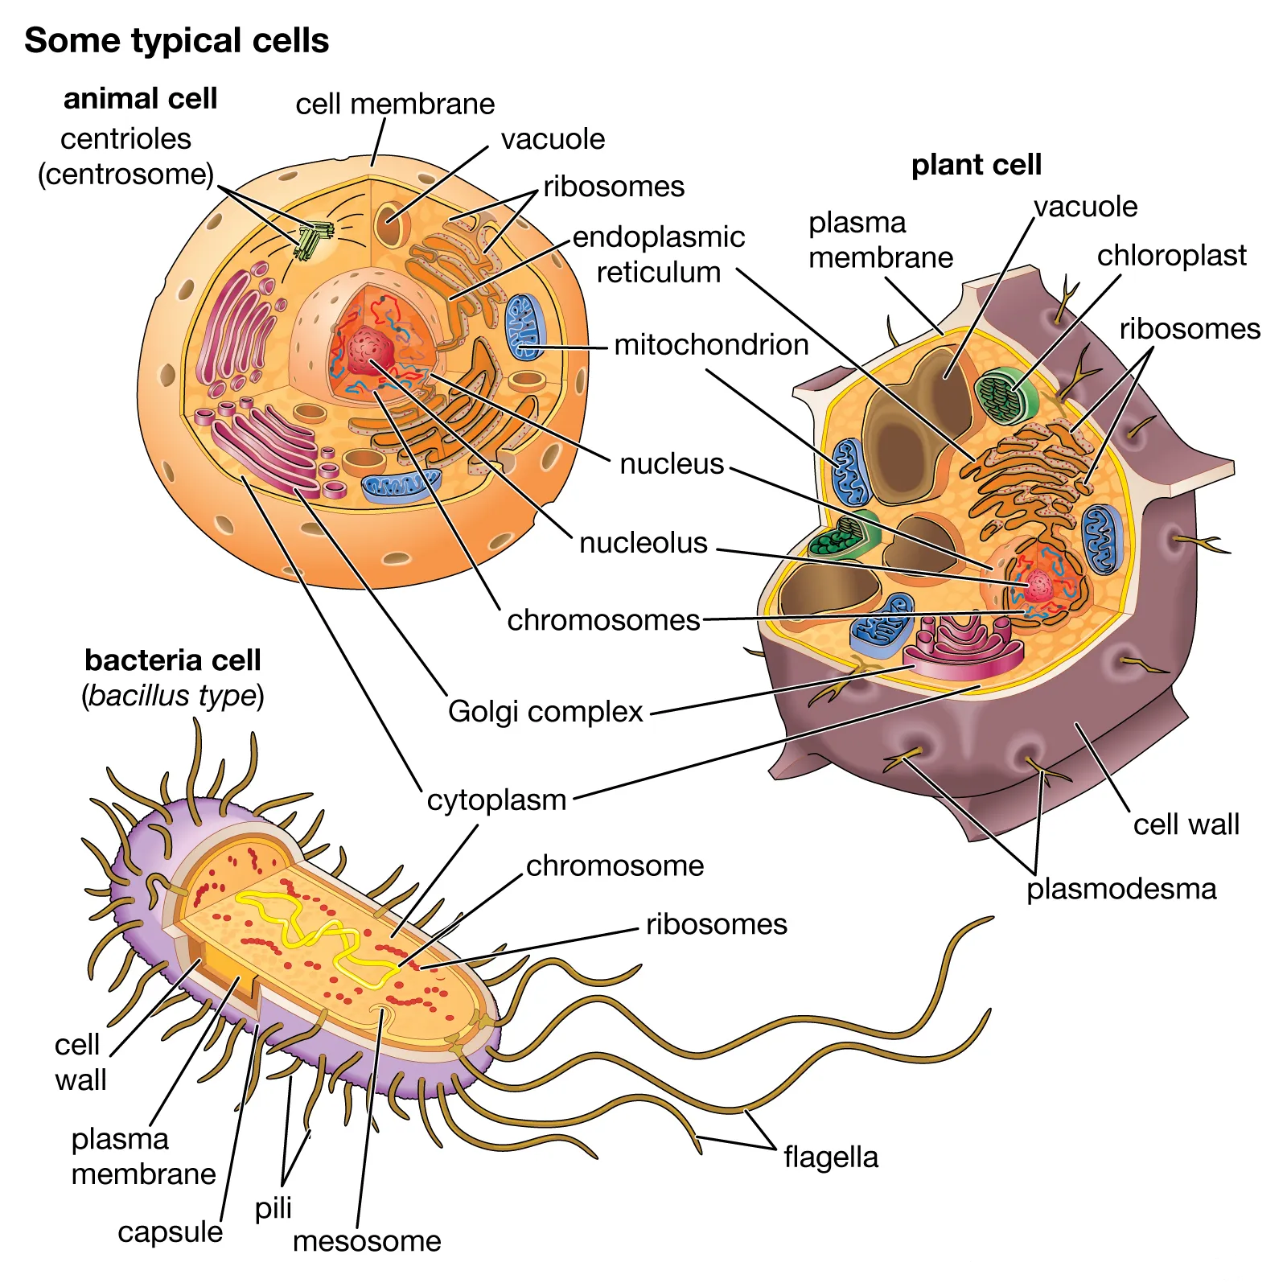

**Examples of eukaryotic cell**

Eukaryotic cells, the fundamental building blocks of multicellular organisms, exhibit remarkable diversity and specialization, each tailored to serve specific functions within the intricate biological machinery. These cells encapsulate a wide array of specialized structures and processes, contributing to the remarkable complexity and adaptability of living organisms. Let’s delve further into some notable examples of eukaryotic cells and their functions

**Neurons (Nerve Osteocytes (Bone cells) cells**

**Cardiomyocytes (Heart muscle cells)**

**Hepatocytes (Liver cells)**

**Adipocytes (Fat cells)**

**Epithelial cells**

**Leukocytes (White blood cells)**

**Ovum (Egg cell)**

