**Biology Foransic avidance**

**First class Prof. Dr. Dina M.R.Alkhafaf**

**The Cell Membrane**

**A. Structure**

The bacterial cell membrane, also called the cytoplasmic membrane, is visible in electron micrographs of thin sections It is a typical “unit membrane” composed of phospholipids and upward of 200 different kinds of proteins Proteins account for approximately 70% of the mass of the membrane, which is a considerably higher proportion than that of mammalian cell membranes. The membranes of prokaryotes are distinguished from those of eukaryotic cells by the absence of sterols, the only exception being mycoplasmas that incorporate sterols, such as cholesterol, into their membranes when growing in sterol-containing media

**B. Function**

The major functions of the cytoplasmic membrane are (1) selective permeability and transport of solutes; (2) electrontransport and oxidative phosphorylation in aerobic species; (3) excretion of hydrolytic exoenzymes; (4) bearing the enzymes and carrier molecules that function in the biosynthesis of DNA, cell wall polymers, and membrane lipids; and

(5) bearing the receptors and other proteins of the chemotactic and other sensory transduction systems.

At least 50% of the cytoplasmic membrane must be in the semifluid state for cell growth to occur. At low temperatures this is achieved by greatly increased synthesis and incorporation of unsaturated fatty acids into the phospholipids of the cell membrane

-Permeability and transport—The cytoplasmic membrane forms a hydrophobic barrier impermeable to most hydrophilic molecules. However, several mechanisms (transport systems) exist that enable the cell to transport nutrients into and waste products out of the cell. These transport systems work against a concentration gradient to increase the concentration of nutrients inside the cell, a function that requires energy in some form. There are three general transport mechanisms involved in membrane transport: passive transport, active transport, and group translocation

**a. Passive transport**—This mechanism relies on diffusion uses no energy, and operates only when the solute is at higher concentration outside than inside the cell. Simple diffusion accounts for the entry of very few nutrients, including dissolved oxygen, carbon dioxide, and water itself. Simple diffusion

provides neither speed nor selectivity. Facilitated diffusion also uses no energy so the solute never achieves an internal concentration greater than what exists outside the cell. However, facilitated diffusion is selective. Channel

proteins form selective channels that facilitate the passage of specific molecules. Facilitated diffusion is common in eukaryotic microorganisms (eg, yeast) but is rare in prokaryotes Glycerol is one of the few compounds that enters prokaryotic cells by facilitated diffusion

**b. Active transport**—Many nutrients are concentrated more than a thousand-fold as a result of active transport. There are two types of active transport mechanisms depending on the source of energy used

The cell membrane (plasma membrane) is a thin semi-permeable membrane that surrounds the cytoplasm of a cell. Its function is to protect the integrity of the interior of the cell by allowing certain substances into the cell while keeping other substances out. It also serves as a base of attachment for the cytoskeleton in some organisms and the cell wall in others. Thus the cell membrane also serves to help support the cell and help maintain its shape​

The cell membrane is a multifaceted membrane that envelopes a cell's cytoplasm. It protects the integrity of the cell along with supporting the cell and helping to maintain its shape

Proteins and lipids are the major components of the cell membrane. The exact mix or ratio of proteins and lipids can vary depending on the function of a specific cell

Phospholipids are important components of cell membranes. They spontaneously arrange to form a lipid bilayer that is semi-permeable, such that only certain substances can diffuse through the membrane to the cell's interior

Similar to the cell membrane, some cell organelles are surrounded by membranes. The nucleus and mitochondria are two examples

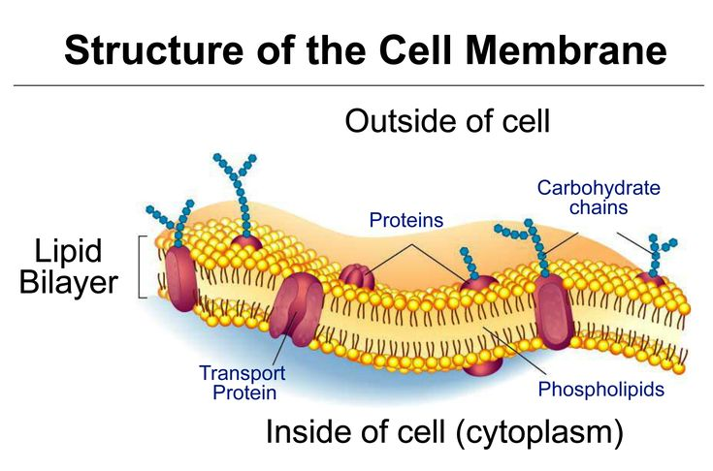

Another function of the membrane is to regulate cell growth through the balance of **endocytosis** and **​exocytosis**. In endocytosis, lipids and proteins are removed from the cell membrane as substances are internalized. In exocytosis, vesicles containing lipids and proteins fuse with the cell membrane increasing cell size. Animal cells, plant cells, prokaryotic cells, and fungal cells have plasma membranes. Internal organelles are also encased by membranes

**Phospholipids** are a major component of cell membranes. Phospholipids form a lipid bilayer in which their hydrophilic (attracted to water) head areas spontaneously arrange to face the aqueous cytosol and the extracellular fluid, while their hydrophobic (repelled by water) tail areas face away from the cytosol and extracellular fluid. The lipid bilayer is semi-permeable, allowing only certain molecules to diffuse across the membrane

**Cholesterol** is another lipid component of animal cell membranes. Cholesterol molecules are selectively dispersed between membrane phospholipids. This helps to keep cell membranes from becoming stiff by preventing phospholipids from being too closely packed together. Cholesterol is not found in the membranes of plant cells

**Glycolipids** are located on cell membrane surfaces and have a carbohydrate sugar chain attached to them. They help the cell to recognize other cells of the body

**Cell Membrane Proteins**

The cell membrane contains two types of associated proteins. Peripheral membrane proteins are exterior to and connected to the membrane by interactions with other proteins. Integral membrane proteins are inserted into the membrane and most pass through the membrane. Portions of these transmembrane proteins are exposed on both sides of the membrane. Cell membrane proteins have a number of different functions

Structural proteins help give the cell support and shape

Cell membrane receptor proteins help cells communicate with their external environment through the use of hormones, neurotransmitters, and other signaling molecules

**Transport proteins**, such as globular proteins, transport molecules across cell membranes through facilitated diffusion

**Glycoproteins** have a carbohydrate chain attached to them. They are embedded in the cell membrane and help in cell to cell communications and molecule transport across the membrane

Some cell organelles are also surrounded by protective membranes. The nucleus, endoplasmic reticulum, vacuoles, lysosomes, and Golgi apparatus are examples of membrane-bound organelles. Mitochondria and chloroplasts are bound by a double membrane. The membranes of the different organelles vary in molecular composition and are well suited for the functions they perform. Organelle membranes are important to several vital cell functions, including protein synthesis, lipid production, and cellular respiration

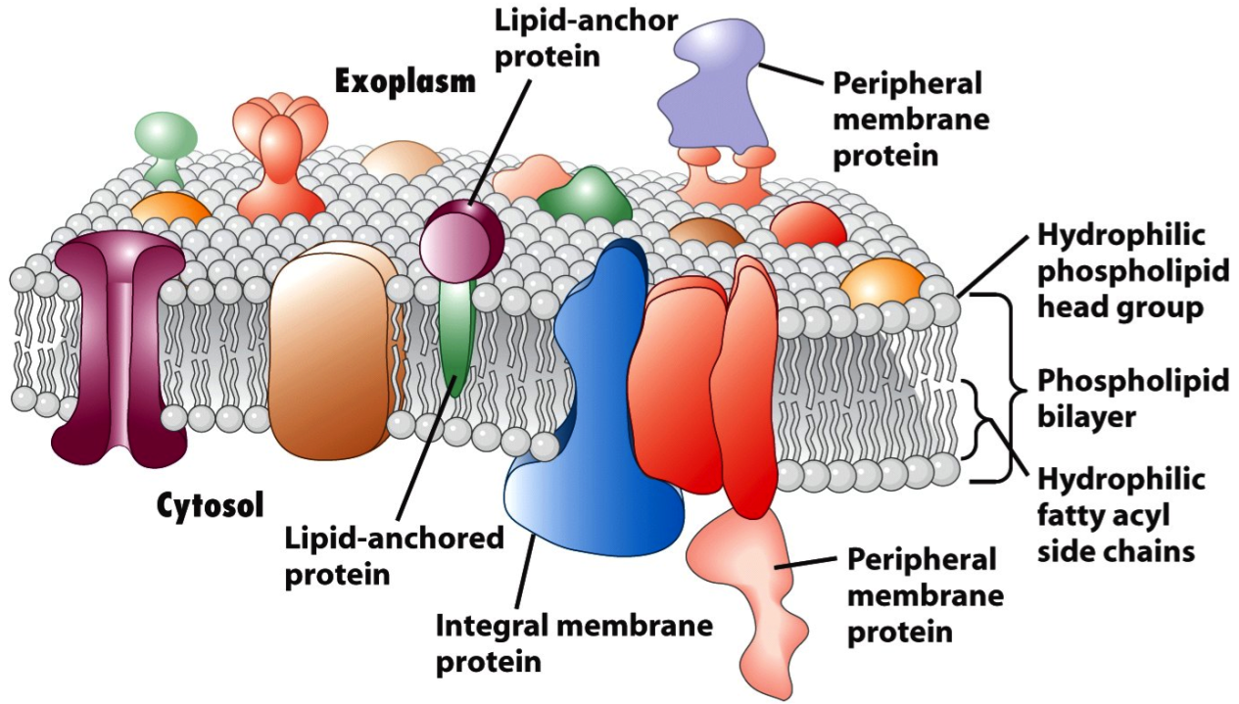

Membrane Proteins

The plasma membrane contains molecules other than phospholipids, primarily other lipids and proteins. The green molecules in Figure below, for example, are the lipid cholesterol. Molecules of cholesterol help the plasma membrane keep its shape. Many of the proteins in the plasma membrane assist other substances in crossing the membrane

The plasma membranes also contain certain types of proteins. A membrane protein is a protein molecule that is attached to, or associated with, the membrane of a cell or an organelle. Membrane proteins can be put into two groups based on how the protein is associated with the membrane

**Integral membrane** proteins are permanently embedded within the plasma membrane. They have a range of important functions. Such functions include channeling or transporting molecules across the membrane. Other integral proteins act as cell receptors. Integral membrane proteins can be classified according to their relationship with the bilayer

**Transmembrane proteins** span the entire plasma membrane. Transmembrane proteins are found in all types of biological membranes

**Integral monotopic proteins** are permanently attached to the membrane from only one side

Some integral membrane proteins are responsible for cell adhesion (sticking of a cell to another cell or surface). On the outside of cell membranes and attached to some of the proteins are carbohydrate chains that act as labels that identify the cell type

**Peripheral membrane proteins** are proteins that are only temporarily associated with the membrane. They can be easily removed, which allows them to be involved in cell signaling. Peripheral proteins can also be attached to integral membrane proteins, or they can stick into a small portion of the lipid bilayer by themselves. Peripheral membrane proteins are often associated with ion channels and transmembrane receptors. Most peripheral membrane proteins are hydrophilic

