**Biology Foransic avidance**

**First class Prof. Dr. Dina M.R.Alkhafaf**

**Biosafety and Risk group**

**Biosafety barriers in labs**

**1-Primary barriers**

-Physical barriers or personal protictive equipment for lab workers including gloves, masks, lab coat and respirators.

-Safety equipmentincluding biological safety cabinets (BSCs), enclosed cantainers. The BSC is principal equipment used to provide containment of infectioعus splashes or aerosols generated microbiological procedures.

**2-Secondary barriers**

Including structural entities of the lab that making the work environment safer against infection such as sinks for hand washing , special air ventiations and sterilization equipment , separation of the laboratory work area from administrative areas and public access , decontamination facilities (ex: autoclaves).

**The World Health Organization (WHO) Risk group classification**

Classification of infective microorganisms by risk group:

**-Risk Group 1 (RG1):** ( Low individual and low community risk) : These microorganisms are unlikely to cause disease ex: *Escherichia coli*.

**-Risk Group 2 (RG2):** (moderate individual risk, low community risk): a pathogen that can cause human or animal disease but is unlikely to be a serious hazard to laboratory workers , the community , livestock or the environment.

**-Risk Group 3 (RG3):** (High individual risk , low or moderate community risk): a pathogen that usually causes serious human or animal disease but does not ordinarily spread from one infected individual to another (ex: *Mycobacterium tuberculosis*)

**-Risk Group 4(RG4):** (High individual and community risk): a pathogen that usually causes serious human or animal disease and that can be readily transmitted from one individual to another, directly or indirectly (ex: Ebola virus).

**سovide containment of infectionnfectionfety cabinets (BSCs), enclosed cantainers.**

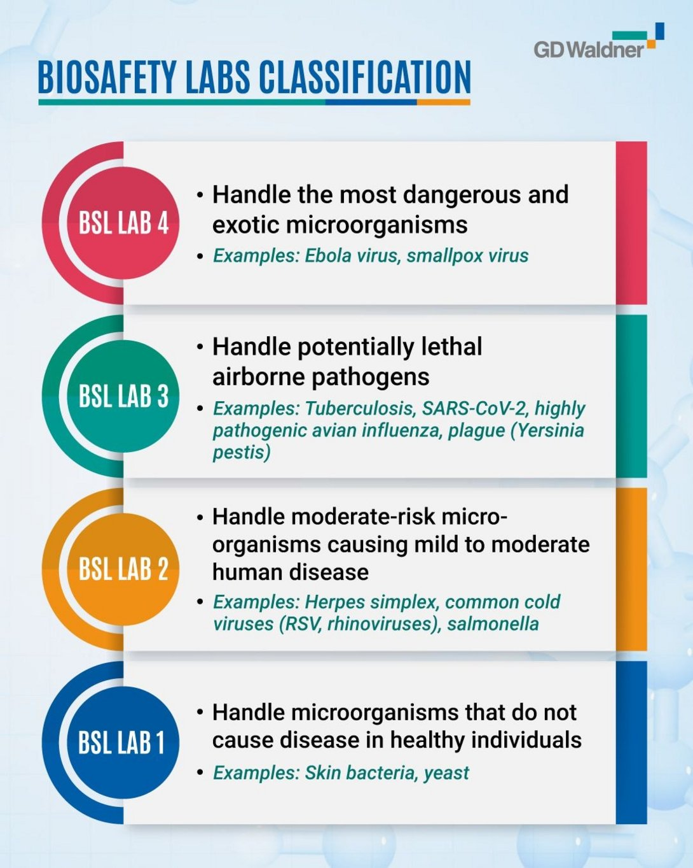

**Biosafety levels**

Biosafety is the application of safety precautions that reduce the risk of exposure in the laboratory to a potentially infections microbe and limit contamination of the work environment.

There are four biosafety levels designated by the center for disease control (CDC) that include BSL-1, BSL-2, BSL-3 and BSL-4. As figuer above.

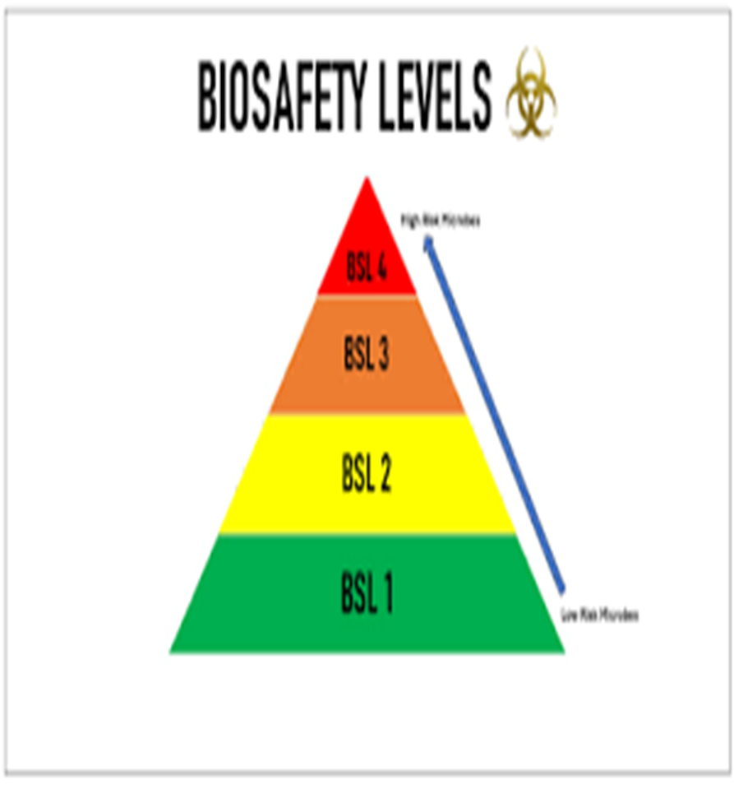

**Important Definitions**

A **hazard** is any source of potential damage , harm or adverse health effects on something or someone. These source includes : **microorganisms** , **toxins** and **allergens** derived from these organisms.

Also allargens and toxins derived from insects , animals and plants are considered as hazards.

**Risk** is the chance or probability that a person will be harmed or experience an adverse health effect if exposed to a hazard. It may also apply harmful effects on the environment.

For example: the risk of developing cancer from smoking cigarettes could be expressed as cigarette smokers are 12 times more likely to die of lung cancer than non-smokers.

**Biohazard materials**

-Viruses -Bacteria

-Fungi -Chlamydiae/Rickettsiae

-Prions -Recombinant DNA

-Trangenic plant and animals

-Brain tissue from demented (mad) patients

-Animals that are potential reservoirs of zoonotic diseases

-Viral vectors.

**Threat:** situation or activity that could cause harm

**Biosecurity:** Are measures that are taken to stop the spread or introduction of harmful organisms. These measures are put by bioscience laboratories to prevent the use of dangerous pathogens and toxins.

**Biosafety:** Are the containment principles, technologies and practice that are implemented to prevent unintenional exposure to hazards .

Whereas **biosafety** aims at protecting public health and environment from accidental exposure to biological agents , **biosecurity** deals with the prevent the prevrntation of misuse through loss , theft , diversion or intentional release of pathogens , toxins and any other biological materials.

**Decontamination (Sterilization):** Reduction of viable biological agents or other hazadous materials on a surface or object(s) to a predefined level by chemical and/or physical means.

**Bioethics**:The study of the ethical and moral implications of biological discoveries, biomedical advances, and their applications as in the fields of genetic engineering and drug research.

**Bioterrorism:** The use of biological agent for terrorist purposes

**Key Elements of Effective Management System**

The concept of improvmenet through a cycle of planning, implementing, reviewing and improving process to achieves the goals.

This is often referred to as the **" Plan – Do – Check – Act"** principle.

**Plan**: includes identification of hazards and risks as well as establishment of goals.

**Do**: includes train ing and operational issues.

**Check**: measure/ monitor performance against the goals.

**Act**: on the bases of review to make necessary changes.

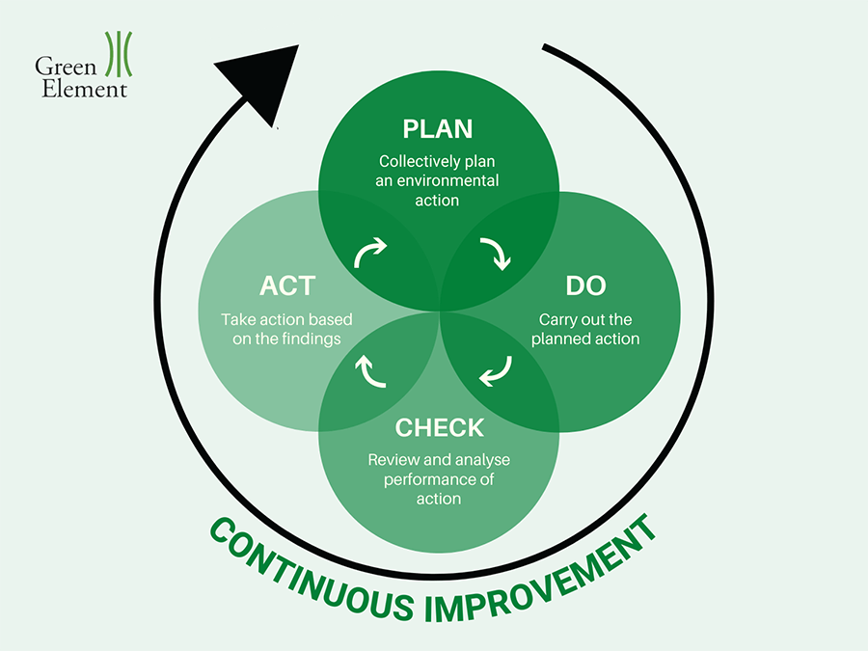

**Universal Safety Precautions**

1- Consider all the specimens collected from blood- borne infection as potentially infectious.

2-All specimens should be placed in a leak – proof container for transport.

3-Use glove while handing all specimens, especially when there is a contact with the body such as blood and cerbrospinal fluid.

4-Use a face mask with glasses and lab coat.

Cover cuts or abrasions occurring over skin with water proof bandage.

5-Decontaminate the labortory work surface immediately in case of spillage of blood or any other body fluids.

6-All sharps should be collected and disposed away properly.

7- Never pipette by mouth, use mechanical pipetting device.

8- There should always be a system working efficiently for management of hospital generated waste.

9-It is advisable for the laboratory personnel to be vaccinated against hepatitis B and C.

10-Not permitted in laboratories : eating, drinking, storing food, smoking, handling contact lenses.