Lecture 1 stoich fiest sys

[Home](https://www.chemistrylearner.com/) / [Physical Chemistry](https://www.chemistrylearner.com/category/physical-chemistry) / Stoichiometry

**Stoichiometry**

Table Of Contents

* [Theory](https://www.chemistrylearner.com/stoichiometry.html#theory)
* [Balancing Chemical Equations](https://www.chemistrylearner.com/stoichiometry.html#balancing-chemical-equations)
* [Stoichiometric Coefficients](https://www.chemistrylearner.com/stoichiometry.html#stoichiometric-coefficients)
* [Example Problems](https://www.chemistrylearner.com/stoichiometry.html#example-problems)

Stoichiometry is the study of the relationship between the quantity of reactants and products in a chemical reaction. German chemist Jeremias Benjamin Richter was the first to define stoichiometry in 1792

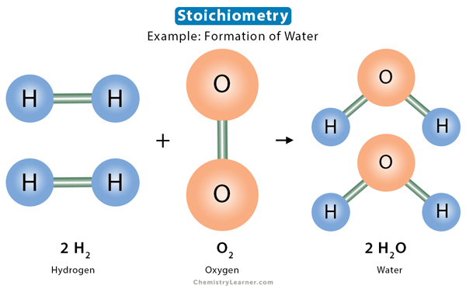

[Home](https://www.chemistrylearner.com/) / [Physical Chemistry](https://www.chemistrylearner.com/category/physical-chemistry) / Stoichiometry

**Stoichiometry**

Table Of Contents

* [Theory](https://www.chemistrylearner.com/stoichiometry.html#theory)
* [Balancing Chemical Equations](https://www.chemistrylearner.com/stoichiometry.html#balancing-chemical-equations)
* [Stoichiometric Coefficients](https://www.chemistrylearner.com/stoichiometry.html#stoichiometric-coefficients)
* [Example Problems](https://www.chemistrylearner.com/stoichiometry.html#example-problems)

Stoichiometry is the study of the relationship between the quantity of reactants and products in a chemical reaction. German chemist Jeremias Benjamin Richter was the first to define stoichiometry in 1792 [1-4].

[](https://www.chemistrylearner.com/wp-content/uploads/2023/06/Stoichiometry.jpg)Stoichiometry

0 seconds of 0 secondsVolume 0%

00:28

**Theory**

Stoichiometry is based on the principle of the law of conservation of mass. According to this law, the total mass of the reactants is equal to that of the product. Since chemical reactions neither create nor destroy matter, the amount of each element is the same throughout the reaction. The number of atoms of a particular element on the reactant side is equal to the number of atoms of that element on the product side [1,2].

The relationship among the quantities of the reactants and products is a positive integral ratio. If the amounts of each reactant are known, each product’s quantity can be easily determined. In this context, we refer to a stoichiometric amount of a reactant, which is an optimum amount where the following happens:

* The reaction proceeds to a completion
* All the reactants are consumed
* There is no deficiency of reagents
* There is no excess of reagents