Medical system

First class

First Semester

PPM

PPM ( Parts Per Million )

It is describe very small concentration in very large solution

The ppm value is calculated by **dividing the mass or volume of the substance by the total mass or volume of the solution and then multiplying the result by one million**.

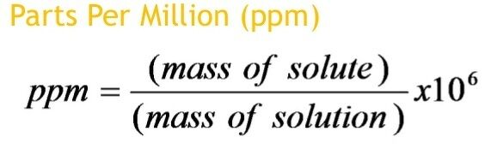

Example