LECTURE No 4 chemical equation

A chemical equation is **a symbolic representation of a chemical reaction that shows the products, reactants, and direction of the reaction.** Learn the parts of a chemical equation, how to balance and ionize them, and see examples of different types of reactions. [See more](https://www.bing.com/ck/a?!&&p=2a69cdb0679b61de9eb719dab7d1b7a01a4fd701786aff489fab477eb7943743JmltdHM9MTczNjAzNTIwMA&ptn=3&ver=2&hsh=4&fclid=31774b2e-04d6-6b1e-0d66-58c9057a6a67&psq=chemical+equation+definition&u=a1aHR0cHM6Ly9zY2llbmNlbm90ZXMub3JnL3doYXQtaXMtYS1jaGVtaWNhbC1lcXVhdGlvbi1kZWZpbml0aW9uLWFuZC1leGFtcGxlcy8jOn46dGV4dD1BIGNoZW1pY2FsIGVxdWF0aW9uIGlz&ntb=1)

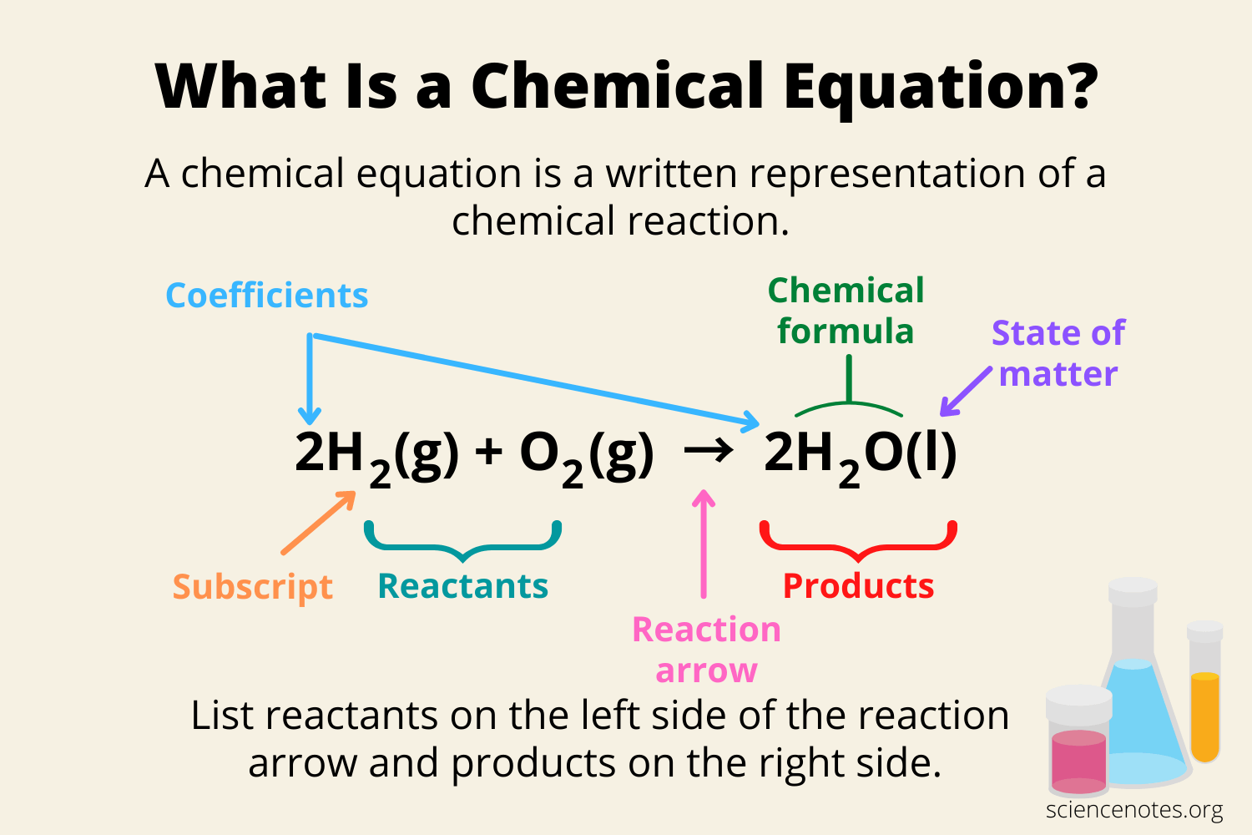

[**Parts of A Chemical Equation**](https://www.bing.com/ck/a?!&&p=d30419bfaf40eb73be688872f8d0c405ac4a2211bc26a20c40a40ec31ee58f34JmltdHM9MTczNjAzNTIwMA&ptn=3&ver=2&hsh=4&fclid=31774b2e-04d6-6b1e-0d66-58c9057a6a67&psq=chemical+equation+definition&u=a1aHR0cHM6Ly9zY2llbmNlbm90ZXMub3JnL3doYXQtaXMtYS1jaGVtaWNhbC1lcXVhdGlvbi1kZWZpbml0aW9uLWFuZC1leGFtcGxlcy8jOn46dGV4dD1UaGUgdGhyZWUgZXNzZW50aWFsIHBhcnRz&ntb=1)

The three essential parts of a chemical equation are the reactants, the products, and the reaction arrow, but many equations contain much more information. 1. Chemical Formulas:

**[Types of Chemical Reactions](https://www.geeksforgeeks.org/types-of-chemical-reactions/?ref=lbp)**

## **Acids, Bases, and Salts**

**Carbon and its Compound**

**Metals and non–metals**