***Salivary Gland Diseases***

* The salivary glands consist of 3 paired major glands,

1- parotid glands: opens against the upper 2nd molar buccally by Stensen’s duct, the secretion is mainly serous.

2- submandibular glands: opens near the lingual frenum by Warthin’s duct, the secretion is mixed but mainly serous.

3- sublingual glands: open near the opening of submandibular gland by Bartholin’s duct, the secretion is mixed but mainly mucous.

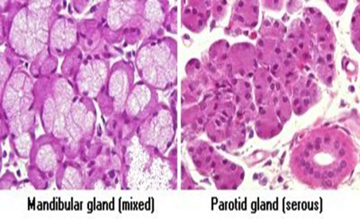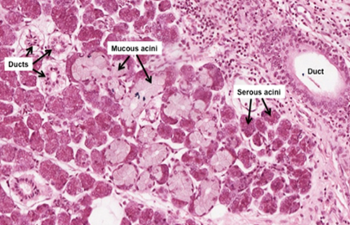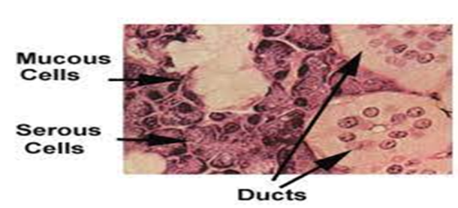

In addition to these major glands, there is a countless of minor salivary glands found in almost every part of the oral cavity, except the gingiva & anterior region of the hard palate.

Both, major & minor salivary glands consist of parenchyma elements which are supported by C.T. stroma.

The parenchymal is derived from the oral epith & consist of terminal secretory units leading to ducts that open into the oral cavity. The parenchyma surrounded by a C.T. capsule & extend into it.

The blood & lymphatic vessels & nerves that supply the gland will contained within the C.T.

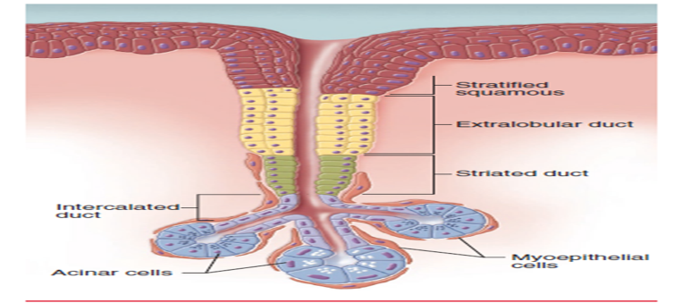

The normal function & health of the mouth depends on the normal composition & secretion of the saliva.

The important function of salivary glands is the production of saliva which contain various organic & inorganic substances & help in mastication, deglutition & digestion of food.

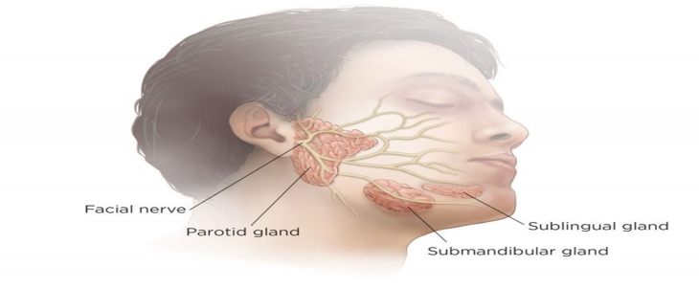

* **Investigations for salivary glands:**

1- Sialometery: measures the amount of saliva production in a certain time.

2- Sialochemistry: measures the composition of saliva.

3- Sialography: by introducing the iodine containing contrast media through the opening of the duct.

4- Sonagraphy: Ultrasonic patterns when dealing with minor salivary glands.

5- Cytology: by aspiration.

6- Biopsy.

* **Classification of salivary glands diseases:**

1- Obstructions: this could be by calculi or cystic type (stone, mucocele)

2- Infections: viral (Mumps), bacterial (acute & chronic Sialadenitis), & Necrotizing sialometaplasia**.**

3- Degenerative changes: Sjogren syndrome.

4- Functional disorders.

5- Neoplasms.

*1-Obstructions:*duct obstruction may result from either:  
A- blockage of the lumen (calculi, mucocele)  
B- disease in or around the duct wall (fibrosis, neoplasia)

**A- Sialoliths (S.G. stone):**

Mean presence of calculi or stones within the duct.

The calculi believed to arise from the deposition of ca ++ salt around a nidus of debris within the duct lumen, these debris include bacteria, ductal epith cells, or foreign bodies.

70-90% of stones occur in the submandibular gland, & this due to long tortuous path of the duct & thick secretion of the gland. about 6% in parotid gland & 2% in sublingual gland & minor S.G.

Mainly occur in adult male & is usually unilateral.

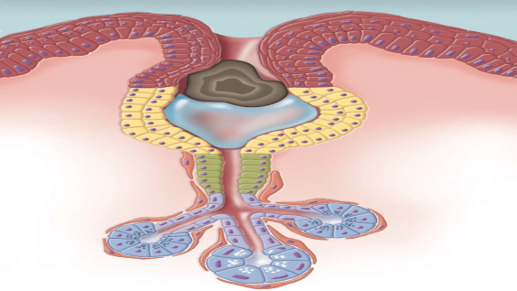

Symptoms:

pain, sudden enlargement specially at meal time.

Radiography:

there will be radiopaque mass, however, about 40% of parotid & 20% of submandibular stones are not radiopaque, therefore Sialography may be needed to locate them.

Histopathology: Intraductal calcified mass showing concentric laminations. The duct exhibits squamous metaplasia.

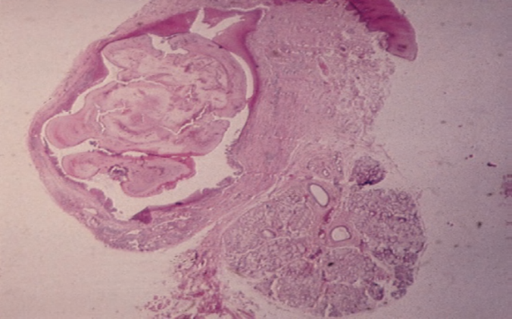

Treatment:

removing the calculi by manipulation or incision of the duct.

***B- Mucocele***

A common lesion of the oral mucosa it is of 2 types:

1. Mucus extravasation cyst
2. Mucus retention cyst

Mucus extravasation cyst

Result from rupture of a S.G. duct & spillage of mucin into the surrounding soft tissue, as a result of local trauma.

**Clinically**

appear as a bluish or translucent swelling, soft, fluctuant, range from mms to cms.

Mostly in child & adult.

The lower lip is the most common site usually lateral to the midline.

The duration of the lesion can vary from a few days to several years & many patients relate a history of a recurrent swelling that may periodically rupture & release its fluid contents.

Mucus extravasation cyst is not true cyst, because it lacks an epith lining.

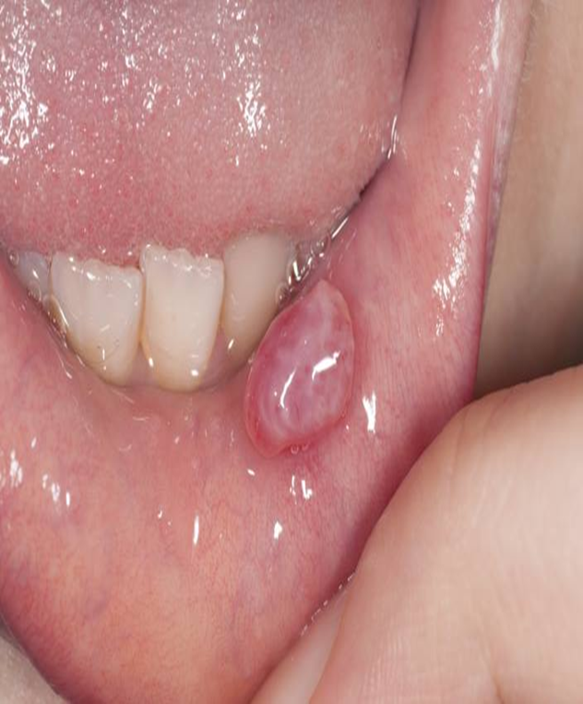

Histopathology:

An area of spilled mucin surrounded by a granulation tissue response.

The inflammation includes numerous neutrophils & foamy macrophages.

In some cases, a ruptured salivary duct may be identified feeding into the area.

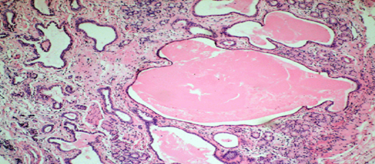

**Treatment:**

surgical excision.

**Mucus retention cyst:**

This derived from cystic dilatation of a duct, due to partial or complete obstruction of the duct, that make the mucin to remain (retention) within the duct.

**Clinically**, like the extravasation type.

**Histopathology**:

Cyst lining is variable (ductal epith in origin) composed of cuboidal, columnar or squamous epith, surrounding the mucoid secretion in the lumen.

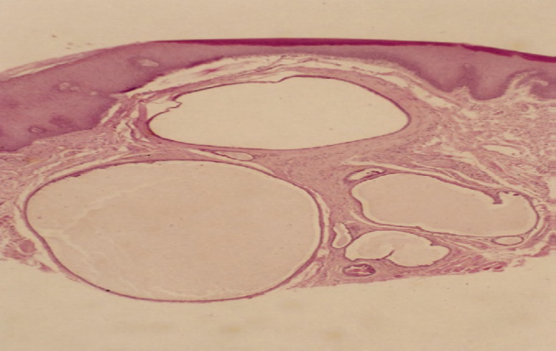

**Treatment:**

Surgical excision.

**3- Ranula**

it is a type of extravasation mucocele, the source of mucin spillage is usually the sublingual gland or from submandibular duct or possibly from minor S.G. in the floor of the mouth.

**Clinically**

appear as swelling in the floor of the mouth resemble a Frog’s belly.

It may interfere with the speech or mastication, because it causes pushing of the tongue up toward the palate.

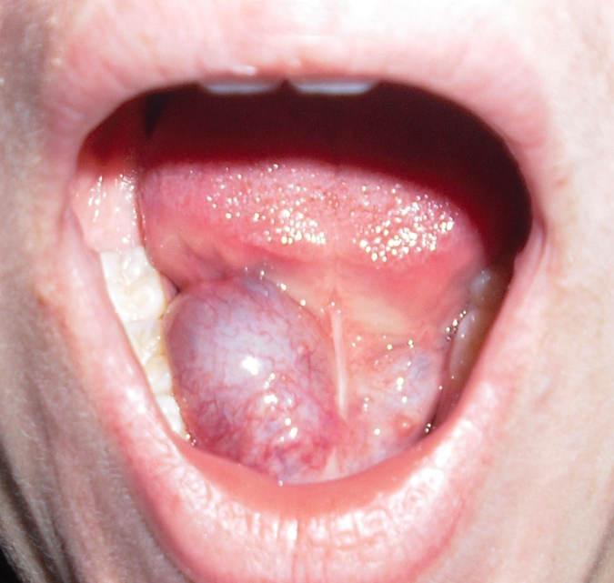

Treatment:

By total or partial removal or marsupialization.

***2- Infections***

A-Viral infection (Mumps):

Is an acute, contagious infection which often occurs in minor epidemics & is caused by Paramyxovirus.

B- Bacterial infection:

**SIALADENITIS**

Inflammation of the salivary glands (sialadenitis) can arise from various infectious and noninfectious causes.

Most bacterial infections arise as a result of ductal obstruction or decreased salivary flow, allowing retrograde spread of bacteria throughout the ductal system. Blockage of the duct can be caused by sialolithiasis, congenital strictures, or compression by an adjacent tumor.

One of the more common causes of sialadenitis is recent surgery (especially abdominal surgery).

Other medications that produce xerostomia as a side effect also can predispose patients to such an infection. Most cases of acute bacterial sialadenitis are caused by Staphylococcus aureus, but they also may arise from streptococci or other organisms.

**CLINICAL AND RADIOGRAPHIC FEATURES**

Acute bacterial sialadenitis is most common in the parotid gland and is bilateral in 10% to 25% of cases. The affected gland is swollen and painful, and the overlying skin may be warm and erythematous. An associated low-grade fever and trismus may be present. A purulent discharge often is observed from the duct orifice when the gland is massaged.

Recurrent or persistent ductal obstruction (most commonly caused by sialoliths) can lead to a chronic sialadenitis. Periodic swelling and pain occur within the affected gland, usually developing at mealtime when salivary flow is stimulated.

Sialography often demonstrates sialectasia (ductal dilatation) proximal to the area of obstruction .

Chronic sialadenitis also can occur in the minor glands, possibly as a result of blockage of ductal flow or local trauma.

**HISTOPATHOLOGIC FEATURES**

In patients with acute sialadenitis, accumulation of neutrophils is observed within the ductal system and acini.

Chronic sialadenitis is characterized by scattered or patchy infiltration of the salivary parenchyma by lymphocytes and plasma cells. Atrophy of the acini is common, as is ductal dilatation. If associated fibrosis is present, then the term chronic sclerosing sialadenitis is used.

**TREATMENT AND PROGNOSIS**

The treatment of acute sialadenitis includes appropriate antibiotic therapy and rehydration of the patient to stimulate salivary flow. Surgical drainage may be needed if there is abscess formation.

The management of chronic sialadenitis depends on the severity of the condition and ranges from conservative therapy to surgical intervention. Initial management often includes antibiotics, analgesics, sialagogues, and glandular massage.

**NECROTIZING SIALOMETAPLASIA**

Necrotizing sialometaplasia is an uncommon, locally destructive inflammatory condition of the salivary glands. Although the cause is uncertain, most authors believe it is the result of ischemia of the salivary tissue that leads to local infarction. The importance of this lesion rests in the fact that it mimics a malignant process, both clinically and microscopically. A number of potential predisposing factors have been suggested, including the following:

● Traumatic injuries

● Dental injections

● Ill-fitting dentures

● Upper respiratory infections

● Adjacent tumors

● Previous surgery

**CLINICAL FEATURES**

Necrotizing sialometaplasia most frequently develops in the palatal salivary glands; more than 75% of all cases occur on the posterior palate. The hard palate is affected more often than the soft palate. About two thirds of palatal cases are unilateral, with the rest being bilateral or midline in location. Necrotizing sialometaplasia also has been reported in other minor salivary gland sites and, occasionally, in the parotid gland.

Although it can occur at almost any age, necrotizing sialometaplasia is most common in adults; the mean age of onset is 46 years. Males are affected nearly twice as often as females. The condition appears initially as a nonulcerated swelling, often associated with pain or paresthesia. Within 2 to 3 weeks, necrotic tissue sloughs out, leaving a craterlike ulcer that can range from less than 1 cm to more than 5 cm in diameter. The patient may report that “a part of my palate fell out.” At this point, the pain often subsides.

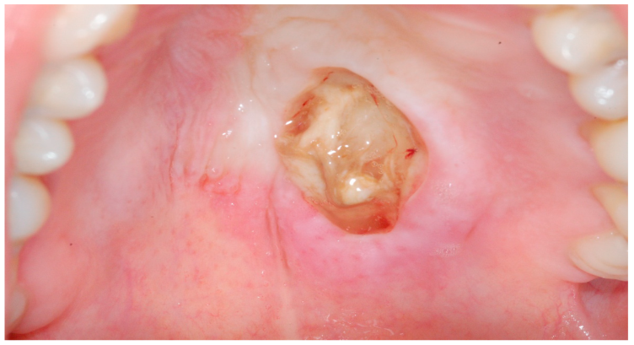

**HISTOPATHOLOGIC FEATURES**

The microscopic appearance of necrotizing sialometaplasia is characterized by acinar necrosis in early lesions, followed by associated squamous metaplasia of the salivary ducts. Although the mucous acinar cells are necrotic, the overall lobular architecture of the involved glands is still preserved—a helpful histopathologic clue.

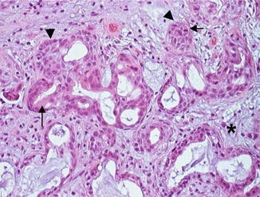

**TREATMENT AND PROGNOSIS**

no specific treatment is indicated or necessary. The lesion typically resolves on its own accord, with an average healing time of 5 to 6 weeks.

***3- Degenerative disease***

**Sjogren Syndrome**

Is an immune-mediated chronic inflammatory disease, characterized by lymphocytic infiltration & acinar destruction of salivary & lacrimal glands.

Mainly affects middle-aged females, & symptoms related to dryness & soreness of the mouth & eyes are common clinical presentations.

The patient also complain from difficulty in swallowing & speaking, increased fluid intake, disturbance of taste, & rapidly progressive caries.

S.G. enlargement is usually bilateral without pain, & predominantly affects the parotid gland.

The disease classified into 2 types:

1- primary: xerostomia + xerophthalmia

2- secondary: xerostomia + xerophthalmia + C.T. disease usually rheumatoid arthritis.

**Histopathology:**

Initially, the S.G. show lymphocytic infiltration around intralobular ducts with acinar atrophy & obliteration of the duct lumen by proliferation of ductal epith, lead to formation of islands of epith tissue, termed epimyoepithelial islands.

Finally, the lesion consists of sheets of lymphoid cells surrounding the epimyoepithelial island & replacing entire S.G. lobules.

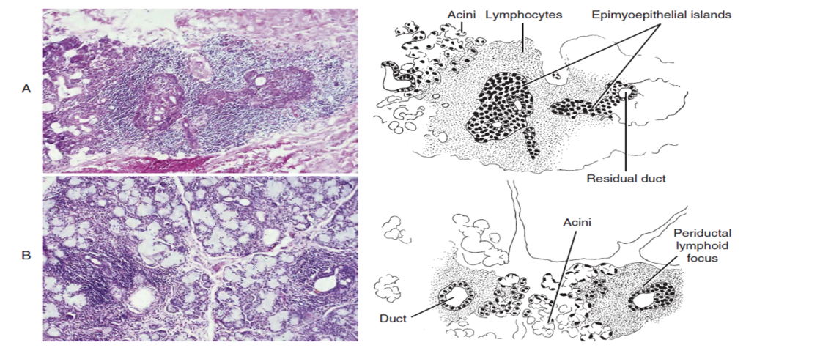

TREATMENT

supportive only