1

**Simple past, modal verbs, auxiliary verbs**

1. **Simple past tense**

The simple past tense is used to describe actions or events that happened and were completed in the past. simple past tense also known as second form of the verb.

**Form**

|  |  |  |  |
| --- | --- | --- | --- |
| Regular verbs, add (–ed) | | Irregular verbs | |
| Present | Past | Present | Past |
| walk | walked | go | went |
| place | placed | eat | ate |
| plan | planned | be | was/were |
| fix | fixed | buy | bought |
| need | needed | come | came |
| help | helped | do | did |
| add | added | find | found |
|  |  | have | had |
|  |  | see | saw |
|  |  | tell | told |
|  |  | write | wrote |

Examples :

دليل على ان الزمن بالماضي

I walked to the store **yesterday**.

تقسيم الجملة Subject simple past tense of verb object

She saw a movie **last night**.

I went to the market **last Sunday**

I finished work, walked to the beach and met my friends

He saw his family last week

The solution separated from the solvent

The fuels was distilled from crude oil تم تقطير الوقود من النفط الخام

**Negative form** ( use did not)

I **had** a car → I didn't **have** a car

I **played** football yesterday → I **didn’t play** football yesterday.

They **didn’t go** to the theater last month.

She **didn’t arrive** on time this morning.

**Question form**

Did subject base form of verb + object?

He brought his friend. → **Did** he bring his friend?

**Did** you go to the theater last night?

**Did** you play football yesterday?

**Did** they lose the match?

1. **Modal verbs**

The common modal verbs are :

Can could  
may might

shall should

will would

must

Modal verbs express necessity, possibility, permission, or ability, and [make requests and offers](https://learnenglish.britishcouncil.org/node/10377):

Examples:

I can swim (ability)

She must finish her homework. (necessity)

He might come to the party. (possibility)

It might rain tomorrow

My keys must be in the car.  
Could I have some tea, please?  
Would you like some help?

1. **Auxiliary verbs**

Auxiliary verbs also known as helping verbs, are used with the verb to form different tenses, moods, or voices. The most common auxiliary verbs are (be, have, and do) .

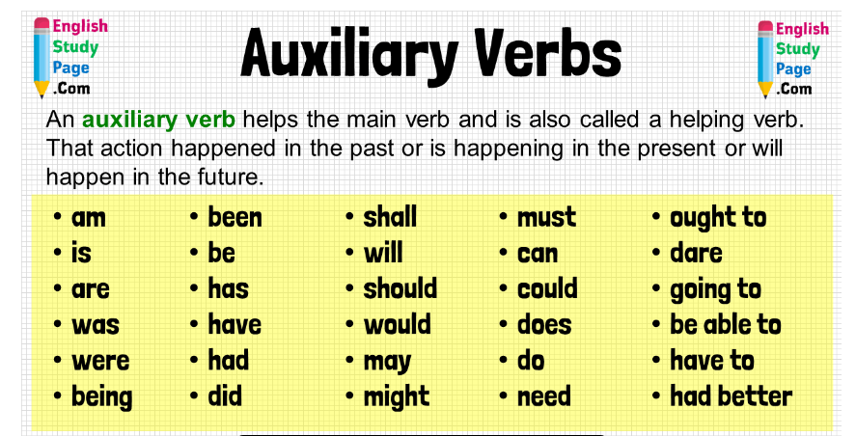

Examples:

I am reading a book (present continuous)

She has finished her homework. (present perfect)

Do you like coffee? (question)