Grammar: Auxiliary Verbs (Intermediate: Unit 1) , Vocabulary: Everyday Expressions (Intermediate: Unit 1) . Reading: "It's a Wonderful World!" (Intermediate: Unit 1)

Writing: Basic sentences using auxiliary verbs (Intermediate: Unit 1)

**Unit 1**

**1.1- Starter**   
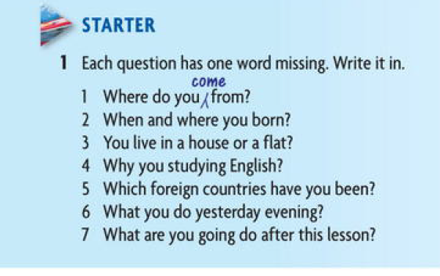

Answers :   
1. Where do you **come** from?  
2. When and where you **are** born?  
3. **Do** you live in a house or a flat?  
4. Why you **are** studying English ?  
5. Which foreign countries have you been **visited**?

6. What **do** you do yesterday evening?  
7. What are you going **to** do after this lesson?

**1.2- Grammar Spot**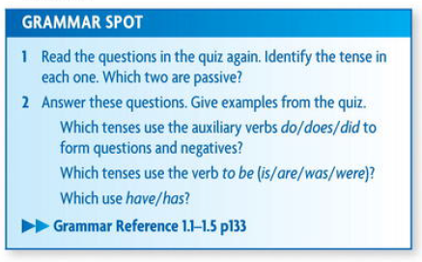

**1.2.1 Auxiliary Verbs**

**1.2.2 Our World**

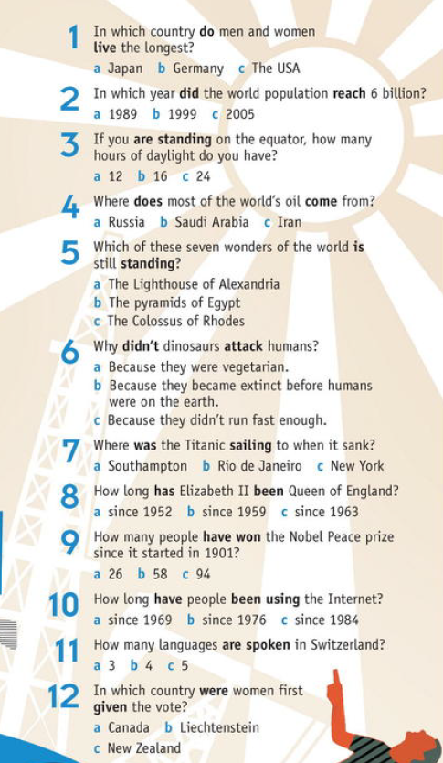

Answers :   
1. A 2. B 3. a 4. B  
5. B 6. B 7. C 8. a  
9. C 10. a 11.b 12. c

**1.3 Writing** - Read the following letter and correct the mistakes with the help of below symbols 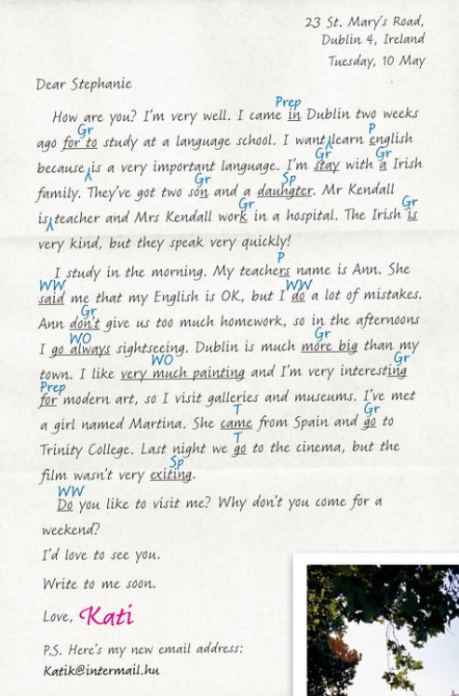

**1.4 Reading and Speaking**

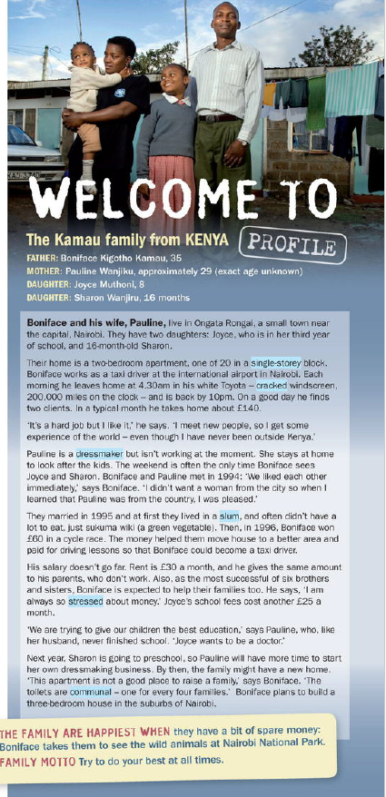 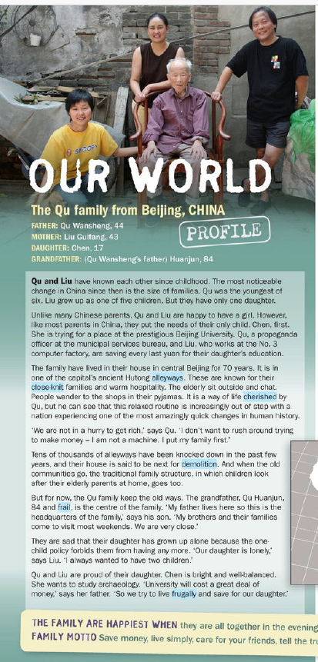

**1.5 Vocabulary**Match from below tables texts the words that meet the meaning in above high- lighted words ?

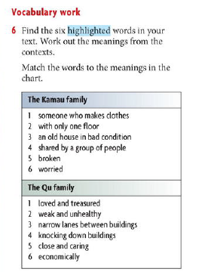

**1.6. Every day English   
**

**Answers :**

**a-7 b- 3 c- 6 d- 8  
e- 10 f- 2 g- 4 h-9**

**i- 5 j- 1**

**1.7 Homework no.1**

**1.7.1 Word formation   
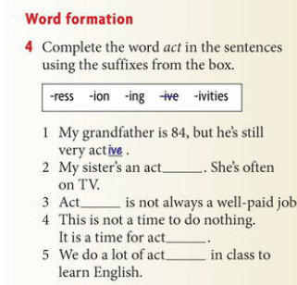**

**1.7.2 Words that go together   
**