Grammar: Present Simple (Intermediate: Unit 2)

Vocabulary: Common Activities (Intermediate: Unit 2)

Reading: "Get Happy!" (Intermediate: Unit 2)

**Unit 2**

**2.1 Grammar Spot   
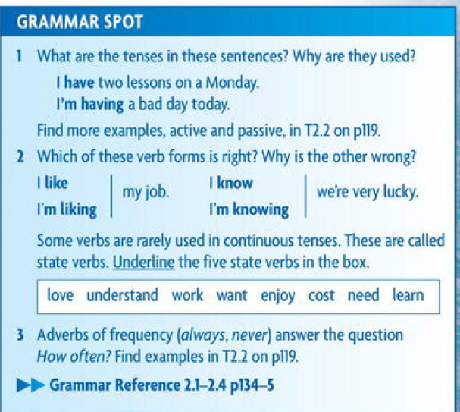  
2.1.1.Present Simple :  
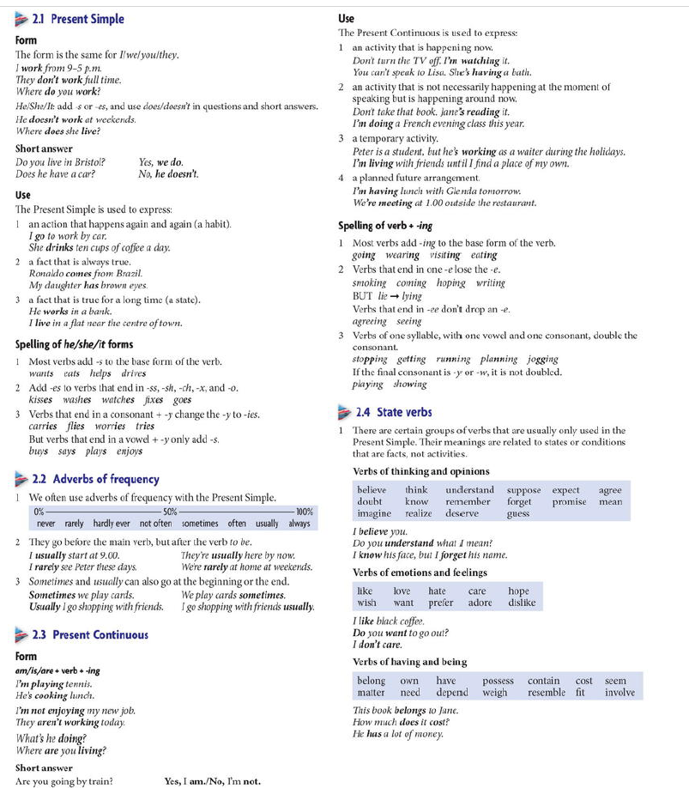**

2.1..2

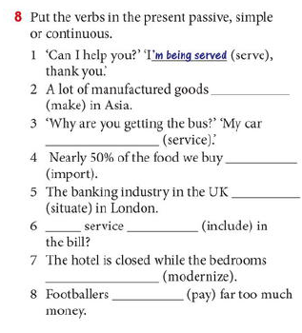

2.3 Reading , making Questions and Answers

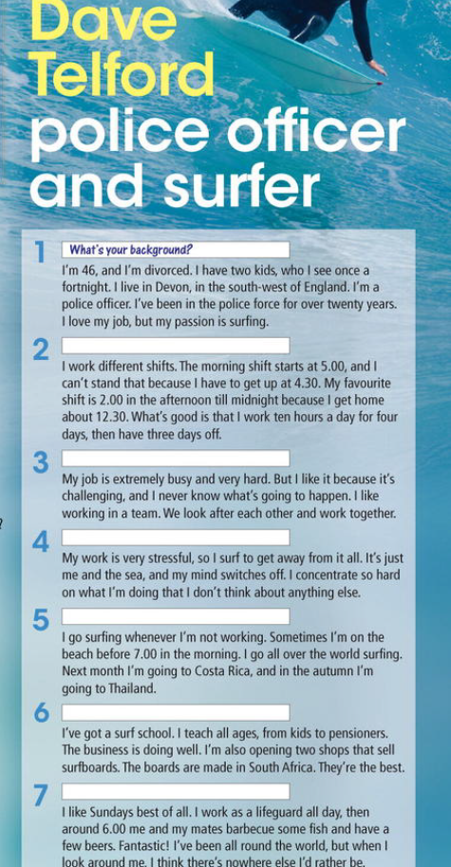

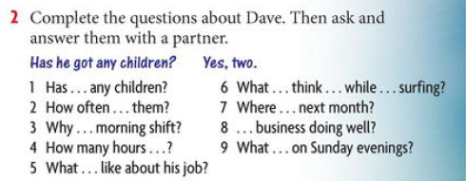

Answers :

**2.4 In the Office**

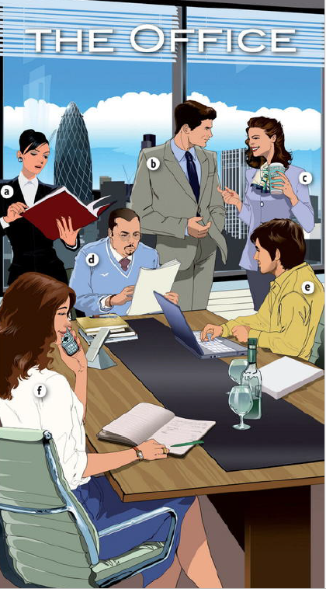

Answers

|  |  |
| --- | --- |
| Is responsible for running the whole company | Discussing plans and targets with the boards |
| Makes appointments and arrangements | Making booking for conference |
| Negotiating the prices and contracts | Visiting new customers in China |
| Runs an IT support team | Buying new hardware |
| Is in charge of budget and cash flow | Preparing financial report |
| looks after employees | Recruiting new staff |

**2.5 Reading and Speaking  
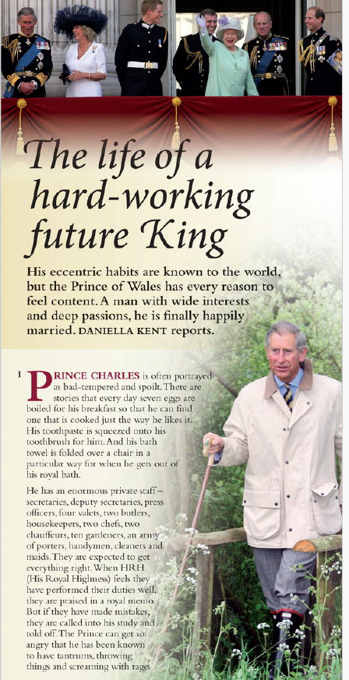**

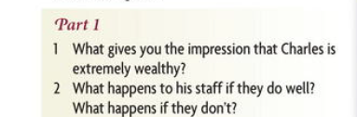

**Answers :   
1. He has a enormous private staff – secretaries , deputy secretaries, two chefs , two chauffeurs , ten gardeners, cleaners and maids.  
2.   
 -** **If his staff doing well they will praised in the royal memo.  
 - If his staff have making mistakes , they will called into his study and told off . the prince can get so angry , have tantrum s and throwing things and screaming.  
  
 -**

**2.6.1. activities**

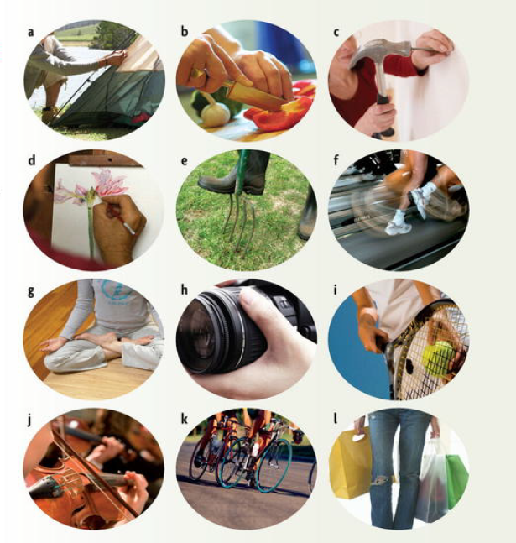

**Answers  
A drill – c  
Planting – e  
a Racket – i  
a concert – j  
zoom – h  
sketching – d  
the sales - l  
meditating – g  
a sleeping bag – a   
weeding – b  
Sweating – f   
keeping fit - k**

**2.6.2. Cooking**

**Answers :**

|  |
| --- |
| **Equipment** |
| A saucepan |
| An oven |
| A casserole dish |
| A food processer |

|  |
| --- |
| **Food preparation** |
| To peel |
| To mix |
| To chop |
| To weigh |

|  |
| --- |
| **Ingredients** |
| Eggs |
| Minced meat |
| Olive oil |

|  |
| --- |
| **Ways of cooking** |
| frying |
| Boiling |
| Baking |
| roasting |

**2.7 . Every day English   
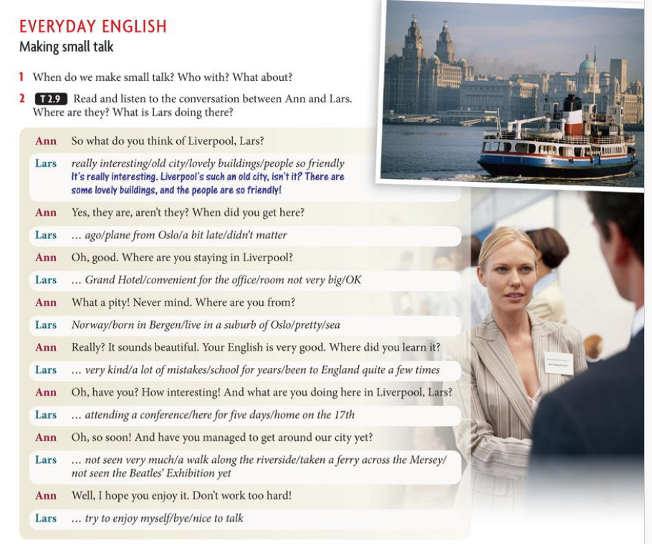**

**Answers :  
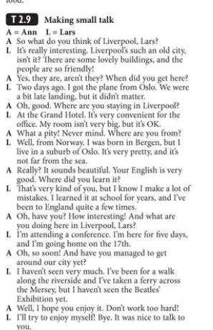  
2.8: Writing( Letters and E- mail )  
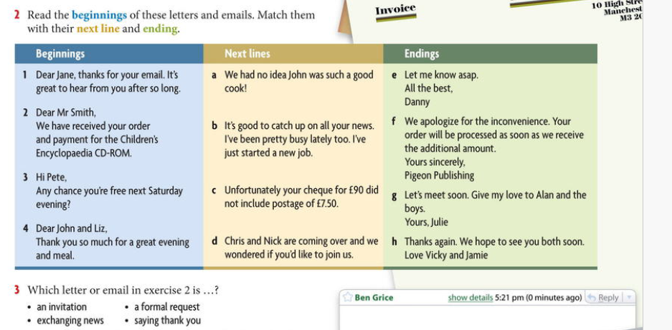**

**Answers:**1-d- g  
2- c- f   
3- b- e  
4- a- h

2.9. Homework – Electric Motors -   
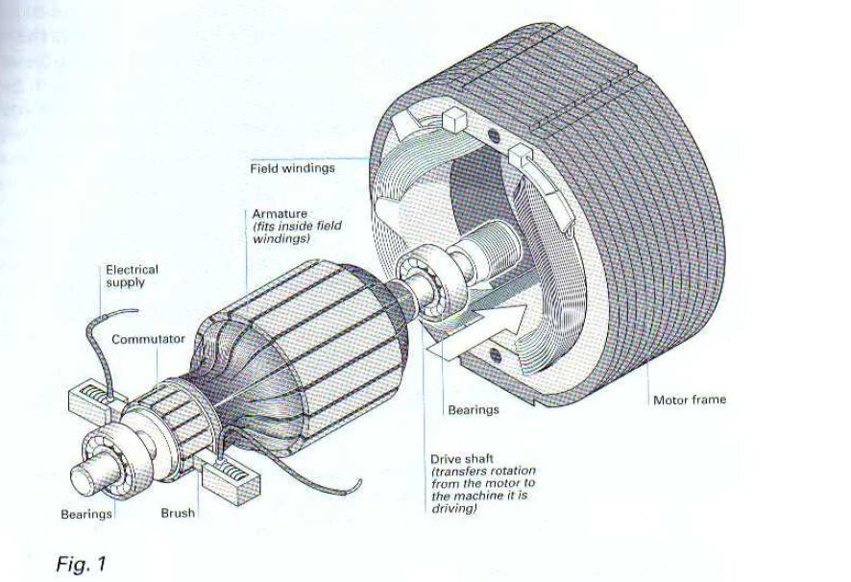  
Match the paragraph below