Lecture 1 Dental Devices Technology Dr.Muna Merza

**Dental Laboratories**

**Types of Dental Laboratories:**

1. General Dental Laboratories:-  
They make all wanted prostheses in dentistry

ex: complete denture, partial denture, oral structure missing, orthodontic and other missed structure in the face.

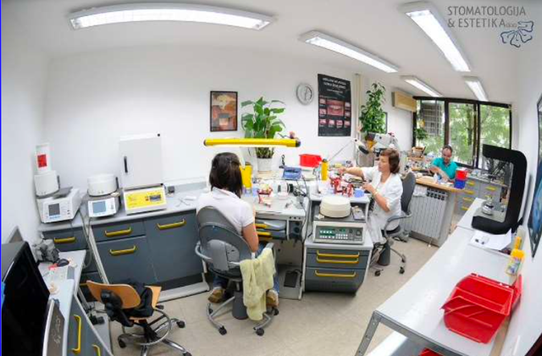

2. Specialized Dental Laboratories:-  
They make only one type of work in fields of

dentistry ex: ceramic bridge or acrylic prostheses.

3. Private Dental Laboratories:-

small laboratories. مختبرات صغيرة ملحقة بعيادة طب الاسنان

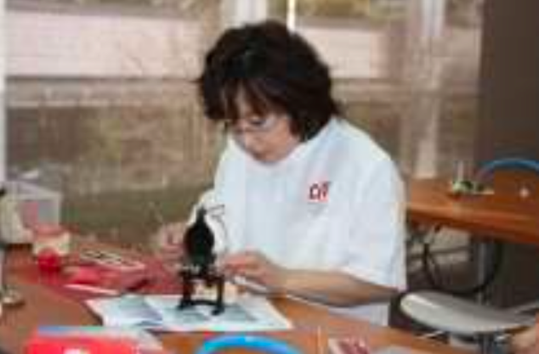

**The Work in Dental Laboratories: -**

1. One step specialization: ex: making base plates, occlusal rim, pouring gypsum casts, pour the cast articulators, or the setting of artificial teeth.
2. One-line specialization: Make a complete product line يختص بخط انتاج كامل
3. General work: small laboratories and in sometimes in private dental laboratories have general work, they make all types of work that wanted.

**Advantages & Disadvantages of the Work in Dental Laboratories:**

1. In the case of specialists,whose work one step they forget other steps.
2. Inthecaseofworkingonestep,ahighdegreeofaccuracywillbefound.
3. The benefitis more in case of general work.
4. Income case of specialist laboratories is more than income case of working all step laboratories (general laboratories).

**The principle of ideal laboratories:-**

1) The money.

2) The plans.

3) Manpower.

**Points which are considered in the planning of penetration of the market:**

1. Planed area of the lab.
2. Location of the lab.
3. The amount of production.
4. A number of technicians & workers.
5. Future expansion.