Lecture 7 Dental Equipment Technologies Dr.Muna Merza
The Dental Surveyor

The Dental Surveyor:
This tool is used in chrome-cobalt, acrylic, and crown &bridge lab, ti helps in designing all type of removable partial denture and have many designs.

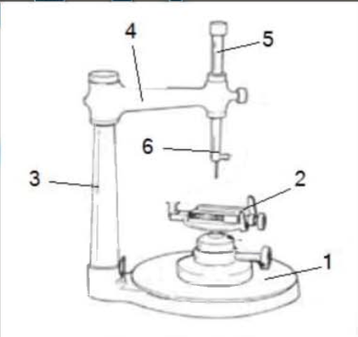
Parts of The Dental Surveyor:
1. Ground plate: (base of surveyor) it hold other parts of the surveyor {the other parts of the surveyor stabilized on it.
2. Table: stabilized from lower on the ground plate by joint and on it stabilize the cast that
needs to draw the line on it.
3. Vertical arm: stabilized from lower on the plate to the other end not stable, always vertical arm the lower part of it is stable and the upper part is rotated.

4. Swiveling bar: connect from one side with the upper part "not stable" of vertical arm and end with charting arm.
5. Charting arm: connect from the upper part with swiveling bar and from lower with the mandrel.
6. Mandrel: for holding special tools.
7. Surveyor tools: it composed from:
a. Analyzing rod:- is a rigid metal rod which used for diagnostic purposes.
b. Carbonmarker:- it is used for marking the survey line on the cast.
c. Undercutgauge:- it is used to measure the extent of the undercut on the tooth and soft tissue.
d. Wax trimmer:- it is used to trim the excess of wax.
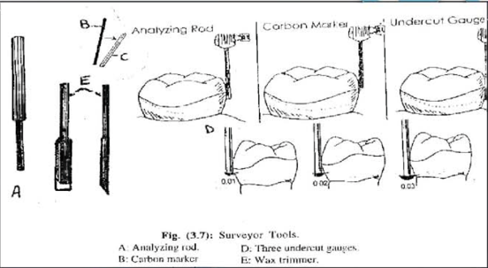

Types of Surveyor:-
The most widely used surveyors are:
1) Ney Surveyor with non-swiveling horizontally.
2) Jelenko Surveyor with swiveling horizontally.

