Lecture 12 Dental Equipments Technology Dr. Muna Merza

**Dental brush,burs and discs**

* **Abrasive**—A sharp, hard, natural or synthetic substance used for grinding, finishing, or polishing a softer surface.
* **Bulk reduction**—Process of removing excess material (natural tooth or synthetic structure) by cutting or grinding with rotary instruments to provide a desired anatomic form.
* **Contouring**—Process of producing a desired anatomic form by cutting or grinding away excess material.
* **Cutting**—Process of removing material from the substrate by use of a bladed bur
* **Finishing**—Process of removing surface defects or scratches created during the contouring process
* **Glaze** **ceramic**—A specially formulated ceramic powder that, when mixed with a liquid, applied to a ceramic surface, and heated to an appropriate temperature for a sufficient time, forms a smooth glassy layer on a dental ceramic surface (see natural glaze).
* **Grinding**—Process of removing material from a substrate by abrasion with relatively coarse particles.
* **Overglaze**—Thin surface coating of glass formed by fusing a thin layer of glass powder that becomes a viscous liquid at a lower temperature than that associated with the ceramic substrate.
* **Polish**—Luster or gloss produced on a finished surface.
* **Polishing**—Process of providing luster or gloss on a material surface

## **Applications of Abrasives in Dentistry**

The intraoral surfaces of virtually every direct and indirect restoration must be contoured by grinding, **finishing**, and **polishing** procedures. The goal of these procedures is to produce the smoothest surface possible in a limited time. A single type of abrasive cannot be used effectively for all types of dental materials

**Types of abrasives**

Different abrasives are used for the three major classes of materials: ceramics, metals, and resin-based composites.

**Why are abrasives different?** The abrasive instruments used for metals must be able to remove metal particles quickly and efficiently without generating excessive heat or becoming clogged with debris.

1. silicon carbide discs are required for **cutting** metal sections such as casting sprues
2. Different types of burs have unique effects on surfaces. In general, a carbide bur with more blades will produce a smoother surface than a carbide bur containing fewer blades.
3. bonded abrasive wheels or points are used for rapid adjustment of surface contours.
4. diamond burs have been developed for grinding and finishing zirconia frameworks,.

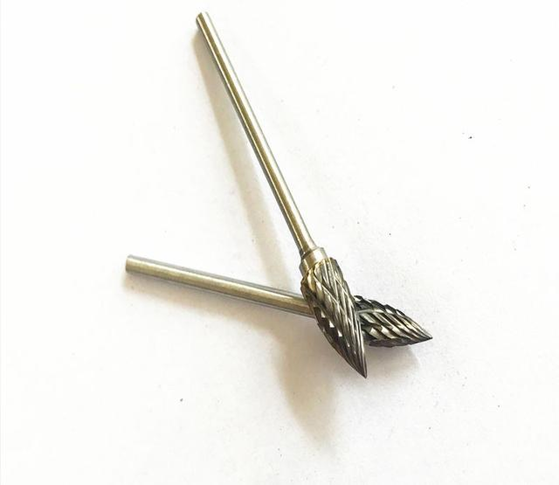

**Polishing**:

1. **Metal Polishin wheel** eliminates scratches and smoothen all surfaces for polishing all alloys and acrylic dentures. Besides smoothes the surface of ceramic for the final shine. used in sequence with slower speed and lighter pressure to achieve the highest polish possible. Polishing pastes are also available for the final polish on ceramics or composite

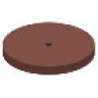

1. 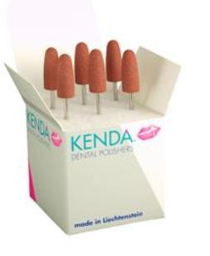**Silicone polisher** for prosthetic and orthodontic acrylics, as replacement for sandpaper in difficult-to-reach areas. It can be found in 3 to 5 degree of roughness as coarse pre-polish, suitable also for soft acrylics.  
   medium grit, fine polish, light shine, suitable for soft acrylics  
   fine grit for high-gloss
2. **Brushes** [**Polishers**](https://www.kerrdental.com/kerr-rotary/polishers)

These natural bristle brushes are best for the polishing and fine tuning the post glazed surfaces of occlusal grooves and concave anatomies;

1. **Micro-cloth Polishing**

**discs** for the final polishing of composite and porcelain restorations.

1. 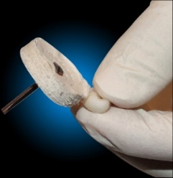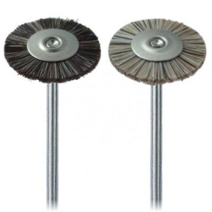**Rag / Muslin Wheel** [**Polishers**](https://www.kerrdental.com/kerr-rotary/polishers)

Ideal for cleaning and polishing of denture acrylic material, cleaning interproximal spaces after denture deflasking, and for general laboratory applications.

## **Polishing Paste for Composites and Porcelain**

diamond polishing gives a high gloss to today’s composites and porcelain. It has a firm consistency and is ideal for use with stiff bristle or felt wheels and comes in a fine, medium and fine-soft grits.

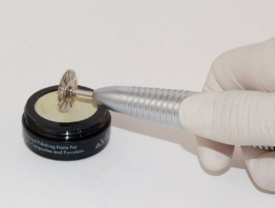**Benefits of finishing and polishing**

1. better gingival health
2. chewing efficiency
3. patient ccomfort
4. esthetic
5. Unfinisied rough surface increased bacterial adhesion as well as surface staining.
6. A well-contoured and polished restoration promotes gingival health by resisting the accumulation of food debris
7. Smoother surfaces have less retention areas and are easier to clean
8. Tarnish and corrosion activity of some metallic materials can be significantly reduced if the entire metal restoration is highly retention