Lecture 9 Dental Equipment Technologies Dr.Muna Merza

**Dental Trimmer**

It,s an electric device used to trimming the model that is made from gypsum products (stone, stone, plaster,.......)

**Use for:**

1‐ Making a model with a suitable width.  
2‐ To match the model together (upper and lower model).

3‐ To determine the occlusal view of the model.

**There are two types of trimmer:**

A‐One wheel model trimmer.  
B‐ Double wheel model trimmer.

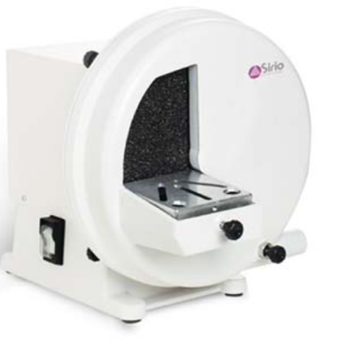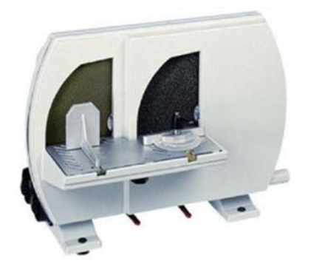

**In general, the trimmer consists of:**

1‐  Coarse or /and fine corundum grinding wheels.

2‐  Control motor switch.

3‐  Motor.

4‐  Individual control water supply

5‐  Work area with squaring and angulation device.

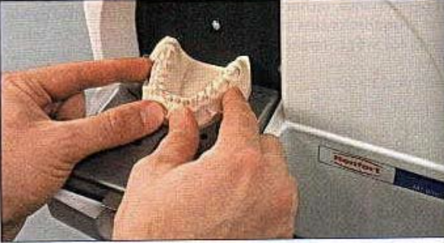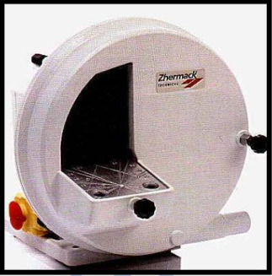

**Dental Vibrator:**

Its electric device used in all dental laboratory, it aid in mixing gypsum product (plaster, stone, die stone.......) & escape the air from it & avoid air bubbles to obtain homogenous mixing during pouring the impression (to produce the casts) & during flasking procedure.

**It consists of:**

1. the switch to open & close the equipment

2. motor to vibrate  
3. Rubber surface.

NOTE: Rubber surface is easily removable for cleaning.

