**Lecture 11: Compression Members – Section 4.6: DESIGN**

**1. Introduction to Compression Member Design**

Compression members are structural elements primarily subjected to axial compressive forces. The design process involves selecting a member that can resist a given compressive load economically while satisfying the strength and stability requirements outlined in the AISC Specification.

* The selection of an economical rolled shape to resist a given compressive load is simple with the aid of the column load tables.
* Enter the table with the effective length and move horizontally until you find the desired available strength (or something slightly larger).
* Usually the category of shape (W, WT, etc.) will have been decided upon in advance.
* All tabulated values correspond to a slenderness ratio of 200 or less.
* The tabulated unsymmetrical shapes—the structural tees and the single and double angles—require special consideration and are covered in **Section 4.8**.

**2. Design Procedure based on column load tables (Table 4-1):**

1. **Determine the available load:**
   * For **LRFD (Load and Resistance Factor Design):** Pu=1.2D+1.6L
   * For **ASD (Allowable Stress Design):** Pa=D+L
2. **Calculate the Slenderness Ratio (KL/r):**
   * The effective length factor **K** depends on the end conditions.
   * The radius of gyration **r** is obtained from the properties table.
3. **Check the Compressive Strength:**
   * The **Design compressive strength (φPn ≥ Pu or Pa)**
4. **Adjust the Section if Necessary:**
   * If the chosen section does not satisfy the design criteria, a different section is selected and re-evaluated.

**3. Design Examples**

**Example 4.6**

*A compression member is subjected to service loads of 165 kips dead load and 535 kips live load. The member is 26 feet long and pinned at each end. Use A992 steel and select a W14 shape.*

Pu=1.2D+1.6L=1.2(165)+1.6(535)=1054 kips

Using the column load tables for **KL = 26 ft**, the closest design strength is **1230 kips** for a **W14 × 145**.

**Solution:** Use a **W14 × 145** section.

**Example 4.7**

*Select the lightest W-shape that can resist a service dead load of 62.5 kips and a service live load of 125 kips. The effective length is 24 feet. Use ASTM A992 steel..*

The appropriate strategy here is to find the lightest shape for each nominal depth in the column load tables and then choose the lightest overall. The factored load is

Pu = 1.2D + 1.6L = 1.2(62.5) + 1.6(125) = 275 kips

Pu=1.2(180)+1.6(320)=768 kips

Using column load tables, the available design strength for **KL = 12 ft**, the choices are as follows:

W8: There are no W8s with ØcPn ≥ 275 kips.

W10: W10 × 54, ØcPn = 282 kips

W12: W12 × 58, ØcPn = 292 kips

W14: W14 × 61, ØcPn = 293 kips

**Solution:** The section **W10 × 54** is adequate.

**For shapes not in the column load tables, a trial-and-error approach must be used:**

1. Assume a value for the critical buckling stress Fcr. Examination of AISC Equations E3-2 and E3-3 shows that the theoretically maximum value of Fcr is the yield stress Fy.

2. Determine the required area.

For LRFD,

For ASD,

3. Select a shape that satisfies the area requirement.

4. Compute Fcr and the strength for the trial shape.

5. Revise if necessary. If the available strength is very close to the required value, the next tabulated size can be tried. Otherwise, repeat the entire procedure, using the value of Fcr found for the current trial shape as a value for Step 1.

6. Check local stability (check the width-to-thickness ratios). Revise if necessary.

**Example 4.8**

*Select a W18 shape of A992 steel that can resist a service dead load of 100 kips and a service live load of 300 kips. The effective length KL is 26 feet.*

Pu=1.2(100)+1.6(300)=600 kips

Choosing an initial **Fcr = 33 ksi**, a **W18 × 71** is tried but found inadequate. A **W18 × 130** is then selected.

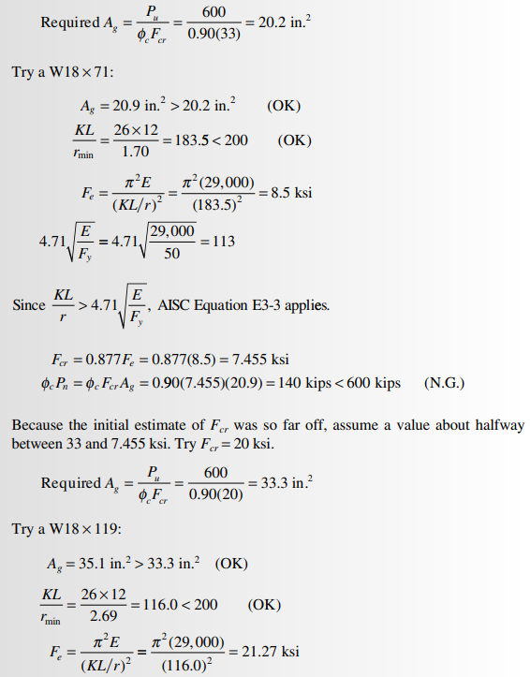

**4. Conclusion**

* The design of compression members involves selecting a section that meets **strength and stability requirements**.
* The **column load tables** simplify the selection process.
* **Iterative adjustments** may be needed for the most economical design.