1

**Electronic Circuit**

**Lecture 4 ( ${ 6}^{th }\& 7 and 8$ Week)**

**Power Amplifier**

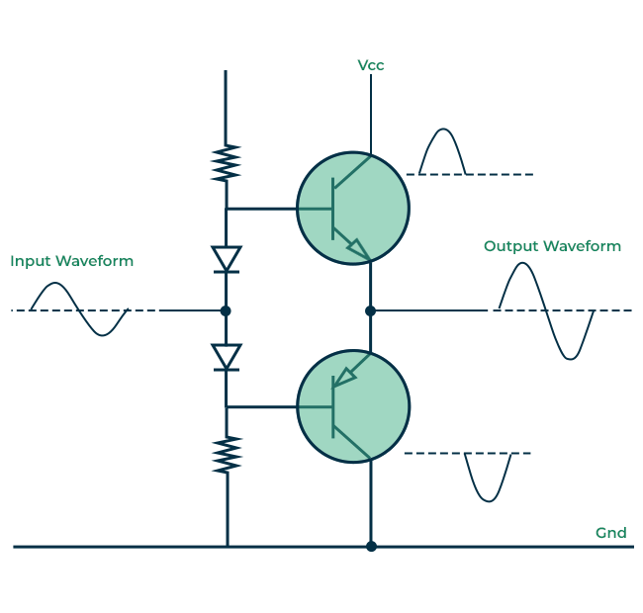

* 1. **Introduction**

An amplifier receives a signal from some pickup transducer or other input source and provides a larger version of the signal to some output device or to another amplifier stage. An input transducer signal is generally small (a few millivolts from a cassette or CD input, or a few microvolts from an antenna) and needs to be amplified sufficiently to operate an output device (speaker or other power-handling device). In small-signal amplifiers, the main factors are usually amplification linearity and magnitude of gain. Since signal voltage and current are small in a small-signal amplifier, the amount of power-handling capacity and power efficiency are of little concern. A voltage amplifier provides voltage amplification primarily to increase the voltage of the input signal. Large-signal or power amplifiers, on the other hand, primarily provide sufficient power to an output load to drive a speaker or other power device, typically a few watts to tens of watts.

**1.2. AMPLIFIERS TYPES**

One method used to categorize amplifiers is by class. Basically, amplifier classes represent the amount the output signal varies over one cycle of operation for a full cycle of input signal. A brief description of amplifier classes is provided next.

Class A: The output signal varies for a full 360° of the input signal. Figure 12.1 a shows that this requires the Q -point to be biased at a level so that at least half the signal

swing of the output may vary up and down without going to a high enough voltage to be limited by the supply voltage level or too low to approach the lower supply level, or 0 V in this description.

Class B: A class B circuit provides an output signal varying over one-half the input signal cycle, or for 180° of signal, as shown in Fig. 12.1 b. The dc bias point for class B is at 0 V, with the output then varying from this bias point for a half-cycle. Obviously, the output is not a faithful reproduction of the input if only one half-cycle is present.

Two class B operations one to provide output on the positive-output half-cycle and another to provide operation on the negative-output half-cycle are necessary. The combined half-cycles then provide an output for a full 360° of operation. This type of connection is referred to as push pull operation, which is

discussed later in this chapter. Note that class B operation by itself creates a very distorted output signal since reproduction of the input takes place for only 180° of the output signal swing

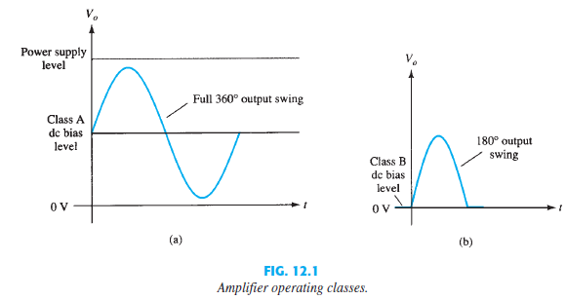

**Class AB:** A n amplifier may be biased at a dc level above the zero-base-current level of class B and above one-half the supply voltage level of class A; this bias condition is class AB. Class AB operation still requires a push pull connection to achieve a full output cycle, but the dc bias level is usually closer to the zero-base-current level for better power efficiency, as described shortly. For class AB operation, the output signal swing occurs between 180° and 360° and is neither class A nor class B operation.

**Class C**: The output of a class C amplifier is biased for operation at less than 180° of the cycle and will operate only with a tuned (resonant) circuit, which provides a full cycle of operation for the tuned or resonant frequency. This operating class is therefore used in special areas of tuned circuits, such as radio or communications.

**Class D:** This operating class is a form of amplifier operation using pulse (digital) signals, which are on for a short interval and off for a longer interval. Using digital techniques makes it possible to obtain a signal that varies over the full cycle (using sample and-hold circuitry) to recreate the output from many

pieces of input signal. The major advantage of class D operation is that the amplifier is “on” (using power) only for short intervals and the overall efficiency can practically be very high, as described next.

**Amplifier Efficiency**

The power efficiency of an amplifier, defined as the ratio of power output to power input, improves (gets higher) going from class A to class D. In general

terms, we see that a class A amplifier, with dc bias at one-half the supply voltage level, uses a good amount of power to maintain bias, even with no input signal applied. This results in very poor efficiency, especially with small input signals, when very little ac power is delivered to the load. In fact, the maximum

efficiency of a class A circuit, occurring for the largest output voltage and current swing, is only 25% with a direct or series-fed load connection and 50% with a transformer connection to the load. Class B operation, with no dc bias power for no input signal, can be shown to provide a maximum efficiency that reaches 78.5%. Class D operation can achieve power efficiency over 90% and provides the most efficient operation of all the operating classes. Since class AB falls between class A and class B in bias, it also falls between their efficiency ratings between 25% (or 50%) and 78.5%. T able 1 2.1 summarizes the operation of the various amplifier classes. This table provides a relative comparison of the output cycle operation and power efficiency for the various class types. In class B operation, a push pull connection is obtained using either a transformer coupling

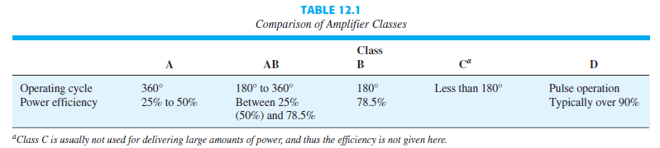

Class C is usually not used for delivering large amounts of power, and thus the

efficiency is not given here. or by using complementary (or quasi-complementary)boperation with npn and pnp transistors to provide operation

on opposite-polarity cycles. Although transformer operation can provide opposite-cycle signals, the transformer itself is quite large in many applications. A transformer less circuit using complementary transistors provides the same operation in a much smaller package

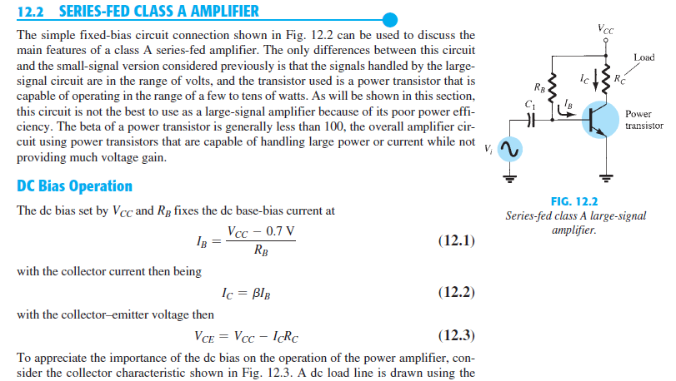

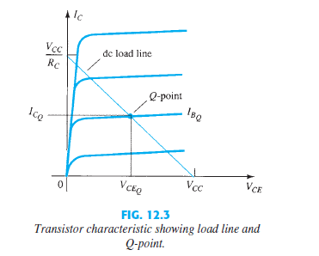

**AC Operation**

When an input ac signal is applied to the amplifier of Fig. 12.2 , the output will vary from its dc bias operating voltage and current. A small input signal, as shown in Fig. 1 2.4, will cause the base current to vary above and below the dc bias point, which will then cause the collector current (output) to vary from the dc bias point set as well as the collector emitter voltage to vary around its dc bias value. As the input signal is made larger, the output will vary further around the established dc bias point until either the current or the voltage reaches a limiting condition. For the current this limiting condition is either zero current at the low end or VCC > RC at the high end of its swing. For the collector emitter voltage, the limit is either 0V or the supply voltage, VCC .

