1

**EXP.NO.2: SINGAL OPERATION**

**1- What Does Signal Mean?**

A signal is an electrical or electromagnetic current that is used for carrying data from one device or network to another.

**It is the key component behind virtually all:**

* Communication
* Computing
* Networking
* Electronic devices

**2- Classification of signal:**

1. Continuous-time and Discrete-time signals.
2. Real and complex signals
3. Deterministic and Random Signals
4. Periodic and Non-periodic signals
5. Even and Odd signals
6. Energy and Power signals

7.Analog and Digital signals

**3- Analog Signals vs. Digital Signals**

 A signal is an electromagnetic or electrical current that carries data from one system or network to another. In electronics, a signal is often a time-varying voltage that is also an electromagnetic wave carrying information, though it can take on other forms, such as current. There are two main types of signals used in electronics: analog and digital signals.

**Analog Signal**

An analog signal is time-varying and generally bound to a range (e.g. +12V to -12V), but there is an infinite number of values within that continuous range. An analog signal uses a given property of the medium to convey the signal’s information, such as electricity moving through a wire. In an electrical signal, the voltage, current, or frequency of the signal may be varied to represent the information. Analog signals are often calculated responses to changes in light, sound, temperature, position, pressure, or other physical phenomena.

When plotted on a voltage vs. time graph, an analog signal should produce a smooth and continuous curve. There should not be any discrete value changes as can see in Fig. 1.

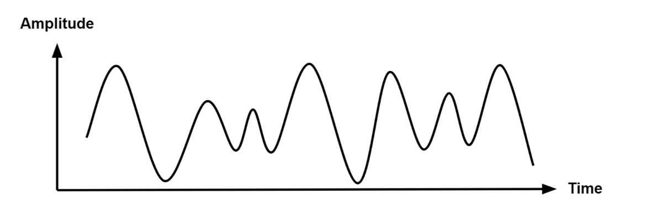

Figure 1: Analog Signal.

**Digital Signal**

A digital signal is a signal that represents data as a sequence of discrete values. A digital signal can only take on one value from a finite set of possible values at a given time.

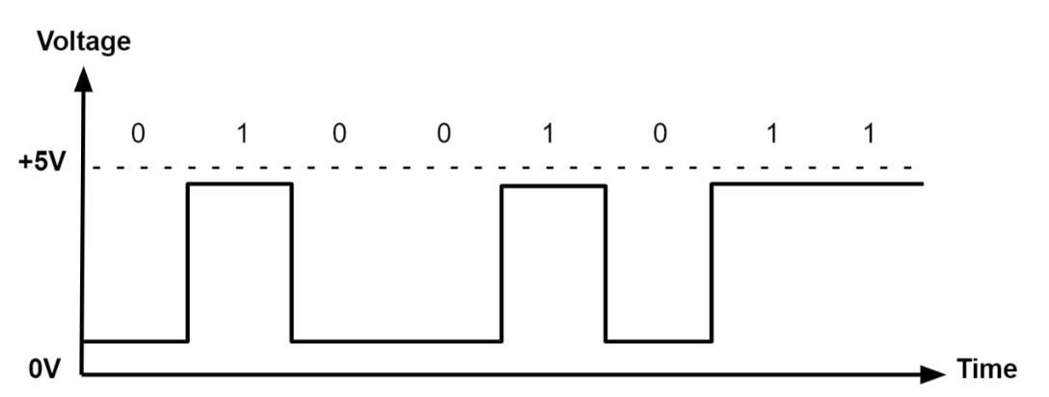

Figure 2: Digital Signal.

**4- Signal Operations**

In this section, we discuss three useful signal operations: inversion, shifting, and scaling.

* Time Inversion: simply flipping the signal about the y-axis.
* Time Shifting: simply shifting the signal in time. When we add a constant to the time, we obtain the advanced signal, and when we decrease the time, we get the delayed signal.
* Time Scaling: is defined as the process of compression or expansion of the time of a signal.

**Coding:**

1- Time Reversal

Time Reversal operation flips each sample of the signal about t=0 or n=0 to obtain a folded sequence. In MATLAB fliplr(x) function is used to flip the sample values and –fliplr(x) is used to flip the indices.

inc=0.1;

t=-10:inc:10;

f=0.1;

a=2; % Amplitude

x=a*sin(2*pi*f*t);

rx=fliplr(x);

rt=-1*fliplr(t);

l=length(x);

subplot(211);

plot(t,x);

title('Original SIgnal');

subplot(212);

plot(rt,rx);

title('Reflected/flipped SIgnal');

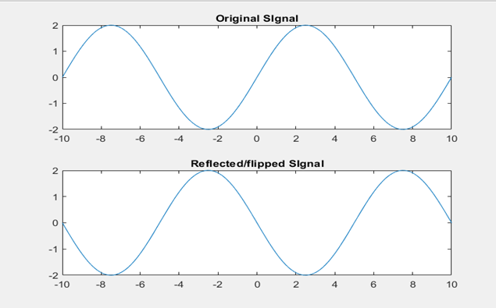

Figure 3: Time Reversal signal.

2- Time Shifting

Time Shift or delay operation shifts the signals to the desired delay. Given a signal $x(t)$ a shifted signal will be of the form $y(t)= x(t- to)$ where to is the delay or shift in time domain. Let $Asin(2πft)$ is the signal which is desired to be shifted by an amount to. Here is the MATLAB code for it.

inc=0.1;

t=-10:inc:10;

f=0.1;

t0=2; % Shift Units

a=2; % Amplitude

x=a*sin(2*pi*f*t);

y=a*sin(2*pi*f*(t+t0));

subplot(311);

hold on;

plot(t,x);

plot(t,y,'r');

title('Original and Shifted Signal');

subplot(312);

plot(t,x);

title('Original SIgnal');

subplot(313);

plot(t,y);

title('Shifted SIgnal');

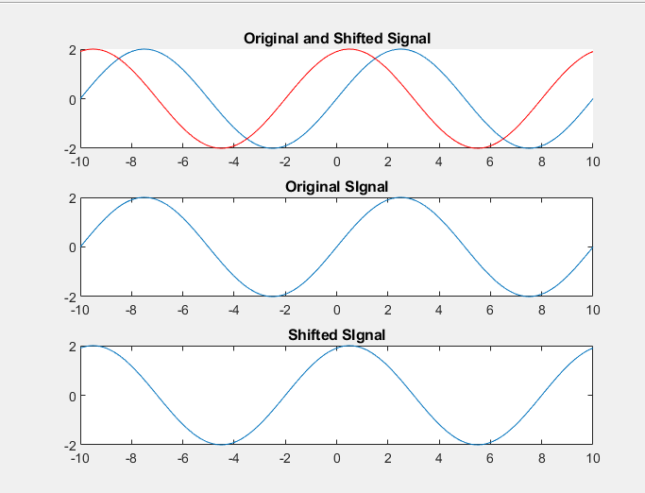

Figure 4: Time Shifting.

3- Time Scaling

Operation of time scaling scales the time axis to a certain scale resulting in increasing or decreasing the frequency of the signal which compresses or expands the signal on time domain. General expression for the time scaled output is given below. Let $Asin(2πft)$ is the original signal on time scale.

We scale the $t$ domain by amount alpha and beta. Alpha scaled signal will be compresses due to increment in frequency while beta scaled signal will be expanded. Exampled is coded below.

inc=0.1;

t=-10:inc:10;

f=0.1;

alpha=2; % Compression Units

a=2; % Amplitude

beta=0.5; % Expension units

x=a*sin(2*pi*f*t);

y=a*sin(2*pi*f*(alpha*t));

z=a*sin(2*pi*f*(beta*t));

subplot(311);

plot(t,x);

title('Original Signal');

subplot(312);

plot(t,y);

title('Time scaled Compressed SIgnal');

subplot(313);

plot(t,z);

title('Time Scaled Expanded SIgnal');

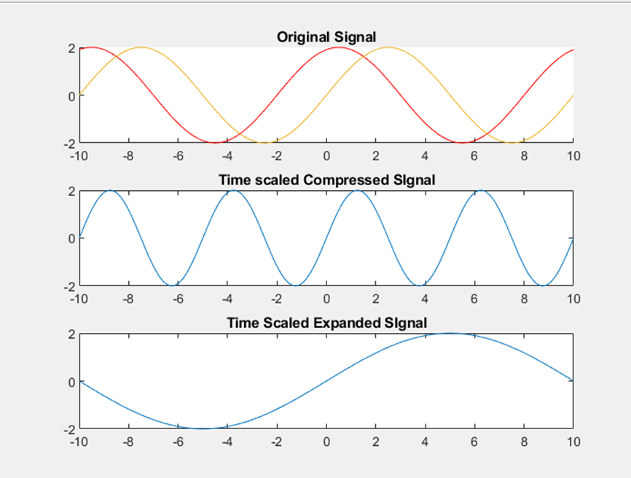

Figure 5: Time Scaling.