1

**EXP.NO.2:** **Frequency Modulation and Demodulation (FM)**

**It is the key component behind virtually all:**

1- Analog Communication Trainer

2- Oscilloscope

**Part 1: Modulation**

Frequency modulation is a technique or a process of encoding information on a particular signal (analog or digital) by varying the carrier wave frequency by the frequency of the modulating signal. As we know, a modulating signal is nothing but information or message that has to be transmitted after being converted into an electronic signal.

Much like amplitude modulation, frequency modulation also has a similar approach where a carrier signal is modulated by the input signal. However, in the FM case, the modulated signal's amplitude is kept or remains constant.

**Applications of Frequency Modulation:**

If we talk about the applications of frequency modulation, it is mostly used in radio broadcasting. It offers a great advantage in radio transmission as it has a larger signal-to-noise ratio. Meaning it results in low radio frequency interference. This is the main reason that many radio stations use FM to broadcast music over the radio.

Additionally, some of its uses are also found in radar, telemetry, seismic prospecting, EEG, different radio systems, music synthesis as well as in video-transmission instruments. In radio transmission, frequency modulation has a good advantage over other modulation. It has a larger signal-to-noise ratio meaning it will reject radio frequency interferences much better than an equal power amplitude modulation (AM) signal. For this major reason, most music is broadcasted over FM radio.

**Modulation Index (β):**

Is the ratio of maximum deviation in frequency of the modulating signal**.**

**β=∆f/f_m**

**Advantages and Disadvantages of Frequency Modulation:**



**Circuit diagram and its output**

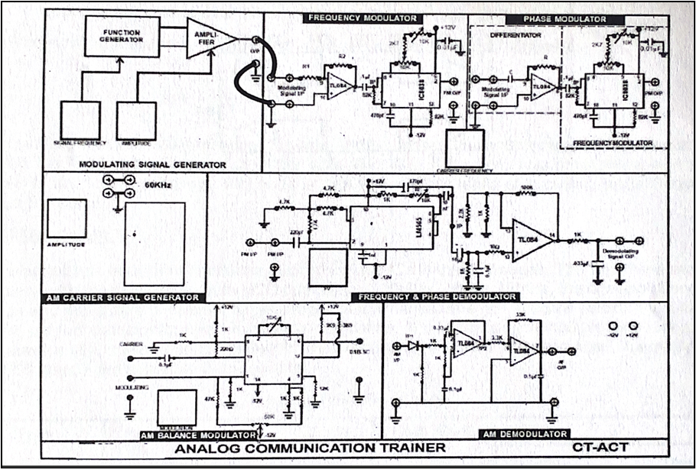

**Figure 1. Connection diagram of Frequency Modulation.**

**Graphical Representation of Frequency Modulated Wave:**

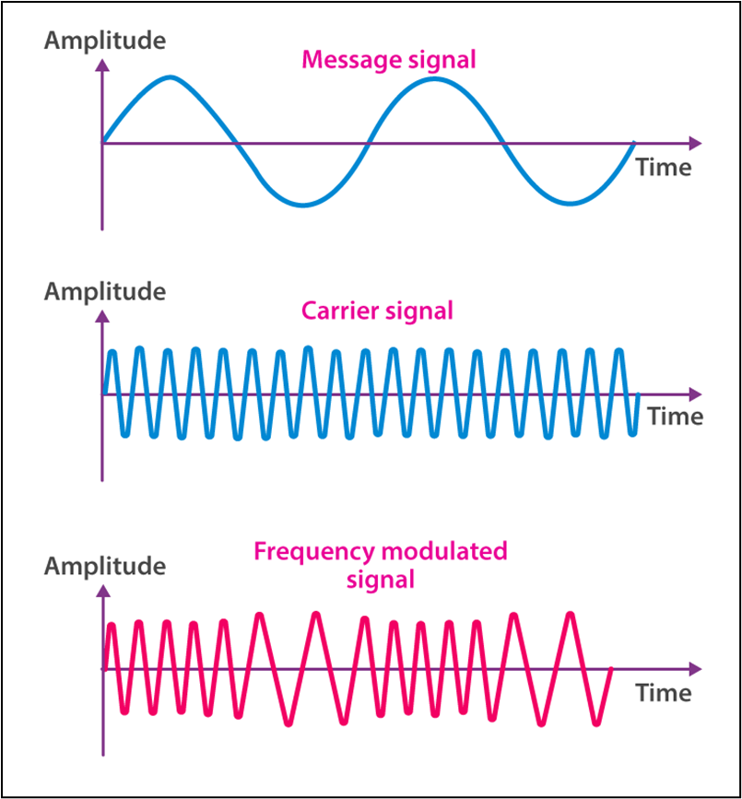

**Figure 2. The output of Frequency modulation.**

If we observe the graph, we will notice that the frequency of a carrier increases when the amplitude of the input signal is increased. Here, the carrier frequency is maximum when the input signal is at its highest. Meanwhile, the frequency of a carrier decreases if the amplitude of the modulating signal goes down. What it means is that the carrier frequency is minimum when the input signal is at its lowest.

**Part 2/ Demodulation**

For communication to work, both the sender and the receiver must agree on what communication channel to use. After which, the sender encodes the message and transmits it to the receiver. Then, the receiver receives the message and decodes it. This holds true to FM: the transmitted FM signal is received and must be demodulated to take the information. This is what FM detectors do.

**Circuit diagram and its output:**

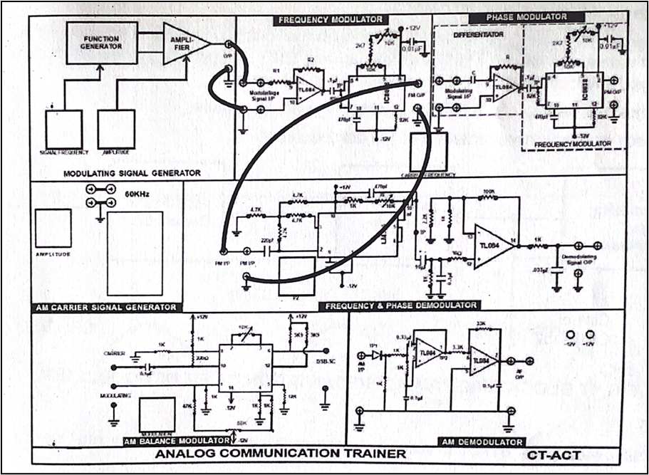

**Figure 3. Connection diagram of Frequency Demodulation.**

**Graphical Representation of Frequency Demodulated Wave:**

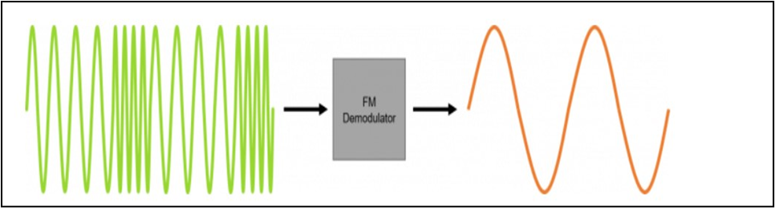

**Figure 4. Demodulation Output.**