1

**Experiment No.4**

**Star-Star connection**

**Objective:**

The purpose of this circuit is:

To investigate the phase transformer connection using three single phase transformers and to determine the equivalent circuit, voltage regulation and efficiency of three phase transformers. Also, to observe magnetizing currents, study non-linearity and harmonic generation in three- phase transformers.

**Component:**

* + - * 1. THREE_ PHASE_WYE.
        2. Transformer (TS-IDEAL).
        3. SWITCH.
        4. Potentiometer
        5. Ammeter.
        6. Voltmeter.

**Method of Work:**

The primary side is star connected. Hence fewer numbers of turns are required. This makes the connection economical for large high voltage step down power transformers. The Y- Y connection has no problem with third harmonic components due to circulating currents and it is also more stable to unbalanced loads since the D partially redistributes any imbalance that occurs.

The star connected

winding carries third harmonic current due to which potential of neutral point is stabilized. Some saving in cost of insulation is achieved if HV side is star connected. But

in practice the HV side is normally connected in star so that the three phase loads like motors and single-phase loads like lighting loads can be supplied by LV side using three phase four wire system.

As Grounding Transformer: In Power System Mostly Grounded Y- Y transformer is used for no other purpose than to provide a good ground source in ungrounded star system. Take, for example, a distribution system supplied by Y connected (i.e., ungrounded) power source.

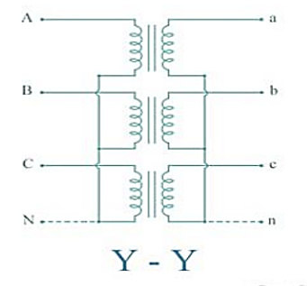

Figure1: Three phase transformer connection test

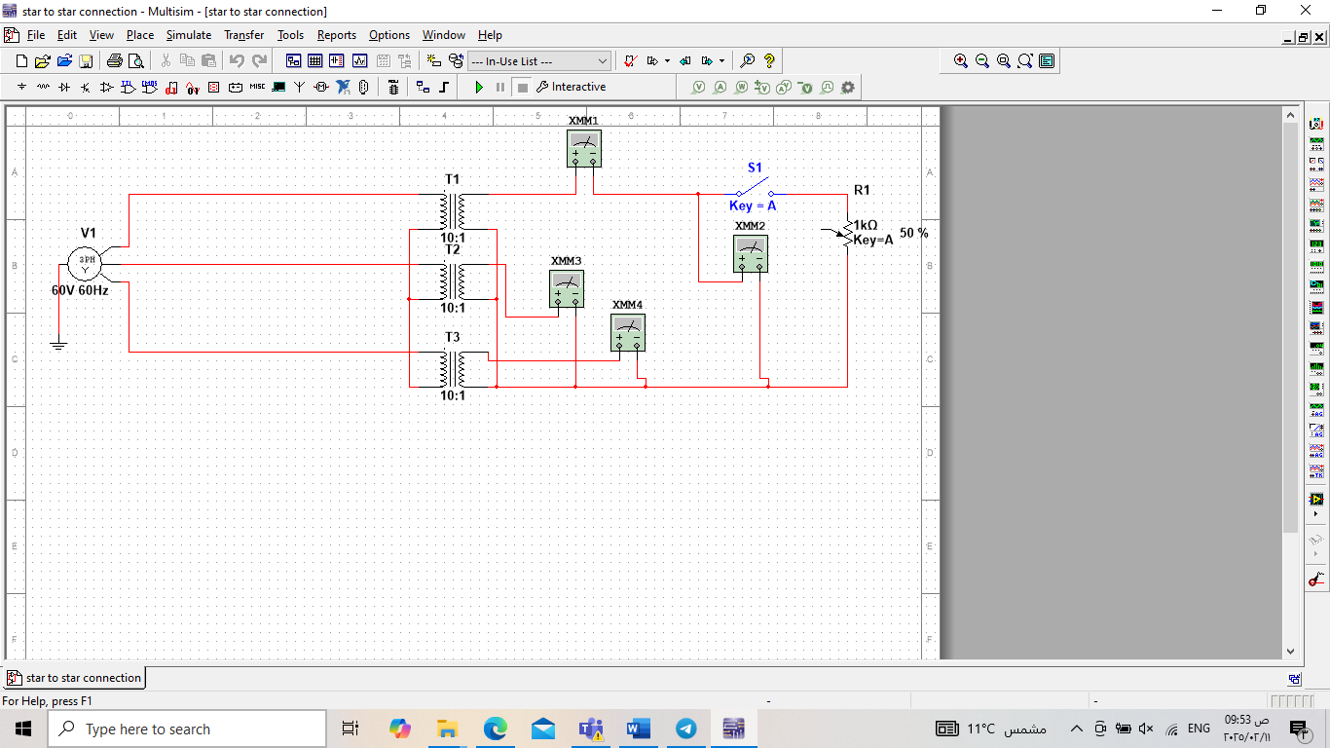

Fig.2:Star to star connection in Multisim