1

# EXP.NO: 1

# Name of experiment: Open circuit test (No load)

**Purpose of experiment:**

The purpose of this circuit is:

1. To understand the basic working principle of a transformer.
2. To obtain the equivalent circuit parameters from open circuit and short circuit tests.

**Apparatus**:

1. AC Voltage.
2. Inductor.
3. Wattmeter.
4. Ammeter.
5. Voltmeter.
6. Transformer (TS-IDEAL).
7. Step down transformer (N1=100H&N2=10H)

**Theory**

It is an electrical connection in which there is a break in the path in which electric current flows. This may result in High resistance, no current flow, etc., Open circuit test or no-load test on a transformer is performed to determine 'no load loss (core loss) and no-load current Io. The circuit diagram for open circuit test is shown in figure below.

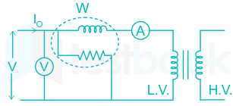

n the circuit diagram, the voltmeter(V), ammeter (A) and wattmeter(W) were all connected on the low-voltage side of the transformer, which is supplied at rated voltage(V1). The secondary winding side is left open, so which a small amount of current(I0) is flowing in primary winding. Here, I0 is called as no – load current. The reading of the wattmeter gives the iron loss.Usually high voltage (HV) winding is kept open, and the low voltage (LV) winding is connected to its normal supply. A wattmeter (W), ammeter (A) and voltmeter (V) are connected to the LV winding as shown in the figure (1).

**Procedure:**

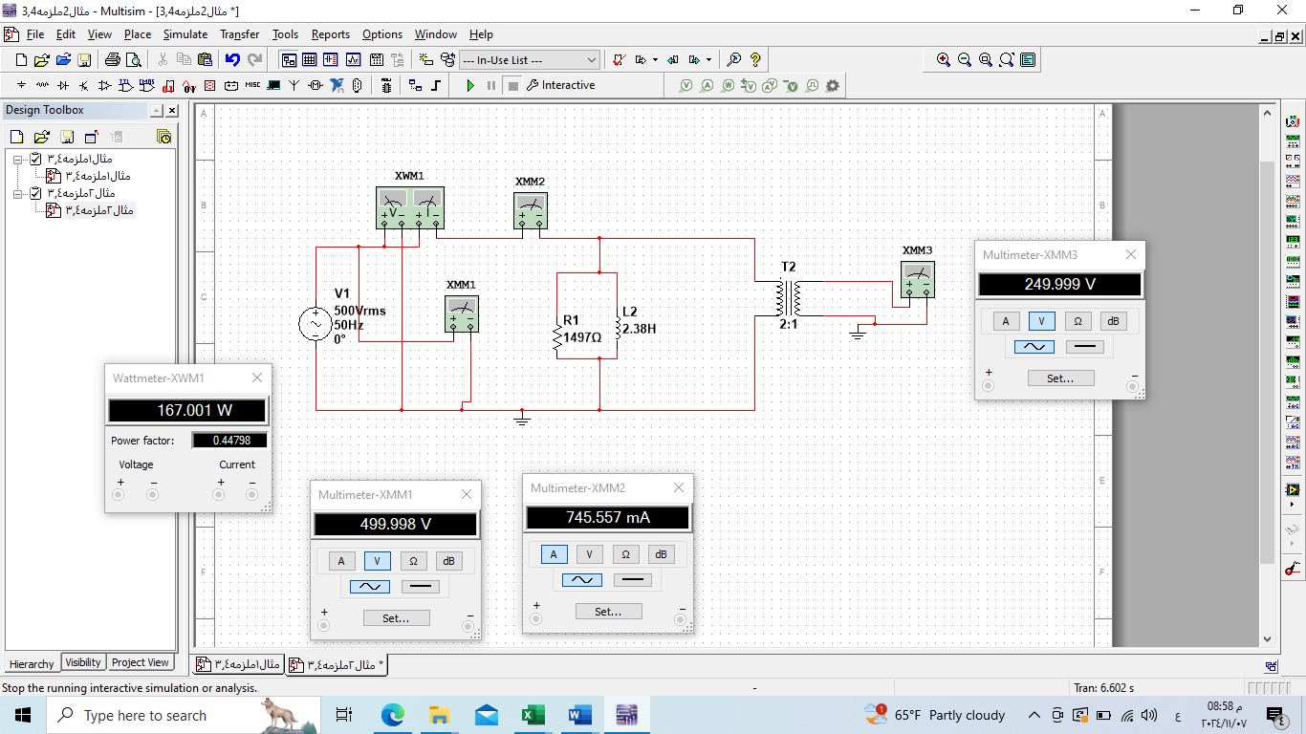Figure2: Multisim open circuit test