1

Experiment No: 3

**Three Phase transformer**

**Objective**

The purpose of this circuit is:

To investigate the phase transformer connection using three single phase transformers and to determine the equivalent circuit, voltage regulation and efficiency of three phase transformers. Also, to observe magnetizing currents, study non-linearity and harmonic generation in three- phase transformers.

**Component of Circuit**

* + - * + THREE_ PHASE_WYE.
        + Transformer (TS-IDEAL).
        + SWITCH.
        + Potentiometer
        + Ammeter.
        + Voltmeter.

**1.Three phase transformer connection**

Three Phase Transformer Connections Windings of a three-phase transformer can be connected in various configurations as (i) Star-star (ii) Delta-delta (iii) Star-delta (iv) Delta-star (v) Open delta (vi) Scott connection. These configurations are explained below. The primary winding is star (Y) connected with grounded neutral and the secondary winding is delta connected.

* This connection is mainly used in step down transformer at the substation end of the transmission line.
* The ratio of secondary to primary line voltage is 1/√3 times the transformation ratio.
* There is 30° shift between the primary and secondary line voltages.

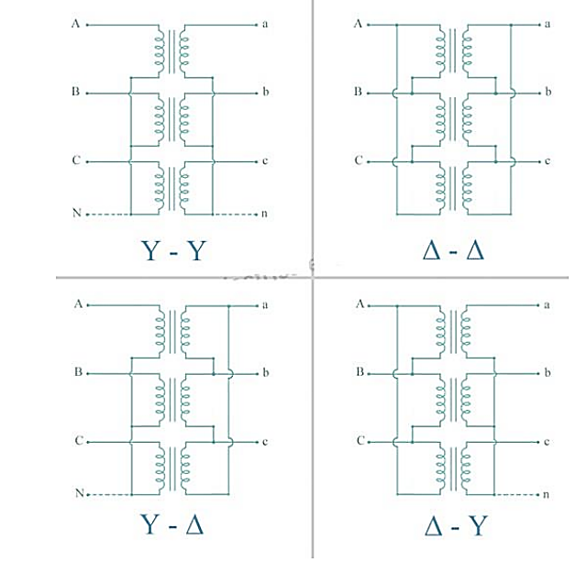

Figure (1). Three phase transformer connection

* 1. **Star -Delta connection (Y-∆)**

1. As Primary in Star connected while the secondary in delta connected

2. Line voltage on Primary side = √3 X Phase voltage on Primary side.

3. Phase voltage on Primary side = Line voltage on Primary side / √3

4. Now Transformation Ration (K) = Secondary Phase Voltage / Primary Phase Voltage

5. Secondary Phase Voltage = K X Primary Phase

6.Line voltage on Secondary side = Phase voltage on Secondary side.

7. Secondary Phase Voltage = K X Primary Phase Voltage. =K X (Line voltage on Primary side / √3)

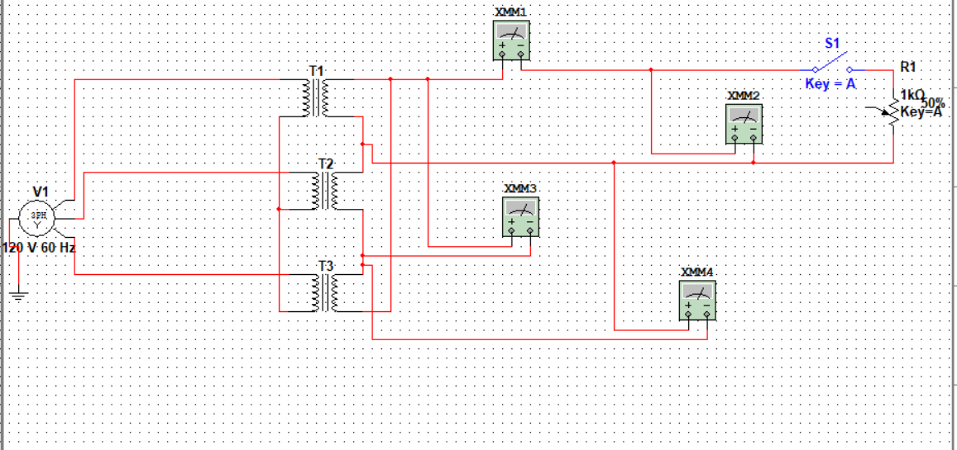

Figure (2). Star to delta connection (Y-∆) in Multisim

* + 1. **Advantage of Star-Delta connection**

1. The primary side is star connected. Hence fewer numbers of turns are required. This makes the connection economical for large high voltage step down power transformers.

2. The neutral available on the primary can be earthed to avoid distortion.

3. The neutral point allows both types of loads (single phase or three phases) to be met.

4. Large unbalanced loads can be handled satisfactory.

5. The Y-D connection has no problem with third harmonic components due to circulating currents and It is also more stable to unbalanced loads since the D partially redistributes any imbalance that occurs.

6. The delta connected winding carries third harmonic current due to which potential of neutral point is stabilized. Some saving in cost of insulation is achieved if HV side is star connected. But in practice the HV side is normally connected in delta so that the three phase loads like motors and single-phase loads like lighting loads can be supplied by LV side using three phase four wire system.

7. As Grounding Transformer: In Power System Mostly Grounded Y- ∆ transformer is used for no other purpose than to provide a good ground source in ungrounded Delta system. Take, for example, a distribution system supplied by ∆ connected (i.e., ungrounded) power source.

**1.2)Star to Star connection (Y-Y)**

Star-star connection is generally used for small, high-voltage transformers. Because of star connection, number of required turns/phase is reduced (as phase voltage in star connection is 1/√3 times of line voltage only). Thus, the amount of insulation required is also reduced. The ratio of line voltages on the primary side and the secondary side is equal to the transformation ratio of the transformers. Line voltages on both sides are in phase with each other. This connection can be used only if the connected load is balanced.

Table of particle results

|  |  |  |  |  |
| --- | --- | --- | --- | --- |
| V3phs | I | V1 | V2 | V3 |
| 60V |  |  |  |  |
| 120V |  |  |  |  |
| 220V |  |  |  |  |

Figure (3). Star to Star connection(Y-Y) in Multisim