1

# EXP.NO: 2

**Name of experiment: Short circuit test (with load)**

**Purpose of experiment:**

The purpose of this circuit is:

1. To understand the basic working principle of a transformer.
2. To obtain the equivalent circuit parameters from open circuit and short circuit tests.

**Apparatus**:

1. AC Voltage.
2. Inductor.
3. Wattmeter.
4. Ammeter.
5. Voltmeter.
6. Transformer (TS-IDEAL).
7. Step down transformer (N1=100H&N2=10H)

**Theory:**

It is a method in electrical engineering used to determine the copper or winding loss and also it determines the impedance of the transformer. The circuit diagram of this is shown below. In this, the secondary winding (low voltage side is shorted by a thick conductor) and on primary side (high voltage side) Ammeter(A), Voltmeter(V) and wattmeter(W) are connected. In [Short Circuit](https://www.electronicshub.org/how-to-find-a-short-circuit-with-a-multimeter/) (SC) test, the primary or HV winding is connected to

the AC supply source through voltmeter, ammeter, wattmeter and a variac as shown in figure. This test is also called as Reduced Voltage Test or Low Voltage Test. As the secondary winding is short circuited, at rated voltage, the transformer draws a very large current due to its very small winding resistance.

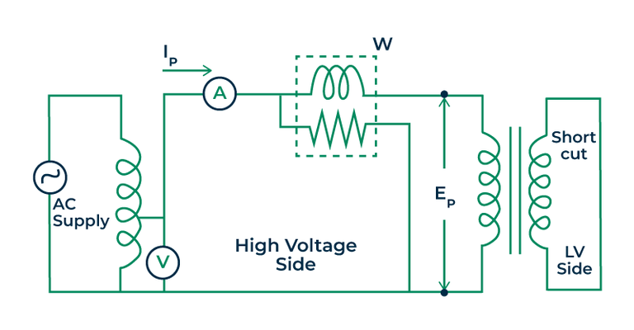Figure 4: Circuit diagram for short circuit test

**Produces and Result of short circuit test:**

