**عنوان المحاضرة:**

**Trigonometric Functions & Relations, Tri Equations, Graphing of Functions الدوال المثلثية وعلاقاتها، المعادلات المثلثية، رسم الدوال المثلثية**

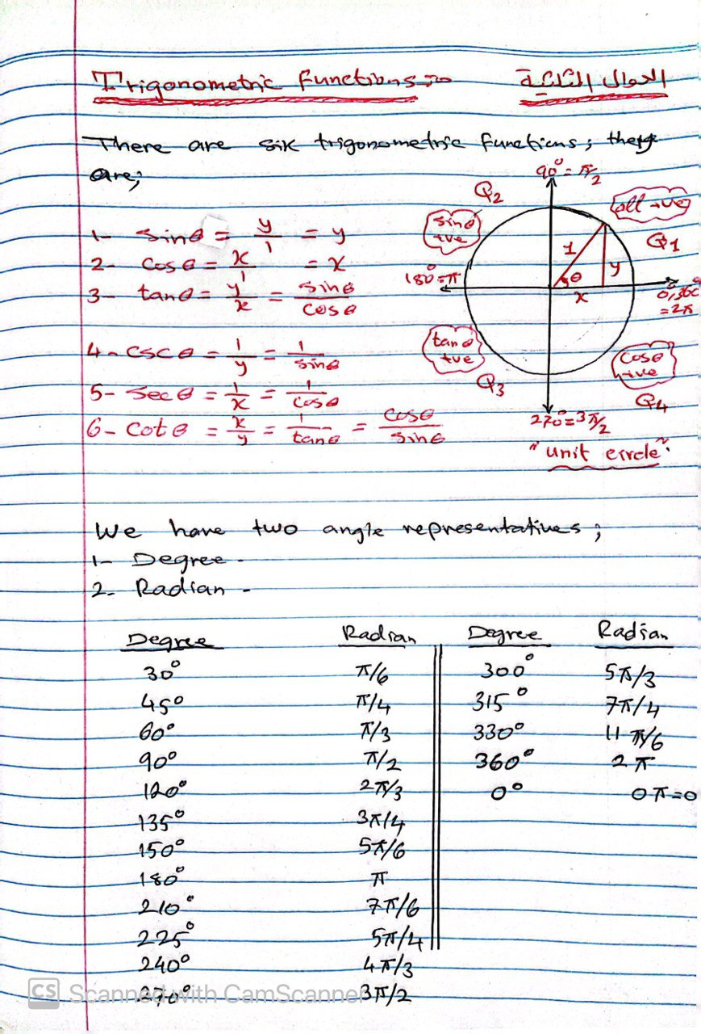

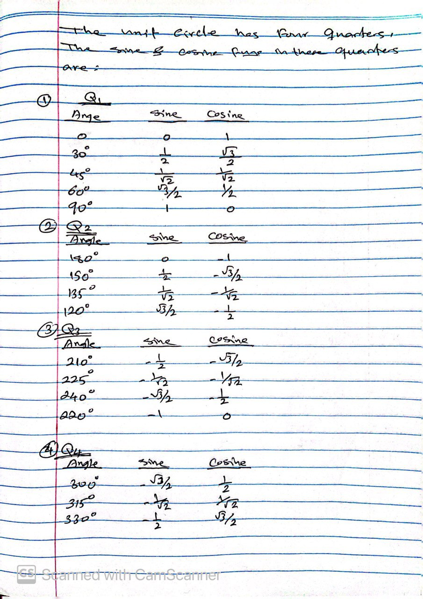

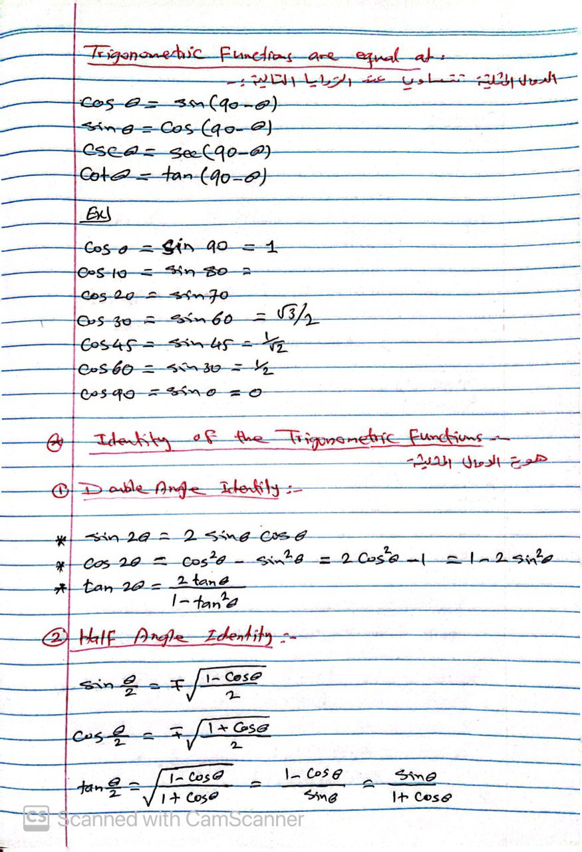

**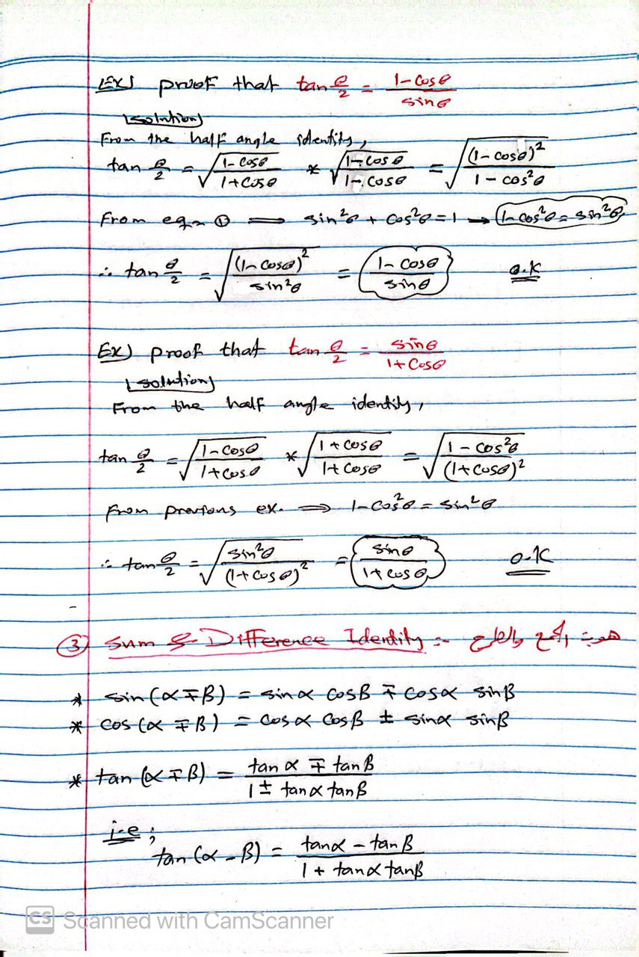  
**

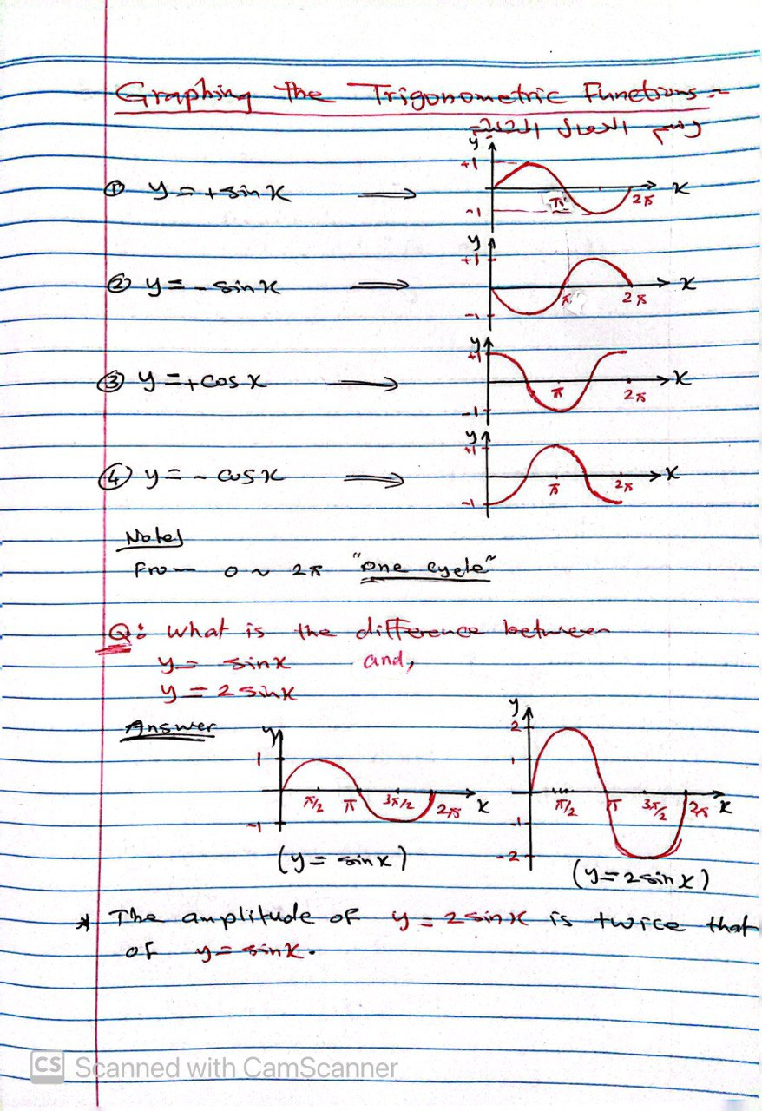

**---- نهاية محاضرة " Trigonometric Functions & Relations, Tri Equations, Graphing of Functions الدوال المثلثية وعلاقاتها، المعادلات المثلثية، رسم الدوال المثلثية" ----**