**عنوان المحاضرة:**

**Hyperbolic Functions and It's Derivatives, Inverse Hyperbolic Functions and It’s Derivatives**

**الدوال الزائدية ومشتقاتها، معكوس الدوال الزائدية ومشتقاتها**

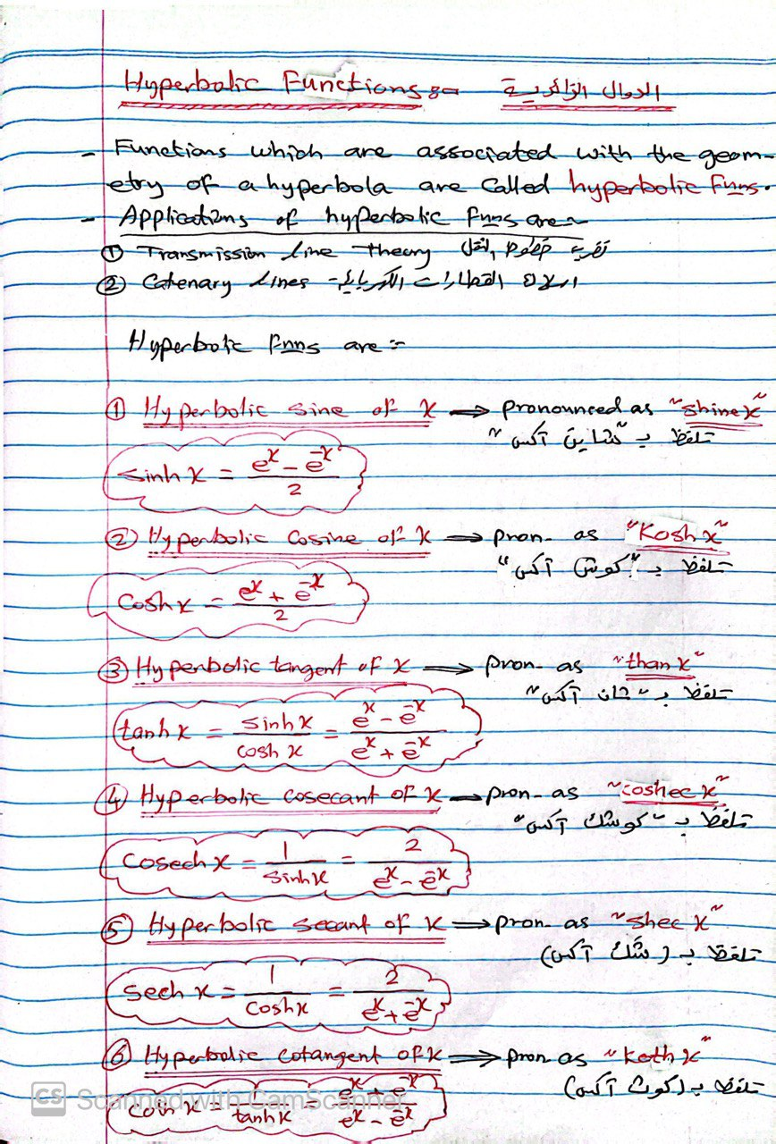

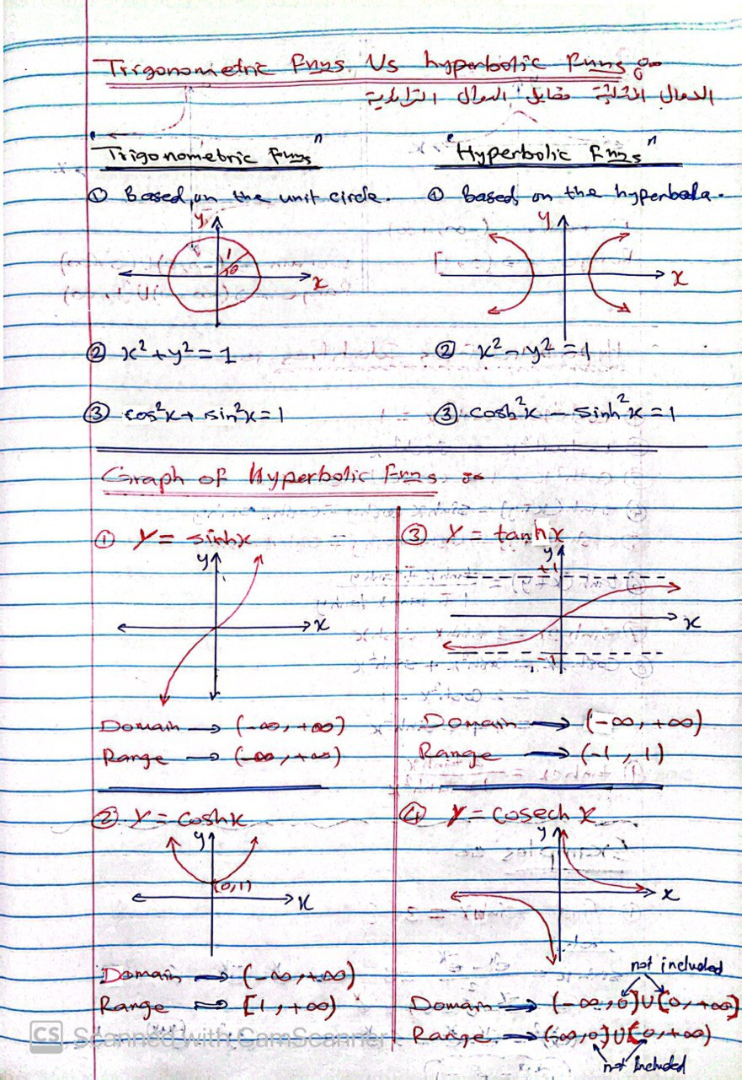

**نهاية محاضرة "Hyperbolic Functions and It's Derivatives, Inverse Hyperbolic Functions and It’s Derivatives**

**الدوال الزائدية ومشتقاتها، معكوس الدوال الزائدية ومشتقاتها"**