**عنوان المحاضرة:**

**Inverse Trigonometric Function and It's Derivatives, Logarithm and Exponential Functions and Their Derivatives**

**مقلوب الدوال المثلثية ومشتقاتها، الدوال اللوغارتمية والاسية ومشتقاتها**

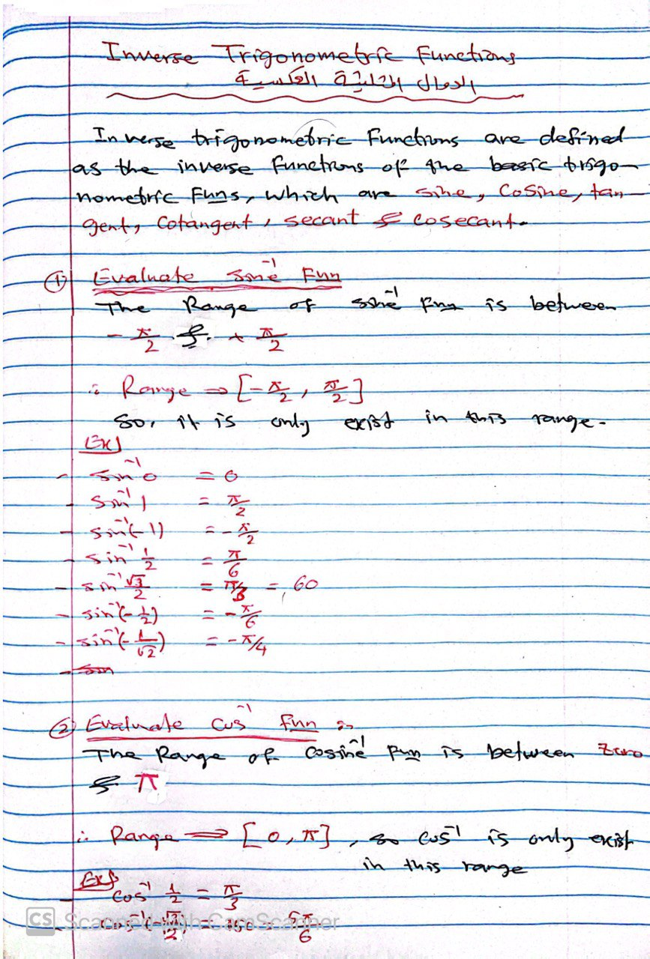

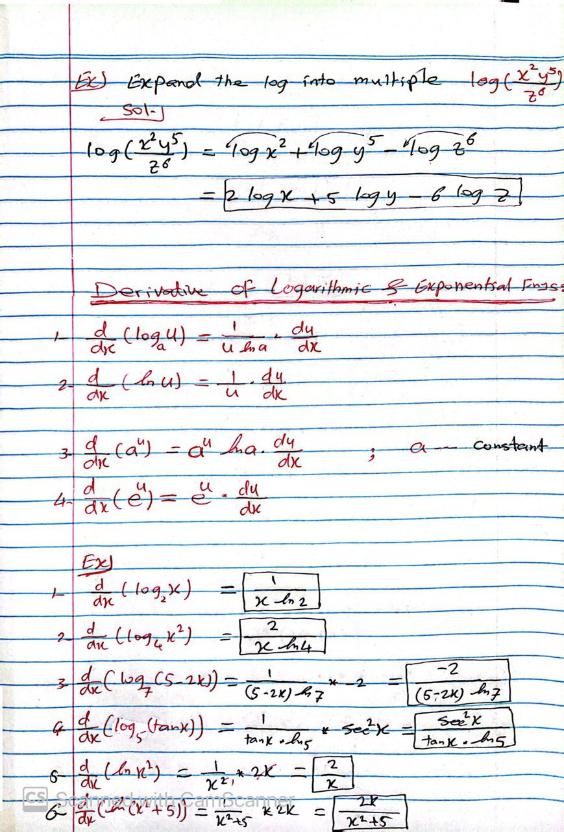

**نهاية محاضرة "Inverse Trigonometric Function and It's Derivatives, Logarithm and Exponential Functions and Their Derivatives**

**مقلوب الدوال المثلثية ومشتقاتها، الدوال اللوغارتمية والاسية ومشتقاتها"**