

LEC 9&10 Dr.Muayad Hashim
White and Red Lesions of the Oral Mucosa Lesions the Oral Mucosa
THESE LESIONS INCLUDE DISORDERS OF THE ORAL MUCOSA THAT CLINICALLY APPEAR EITHER RED OR BOTH IN COLOUR.

A white appearance of the oral mucosa may be caused by :
- The oral epithelium may be stimulated to an increased production of keratin (hyperkeratosis)
- An abnormal but benign thickening of stratum spinosum
- Intra and extracellular accumulation of fluid in the epithelium may also result in clinical whitening of mucosa.
- Necrosis of the oral epithelium
( occurs when the oral mucosa is exposed to toxic chemicals. Microbes, particularly fungi, can produce whitish pseudomembranes consisting of sloughed epithelial cells or debris, fungal mycelium, and neutrophils, which are loosely attached to the oral mucosa.).

A red lesion of the oral mucosa may develop as the result of:
- Atrophic epithelium,characterized by a reduction in the number of epithelial cells. Or increased vascularization.

Classification

Hci-cdi!.ury
i- Leukoedema
z- White Sponge Nevus
Infectious
- Oral Hairy Leukoplakia
I- Koplik’s SpOts
Letilioplaltia

Erythroplalcia

  - Hereditary Benign
Intraepithelial Dyskeratosis
- Candidiasis
- Mucous Patches
Atitoiitmnttine
i.
z.
3
Oral Lichen Planus Lichenoid Reactions Lupus Erythematosus

  - Dyskeratosis Congenita
- Parulis

Re.uc?ive/1nfl.uin1natorj' i- Linea Alba (White Line)
z- Frictional (Traumatic) Keratosis
    - Cheek Chewing
    - Chemical Injuries of the Oral Mucosa
- uremic stomatitis
- Actinic Keratosis (Cheilitis)
- Smokeless Tobacco—lnduced Keratosis
- Nicotine Stomatitis

Miscellaneous Lesions Fordyce’s Granules Geographic Tongue
Hairy Tongue (Black Hairy Tongue
Oral Submucous Fibrosis



Premalignant Lesions 1.Oral leukoplakia :
Oral leukoplakia is defined as a predominantly white lesion of the oral mucosa that cannot be characterized clinically or pathologically as any other definable lesion.
This disorder can be further divided into a homogeneous and a non homogeneous type.
The nonhomogeneous type of oral leukoplakia may have white patches or plaque intermixed with red tissue. also been called erythroleukoplakia and speckled leukoplakia. Both homogeneous and non homogeneous leukoplakias may be encountered in all sites of the oral mucosa. Oral leukoplakias, where the white component is dominated by papillary projections, similar to oral papillomas, are referred to as verrucous
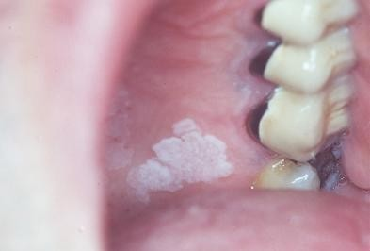or verruciform leukoplakias. The clinical forms, planner, verruciform, speckeled, snuff and dipper are types of tobacco associated leukopakia. The floor of the mouth and the lateral borders of the tongue are high-risk sites for malignant transformation.
The typical homogeneous leukoplakia is clinically characterized as a white, well-demarcated plaque with an identical reaction pattern

Plaque

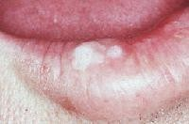

throughout the entire lesion. The lesions are asymptomatic in most patients. There is a lack of a peripheral erythematous zone in homogeneous Oral leukoplakia

verrucous leukoplakia
- Erythroplakia
Is defined as a red lesion of the oral mucosa that cannot be characterized as any other definable lesion.
The lesion comprises an eroded red velvety lesion that is frequently observed with distinct not well demarcated borders.



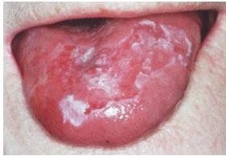
Erythroplakia is usually no symptomatic, although some patients may experience a burning sensation in conjunction with food intake.
The provisional diagnosis is based on the clinical observation of a white or red patch that is not explained by a definable cause, such as trauma. If trauma is suspected, the cause, such as a sharp tooth cusp or restoration, should be eliminated. If healing does not occur in 2 weeks, biopsy is essential to rule out malignancy
3- Oral Submucous Fibrosis (OSMF)

Is a chronic disease that affects the oral mucosa as well as the pharynx and the upper two-thirds of the esophagus. It appears clinically, paler mucosa, which may comprise white marbling.

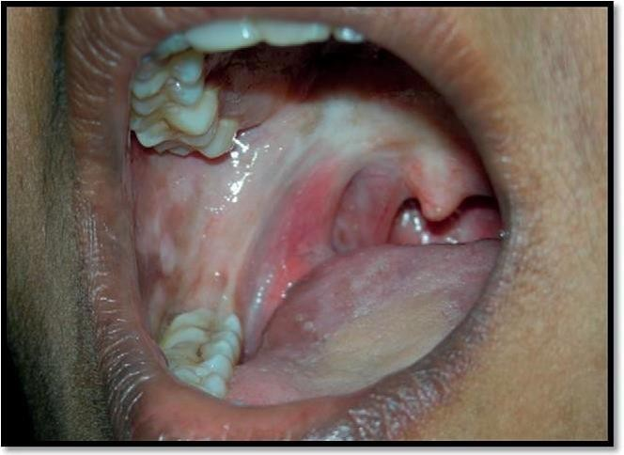

The most prominent clinical characteristics will appear later in the course of the disease and include fibrotic bands located beneath an atrophic epithelium.
Increased fibrosis eventually leads to loss of resilience, which interferes with speech, tongue mobility, and a decreased ability to open the mouth

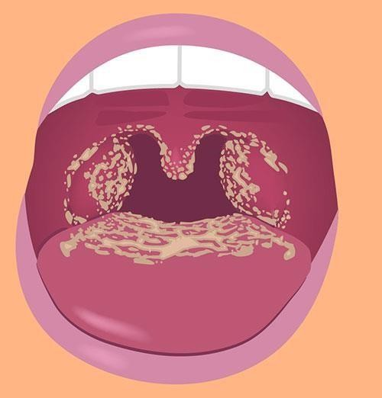

INFECTIOUS DISEASES
  - Oral candidiasis the most prevalent opportunistic infection affecting the oral mucosa. In the vast majority of cases, the lesions are caused by the yeast Candida albicans. The pathogenesis is not fully understood, but a number of predisposing factors have the capacity to convert
Candida from the normal | commensal | flora(saprophytic | stage) | to | a pathogenic
organism (parasitic stage).
Symptoms
Candidiasis in the mouth |  |  |  |  | and throat can have many
different symptoms, |  |  |  |  | including:
-White patches on the inner |  |  |  |  | cheeks, tongue, roof of the
mouth, and throat (photo |  |  |  |  | showing candidiasis in the
mouth)
-Redness or soreness

-Cotton-like feeling in the mouth
-Loss of taste
-Pain while eating or swallowing Cracking and redness at the corners of the mouth

1- Acute Pseudomembranous Candidiasi» (Thrush)

    - lt is a superficid infection of the outer
of tfie
and it

resulo the b rmation of patchy

mucosd surface.
white

plaques
or flecks

on the

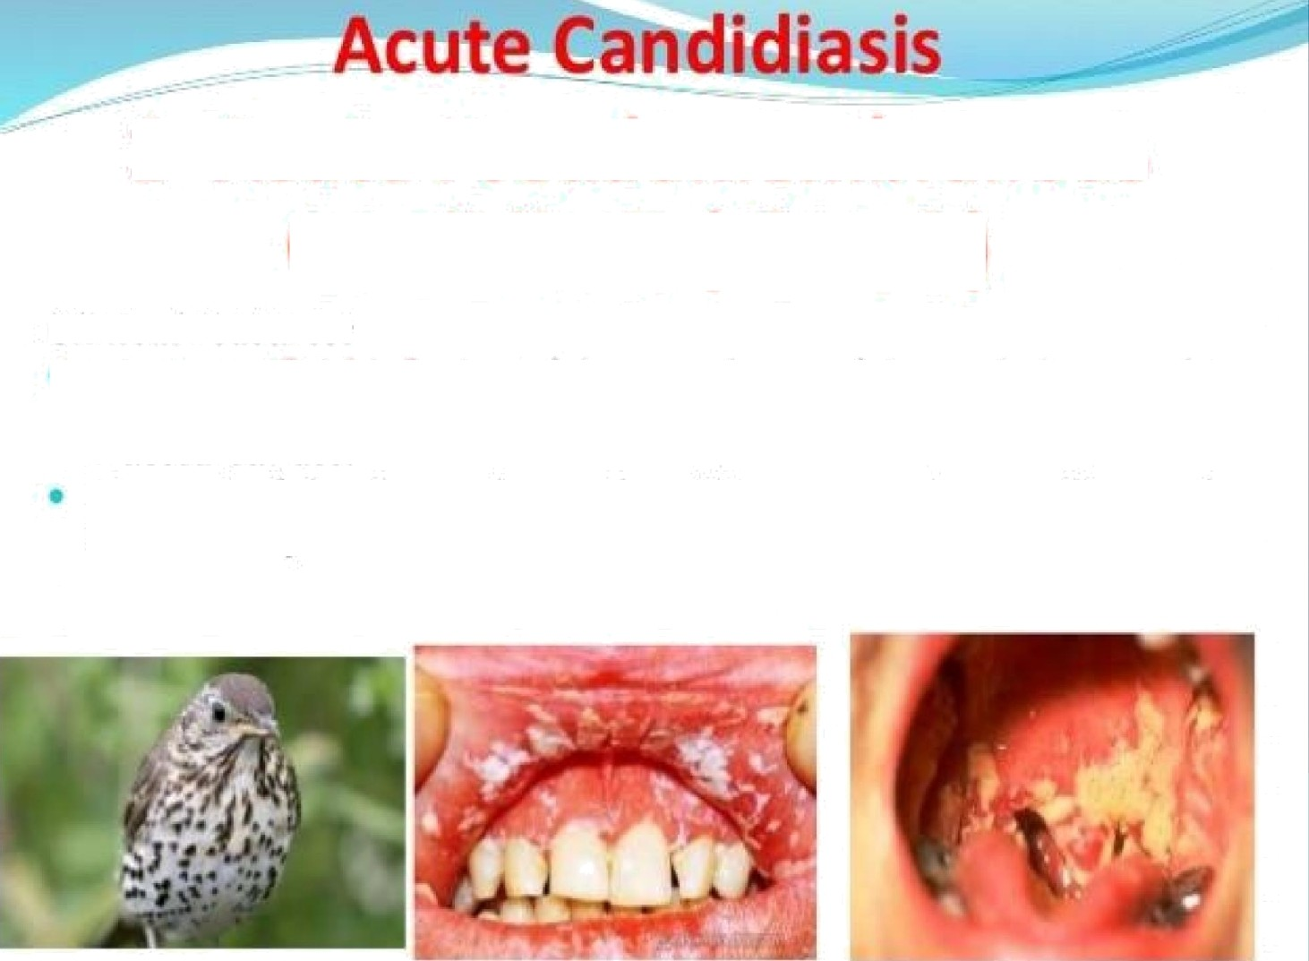.Rn.. a«l :« a1:«ir.bz,&..n«bc«b‘:isa

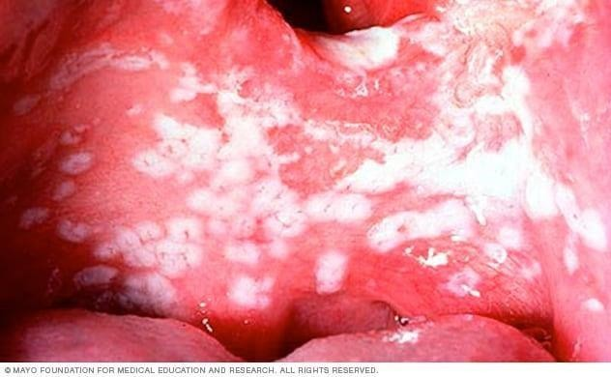

Thrush

The acute form is grouped with the primary oral candidiasis and is recognized as the classic Candida infection. The infection predominantly affects patients medicated with antibiotics, immunosuppressant drugs, or a disease that suppresses the immune system.

Oral thrush causes creamy white lesions, usually on your tongue or inner cheeks. Sometimes oral thrush may spread to the roof of your
mouth, your gums or tonsils, or the back of your throat. it's more likely to occur in babies and older adults because they have reduced immunity; in other people with suppressed immune systems or certain health conditions; or people who take certain medications.





iagncsis an
A smear demonstrating a yeast or myelin is helpful when the diagnosis is uncertain.
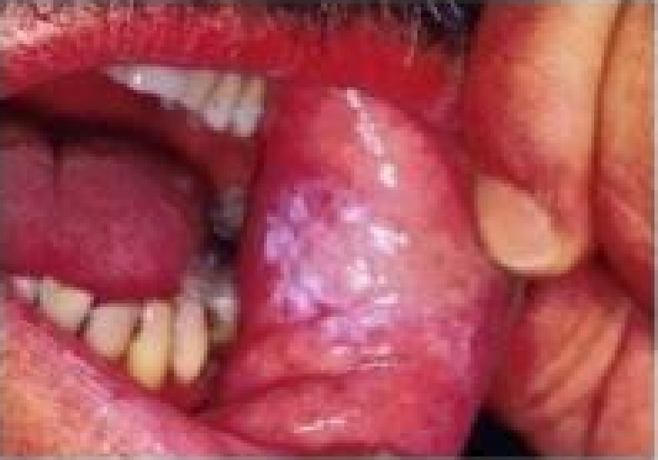

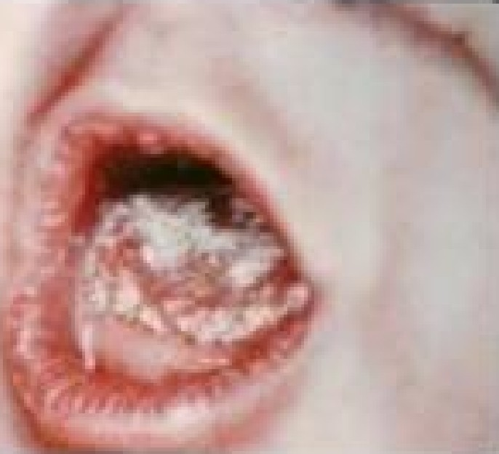

The differential diagnosis of ihrush includes f‹ tiil clcbris, h.abitti.al chcci‹ biting, and rarely, a genetically determined epithelial abnormality such as w'hitc spt ngc net tis.

Erythematous Candidiasis
The erythematous form of candidiasis was previously referred to as atrophic oral candidiasis. An erythematous surface may not just reflect atrophy but can also be explained by increased vascularization.
The lesion has a diffuse border, which helps distinguish it from erythroplakia, which has a sharper demarcation.



Acute Atrop ic Ca 
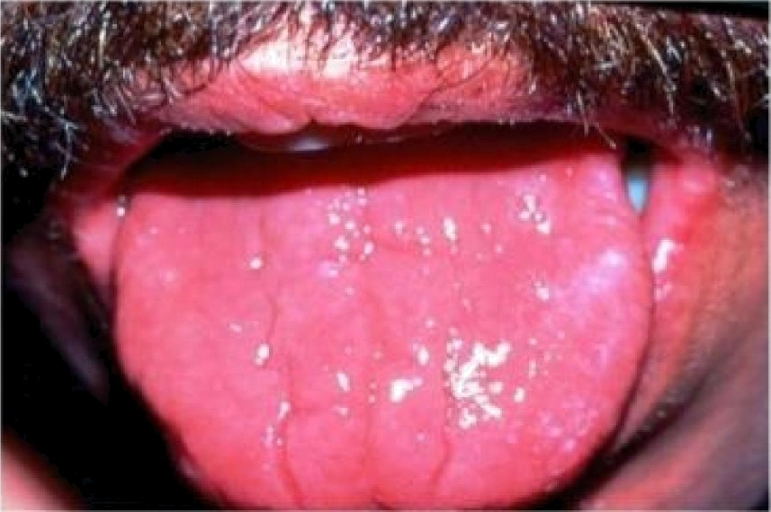
Acute atrophic candidiasis presents as a red patch of atrophic or erythematous raw and painful mucosa., with minimal evidence of the white psetidomembranous lesions observed in thrush.


Acute Atrop ic Cand iasis

Forms:
Antibiotic sore moulh, develops symptoms of’oral burning, bad fiaste, or sore throat during or after therapy wilh broad- spectrum antibiotics.
Patients with chronic iron deficiency anemia may also

develop atrophic candidiasis.
Removal of" the cause such as withdrawal of the offending antibiotic and institution of appropriate oral hygiene leads to improvement.
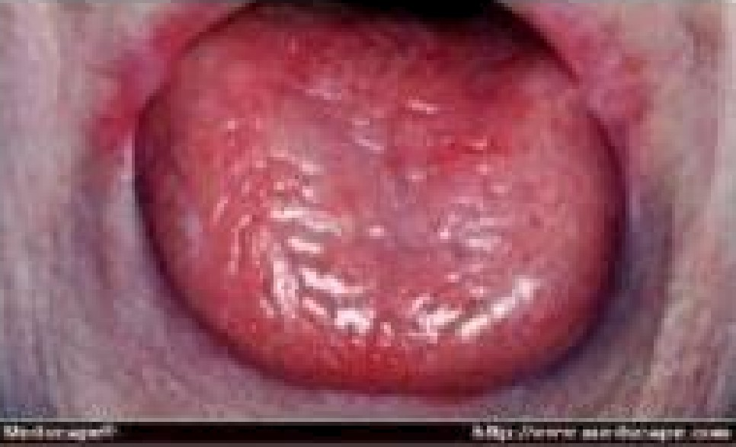
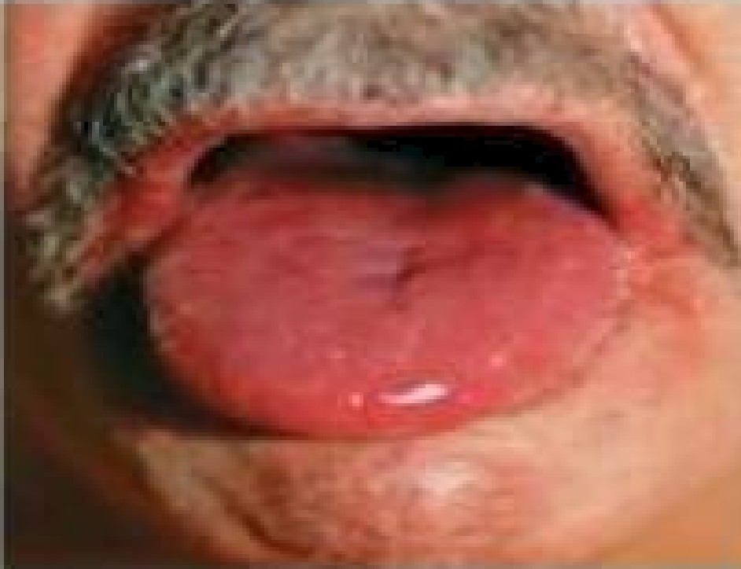

Chronic Plaque-Type and Nodular Candidiasis (hyperplastic candidiasis).
The chronic plaque type of oral candidiasis replaces the older term, candidal leukoplakia.

The typical clinical presentation is characterized by a white plaque, which may be indistinguishable from an oral leukoplakia.
A positive correlation between oral candidiasis and moderate to severe epithelial dysplasia has been observed, and both the chronic plaque-type and nodular candidiasis have been associated with malignant transformation
Chronic atrophic Candidiasis (Denture Stomatitis).

The most prevalent site for denture stomatitis is the denture-bearing palatal mucosa. It is unusual for the mandibular mucosa to be involved.
Denture stomatitis is classified into three different types:

Type I is localized to minor erythematous sites caused by trauma from the denture.
Type II affects a major part of the denture covered mucosa. In addition to the features of type II,
type III has a granular mucosa in the central part of the palate.



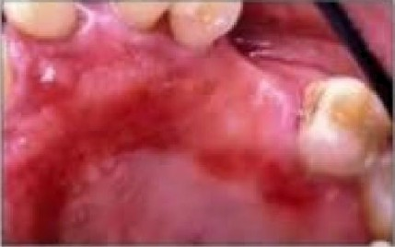
Tht• firs t stvifiv consists of numerous palatal petechiae
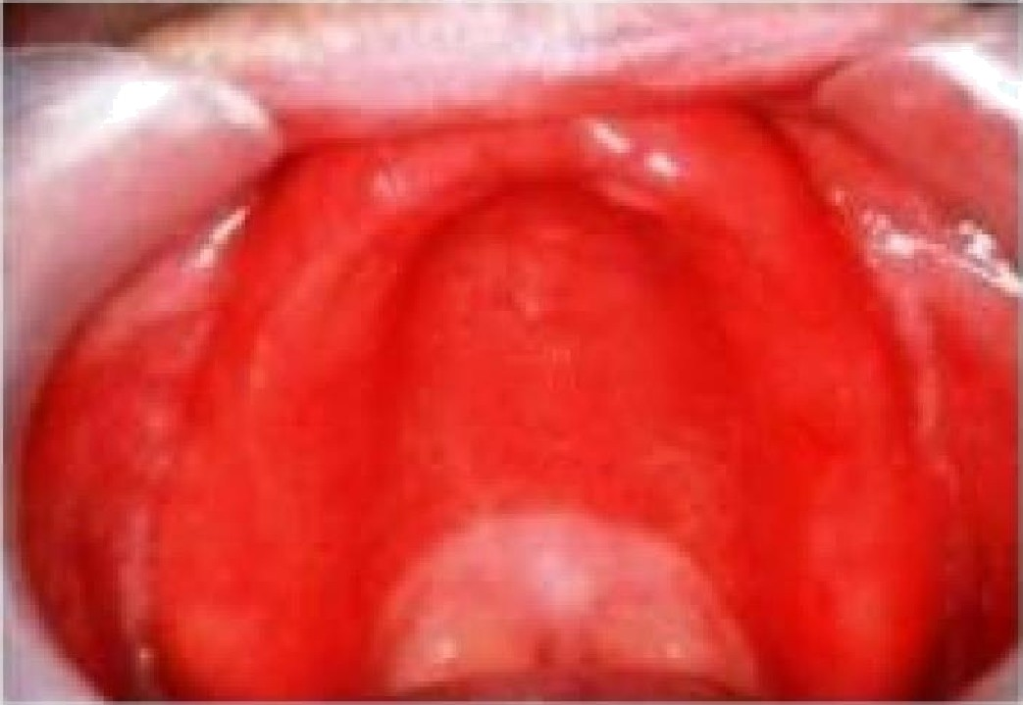
ThL• LL•.L’uHiI stclyv displays a more dif/rise erythemo involving most of the denture- covered
N UCOU
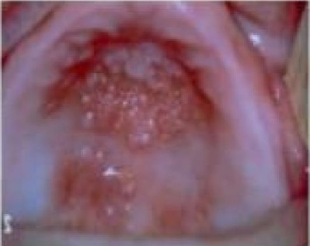
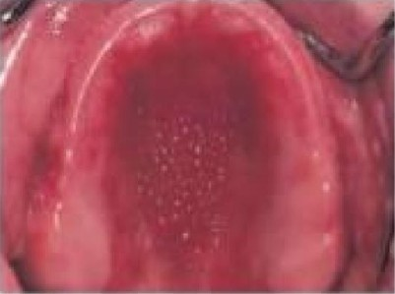
Th t• th iril stuyc includes the development ol tissue granulation or nodularity (papillary hyperplasia).

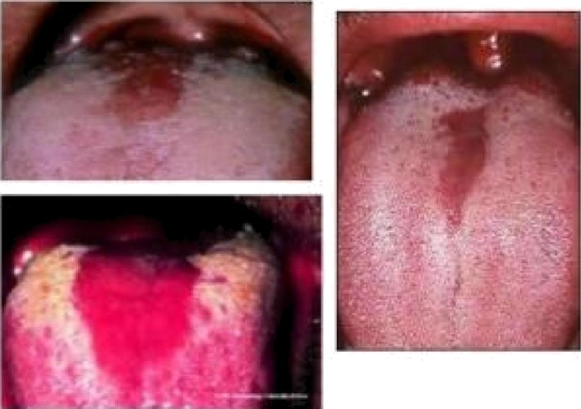
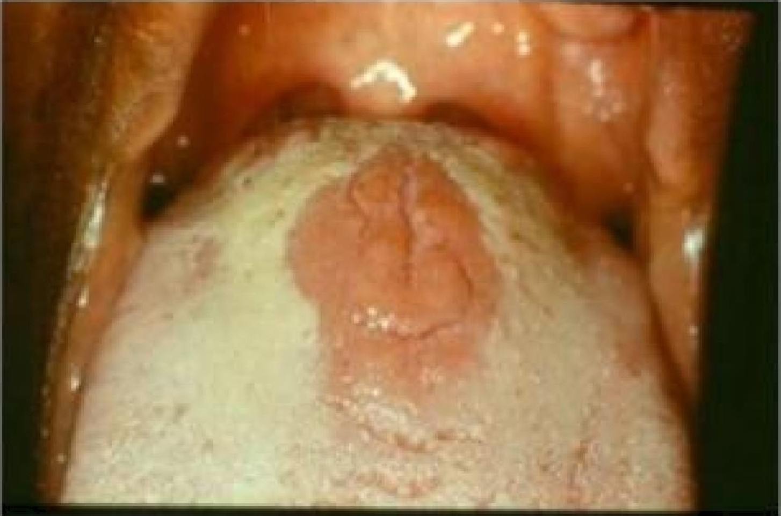
-  Erythematous patches of aoophic papi£ae located in the central area of the dorsum of the tongue are considered a form of chronic aoophic candidiasis. When these lesions become more nodular, the condition is referred to as hyperplastic median rhomboid glossitis.
Median Rhom*&or

Angular Cheilitis

Angular cheilitis is the lerm used for an infectiOn involving the lip commissures. The majority of’ cases is Candida associated and respond promplly to antihingal therapy.
Lesions are moderately painfiil, fissured due to accumulation of saliva in lhe sltin fiilds al the commissural angles.

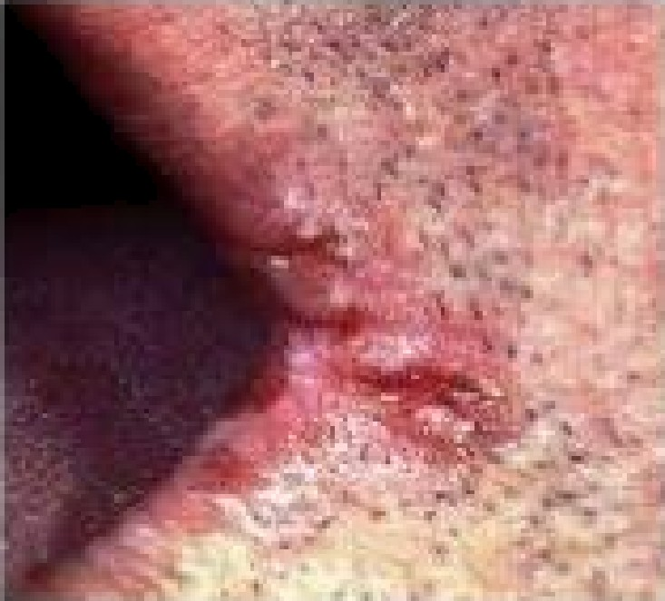
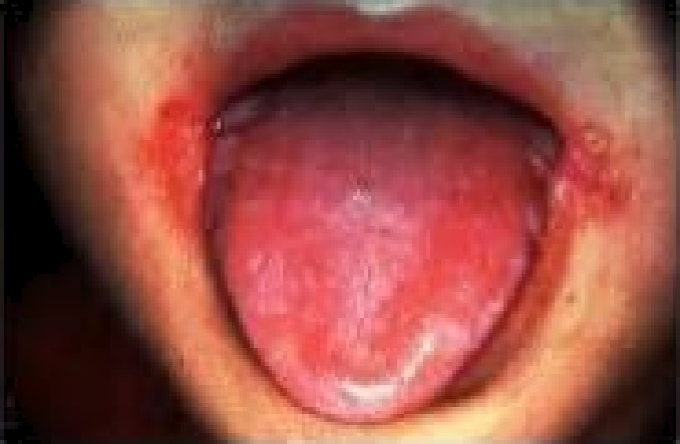
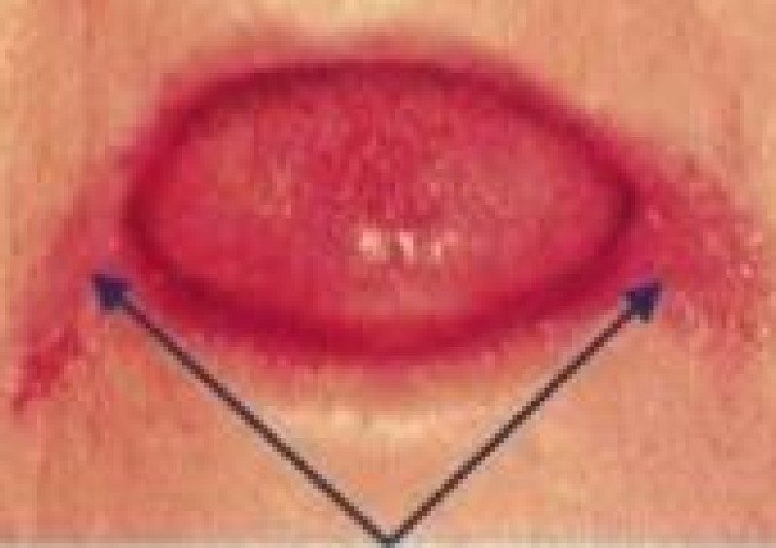

Photc shn‹’yIn¿ l»‹IateraI
›“\r g‹/›'ai’ Cl›e///I/»

Angular cheilitis is a common, noncontagious, inflammatory condition affecting the corners of the mouth or oral commissures.
Depending on the underlying cause, it may last a few days or persist indefinitely. It is also called angular stomatitis, or perleche (perlèche).

Angular cheilitis most commonly occurs due to prolonged exposure of the corners of the mouth to saliva and its digestive enzymes, resulting in eczematous cheilitis (a form of irritant contact dermatitis)
What are the clinical features of angular cheilitis?
- Painful cracks/fissures worse on mouth opening
- Blisters, erosions, oozing, crusting
- Redness
- Bleeding.
It is usually bilateral and symmetrical, however, it can occur on one side.
It may progress to more widespread impetigo or candidiasis (oral thrush) on the adjacent skin and elsewhere

—” Anguaé"$8&Eiéiâ '
Etiologic cofactors include:

Reduced ver tical dimen sion
  - A nutritional deficiency (iron deficiency anemia and

vitamin B or folic acid deficiency)

Diabetes
AIDS

Co-infection wifh siaphyfococcus and beta-hemolytic
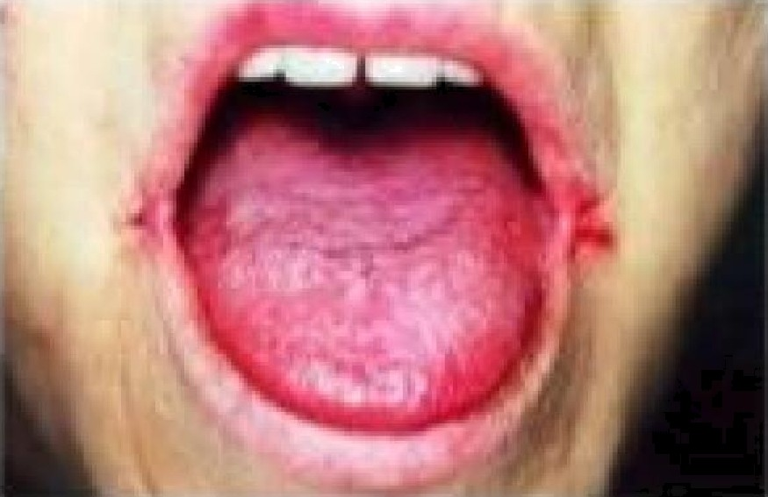
streptococcus.

Treatment:
General measures
- Improved general hydration
- Use of lip balm or a thick emollient ointment applied frequently.
- Topical antiseptics

Specific measures
Depending on the specific cause, oral and topical treatment options include:
- Topical antifungal cream

- Oral antifungal medication

- Topical or oral antistaphylococcal antibiotic
- Topical steroid ointment if the skin is significantly inflamed

Oral Candidiasis Associated with HIV:
The most common types of oral candidiasis in conjunction with HIV are: 1-pseudomembranous candidiasis
  - Erythematous candidiasis 3-Angular cheilitis,
4- Chronic hyperplastic candidiasis.

Management:

-Antifungal drugs have a primary role in such cases. The most commonly used antifungal drugs belong to the groups of polyenes or azoles.
Polyenes such as nystatin and amphotericin B.
while azoles are Ketoconazole , Miconazole, Fluconazole.



Oral Hairy leukoplakia (OHL):
Is the second most common HIV associated oral mucosal lesion
HL has been used as a marker of disease activity since the lesion is associated with low CD4+Tlymphocyte counts.
The lesion is not pathognomonic for HIV since other immune deficiencies, such as immunosuppressive drugs and cancer chemotherapy, are also associated with HL.
HL is strongly associated with Epstein Barr virus(EBV) and with low levels of CD4+ T lymphocytes.



Antiviral medication , which prevents EBV replication, is curative. OHL can be seen with drug-induced immunosuppression such as required for organ and bone-marrow transplants, primary blood disorders, and with inhaled corticosteroids for asthma.
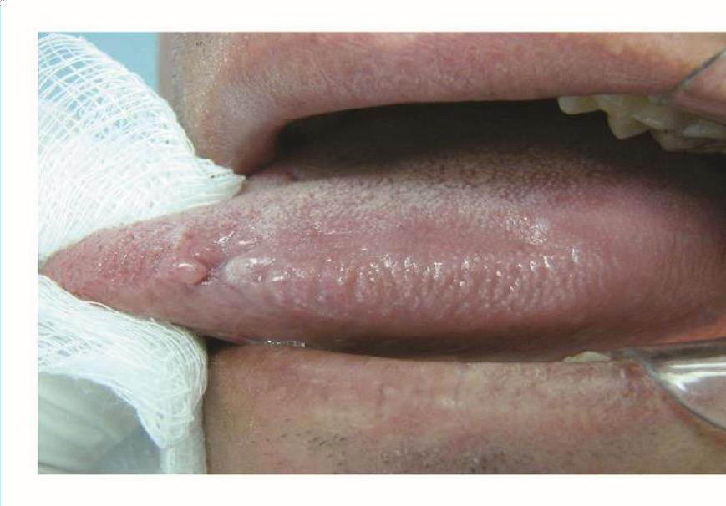

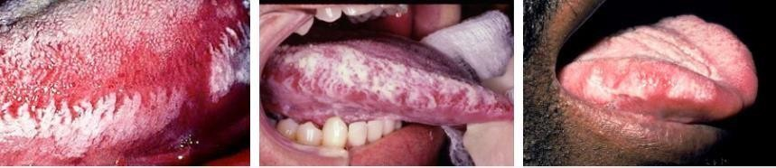

As asymptomatic white plaques on the lateral tongue which do not wipe off. It may be unilateral or bilateral.
The appearance can range from faint white streaks to a furrowed corrugated surface.
Discomfort, burning, or stinging may be reported by the patient.
What are the complications of oral hairy leukoplakia?

Oral hairy leukoplakia associated with HIV infection is a sign of severe immunosuppression and progression to AIDS

Secondary candidiasis can obscure the clinical and histological features of OHL is not a premalignant lesion
What is the differential diagnosis for oral hairy leukoplakia? Oral candidiasis
Oral lichen planus Geographic tongue Lichen Planus
The precise cause of oral lichen planus is not fully understood. It involves cytotoxic CD8+ T lymphocytes and
proinflammatory cytokines, which attack the oral epithelial cells — resulting in their death. The immune response is mediated by antigen-specific cells.
Immunopathologic Diseases:

Oral Lichen Planus
Lichenoid reactions represent a family of lesions with different etiologies with a common clinical and histologic appearence. Histopathologic examination does not enable discrimination between

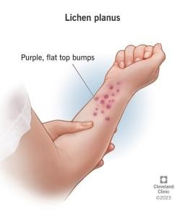

different lichenoid reactions but may be used to distinguish lichenoid reactions from other pathologic conditions of the oral mucosa.
The classic appearance of skin lesions consists of pruritic erythematous to violaceous papules that are flat topped that have a predilection for the trunk and flexor surfaces of arms and legs.

In most cases oral lichen planus is idiopathic, when the reaction is thought to be against autoantigens. In other cases, it may be precipitated by exogenous antigens described below.

Drugs — this is called oral lichenoid drug reaction. It is most often due to gold therapy

Contact allergens in dental restorative materials (mercury, nickel, gold, resins, acrylates Viral infection, particularly Hepatitis C
Oral lichenoid lesions are also part of the spectrum of chronic graft-versushost disease that occurs after bone marrow transplantation

Drugs — this is called oral lichenoid drug reaction. It is most often due to gold therapy.

Contact allergens in dental restorative materials (mercury, nickel, gold, resins, acrylatesViral infection, particularly Hepatitis C


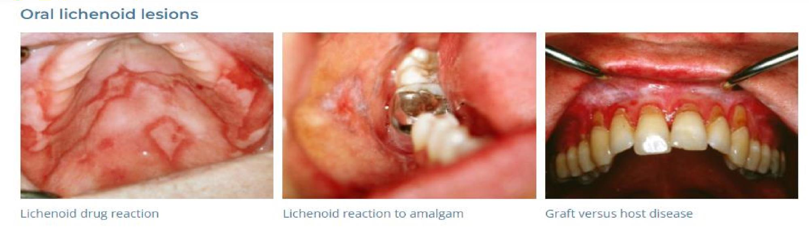
Oral lichenoid lesions are also part of the spectrum of chronic graft-versus- host disease that occurs after bone marrow transplantation

Lichen planus is a mucocutanous lesion affecting the skin as well as the oral mucosa.

The oral lesions may be the only site. The etiology of the disease is unknown.

OLP may contain both red and white elements and provide, together with the different forms the basis for the clinical classification of this disorder.
The white and red components of the oral lesion can be a part of the following textures:

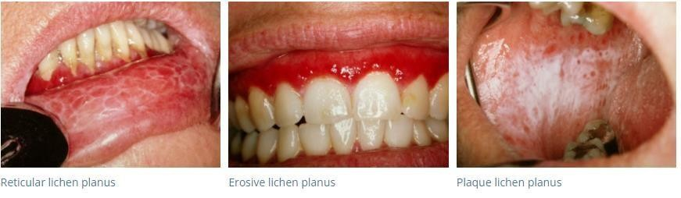
  - Reticular
  - Papules
  - Plaque-like
  - Erosive or atrophic (erythematus) most precancerous type 5-Ulcerative and Bullous
6-Pigmented LP

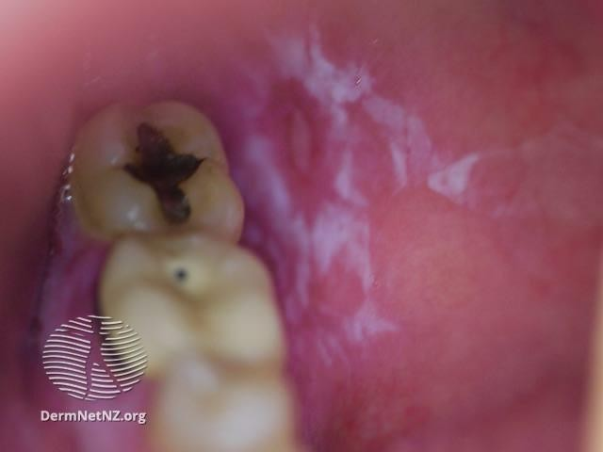

Reticular lichen planus
- Symmetrical white lace-like pattern on buccal mucosa (inner aspects of cheeks) Wickham striae
- There may be no symptoms or discomfort and soreness.
- May affect tongue or gums
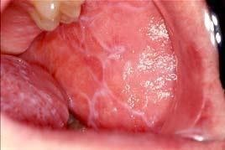
- May ulcerate

Wickham striae whitish lines visible in the papules of lichen planus and other dermatoses, typically in the oral mucosa

Plaque type oral lichen planus

  - Usually seen in smokers
- Confluent white patches similar to oral keratoses
Plaque-type OLP shows a homogeneous well-demarcated white plaque often , but not always, surrounded by striae.

Management:
Several topical drugs have been suggested, including steroids,(cyclosporine and , retinoids, Antifungal therapy ultraviolet phototherapy.
Among these, topical steroids, triamcenolone acetonide (Kenaloge orabase) are widely used and accepted as the primary treatment of choice.

Lupus Erythematosus (LE):

LE represents the classic prototype of an autoimmune disease involving immune complexes. Both the natural and the adaptive
parts of the immune system.

Environmental factors are of importance as sun exposure, drugs, chemical substances, and hormones which all have been reported to aggravate the disease.
The oral lesions

observed in Systemic LE and Discoid LE are similar in their characteristics, both clinically and histopathologically. The
typical clinical lesion comprises white striae with a radiating orientation, and these
may sharply terminate toward the center of the lesions, which has a more erythematous appearance (similar to erythematus LP).
The most affected sites are the gingiva, buccal mucosa, tongue, and palate.

Lesions in the palatal mucosa can be dominated by erythematous lesions, and white structures may not be observed .
Differential Diagnosis is:
OLP and Leukoplakia lesions.
The typical DLE diagnosis comprises well-demarcated cutaneous lesions with round or oval erythematous plaques with scales and follicular plugging.
These lesions may form butterfly- like rashes over the cheeks and nose known as malar rash.
SLE may also occur in association with other rheumatologic diseases such as Secondary Sjögren’s syndrome and mixed connective tissue disease.


Diagnosis;
Antinuclear antibodies are frequently found in patients with SLE and can be used to indicate a systemic involvement.

OTHER RED AND WHITE LESIONS
1-Leukoedema. is a generalized white change of oral mucosa which is probably a
variation of normal rather than a disease. The cause is unknown.
It occurs much more commonly in blacks than whites.
Leukoedema is diffuse and symmetrically distributed on the buccal mucosa and may extend onto the labial mucosa.
The appearance is gray-white, opaque, or milky.
It can be smooth to palpation or wrinkled, and it does not rub off.
A characteristic clinical feature is that the white appearance decreases when the buccal mucosa is stretched.

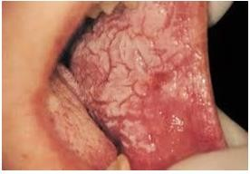
Leukoedema
A characteristic clinical feature is that the white appearance decreases when the buccal mucosa is stretched.
.

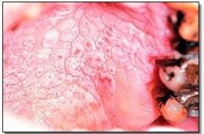

Nicotine stomatitis:

Is an epithelial thickening lesion of the hard palate caused by :
heat from smoking a pipe, cigar, or occasionally cigarettes.
The lesion is white, rough, asymptomatic, and leathery appearing and contains numerous red dots or macules.
The red macules represent inflamed salivary gland duct orifices.
Nicotine stomatitis is not considered a premalignant lesion and does not need to be biopsied.
However, the patient should be encouraged to stop smoking, and the oral mucosa should be evaluated periodically.



Erythema migrans (geographic tongue, benign migratory glossitis):
is a common, harmless lesion that can typically be diagnosed by its clinical features.
It presents as multiple red patches surrounded by a thickened, irregular, white border.
A lesion will resolve in one area and appear in other areas (migrate).

This condition is usually not painful and requires no treatment.

If the patient complains of pain or burning with the lesions, a diagnosis of candidosis should be considered.

Rarely, lesions of erythema migrans can be found on oral mucosal surfaces other than tongue
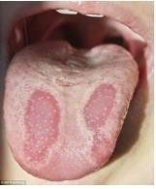

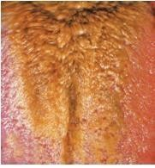
Hairy Tongue

The etiology of hairy tongue is unknown in most cases.
There are a number of predisposing factors that have been related to this disorder, such as:
Neglected oral hygiene,
A shift in the microflora, antibiotics and immunosuppressive drugs,
oral candidiasis, excessive alcohol consumption, oral inactivity, and therapeutic radiation. Hairy tongue is also associated with smoking habits.

The lesion is commonly found in the posterior one-third of the tongue but may involve the entire dorsum. Hairy tongue may adopt colors from white to black depending on food constituents and the composition of the oral microflora.

The treatment of hairy tongue is focused on reduction or elimination of predisposing factors and removal of the elongated filiform papillae.

The patients should be instructed on how to use devices developed to scrape the tongue.

The use of food constituents with an abrasive effect may also be used.

