**Formulas and Functions**

There is a whole new formula bar in Excel 2013 to make entering Formulas and

Functions easier.

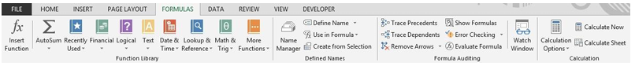

**Formulas**

**Rules and Syntax**

All Formulas or Functions start with an “=”

Formulas use these operators (all of these operators can be found on the

numeric keypad) and are calculated in the following order:

**“*” Multiplication**

**“/” Division**

**“+” Addition**

**“-” Subtraction**

**Example of a Formula and its Answer:**

**=5+4*2 would the answer be 18 or 13?**

IMPORTANT: The answer would be 13 because the Mathematical

Hierarchy states the multiplication and division always occur before

addition and subtraction unless parenthesis are used. If parentheses are

used, that operation will override the default hierarchy. In other words,

if you wish the answer to be 18, the formula must be

= (5+4)*2.

**Syntax**

The syntax of a function is generally “=function name(range)” see examples

below

**Sum: =SUM(B5:B10)**

**Minimum: =MIN(B5:B10)**

**Maximum: =MAX(B5:B10)**

**Average: =AVERAGE(B5:B10)**

**The AutoSum Tool on the Home tab**

**Sum a Column**

**Using the example below:**

**1. Click in cell B9 -** the cell directly below the data.

**2.** Click the **AutoSum tool.**

Notice that the cells it thinks you want to add have a marquis, a dotted line,

around them.

**3.** If the cells you wish to add have a marquis around them, simply press Enter or

**click the AutoSum tool again to remove the marquis.**

**Sum Multiple Columns**

**4.** Select all the cells where you want the totals to appear.

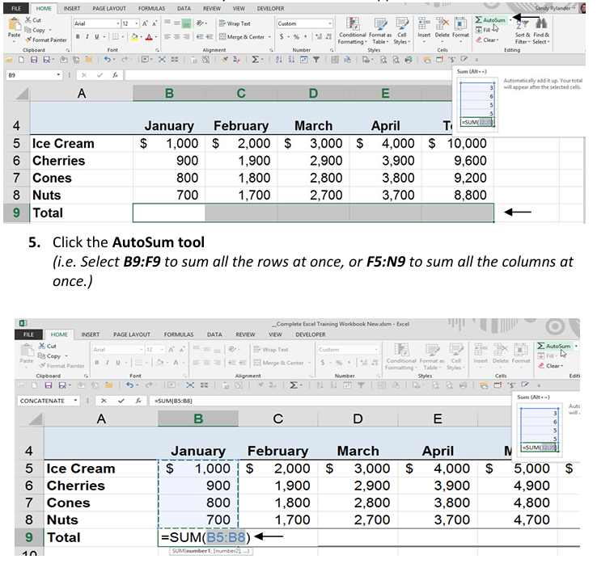

**MIN function - syntax and usage examples in Excel**

The MIN function checks your data range and returns the smallest value in the

set. Its syntax is the following:

MIN (number1, [number2], …)

number1, [number2], … is the series of values from where you want to get a

minimum. Number1 is required while [number2] and the following are optional.

There are up to 255 arguments allowed in one function. The arguments can be

numbers, cells, arrays of references, and ranges. However, arguments like

logical values, text, empty cells are ignored.

Examples of using MIN formula

MIN is one of the easiest functions to apply. Let me prove it to you:

Example 1. Locating the smallest value

Let's say you have some fruits in stock. Your task is to check if you are running out of any.

There are several ways to go:

Case 1: Enter each and every numeral from the Qty in stock column:

=MIN(366, 476, 398, 982, 354, 534, 408)

Case 2: Reference the cells from the Qty column one by one:

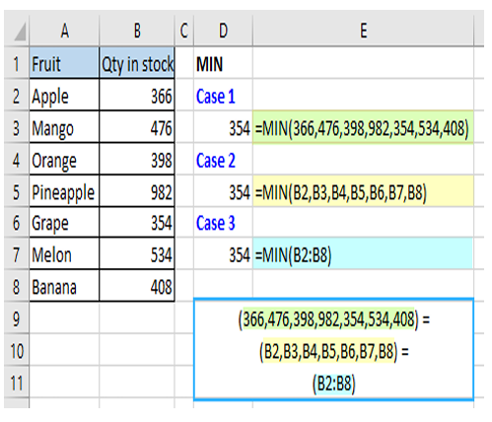=MIN(B2,B3,B4,B5,B6,B7,B8)

Case 3: Or simply reference the whole range:

=MIN(B2:B8)

**Excel MAX function**

The MAX function in Excel returns the highest value in a set of data that you specify.

**The syntax is as follows:**

MAX(number1, [number2], …)

Where number can be represented by a numeric value, array, named range, a reference

to a cell or range containing numbers.

Number1 is required, number2 and subsequent arguments are optional.

The MAX function is available in all versions of Excel for Office 365, Excel 2019, Excel

2016, Excel 2013, Excel 2010, Excel 2007, and lower.

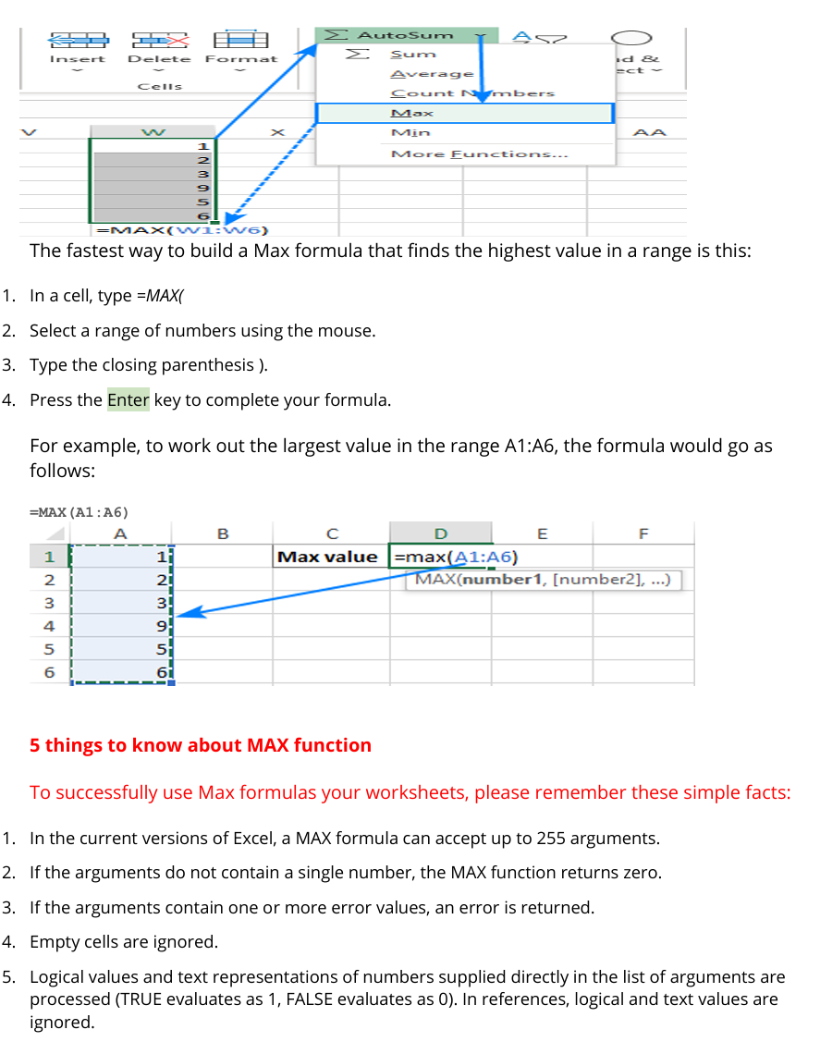

How to calculate average manually

In math, to find the arithmetic mean of a list of numbers, you need to add up all the values, and

then divide the sum by how many numbers there are in the list. In Excel, this can be done using

the SUM and COUNT functions, respectively:

SUM(range)/COUNT(range)

For the range of numbers below, the formula goes as follows:

=SUM(B3:B12)/COUNT(B3:B12)

As you can see, the result of the formula exactly matches the average value in the status bar.

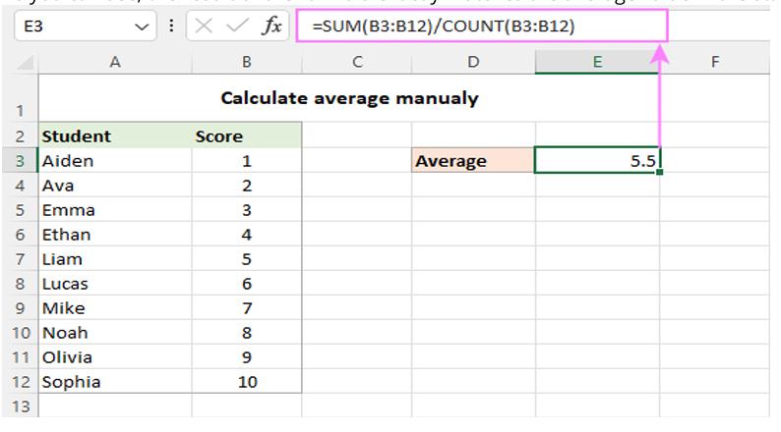

In practice, you will hardly ever need to do a manual average in your worksheets. However, it may

be useful to re-check the result of your average formula in case of doubt.

And now, let's take a look at how you can do average in Excel using the functions specially

designed for the purpose.