1

**Electronic Circuit**

**Lecture 2 ( $3rd$ Week)**

**General Frequency Considerations**

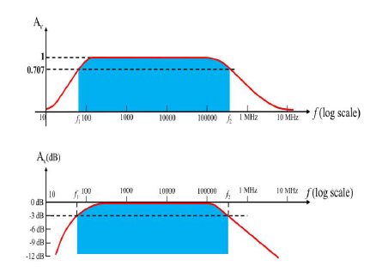

* 1. **Introduction**

We will now investigate the frequency effects introduced by the larger capacitive elements of the network at low frequencies and the smaller capacitive elements of the active device at the high frequencies Since the analysis will extend through a wide frequency range, the logarithmic scale will be defined and used throughout the analysis.

In addition, since industry typically uses a decibel scale on its frequency plots, the concept of the decibel is introduced in some detail.

في المحاضرات السابقة وعند القيام بعملية تحليل الدوائر الالكترونية , تم اعتبار دوائر المتسعات كدائرة مغلقة واهمال قيم التردد وتاثيرها على الدائرة الالكترونية. وذلك لان قيمة التردد عالي جدا بحيث لا يؤثر عند حساب قيمة الكسب في التيار او الفولتية.

في هذه المحاضرة سيتم دراسة تاثير التردد في قيمة الجهد المراد حسابة في الترددات العالية والواطئة كما سيتم ايضاحه بالتفصيل.

1.2 **LOGARITHMS**

As a first step in clarifying the relationship between the variables of a logarithmic function, consider the following mathematical equations:

بما انه سيتم التعامل مع طيف واسع من الترددات تبدا من الترددات الصغيرة الى الترددات العالية لذلك سيتم استخدام اللوغارتيمات ووحدة الديسيبل لوصف وقياس النتائج عند القيام بتحليل الدوائر الالكترونية.

الخطوة الاولى هي تحديد العلاقة بين مختلف المتغيرات التي نحتاجها في معادلات اللوغارتيمات وكما موضح في المعادلات ادناه.

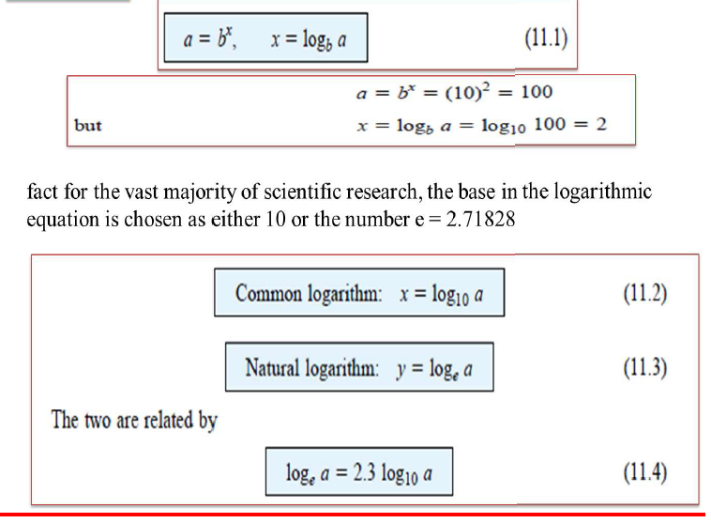

EXAMPLE 9.1 Using the calculator, determine the logarithm of the following numbers to the base indicated:

a. log10 106.

b. loge e3.

c. log10 10-2.

d. loge e-1.

Solution:

a. 6 b. 3 c. 2 d. 1

the logarithm of a number taken to a power is simply the power of the number if the number matches the base of the logarithm

Tab 9.1 shows how the logarithm of a number increases only as the exponent of

the number

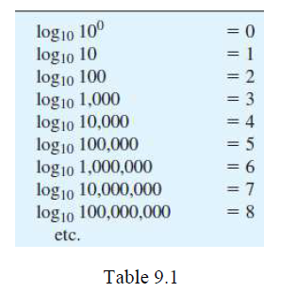

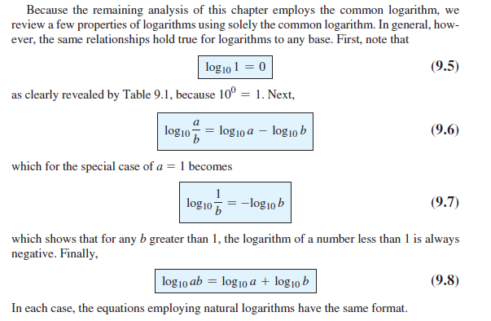

**Semilog graph paper**

The log of 2 to the base 10 is approximately 0.3. The distance from 1 (log10 1 = 0) to 2 is therefore 30% of the span. The log of 3 to the base 10 is 0.4771 or almost 48% of the span (very close to one-half the distance between power-of- 10 increments on the (log scale).

يلاحظ ان التخطيط يحتوي على محور تدرجه طبيعي يبدا من الواحد الى الستة ومحور تدرجة لوغارتيمي ومن هنا اصل التسمية. يلاحظ ايضا عدم وجود صفر او قيمة سالبة في المحور اللوغارتيمي. ملاحظة اخرى هي ان لوغارتيم الواحد يساوي صفر لذلك يوضع بمكان الصفر وهكذا لبقية القيم. الملاحظة الاخيرة هي ان المسافة بين القيم ليست مسافة حقيقة وانما مسافة لوغارتيمية.

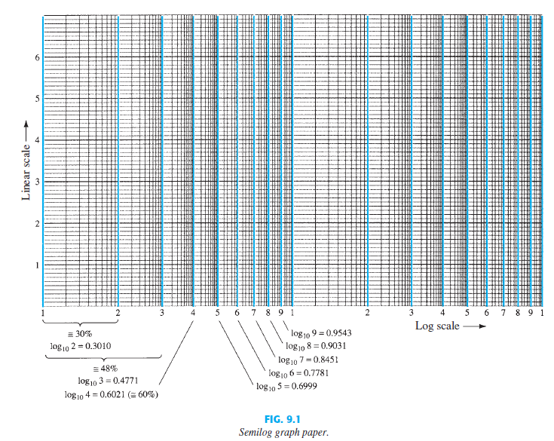

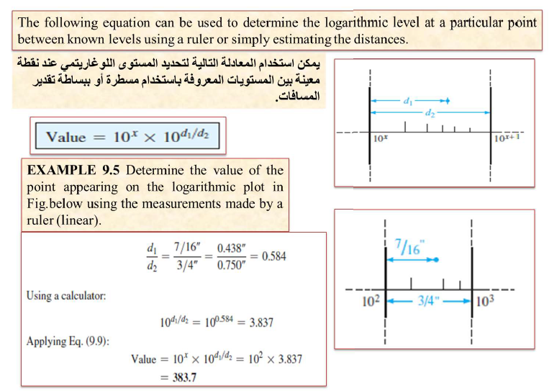

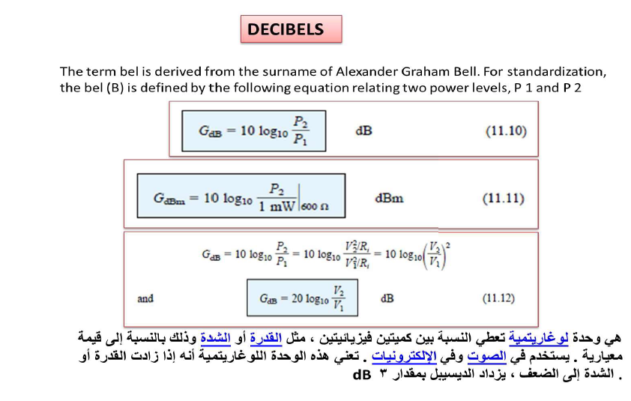

* The power and audio levels are related on a logarithmic basis.
* For an increase in power level of 4w to 64w , the audio level will increase by a factor of 3 because 4^3 = 64. In logarithmic form the relationship can be written as
* Log4 64 = 3

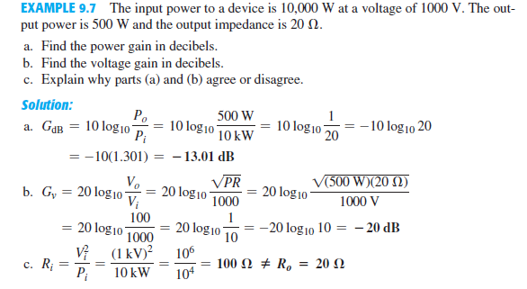

GENERAL FREQUENCY CONSIDERATIONS

At low frequencies, we shall find that the coupling and bypass capacitors can no longer be replaced by the short-circuit approximation because of the increase in reactance of these elements The frequency-dependent parameters of the small-signal equivalent circuits and the stray capacitive elements associated with the active device and the network will limit the high-frequency response of the system An increase in the number of stages of a cascaded system will also limit both the high- and low-frequency responses

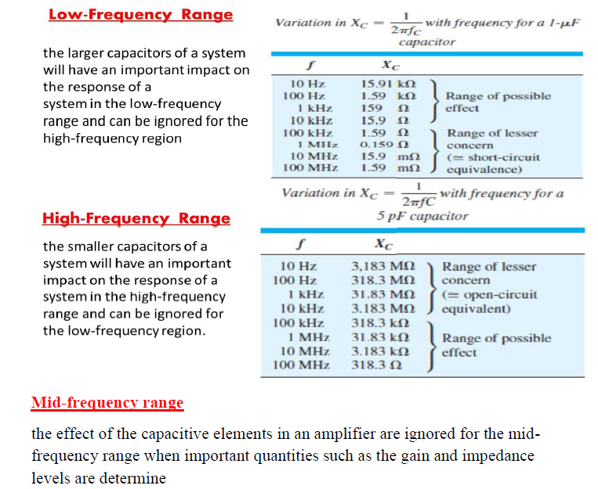

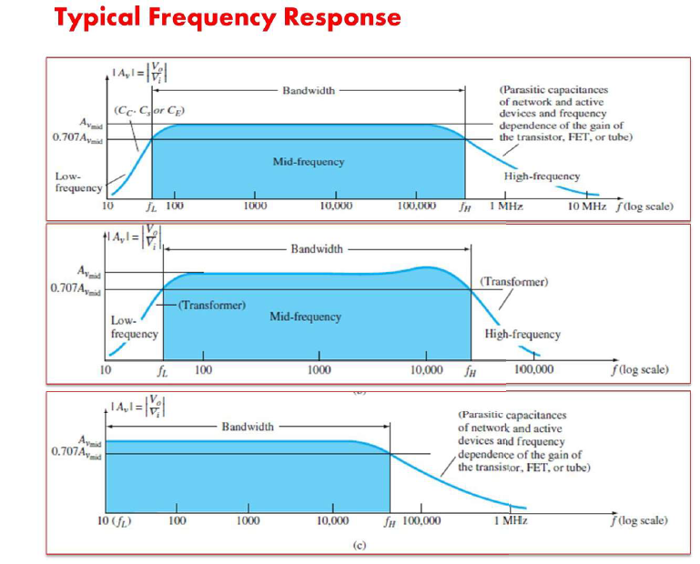

**Band of frequencies**

For each system of Fig. 9.8 , there is a band of frequencies in which the magnitude of the gain is either equal or relatively close to the midband value. To fix the frequency boundaries of relatively high gain, 0.707Avmid was chosen to be the gain at the cutoff levels. The corresponding frequencies f 1 and f 2 are generally called the corner, cutoff, band, break, or half-power frequencies. The multiplier 0.707 was chosen because at this level the output power is half the midband power output, that is, at midfrequencies

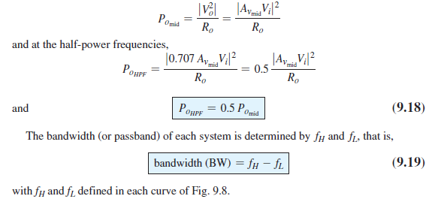

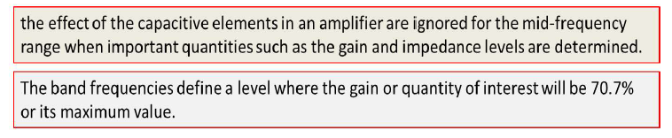

EXAMPLE 9.9 Given the frequency response of Fig. 9.10 :

a. Find the cutoff frequencies *f L* and *f H* using the measurements provided.

b. Find the bandwidth of the response.

c. Sketch the normalized response.

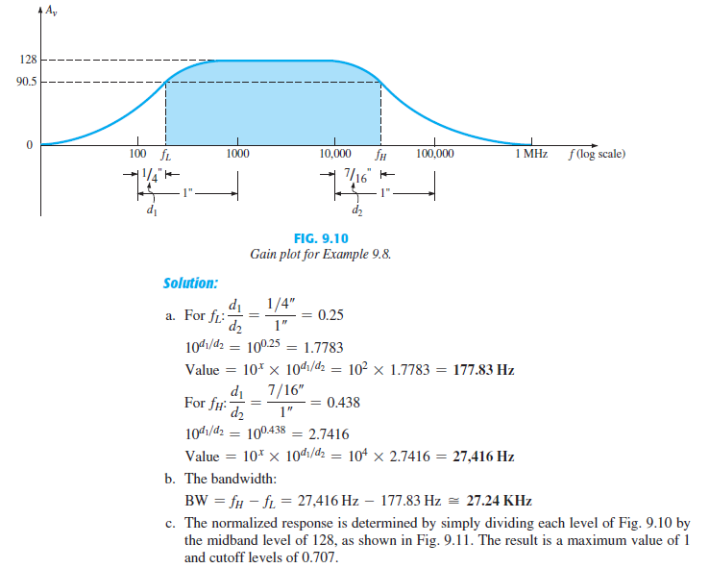

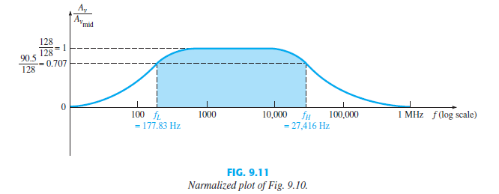

LOW-FREQUENCY ANALYSIS- BODE PLOT

In the low-frequency region of the single-stage BJT or FET amplifier, it is the RC combinations formed by the network capacitors CC, CE, and C s and the network resistive parameters that determine the cutoff frequencies. In fact, an RC network similar to Fig. 9.14 can be established for each capacitive element, and the frequency at which the output voltage drops to 0.707 of its maximum value can be determined. Once the cutoff frequencies due to each capacitor are determined, they can be compared to establish which will determine the low cutoff frequency for the system.

